3DPrint-AU brings three-dimensional shapes to life with high quality compressed air from Kaeser
3DPrint-AU recently invested in a KAESER SM9T rotary screw compressor to meet its requirement for a reliable supply of high quality and clean compressed air in its new dedicated 3D printing facility.
3D Printing Systems is Australia's leading distributor of 3D printers. The company recently expanded its capabilities by opening its own dedicated 3D print services facility - 3DPrint-AU that services consumer and business customers Australia wide.
3D printing, or additive manufacturing, is the process whereby a real object is created from a 3D design. Originally developed for rapid prototyping, 3D printing has become popular for the production of end use component parts.
Utilising Elite Selective Sintering (SLS) additive manufacturing 3D printers, 3DPrint-AU can print a range of products from; hobbiest models, smart phone cases and life critical orthopaedic surgical gloves, to strong and flexible functional nylon parts for industry that have highly complex designs, such as component parts for the automotive sector.
The SLS printing process involves a laser being aimed into a bed of nylon powder. The laser fuses (or sinters) the nylon powder, layer upon layer. Once cooled, excess powder is then brushed off to reveal the three-dimensional shape!
Compressed air is an integral part of the 3D printing process. The Atmosphere in the printing chamber must be tightly controlled. This is achieved by using nitrogen as an inert gas, and this is produced by passing compressed air through a nitrogen generator. Crucially, the compressed air must be clean and dry, therefore free of water and oil vapour contaminants, which if present could cause product spoilage.
As a result a reliable supply of compressed air is a must in the 3D printing process, as Bruce Jackson, Managing Director at 3DPrint-AU explains: 'If the compressor system were to fail when we were printing it would deteriorate the quality of the end product. We cannot open the printer up mid-job, therefore we only find out if a print job has been successful once it has completed. And, with a typical print job running continuously for 40 plus hours, you can understand why it was imperative that we sourced a reliable supply of compressed air!'
Having learnt that Kaeser compressors were renowned for their reliability, in setting up the new 3D printing production facility in Auckland, 3DPrint-AU called upon authorised Kaeser Compressors distributor Plummer Compressors to supply the compressed air system. Plummer Compressors recommended, and subsequently installed, a Kaeser SM9T series rotary screw compressor with integrated refrigeration dryer, to reliably meet their demand for high quality compressed air.
The compact SM series rotary screw compressors from Kaeser provide a reliable and energy efficient supply of compressed air to the smaller compressed air user.
At the heart of every SM series compressor lies a premium quality screw compressor block that features Kaeser's Sigma Profile rotors. Designed to ensure maximum energy efficiency, the Sigma Profile rotors can achieve power savings of up to 15 per cent compared with conventional screw compressor block rotor profiles.
For maximum performance, reliability and efficiency, the screw compressor block is powered by a premium efficiency IE3-rated drive motor (that complies with, and exceeds, prevailing Australian MEPS regulations for 3 phase electric motors).
In addition, the SM T models include an integrated energy-saving refrigeration dryer. Linked to the operational status of the compressor, the refrigeration dryer automatically shuts down when the compressor is not in use for the ultimate energy saving solution.
Jackson concluded: 'The Kaeser compressed air system has proven to be reliable in operation. In fact we are so impressed with its performance that we are now recommending the Kaeser equipment to our 3D printer customers.'
3DPrint-AU continues to rely on compressor specialist Plummer Compressors for its on-going compressor maintenance requirements.
Quiet, dependable and efficient, the Kaeser SM series rotary screw compressors are available with integrated refrigeration dryer (SM T), with variable speed control (SM T SFC) or as a complete compressed air package; where both the compressor and refrigeration dryer are mounted on a compressed air receiver (AIRCENTER). Drive power 5.5 to 9 kW, working pressure 8, 11 and 15 bar with free air deliveries from 0.60 up to 1.50 m³/min (fixed speed) or 0.34 to 1.24 m³/min (variable speed).

File: Q-3DPrint-nz
Approved for publication, copy acknowledgement appreciated
Images: (contact the press office for high res copies of the following images)

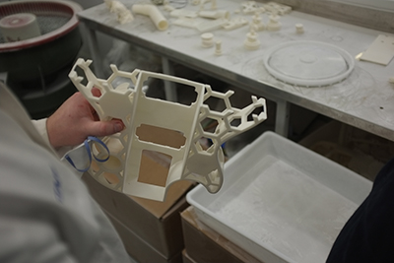
Caption: The SLS printing process involves a laser being aimed into a bed of nylon powder. The laser fuses (or sinters) the nylon powder, layer upon layer. Once cooled, excess powder is then brushed off to reveal the three-dimensional shape

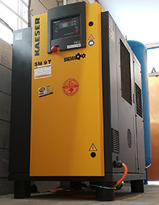
Caption: 3DPrint-AU chose to invest in a Kaeser SM9T series rotary screw compressor with integrated refrigeration dryer, to reliably meet their demand for compressed air.

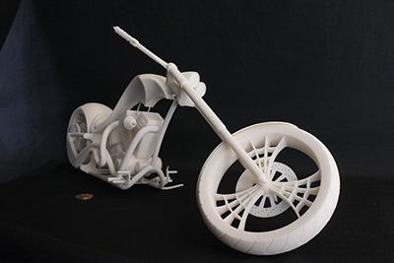
Caption: 3DPrint-AU can print a range of products including hobbiest models

