June 2021

Kaeser Compressors becomes a Capricorn Preferred Supplier
Kaeser Compressors NZ is excited to announce that it recently became a Capricorn Preferred Supplier. Established almost 50 years ago, Capricorn is Australasia’s largest automotive cooperative.
Established in 1974, and with over 20,000 members across Australia and New Zealand, Capricorn is Australasia’s largest automotive cooperative. Capricorn’s mission is to make it easier for automotive businesses to grow and be sustainable and opens up access to its members to quality parts and services at a competitive price.

As one of the world’s largest compressed air systems providers and compressor manufacturers, Kaeser Compressors has been supplying the automotive industry with compact, reliable and energy efficient compressed air system solutions for many years. Becoming a Capricorn Preferred Supplier was therefore a perfect fit for Kaeser Compressors NZ.

Compressed air is an essential utility in the automotive industry and will be the energy source for most of the equipment that is used in a body shop. Operating a reliable and energy efficient compressed air system is critical in order to reduce energy costs, maximise compressed air availability and produce high quality compressed air (especially critical when compressed air is used for paint spraying operations). A compact compressed air solution that is quiet in operation is also important where space is at a premium.
One very popular Kaeser compressed air system within the automotive industry that fulfils these requirements is the Aircenter. Remaining proudly manufactured in Germany, the user-friendly Aircenter is a complete turnkey system which incorporates a Kaeser rotary screw compressor, an energy efficient refrigeration dryer and an air receiver all in one space-saving compact package. The space-saving design has long since made the Aircenter the ideal solution where space is at a premium - such as in automotive body shops.

Anthony Long, Director of Kaeser Compressors NZ said: ‘We are delighted to now be a Capricorn Preferred Supplier. As a supplier to many businesses in the automotive aftermarket industry there was a clear synergy for us in becoming a Capricorn Preferred Supplier.

When Capricorn Members choose Kaeser Compressors NZ, they can benefit from access to high quality ‘Made in Germany’ compressed air system solutions renowned for their ease of use and maintenance, durability and reliability - as well as their energy efficiency, and all backed up with local and nationwide service support.

Capricorn also offers its members easy access to CAP ezi-finance - its own equipment finance product. That means a Member may be eligible to finance the purchase of a Kaeser compressor with terms from 6 months to 5 years*.

For more information visit nz.kaeser.com or phone 0800 447 820.
*Capricorn Finance offers business equipment finance in New Zealand through Capricorn Society Limited (NZBN 9429038593185) and brokers business finance through Capricorn Society Financial Services Pty Ltd (ACN 129 134 667). Fees and charges, terms and conditions, and lending criteria apply.
-END- Free for publication, copy appreciated
Editors Notes
From 0.18 to 515 kW, Kaeser Compressors manufactures a wide range of compressors and associated auxiliary equipment that meet the varying requirements of a diverse range of industries and applications.
One of the world’s largest manufacturers of compressors, blowers and compressed air systems, Kaeser Compressors is represented throughout the world by a comprehensive network of branches, subsidiaries and authorised distribution partners in over 140 countries.
Kaeser Compressors NZ provides comprehensive sales and service throughout New Zealand, from its facility in Auckland, alongside an extensive network of authorised partners.
For editorial and advertising enquiries contact: Beth Wood, Marketing Manager
Press office: +61 3 9791 5999 E-mail: beth.wood@kaeser.com
KAESER COMPRESSORS NZ Limited
18B Tarndale Grove, Albany, Auckland 0632, New Zealand
Phone: +64 9 941 0499 Email: info.newzealand@kaeser.com Web: nz.kaeser.com
File: P-Kaeser-Capricorn-Preferred-Supplier-nz
Approved for publication, copy acknowledgement appreciated
Images:

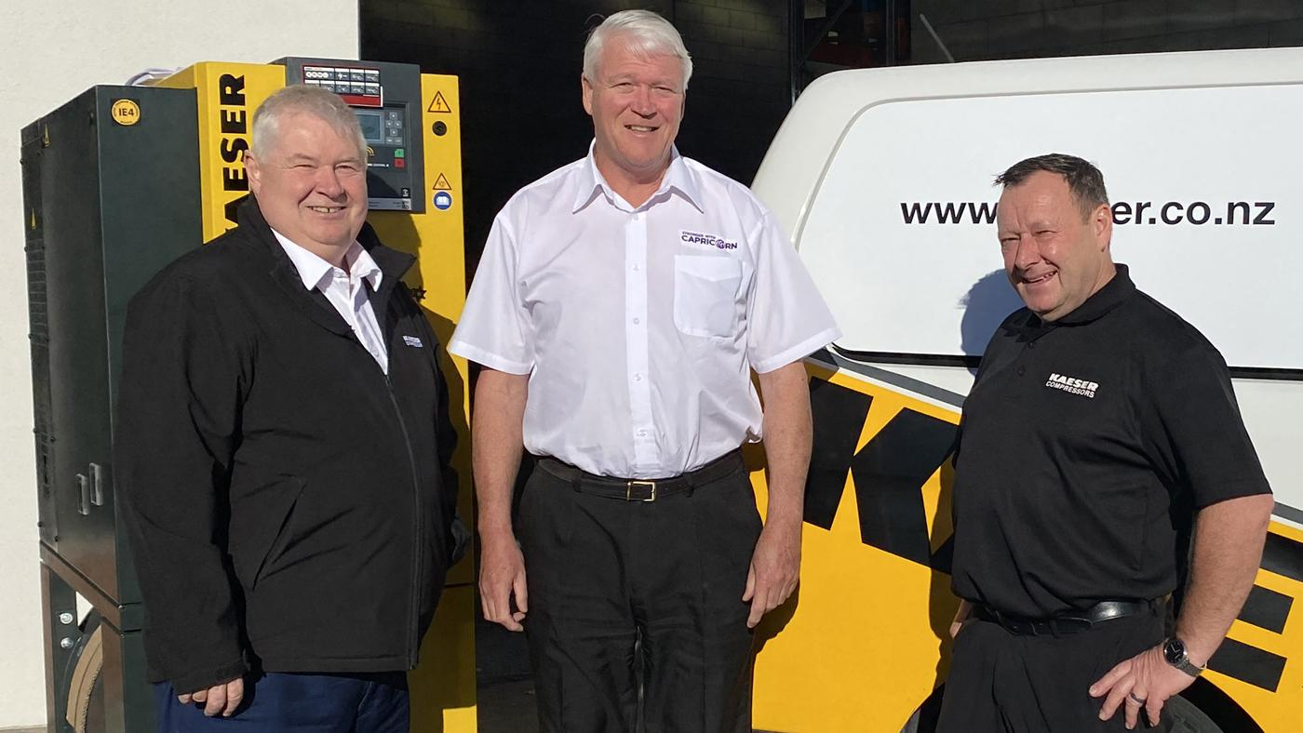
Caption: Kaeser Compressors is now a Capricorn Preferred Supplier. Pictured (left to right): Anthony Long, Director at Kaeser Compressors NZ with Jonty Cooper, Area Manager at Capricorn and Mike Moore, Sales Engineer at Kaeser Compressors NZ

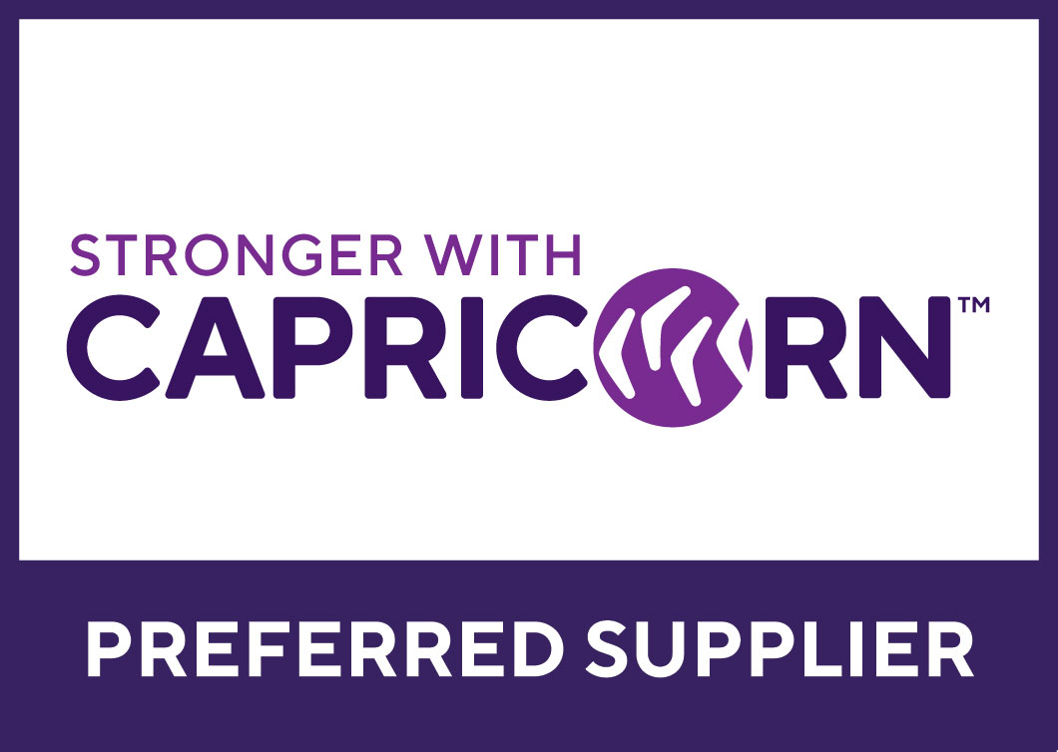
Caption: Capricorn is Australasia’s largest automotive cooperative. Kaeser Compressors NZ is now a Capricorn Preferred Supplier.

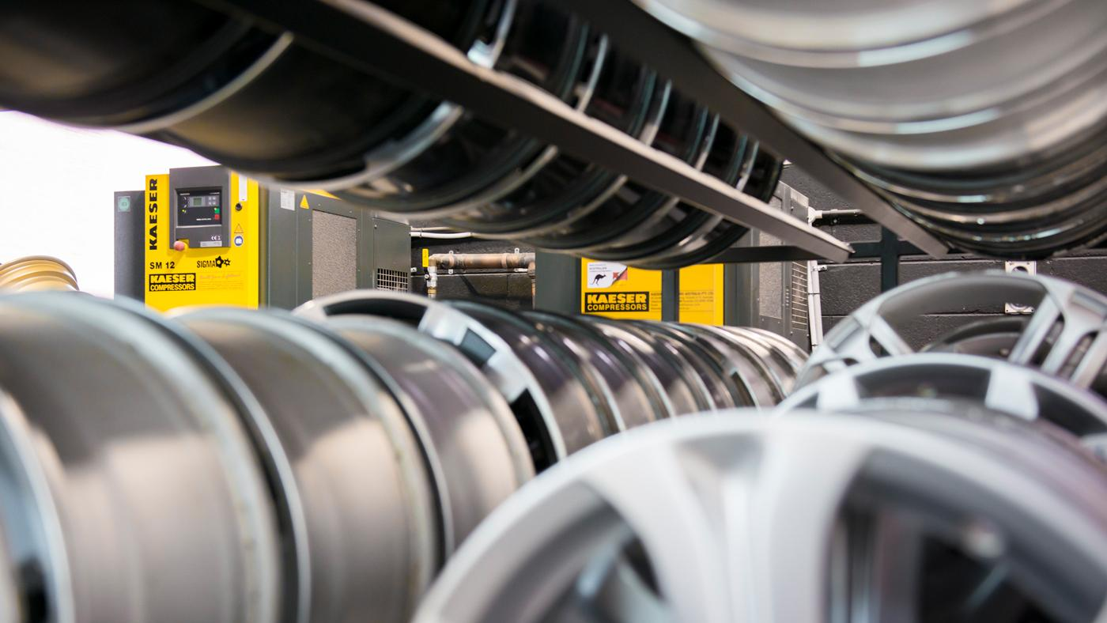
Caption: Kaeser Compressors has been meeting the compressed air needs of the automotive industry for quite some time.

Kaeser photo(s) – free for publication, credits appreciated.

