Hose reels for portable compressors
Safe and quick access to compressed air
A construction site is a place of hectic activity with many workers, sometimes of different companies, concentrating on the job in hand without too much regard to what's going on around them. Many feet have stumbled over carelessly laid air hoses and many an air tool has ceased to function because a parked truck has cut off its energy supply. Sometimes its just too much trouble to pick up and stow unused air hoses and the results can be accidents, holdups and damaged equipment.
Such problems are easily dealt with by a convenient hose reel such as Kaeser now offer as an option for all their range of portable compressors, either as part of the original scope of supply or for retrofitting to machines already in service.
The reel is supplied with 20 metres of light air hose that can be used without fully unwinding if necessary. This makes it quick and easy to use and just as quick and easy to roll up safely out of harms way when no longer needed.
The hose functions better without twists or kinks, it stays cleaner, lasts longer and accidents are avoided. There's less likelihood of dirt getting into air tools with consequent loss of function and possibly costly repair bills resulting. In conclusion, properly looked after air hoses can contribute greatly to the safety and economics of the construction site.

File: g-hose-reels-nz
Approved for publication, copy acknowledgement appreciated
Image:

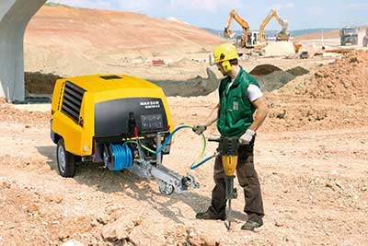
Properly looked after air hoses can contribute greatly to the safety and economics of the construction site. Kaeser now offers a practical hose reel for all their 'Mobilair' range of portable compressors as an original optional item or for retrofitting.

