July 2020

Compact and highly efficient:
Kaeser launches its next generation heatless regenerated desiccant dryers

Kaeser Compressors recently launched the latest generation of its smaller heatless regenerated desiccant dryers for flow rates from 0.2 to 1.13 m³/min. Compact, highly efficient and exceptionally reliable, these enhanced models present the ideal choice for compressed air supply systems serving sensitive industrial processes such as those found in the food, beverage, medical and pharmaceutical industries to name only a few.

The DC series of desiccant dryers from Kaeser Compressors can lower the pressure dew point of the compressed air to -70 °C. They combine reliable system design, high energy efficiency and extremely low maintenance costs, delivering dependable frost protection for control valves and lines while producing dry compressed air for sensitive processes at minimal cost. The design of the smaller DC series heatless regenerated desiccant dryers has recently been enhanced;

The new DC 2.0 to 11.3 models can operate in, for example, ten minute cycles to achieve pressure dew points down to -40ºC. During this process, the dryer switches between the two desiccant chambers only once every five minutes. This dramatically reduces the number of switching sequences between the chambers and resulting material wear on the valves and desiccant.
Moreover, long cycle times additionally reduce the amount of compressed air required to restore pressure following the desiccant regeneration phase. As an example, whereas 7.6 percent of the compressed air must be diverted for a two minute cycle, this proportion falls to just 1.3 percent with the ten minute cycle of the small DC units. This reduction makes them highly efficient, saves energy and extends desiccant service life.

On/off control of the DC 2.0 to 11.3 series models allows for intermittent operation, which saves energy when there is frequent interruption of duty cycles. This employs ‘reverse regeneration’ - where the regeneration cycle always uses up air from the downstream air receiver. This is particularly reliable as a completely regenerated desiccant chamber is always available each time the drying cycle restarts. This technique eliminates the possibility of extreme pressure dew point values from occurring at the outlet as a result of excessive loading of the desiccant.

Kaeser DC series dryers are provided with a generous fill-volume of desiccant material. Moreover, the desiccant supplied with the units features outstanding crush strength and resistance to liquid water. This keeps pressure dew points reliably low even under demanding operating conditions.

Long term reliability is assured thanks to the tried-and-tested valve technology which ensures trouble-free cycling over the long term. In addition the durable desiccant chamber is designed for continuous operation for at least 10 years.

As standard these models come equipped with an Eco Control Smart Controller, a Modbus TCP interface for quick and easy Network setup. Network enabled, they can also communicate with the Sigma Air Manager 4.0 compressed air management master system from Kaeser. Here the dryer(s) can be optimally controlled and managed as part of an entire compressed air supply system.

Highly effective silencers ensure that these latest DC models are also quiet in operation. Averaged across a cycle and depending on the model, the equivalent noise level is just 60 - 63 dB(A).

Space-saving and easy to install, the compact design of the protective all-round enclosure makes these smaller desiccant dryers ideal for decentralised compressed air treatment. They are also perfect for wall installation.

Compact, durable, efficient and reliable - the DC 2.0 to 11.3 models deliver flow rates from 0.2 - 1.13 m³/min - and form part of the wider range of DC series heatless regenerated desiccant dryers from Kaeser Compressors that in total deliver flow rates up to 154.53 m³/min. A pre micro filter and a post dust filter are also included as standard with the DC 2.0 to 11.3 models. For more information visit nz.kaeser.com or phone 0800 447 820.
-END- Free for publication, copy appreciated
Editors Notes
From 0.18 to 515 kW, Kaeser Compressors manufactures a wide range of compressors and associated auxiliary equipment that meet the varying requirements of a diverse range of industries and applications.

One of the world’s largest manufacturers of rotary screw compressors, Kaeser Compressors is represented globally in over 100 countries through a dedicated network of branches, subsidiary companies and authorised partners.

Kaeser Compressors NZ Limited provides comprehensive air compressor and blower sales and service throughout New Zealand from its offices in Auckland, alongside a dedicated and nationwide network of authorised partners.

For editorial and advertising enquiries contact: Beth Wood, Marketing Manager
Press office: +61 3 9791 5999 Fax: +61 3 9791 5733
E-mail: beth.wood@kaeser.com

KAESER COMPRESSORS NZ Limited
18B Tarndale Grove, Albany, Auckland 0632, New Zealand
Phone: +64 9 941 0499 Email: info.newzealand@kaeser.com
nz.kaeser.com
Kaeser photo(s) – free for publication, credits appreciated.

File: D-DC-nz
Approved for publication, copy acknowledgement appreciated
Images:
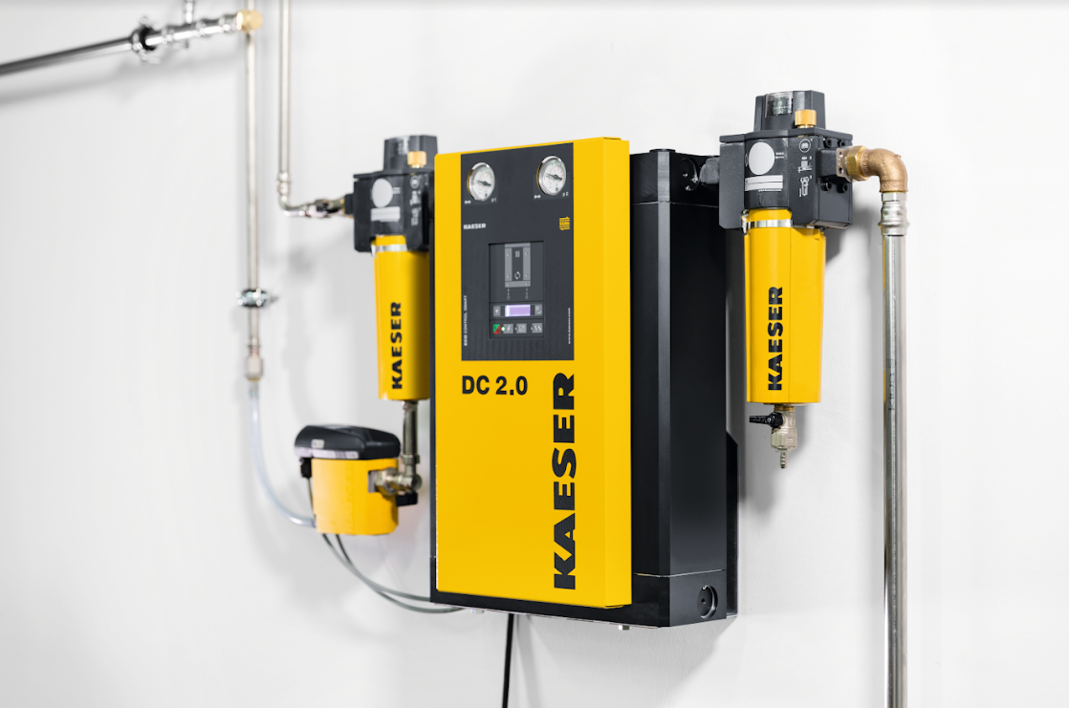
Caption: The compact design of the protective all-round enclosure makes these smaller DC series desiccant dryers ideal for decentralised compressed air treatment. They are also perfect for wall installation.
Kaeser photo(s) – free for publication.

