July 2021
Flushing out excess energy costs:
Radiator specialist slashes electricity bill in half with Kaeser
Kaeser Compressors has assisted radiator specialist Trevor French Radiators in reducing its electricity costs by 50 percent. This has been achieved by replacing an ageing compressor with an energy efficient all-in-one compressed air station.

From cars, trucks and vans to industrial earth-moving machinery and everything in between, Trevor French Radiators has been specialising in the repair and replacement of radiators now for over 30 years. Based in Otahuhu, Auckland, the company prides itself on delivering unbeatable quality service.
From cleaning radiators with a bead blaster, to using gas torches for welding, and powering the paint guns in the paint spraying booth - compressed air is an essential utility used and relied upon every day in Trevor French Radiators’ workshop.
Unfortunately the ageing compressor powering these tools was becoming more and more unreliable, and with the compressor running continuously on load / off load without ever stopping, Trevor French Radiators was finding that the compressor would cut out most days when it reached a high temperature. Assuming that a service may resolve these issues, Graeme Tutt, the Director at Trevor French Radiators contacted the original supplier for a quote. However, due to its age the quote was extremely high and it looked like replacing the compressor with a new one would be more cost effective in the long run.
Tutt contacted a number of local compressed air suppliers for a solution including Kaeser Compressors. Quick to respond, and after visiting the workshop and assessing its compressed air requirements, Kaeser recommended and subsequently installed an Aircenter SK 22 to replace the ageing compressor at Trevor French Radiators.
Remaining proudly manufactured in Germany, the user-friendly Aircenter is a complete turnkey system which incorporates a Kaeser rotary screw compressor - complete with the highly efficient Sigma Profile screw compressor block - an energy efficient refrigeration dryer and an air receiver all in one space-saving compact package.
At the heart of the SK series rotary screw compressor lies the premium quality Sigma Profile screw compressor block. Operating at low speed, the Kaeser screw compressor block is equipped with flow-optimised rotors for superior efficiency. Furthermore, all SK series rotary screw compressors feature energy-saving, premium efficiency IE3 drive motors, which comply with and exceed prevailing New Zealand EECA regulations for 3 phase electric motors. For Trevor French Radiators this would translate into more compressed air for less energy consumption.
As the new system at Trevor French Radiators would remain situated in the workshop itself where space is at a premium, the Aircenter was ideal with a total footprint of just one square metre. Another pleasing attribute of the Aircenter for Trevor French Radiators was its low sound pressure level. Thanks to its sound adsorbing compressor enclosure, operational sound levels are kept to a minimum. At just 66 dB(A) it would prove to be quiet in operation - something really important where a compressed air system is situated at point of use.
The Aircenter was supplied complete with filtration. Previously the ageing system did not have a dryer or filtration. This meant that there was a lot of moisture present in the compressed air reticulation system - not ideal when compressed air is being used for applications such as blast and spray booths. The Aircenter with its integrated refrigeration dryer, alongside a filter system meant that high quality dry compressed air would be produced and delivered.
By evaluating Trevor French Radiators precise compressed air requirements, Kaeser was also able to identify that energy savings could be realised by installing a smaller kW rated compressor.
Tutt commented: ‘The Kaeser compressed air system has been up and running now for over 5 months. One of the first things we noticed is how quiet it is in operation - you can barely hear it! The only downside has been that now we can hear air leaks which we couldn’t before - but that’s not a bad thing because it highlighted something we weren’t really aware of before and we are now addressing this.
By installing a compressed air system complete with a dryer, we have also noticed a big difference - especially with our bead blaster. With no moisture in the line, parts are being cleaned a lot easier and faster. But, by far the most significant change has been to our electricity bill. This has halved since we installed the Kaeser compressed air system!’

Trevor French Radiators also chose to take out a service agreement with Kaeser Compressors to ensure the compressed air system continues to operate at its optimum, efficiently and reliably into the future.

The Aircenter compressed air stations from Kaeser are available with drive powers of 2.2 to 15 kW and produce flow rates from 0.26 to 2.5 m³/min, designed for pressures 7.5 to 13 bar. For more information visit nz.kaeser.com or phone 0800 447 820.
-END- Free for publication, copy appreciated
Editors Notes
From 0.18 to 515 kW, Kaeser Compressors manufactures a wide range of compressors and associated auxiliary equipment that meet the varying requirements of a diverse range of industries and applications.
One of the world’s largest manufacturers of compressors, blowers and compressed air systems, Kaeser Compressors is represented throughout the world by a comprehensive network of branches, subsidiaries and authorised distribution partners in over 140 countries.
Kaeser Compressors NZ provides comprehensive sales and service throughout New Zealand, from its facility in Auckland, alongside an extensive network of authorised partners.

For editorial and advertising enquiries contact: Beth Wood, Marketing Manager
Press office: +61 3 9791 5999 Fax: +61 3 9791 5733
E-mail: beth.wood@kaeser.com

KAESER COMPRESSORS NZ Limited
18B Tarndale Grove, Albany, Auckland 0632, New Zealand
Phone: +64 9 941 0499 Email: info.newzealand@kaeser.com
nz.kaeser.com
File: Q-Trevor-French-Radiators-nz
Approved for publication, copy acknowledgement appreciated
Images:
Contact out press office for high res versions (beth.wood@kaeser.com)
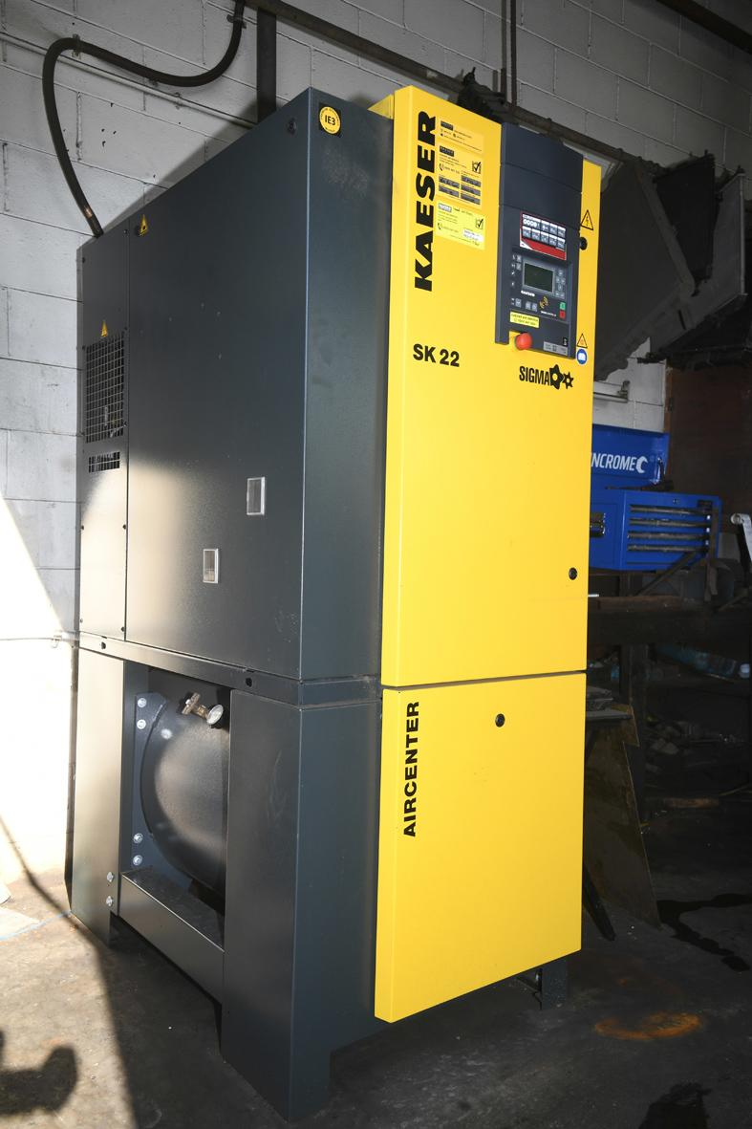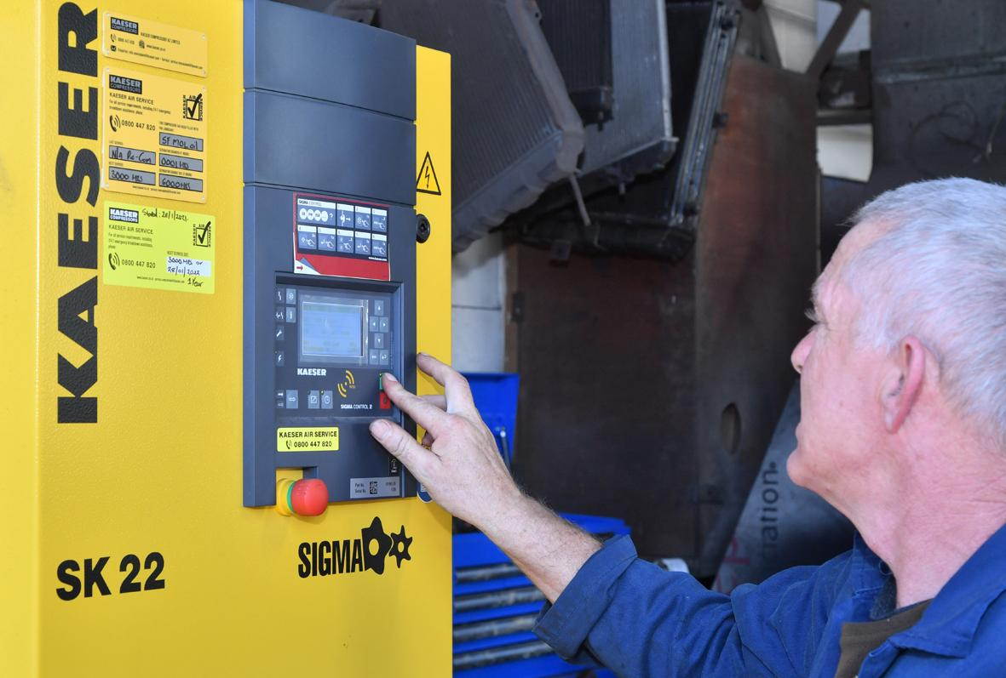
Caption: Kaeser recommended and subsequently installed an Aircenter SK 22 to replace the ageing compressor at Trevor French Radiators.

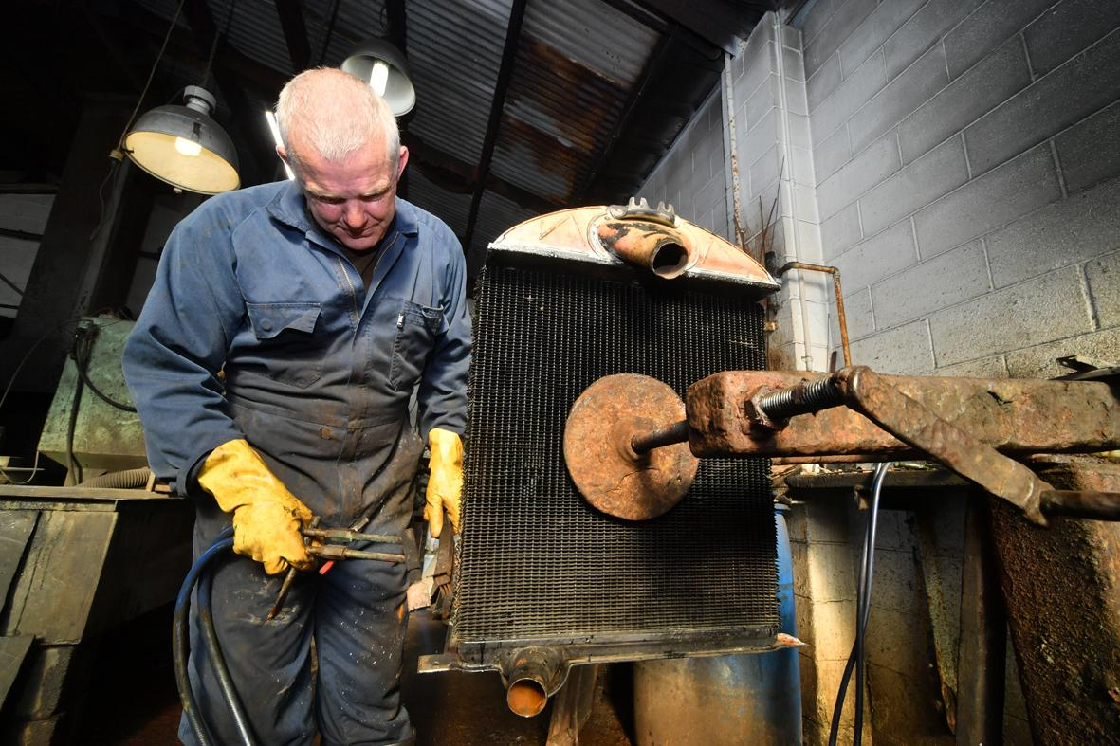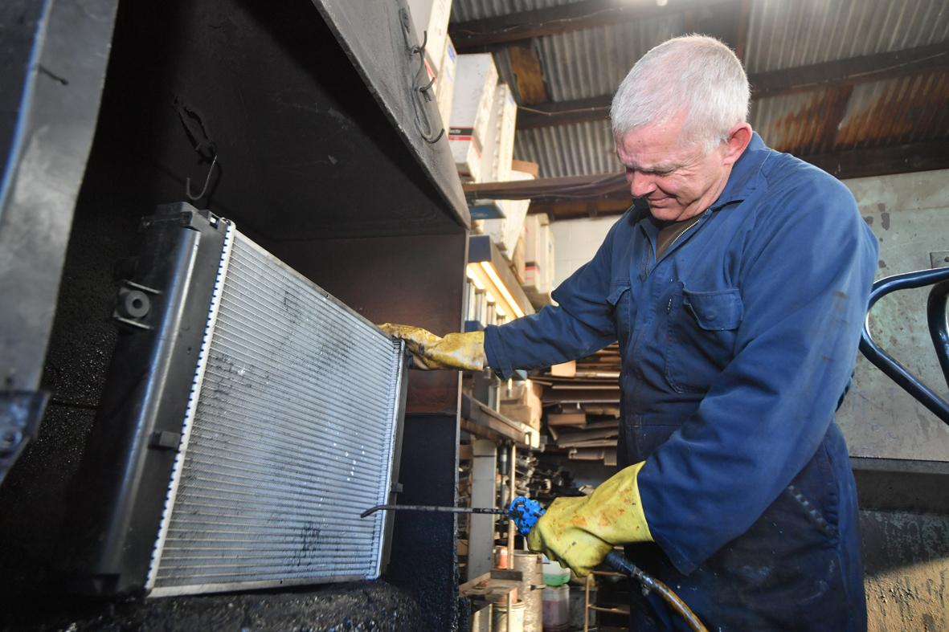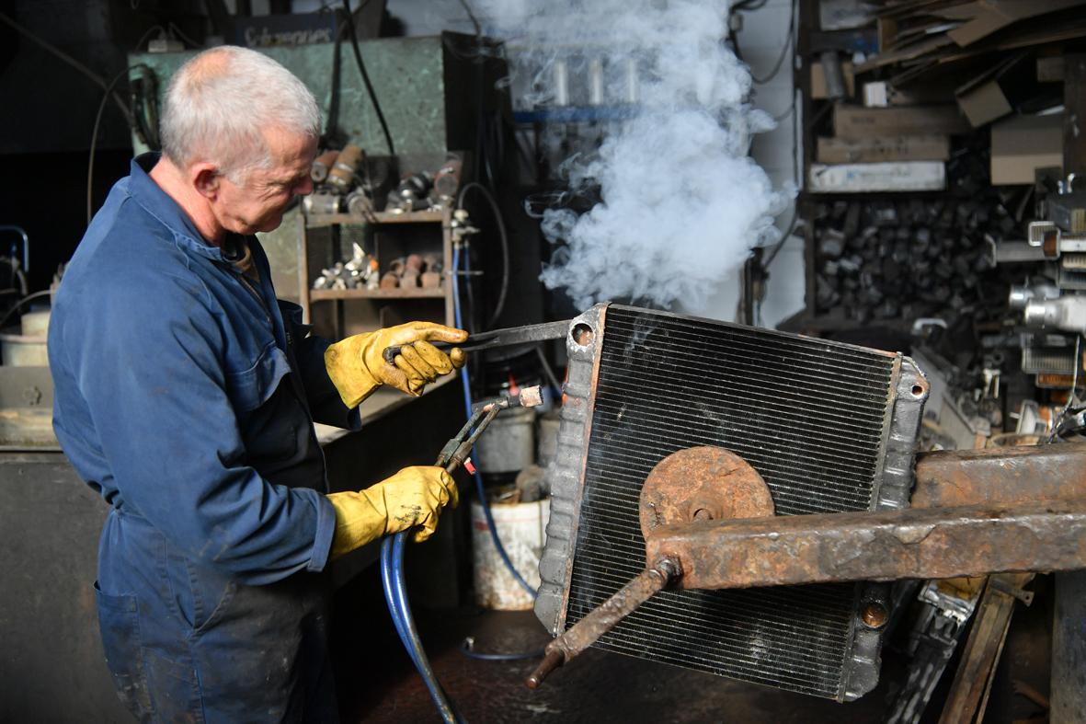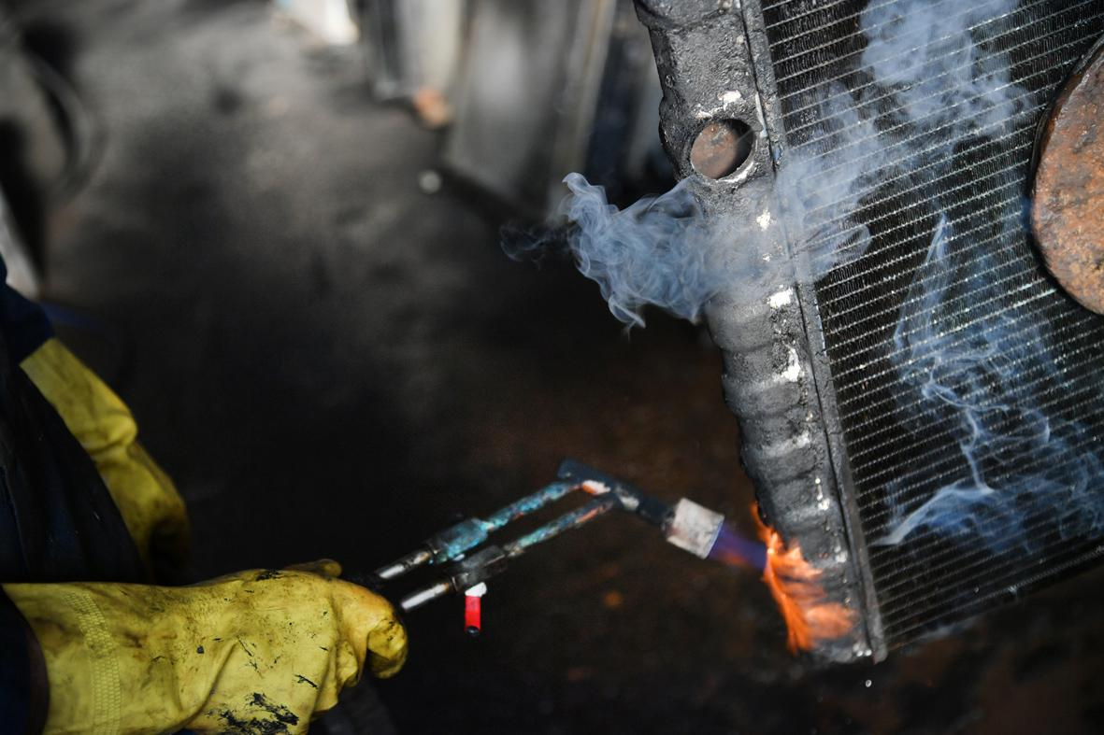
Caption: From cleaning radiators with a bead blaster, to using gas torches for welding - compressed air is an essential utility used and relied upon every day in Trevor French Radiators’ workshop.

Kaeser photo(s) – free for publication, credits appreciated.

