Mobilair 122 – Portable Compressed Air Efficiency
Modern portable compressors should not only deliver exceptional performance and efficiency, but should also ensure simple operation and be kind to the environment. With a standard pressure range from 7 to 14 bar and a free air delivery of 11.1 m³/min at 7 bar, the new ‘Mobilair 122’ from Kaeser meets all of these needs.
Providing a reliable source of quality compressed air, the Mobilair 122 is ideal for large construction site applications such as sand & dry ice blasting, concrete repair and as a standby for stationary compressors. The compressor is powered by a water-cooled Deutz turbo-charged diesel engine with intercooler, which complies with all exhaust emissions as per EU regulation 2004/26, Class III A. Furthermore, the regulating system ensures optimum fuel economy, whilst the fuel tank capacity is more than sufficient to allow continuous operation for an entire eight hour shift. The unit automatically shuts down if the fuel volume falls below the minimum level. Heavy-duty design allows the machine to be used at ambient temperatures of up to 50 °C.
Simple to operate via its easy-to-use control panel, the M 122 allows manual switchover from pressure-free start to full-load operation to ensure gentle and reliable compressor start-up even under cold conditions. For added flexibility, the 10, 12 and 14 bar versions enable infinitely variable pressure adjustment down to 5 bar via a manual wheel control on the proportional controller. As the M 122 is equipped as standard with a 1900 kg chassis, a truck is not necessarily required to tow the unit.
Instead of the standard towing chassis, the compressor is also available as a skid-mounted version. Optional additional equipment includes air treatment systems to provide cool, dry, technically oil-free air of various classes to meet the special demands of e.g. concrete repair as per German ZTV-SIB regulations, or fresh air.

File: c-m122-nz
Approved for publication, copy acknowledgement appreciated
Image:

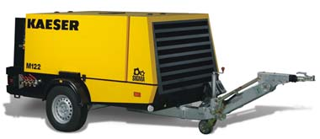
The new Mobilair 122 portable compressor from Kaeser combines user-friendliness with exceptional efficiency and flexibility.

