March 2019

100 years of Kaeser: A tradition of innovation

2019 marks an important anniversary for Kaeser Compressors – its centenary year. 100 years after it was established in Coburg, Germany and the company is now active all over the world including both Australia and New Zealand.

The history of the German compressed air specialist, Kaeser Kompressoren truly is a remarkable story. Although many a company celebrates its centenary, they cannot all boast such sustained and continuously positive development.

Whilst the Kaeser product range can be found in action all over the world, the general public rarely come face to face with the compressed air specialist's products. Only the portable compressors catch the eye with their black and yellow livery, when used for road construction work. Compressed air stations tend to be hidden away in outbuildings. Yet Kaeser compressors are just as likely to be found in power stations in Australia as in Peruvian gold mines, used by aerospace engineers in the US, fish farms in Norway, car manufacturers in Germany, at the CERN particle accelerator in Switzerland, on ski pistes in Austria, on Arabian oil fields or the weaving mills in Asia.
Often considered the fourth utility, compressed air is just as vital as electricity and no company with an industrial production line can get by without compressed air.

Humble beginnings
It all began in a small workshop in Coburg's Hahnweg. The old buildings are still standing in which Carl Kaeser senior started producing spare parts and engines for cars, along with gear wheels and special machines for the glass industry, with a team of eight employees and two apprentices in June 1919. Business was booming. Within a few years, the company was to employ a 150-strong workforce. After World War II, virtually the entire customer base fell by the wayside as most were located in Thuringia and Saxony – and thus on the other side of the border. Taking advantage of the available automotive expertise, production was adapted without further ado to similar products: reciprocating compressors. Thus began Kaeser's successful focus on compressed air. In 1948, the first reciprocating compressor rolled off the Hahnweg production line as the company continued to evolve.

Further challenges emerged during the mid-1960s. In retrospect, it may perhaps be described as the first technological shift. Screw compressors came onto the market. Once again, Kaeser spearheaded the change with its very own invention: Sigma Profile was born. Developed in-house, it is a rotary screw compressor block with a special energy-efficient rotor profile that was groundbreaking at the time. Since then, Sigma Profile has been the centrepiece of every Kaeser rotary screw compressor; needless to say, it is also refined on an ongoing basis.

A tradition of innovation
This innovative spirit pervades the company to this day, resulting in a steady stream of innovations in compressed air technology and applying equally to hardware, software and services. From the refrigeration dryer to revolutionary controllers (Sigma Air Manager 4.0), from the portable compressor to completely new business models, where the customer basically only purchases the compressed air, through to digitalisation and Industrie 4.0, Kaeser still blazes a trail in the industry for the cost-effective, reliable, efficient generation and use of compressed air, thanks to its innovative, top-quality products and services. Most production facilities are located in Germany, with sales and service available in every corner of the globe.

The company's early international expansion was a vital aspect of its growth. The first branch opened in Switzerland in 1978, with Austria and France following hot on its heels. Today, Kaeser has more than 50 own subsidiaries and is represented by exclusive contract partners in over 100 countries. Kaeser employs in excess of 6000 staff worldwide, many of whom have been loyal for decades.

A recipe for success
How was this achieved? The company's secret recipe is an unwavering passion for innovation, sound engineering expertise, close customer contact and an awareness of their needs, combined with exceptional quality standards, a good dose of common sense and the main ingredients: excellent teams and strong family ties. However, family does not just refer to the owner family, Thomas Kaeser and Tina-Maria Vlantoussi-Kaeser, now the third generation to manage the company, while the fourth has also just come on board, in the form of their son Alexander Jan Kaeser. All staff are considered family at Kaeser. This is evident in the high apprenticeship rate, well above average, and the extremely long service record of the employees, usually more than 30 years. But it is also reflected in the company's business development: for 100 years without fail, the operating result has been positive. Even in 2009, the year of the global crisis. From Anchorage to Auckland, Coburg or Kauai, Kaeser is a family-owned company with strong ties to Germany; it views the entire world as its home turf and offers 'Made in Germany' quality from start to finish. The next innovative chapter is just waiting to be written. For more information visit www.kaeser.co.nz or phone 0800 447 820.
-END-
Editors Notes
From 2.2 to 500 kW, Kaeser Compressors manufactures a wide range of compressors and associated auxiliary equipment that meet the varying requirements of a diverse range of industries and applications.

One of the world’s largest manufacturers of rotary screw compressors, Kaeser Compressors is represented globally in over 100 countries through a dedicated network of branches, subsidiary companies and authorised partners.

Kaeser Compressors NZ Limited provides comprehensive air compressor and blower sales and service throughout New Zealand from its offices in Auckland, alongside a dedicated and nationwide network of authorised partners.

For editorial and advertising enquiries contact:
Press office: +61 3 9791 5999 Fax: +61 3 9791 5733
E-mail: info.newzealand@kaeser.com

KAESER COMPRESSORS NZ Limited – 18B Tarndale Grove, Albany, Auckland 0632, New Zealand
Phone: +64 9 941 0499 – www.kaeser.co.nz – E-mail: info.newzealand@kaeser.com

File: P-100-years-nz
Approved for publication, copy acknowledgement appreciated
Images:

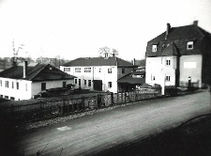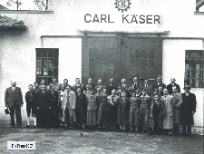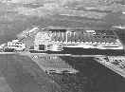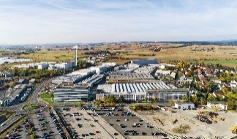
007_Image 1_KAESER Hahnweg.jpg
007_Image 2_KAESER Hahnweg.jpg
007_Image 3_KAESER_1961 Carl-Kaeser-Straße.jpg
007_Image 4_KAESER Coburg today.jpg
Caption: From its founding location in Hahnweg in Coburg, over the first buildings on Carl-Kaeser-Straße, to its current size (not completely visible in the picture), Kaeser has grown a lot.

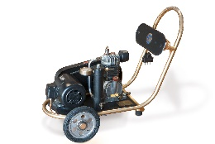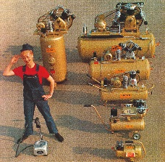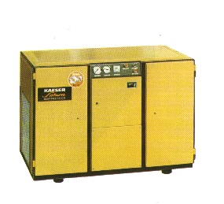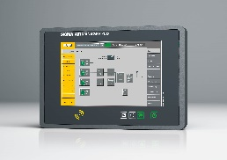
007_Image 5_KAESER Reciprocating compressor_1948.jpg
007_Image 6_KAESER Reciprocating compressor range.jpg
007_Image 7_KAESER screw compressor_1979.jpg
007_Image 8_KAESER Sigma_Air_Manager_4_0.jpg
Caption: From the first reciprocating compressor to the reciprocating compressor range, the first screw compressor, to the modern master control system, Kaeser's range of products and services has steadily grown thanks to constant innovation.
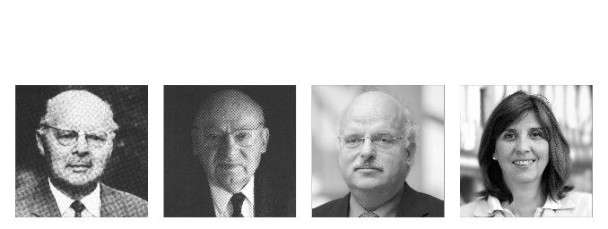
007_Image 9_Kaeser-Family.jpg
Caption: Three generations of Kaeser: company founder Carl Kaeser senior, Carl Kaeser junior and Thomas Kaeser with his wife Tina-Maria Vlantoussi-Kaeser. Carl Kaeser senior, born 1886 in Geislingen / Steige, headed the company together with his son until his death in 1964. Dipl.-Ing. Carl Kaeser junior, born 1914 in Munich. Educated in Coburg, he entered the company in 1937 and, along with his son Thomas who joined in 1985, stood at the top until his death in 2009. Today's board consists of Thomas and Tina-Maria Vlantoussi-Kaeser.
((Kaeser photo – free for publication))

