Even more energy savings with the Kaeser DSDX.3 series rotary screw compressors

Kaeser recently introduced its latest generation of DSDX series rotary screw compressors. Now available for free air deliveries from 25 to 31 m³/min, the new DSDX series brings together a range of product enhancements, all of which translate into significant energy cost savings for the end user.
For maximum efficiency, the recently re-designed DSDX series rotary screw compressors from Kaeser now feature the super-premium efficiency IE4 motor. Currently the most efficient motor available, IE4 complies with and exceeds, prevailing Australian GEMS regulations for 3 phase electric motors.
The DSDX rotary screw compressors from Kaeser feature an electronic Thermo Management system. This controls the oil temperature to ensure a safe and consistent differential from the dewpoint temperature. In addition, this feature creates energy savings by preventing unnecessarily high screw compressor block discharge temperatures.
A sophisticated design and the inclusion of the proven 1:1 drive configuration combine to enhance the efficiency of these versatile compressors even further. The screw compressor blocks have been completely redesigned and now feature a refined Sigma Profile design. This along with other improvements, such as; a redesigned inlet valve and significantly reduced internal pressure losses, deliver improved specific power on previous models.
The new DSDX series models include an integrated Kaeser axial centrifugal separator and no loss electronic Eco-Condensate Drain. This ensures exceptional moisture separation performance with minimal pressure loss. Condensate separation is performed with maximum reliability and energy efficiency at all times - even with high ambient temperatures and air humidity.
For optimum performance the latest DSDX series rotary screw compressors from Kaeser feature the innovative Sigma Control 2 controller. Equipped with its own web server, it is possible to communicate with the compressor via intranet / internet. Operational data as well as maintenance and alarm messages can therefore be viewed from any PC running a standard internet browser, simplifying compressor operation and maintenance.
The highly versatile DSDX series includes both water- and air-cooled models. For exceptional energy efficiency, versions are also available with Sigma Frequency Control. As with the standard models, these machines have also been designed with maximum efficiency, reliability and ease of maintenance in mind.

File: A-DSDX-aus_2016
Approved for publication, copy acknowledgement appreciated

Images:
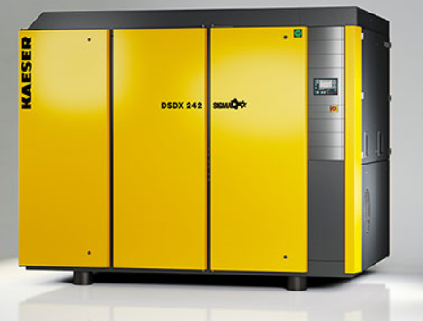
The new DSDX series rotary screw compressors deliver even greater efficiency.

