May 2016

Knowledge is power and knowledge can save you power!

Energy costs can account for a considerable amount of manufacturer’s operating costs, a large proportion of which may well be attributed to running a compressed air system. So how can manufacturers reduce the impact to their bottom line?
Knowledge gained through compressed air training may well be the key to unlocking the energy savings potential of a compressed air system, says Peter Eckberg, the Managing Director at Kaeser Compressors New Zealand.

‘It is well documented that electricity prices have risen sharply over the past decade in New Zealand. Once seen as a relatively low fixed cost, energy has become an ever more important variable cost that impacts on company profits.
Often considered the fourth utility, compressed air is commonly one of the largest single energy consumers within a manufacturing facility and, depending on utilisation, electrical power can account for up to 90 percent of the total costs of compressed air production. In addition, the energy costs of a typical compressed air system can account for almost three quarters of its lifetime costs. It therefore makes sense to keep the power consumption of a compressed air system to a minimum.
Fortunately, compressed air is one source of energy where significant and sustainable energy savings can be found and many existing compressed air users could be hiding an energy savings potential of 30 percent or more!

Anyone wanting to use compressed air energy efficiently must consider the compressed air system as a whole and understand the numerous correlations and interactions within the system and its integration into the operational environment. The first step in realising such energy savings potential is therefore knowledge, and for many, compressed air training and education will be the key to unlocking this potential.’

Kaeser launch 2016 Compressed Air Seminar Series
Kaeser Compressors New Zealand has just released its 2016 Compressed Air Seminar Series.
Committed to supporting the compressed air industry with training and education, these one day seminars developed by Kaeser, are designed to equip compressed air; end users, operators, supervisors and consultants, with the knowledge to assist them in optimising the productivity and energy efficiency of a compressed air system as well as controlling associated operating costs.

From the fundamental principles of compressed air to the operation and maintenance of air compressors, control systems and air treatment, the one day Compressed Air Seminar from Kaeser, provides participants with the knowledge that can ultimately assist them in optimising the energy efficiency of a compressed air system.

Eckberg concluded: ‘Knowledge really is power in optimising the energy efficiency of a compressed air system and consequently, knowledge can also save you power!’

The one day Kaeser Compressed Air Seminars are running throughout New Zealand in 2016.
-END-
Editors Notes
From 2.2 to 500 kW, Kaeser Compressors manufactures a wide range of compressors and associated auxiliary equipment that meet the varying requirements of a diverse range of industries and applications.

One of the world’s largest manufacturers of rotary screw compressors, Kaeser Compressors is represented globally in over 100 countries through a dedicated network of branches, subsidiary companies and authorised partners.

Kaeser Compressors NZ Limited provides comprehensive air compressor and blower sales and service throughout New Zealand from its offices in Auckland, alongside a dedicated and nationwide network of authorised partners.

For editorial and advertising enquiries contact: Beth Wood, Marketing Manager
Press office: +61 3 9791 5999 Fax: +61 3 9791 5733
E-mail: beth.wood@kaeser.com

KAESER COMPRESSORS NZ Limited – 18B Tarndale Grove, Albany, Auckland 0632, New Zealand
Phone: +64 9 941 0499 – www.kaeser.co.nz – E-mail: info.newzealand@kaeser.com

File: O-CAS-2016-nz
Approved for publication, copy acknowledgement appreciated
Images:

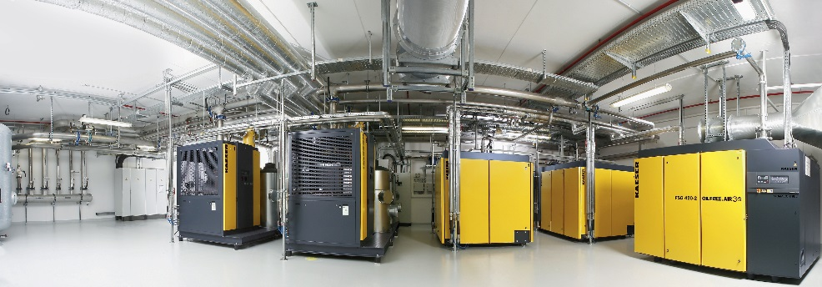
Knowledge really is power in optimising the energy efficiency of a compressed air system and consequently, knowledge can also save you power
006_Image 1_KAESER Installation.jpg

Kaeser has just released its 2016 Compressed Air Seminar Series
006_Image 2_KAESER Seminars.jpg

((Kaeser photo – free for publication))

