July 2017

Kaeser to demonstrate the benefits of Industrie 4.0-ready compressed air technology at NMEC 2017

Kaeser Compressors will demonstrate the benefits that Industrie 4.0-ready compressed air technology has to offer at the forthcoming National Maintenance Engineering Conference.

Industrie 4.0 - or the fourth industrial revolution - presents a new era of manufacturing led by a number of cyber-physical systems. As a leader in the engineering of compressed air technology, Kaeser products and services are not only designed to deliver the most reliable, efficient and cost-effective compressed air supply possible, but they are also fully ready to take advantage of the future-oriented benefits that Industrie 4.0 has to offer.

In the ultra-flexible Industrie 4.0 production environment, intelligently networked compressed air systems provide the optimal compressed air power and quality required. Moreover, potential issues within the compressed air network are identified at a very early stage so that appropriate service measures can be taken before a fault even occurs.

Visitors to stand 33 will be able to learn more about a number of Kaeser 4.0 products and services that can seamlessly be incorporated into a production or energy management system. This includes the Sigma Air Manager 4.0 (SAM 4.0).

A key technology in the advanced world of Industrie 4.0, SAM 4.0 is a cutting-edge compressed air controller and the central mastermind that controls the entire compressed air supply system. Via IoT (the Internet of Things), the SAM 4.0 is responsible for data streaming to a centralised application in real-time via the powerful Ethernet-based Sigma Network. Here the parameters are analysed, processed, supplemented with expert knowledge and output to various mobile end devices.
Monitoring key operating parameters ensures that compressed air system efficiency can be kept in the optimum range at all times, and thanks to real-time transmission and evaluation, data is always as up to date as possible.

A key advantage of Kaeser 4.0 compressed air technology is the unprecedented efficiencies that can be achieved. Jeff Coyle, National Design & Engineering Manager at Kaeser Compressors Australia, will be speaking on this topic at the NMEC conference. In addition Coyle will review what the current ISO standards for compressed air quality are, who they might apply to and how different compressed air treatment technologies can assist in meeting them.

Are you Industrie 4.0-ready? Join Kaeser Compressors at NMEC 2017 on stand 33 to discover tomorrow’s technology today. 15 – 16 November at Claudelands Event Centre, Hamilton.
-END-
Editors Notes
From 2.2 to 500 kW, Kaeser Compressors manufactures a wide range of compressors and associated auxiliary equipment that meet the varying requirements of a diverse range of industries and applications.

One of the world’s largest manufacturers of rotary screw compressors, Kaeser Compressors is represented globally in over 100 countries through a dedicated network of branches, subsidiary companies and authorised partners.

Kaeser Compressors NZ Limited provides comprehensive air compressor and blower sales and service throughout New Zealand from its offices in Auckland, alongside a dedicated and nationwide network of authorised partners.

For editorial and advertising enquiries contact: Beth Wood, Marketing Manager
Press office: +61 3 9791 5999 Fax: +61 3 9791 5733
E-mail: beth.wood@kaeser.com

KAESER COMPRESSORS NZ Limited – 18B Tarndale Grove, Albany, Auckland 0632, New Zealand
Phone: +64 9 941 0499 – www.kaeser.co.nz – E-mail: info.newzealand@kaeser.com

File: O-NMEC-2017-nz
Approved for publication, copy acknowledgement appreciated
Images:

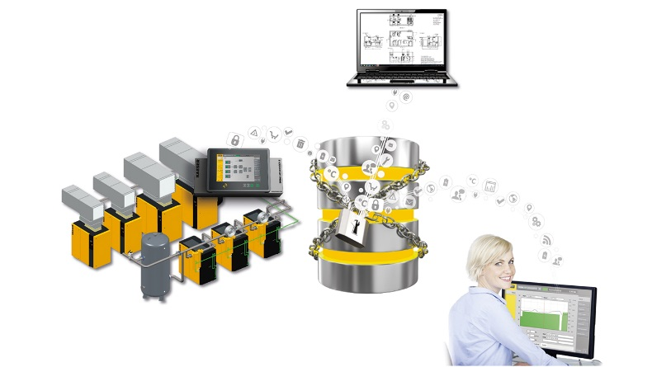
Caption: Discover tomorrow’s technology today with Kaeser at NMEC 2017
016_Image 1_Kaeser 4_0.jpg

((Kaeser photo – free for publication))

