Kaeser launches the next generation compact, convenient and cost-effective Mobilair 57 Utility
Kaeser recently launched its latest generation M57 Utility portable compressor. Compact, convenient and cost-effective the M57 Utility is now configured for even greater flexibility thanks to a number of new design features.
The latest generation M57 Utility retains all of the original series popular features, including its compact size - crucial for truck-mounting, upward expelling exhaust gas outlet and all-round intelligent design.
The unit is configured as standard for an impressive temperature range from -10°C to +50°C, whilst a version designed for even lower ambient temperatures is offered with pre-warming of the motor cooling water.
In addition to the proven and renowned 7-bar version, which up until now delivered 5.4 m³/min, a new model with a flow rate of 4.7 m³/min at 10 bar maximum pressure is now available and ideal for applications such as sand-blasting.
With the intelligent Sigma Control Smart (SCM) controller fitted as standard, pressure can be reduced down to 5 bar in precise 0.1 bar increments for perfect adjustment to on-site conditions. The appropriate pressure setting helps protect, for example hammer drills that operate at 6 bar for optimum performance, from wear. The colour display provides a convenient overview of all operating parameters, alarm notifications and upcoming required maintenance. Motor start-up is made easy with just the push of a button.
The service-friendliness of the Mobilair series has always been a key characteristic of all models in the range and this has never been truer than with the compact M57 Utility. The unit is designed in such a way that all maintenance points are easily accessible from the cargo bed side once the panels have been removed. Fuelling is performed from the front side. Operating fluids and liquids can be easily drained via externally mounted service connections without having to hoist up or lift the compressor unit.
Also noticeable are the low-positioned compressed air take-off taps and the metal cover protected operating panel. This attention to detail makes operation especially easy, particularly when the unit is installed on a truck cargo bed. Furthermore, in combination with an integrated tool lubricator, the Anti-Frost control protects connected tools from potential damage caused by freezing and corrosion. For even higher compressed air quality requirements, the M57 Utility can be optionally equipped with a compressed air aftercooler.
The premium quality Kaeser rotary screw compressor block with Sigma Profile rotors is directly driven without transmission loss by an energy-saving Kubota diesel engine. Moreover, with its integrated fuel tank, the M57 is able to ensure over 10 hours of uninterrupted operation.
The Mobilair M57 Utility portable compressor from Kaeser is available in two pressure stages 7 bar (5.4 m³/min) and 10 bar (4.7 m³/min).

File: c-M 57 Utility-nz
Approved for publication, copy acknowledgement appreciated
Image:

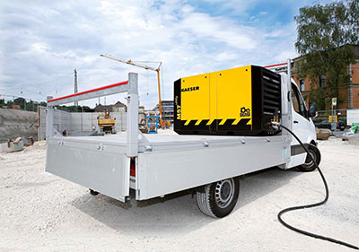
The M57 Utility from Kaeser provides a mobile, compact and energy-saving compressed air supply

