January 2020

Make a date with Kaeser at EMEX 2020:
Smart and efficient compressed air solutions for every need

Kaeser Compressors is set to present a wealth of its innovative products and services at EMEX 2020. Catering to users of all sizes from all market sectors, Kaeser offers the perfect solution for a reliable, efficient and future-oriented compressed air supply – all within the scope of Industrie 4.0.

Kaeser will be exhibiting its CSD SFC series rotary screw compressors at EMEX 2020. Operating efficiency is of key importance at Kaeser on every level, together with a responsible approach to resource conservation. Therefore, all variable-speed rotary screw compressors are being systematically equipped with a synchronous reluctance motor, which boasts considerably lower losses – and, in turn, greater efficiency - in the crucial partial-load range, compared to asynchronous motors. Following in the footsteps of the ASD series, the CSD/CSDX series is the next to feature efficiency improvements of up to 10%, with flow rates ranging from 1.1 to 17.5 m³/min., paving the way for minimal energy costs.

The needs of trades and workshops are also well catered for at Kaeser Compressors, with a compressed air solution for every application. Visitors to stand 1059 will be able to see the new i.Comp reciprocating compressor range. Robust, powerful, compact, maintenance-friendly, efficient – the list goes on. The centrepiece is the new drive concept, which offers a host of advantages. Every reciprocating compressor model delivers exactly the output required and can be infinitely adjusted to suit actual compressed air demand. Manufactured to the very highest industrial quality standards for which Kaeser is world-renowned, the i.Comp range includes portable models as well as the space-saving i.Comp tower compact stations – a completely new compressed air supply concept that was specially developed for workshops.

Kaeser will also be exhibiting its popular Aircenter range. These complete turnkey systems incorporate a Kaeser rotary screw compressor, an energy efficient refrigeration dryer and an air receiver all in one space-saving compact package.
For 5.5 to 9 kW requirements, the Aircenter incorporates the Kaeser SM series rotary screw compressor. For maximum efficiency, the SM 13 and SM 16 compressor models are now equipped as standard with a super-premium efficiency IE4 motor that complies with and exceeds prevailing New Zealand EECA regulations for 3 phase electric motors. For the end user this translates into best possible compressor performance, reduced energy costs and significantly enhanced compressed air production efficiency.
All SM series compressors incorporate a Sigma Control 2. With this internal controller, compressor performance can be precisely adjusted to match respective compressed air consumption for optimum efficiency. And, where multiple compressors exist as part of a compressed air station, the Sigma Control 2 can easily be integrated with the master compressed air management controller from Kaeser - the Sigma Air Manager 4.0 (SAM 4.0).

A key technology in the advanced world of Industrie 4.0, the SAM 4.0 seamlessly monitors and controls all components within a compressed air supply system for maximum cost savings, continuously fine-tuning system performance to ensure optimised energy efficiency. In addition, predictive maintenance is possible preventing unplanned downtime.
The SAM 4.0 not only ensures highly efficient monitoring and control of all compressed air station components, it also enables the user to take advantage of the future-oriented benefits that Industrie 4.0 has to offer. Visitors to the Kaeser stand will also be able to see the SAM 4.0 in action.

Highly efficient compressors, effective compressed air treatment systems, smart engineering and intelligent services are just a few of the highlights that reveal the modern face of needs-based compressed air production, combined with good planning. Join Kaeser at EMEX 2020 on stand 1059 to discover the latest in smart and efficient compressed air solutions. For more information visit nz.kaeser.com or phone 0800 447 820.

-END-
Editors Notes
From 0.18 to 515 kW, Kaeser Compressors manufactures a wide range of compressors and associated auxiliary equipment that meet the varying requirements of a diverse range of industries and applications.

One of the world’s largest manufacturers of rotary screw compressors, Kaeser Compressors is represented globally in over 100 countries through a dedicated network of branches, subsidiary companies and authorised partners.

Kaeser Compressors NZ Limited provides comprehensive air compressor and blower sales and service throughout New Zealand from its offices in Auckland, alongside a dedicated and nationwide network of authorised partners.

For editorial and advertising enquiries contact: Beth Wood, Marketing Manager
Press office: +61 3 9791 5999 Fax: +61 3 9791 5733
E-mail: beth.wood@kaeser.com

KAESER COMPRESSORS NZ Limited
18B Tarndale Grove, Albany, Auckland 0632, New Zealand
Phone: +64 9 941 0499 Email: info.newzealand@kaeser.com
nz.kaeser.com

File: O-EMEX-2020-preview-nz
Approved for publication, copy acknowledgement appreciated

Images:
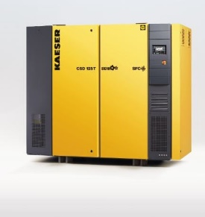
Caption: Optimal configuration for maximum efficiency: the variable-speed versions of the CSD rotary screw compressors feature a highly efficient synchronous reluctance drive system.

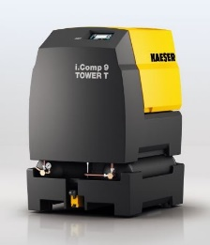
Caption: The new i.Comp reciprocating compressor range - robust, powerful, compact, maintenance-friendly and efficient.
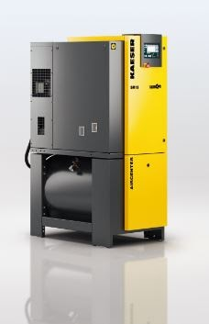

Caption: The complete turnkey Aircenter systems incorporate a compressor, a refrigeration dryer and an air receiver all in one compact package.
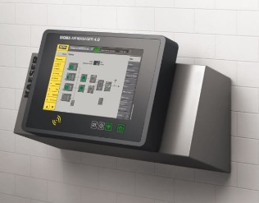

Caption: The Sigma Air Manager 4.0 (SAM 4.0) is a key technology in the advanced world of Industrie 4.0.

Kaeser photo(s) – free for publication.

