October 2021

Get ready for the festive plant shutdown:
Plan today for optimal results

For those industries that shut down over the Christmas and New year period, planning will now be well underway for any shutdown maintenance required. As an essential utility which rarely goes offline, this shutdown period presents the ideal time to schedule in compressed air system maintenance and upgrades, as Kaeser Compressors discusses.

Like gas, electricity and water, compressed air is an essential utility required day in and day out by many areas of industry. It can therefore be quite difficult (especially if a back up system does not exist) to schedule in time for larger maintenance tasks and to undergo system upgrades. Here, the festive shutdown period offers the perfect opportunity.

Make the most of the longer shutdown
Some typical compressed air system maintenance tasks that require a longer shutdown period include; replacing motor bearings, removing and cleaning coolers as well as oil/water separator cleaning and replacement.

With the festive period also falling towards the beginning of summer, it also makes sense to perform a number of routine maintenance tasks that will ensure your compressed air system is ready to handle the hot summer days ahead such as; changing the oil and the inlet filter to checking the fluid system, belts and couplings.

One of the most important things you can do during the summer months is keep your coolers clean. Dirty coolers can cause a number of problems such as contributing to your compressor running hot. And, elevated running temperatures increase oil carry over from your compressor which will eventually lead to a low oil level and ultimately a compressor shutdown. Depending on the state of your coolers, high pressure cleaning and/or ultrasonic cleaning may be advised. The festive shutdown period would be a perfect time to have your coolers cleaned.

A long shutdown may also be the ideal opportunity to fix identified air leaks. Unfortunately all compressed air systems will have compressed air leaks. Statistics suggest that the average leak rate is 25 percent with some plants losing as much as 80 percent of their compressed air through leaks! But, what is the cost of leaks? As an example, a compressor which operates at 6 bar will consume an additional 0.39 kW/h for one 1mm hole. This equates to an annual cost of $512, assuming the system has a power cost of 15 cents/kW/hr. Now think of the accumulative cost for a number of undetected and unmanaged compressed air leaks! The good news - detecting and fixing compressed air leaks has an overall energy savings potential of 6-10 percent.

Upgrade and optimise your compressed air system
Beyond maintenance, if you are looking at system upgrades and optimisation, then the shutdown period also presents a great opportunity to implement them. Here are a few areas you could consider;

Implement a bypass line
A bypass line allows you to be able to continue to transport compressed air through your system while for example, line filtration is maintained. However, a bypass line can often be overlooked when a compressed air system is installed. Installing a bypass line would therefore mean that any future work required on line filtration will not have to wait until longer shutdown periods. The festive shutdown is the perfect opportunity to install a bypass line if you don’t already have one.

Invest in an air-main charging system
Whether it be overnight, over the weekend, or for an extended shutdown period such as the festive season - when compressors are shut down, there is a risk of overloading the air treatment equipment and contaminating the compressed air system when you restart the compressors. These unwanted outcomes can be easily and cost-effectively avoided by simply integrating an air-main charging system. Installed in the compressor station just downstream from the last air treatment component, the air-main charging system ensures that the compressed air system remains pressurised even after the compressors have been shut down, thereby safeguarding compressed air quality.

Planning ahead for optimal outcomes
A little planning now will go a long way in terms of making the most of the upcoming festive shutdown period. It’s a good time to consult your compressed air provider and to discuss together what maintenance jobs need to be conducted and any upgrade plans you are considering. Not only can you then get your visit booked in, but you can also place an order for the required consumables, spare parts and so on that will be required, ensuring they are all available and ready to go. For further advice visit nz.kaeser.com or phone 0800 447 820.
-END- Free for publication, copy appreciated
Editors Notes
From 0.18 to 515 kW, Kaeser Compressors manufactures a wide range of compressors and associated auxiliary equipment that meet the varying requirements of a diverse range of industries and applications.
One of the world’s largest manufacturers of compressors, blowers and compressed air systems, Kaeser Compressors is represented throughout the world by a comprehensive network of branches, subsidiaries and authorised distribution partners in over 140 countries.

Kaeser Compressors NZ Limited provides comprehensive air compressor and blower sales and service throughout New Zealand from its offices in Auckland, alongside a dedicated and nationwide network of authorised partners.

For editorial and advertising enquiries contact: Beth Wood, Marketing Manager
Press office: +61 3 9791 5999 Fax: +61 3 9791 5733
E-mail: beth.wood@kaeser.com

KAESER COMPRESSORS NZ Limited
18B Tarndale Grove, Albany, Auckland 0632, New Zealand
Phone: +64 9 941 0499 Email: info.newzealand@kaeser.com
nz.kaeser.com
File: N-festive-plant-maintenance-21-nz
Approved for publication, copy acknowledgement appreciated
Images:
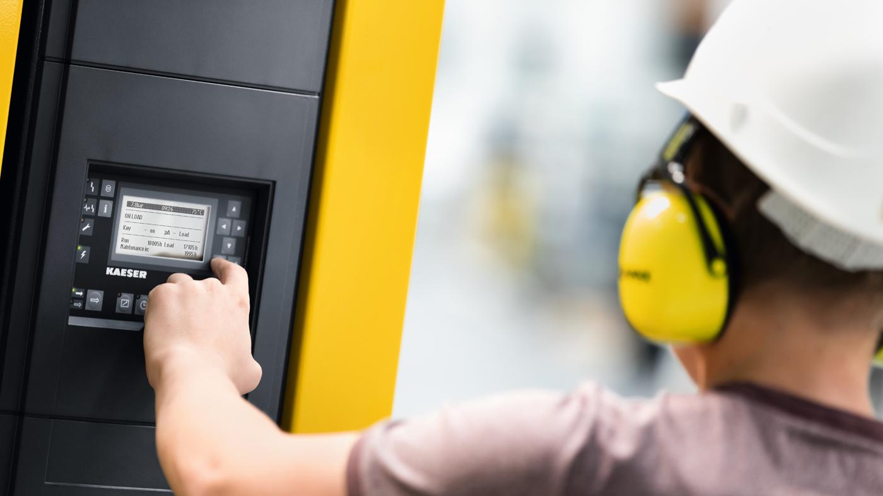
Caption: The festive shutdown is the perfect time to schedule larger compressed air maintenance tasks.

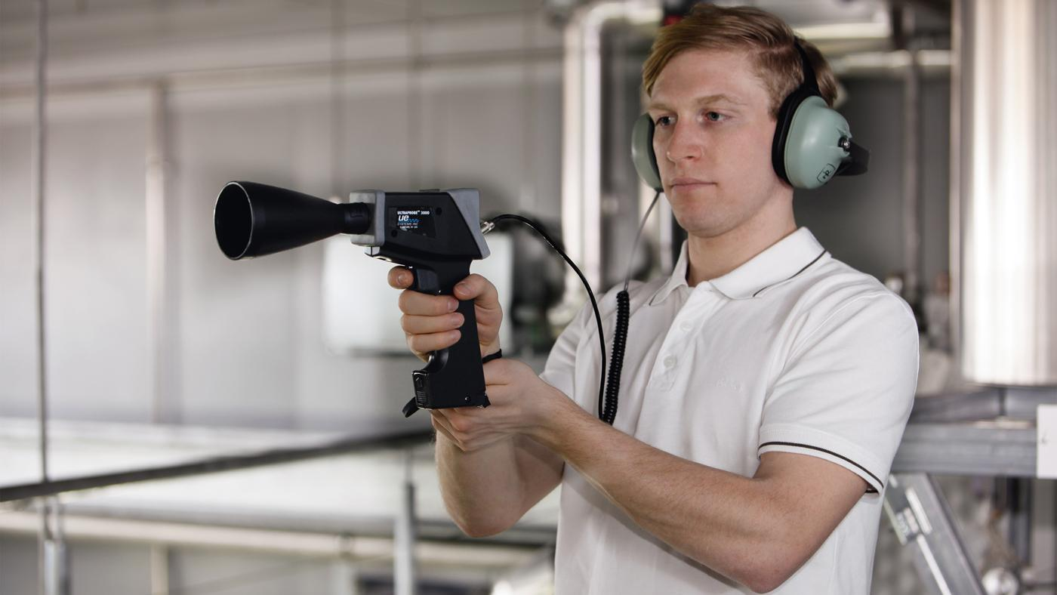
Caption: Detecting and fixing compressed air leaks has an overall energy savings potential of 6-10 percent.

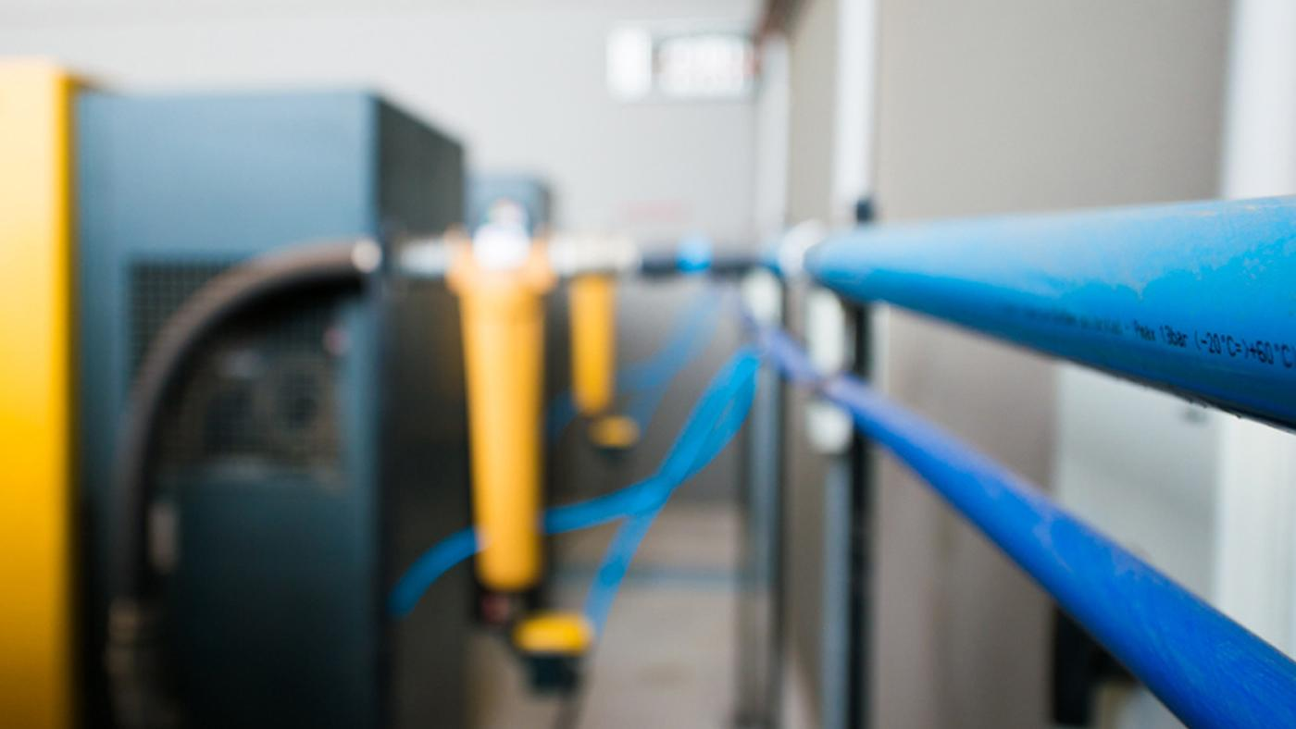
Caption: The festive shutdown is the perfect opportunity to install a bypass line if you don’t already have one.

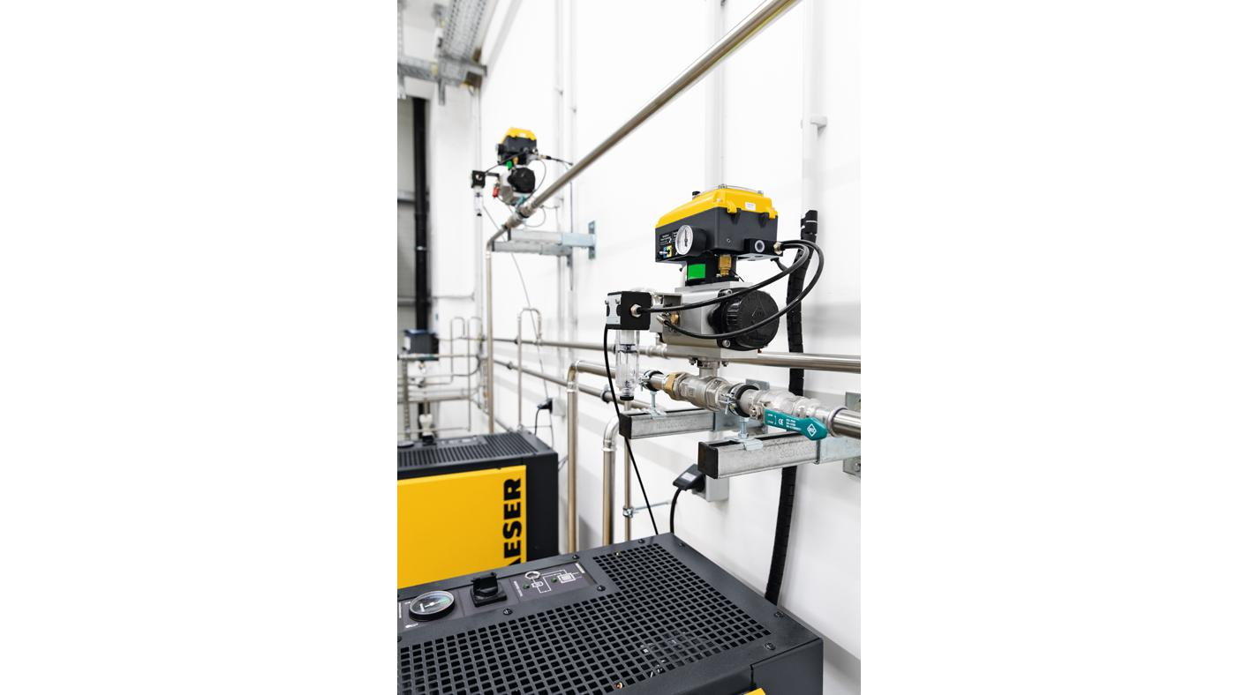
Caption: The DHS 4.0 air-main charging system from Kaeser protects the compressed air treatment components, and helps ensure reliable compressed air quality - even following a complete shutdown.
Kaeser photo(s) – free for publication, credits appreciated.

