August 2021

No investment required!
Buy compressed air like all other utilities

No capital investment costs and no on-going maintenance costs to budget for, just access to a reliable and efficient supply of compressed air on demand. The Sigma Air Utility operator model from Kaeser Compressors makes this all possible. Here the end user can simply buy the compressed air they need, in the same way you would buy gas, electricity or water.

With capital expenditure constraints being felt by many businesses, achieving the necessary compressed air system upgrades or expansions required may seem insurmountable. However many compressed air users don't realise that it is not necessary to own or invest in compressed air equipment to obtain the compressed air they require. With Sigma Air Utility from Kaeser Compressors, a compressed air user can literally just buy the compressed air they need, in the same way you would buy gas, electricity or water. The only key difference is that the user will need a few square metres of floor space where a compressed air system can be located.

Instead of investing in a complete compressed air system, with the Sigma Air Utility operator model from Kaeser, all the end user pays for is the compressed air they actually use. This presents a number of unique benefits compared to operating a conventional compressed air system;

Companies that just buy the compressed air they need, instead of a complete compressed air system, enjoy maximum cost transparency. Kaeser first analyses the end users compressed air needs and then draws up an individual concept based on what is required. This allows Kaeser to set a price for the duration of the contract, which covers system and operating costs along with consumption of a mutually-agreed base volume of compressed air. The contract also includes an agreed surplus air charge that would be applied if consumption were to exceed that amount. Precise measurements guarantee that users are only charged for the volume of compressed air actually drawn from the system.

From planning and installation through to system operation, maintenance and repair, with Sigma Air Utility, Kaeser takes care of everything. The end user has no investment costs to worry about, and will not need a budget requirement moving forward for maintenance or repairs.

As you would expect from a leading compressed air solutions provider, end users opting to obtain their compressed air through Kaeser’s Sigma Air Utility operator model, are assured of receiving maximum air system efficiency and reliability at all times. And, Kaeser will adapt the compressed air system as and when necessary to meet changing operating conditions and to incorporate the very latest technological innovations.

Each Sigma Air Utility compressed air system comes complete with a Sigma Air Manager 4.0 compressed air management master system. Utilising adaptive 3-D^{advanced} Control, the inclusion of a Sigma Air Manager 4.0 makes air generation and treatment even more intelligent, reliable and efficient. This effectively ensures maximum efficiency and compressed air availability whilst enhancing production reliability.

Where a compressed air user wants to reduce their fixed costs and the burden of investing in and maintaining a compressed air system, but still requires a reliable and energy efficient supply of compressed air, buying compressed air like all other utilities with Sigma Air Utility may present the ideal solution. After all, compressed air is a utility, so why not buy it like one! For more information visit nz.kaeser.com or phone 0800 447 820.
-END- Free for publication, copy appreciated
Editors Notes
From 0.18 to 515 kW, Kaeser Compressors manufactures a wide range of compressors and associated auxiliary equipment that meet the varying requirements of a diverse range of industries and applications.
One of the world’s largest manufacturers of compressors, blowers and compressed air systems, Kaeser Compressors is represented throughout the world by a comprehensive network of branches, subsidiaries and authorised distribution partners in over 140 countries.

Kaeser Compressors NZ Limited provides comprehensive air compressor and blower sales and service throughout New Zealand from its offices in Auckland, alongside a dedicated and nationwide network of authorised partners.

For editorial and advertising enquiries contact: Beth Wood, Marketing Manager
Press office: +61 3 9791 5999 Fax: +61 3 9791 5733
E-mail: beth.wood@kaeser.com

KAESER COMPRESSORS NZ Limited
18B Tarndale Grove, Albany, Auckland 0632, New Zealand
Phone: +64 9 941 0499 Email: info.newzealand@kaeser.com
nz.kaeser.com
File: L-SAU-nz
Approved for publication, copy acknowledgement appreciated
Images:
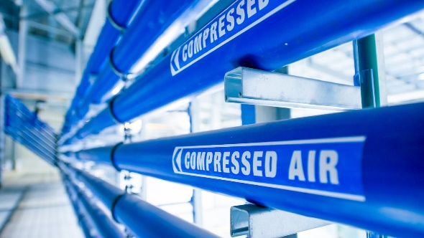
Caption: With the Sigma Air Utility operator model from Kaeser Compressors, the end user can just buy the compressed air they need with no investment costs and no on-going maintenance costs to budget.

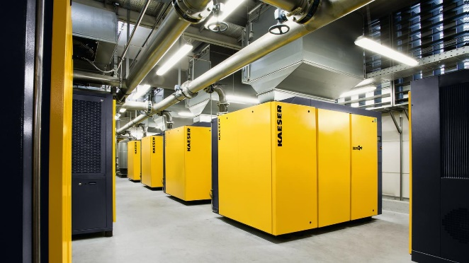
Caption: From planning and installation through to system operation, maintenance and repair, with Sigma Air Utility, Kaeser takes care of everything.
Kaeser photo(s) – free for publication, credits appreciated.

