Achieve optimum compressed air efficiency with the Kaeser SAM 4.0
Kaeser Compressors recently launched its second generation master compressed air management system. The new Sigma Air Manager (SAM 4.0) is the even more powerful second generation version of the highly successful master controller from Kaeser. Amongst its numerous features, SAM 4.0 maximises the efficiency of all components within the compressed air station. For the user this translates into reduced energy costs, improved efficiency and sophisticated energy management as per ISO 50001.
A PC-based master compressed air management system, the SAM 4.0 allows the compressed air user to manage all of their compressed air production and treatment components from one single unit.
For optimum energy efficiency, the SAM 4.0 uses Kaeser's advanced 3-D Control to analyse the relationship between three key factors; switching losses (start/stop), control losses (idling and frequency conversion) and pressure flexibility (average increase above required pressure). Based on this information and the specific pressure required by the user, the SAM 4.0 then predictively calculates the optimum achievable configuration and adjusts the connected components accordingly.
Operating status, pressure history, free air delivery, power consumption, as well as maintenance and any error messages can all be easily displayed and analysed on the SAM 4.0 in both real-time and retrospectively from the user-friendly 12-inch colour touchscreen.
It is also possible to see at a glance whether the compressed air system is operating in the "green zone" from an energy management perspective. Alternatively data can be accessed remotely using a PC and network connection.
The SAM 4.0 offers additional powerful features. For example, maintenance and error messages can be immediately sent via email to a pre-set personal address. The remote diagnostics option also allows for preventative maintenance and service requirements to be based on actual use. Both of these features increase compressed air availability and reliability and also help keep lifecycle costs to an absolute minimum.
The SAM 4.0 from Kaeser has also been designed to accommodate potential future expansion of a compressed air system. A simple software upgrade is all that is required to meet these new requirements. No additional hardware investment is necessary.
The extensive benefits of the SAM 4.0 are expanded even further when combined with the Sigma Network. Created by Kaeser, Sigma Network is a highly secure, closed Ethernet network that has been specifically developed to support optimal monitoring and coordinated control of compressed air stations. Users of the Sigma Network are able to enjoy significant cost savings and maximum service convenience as a result of rapid data availability and evaluation.
Supporting operation in 30 languages, the SAM 4.0 can boost operational reliability and efficiency, as well as significantly reduce energy costs.

File: m-sam4.0-nz
Approved for publication, copy acknowledgement appreciated
Image:

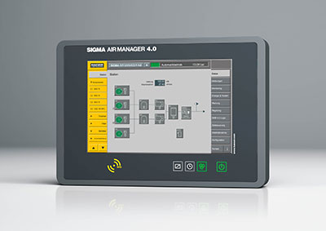
The SAM 4.0 ensures highly efficient monitoring and control of all compressed air station components

