April 2019

Maximise compressed air availability and minimise life-cycle costs with Sigma Smart Air from Kaeser

Predictive compressed air maintenance for the digital age is now available from Kaeser Compressors. Sigma Smart Air assists with the gradual digitalisation of a compressed air system, where real-time data management along with Kaeser’s expertise and predictive maintenance, makes it possible to maximise the compressed air supply whilst minimising life-cycle costs.

Sigma Smart Air from Kaeser Compressors offers the end user so much more than what would typically be included in the framework of servicing a compressed air system. Here maintenance is performed either upon request or at established intervals. This means there is always the risk that service will be performed too early or too late, depending on the actual operating hours – both of which result in additional costs and the risk of downtime for the operator.

With Sigma Smart Air, Kaeser offers a service that delivers predictive maintenance and maximum energy efficiency, while guaranteeing the availability of the compressed air supply – far beyond what could be expected of any system in the past. In order for users to benefit from real-time display of operating, service and energy data for the compressed air station, it must be 'intelligent', in other words, connected to an Ethernet-based network (or Profibus) - Sigma Network - and controlled by a master controller - the Sigma Air Manager 4.0.

Sigma Smart Air offers the option of creating the above conditions for existing and new compressed air systems, without the need for further investments. It combines the powerful feature of real-time data management with Kaeser's expertise and predictive maintenance, making it possible to maximise the compressed air supply whilst minimising life-cycle costs without additional investments.

How does Sigma Smart Air work?
The physical meets the virtual world within the framework of a structural model in which the specific compressed air system, configured according to the operator's requirements, is represented virtually by a digital twin. Real-time availability of operating data makes it possible to monitor the 'health' status of a compressed air station. This means that potential faults can be detected in advance and appropriate maintenance measures automatically initiated at the right time. Ultimately, operators benefit from significantly reduced compressed air production and operating costs, as well as improved compressed air availability.

Sigma Smart Air saves costs otherwise required for procurement, training, logistics, service and in-house service staff. It also provides maximum cost transparency throughout the compressed air system’s entire life-cycle. This is guaranteed by a service price, based on the volume of compressed air that is actually produced and adjusted flexibly to additional or reduced demand, similar to an electricity bill. Fixed prices over long periods of time facilitate advance planning.

Moreover, Sigma Smart Air includes monitoring of key figures such as service costs, reserves and specific power, enabling sophisticated energy and life-cycle management of the compressed air station throughout its entire service life. Always up-to-date, the energy data figures from a single source also lay the foundation for energy management as per ISO 50001. Visit www.kaeser.co.nz or phone 0800 447 820 for more information.
-END-
Editors Notes
From 2.2 to 500 kW, Kaeser Compressors manufactures a wide range of compressors and associated auxiliary equipment that meet the varying requirements of a diverse range of industries and applications.

One of the world’s largest manufacturers of rotary screw compressors, Kaeser Compressors is represented globally in over 100 countries through a dedicated network of branches, subsidiary companies and authorised partners.

Kaeser Compressors NZ Limited provides comprehensive air compressor and blower sales and service throughout New Zealand from its offices in Auckland, alongside a dedicated and nationwide network of authorised partners.

For editorial and advertising enquiries contact: Beth Wood, Marketing Manager
Press office: +61 3 9791 5999 Fax: +61 3 9791 5733
E-mail: beth.wood@kaeser.com

KAESER COMPRESSORS NZ Limited – 18B Tarndale Grove, Albany, Auckland 0632, New Zealand
Phone: +64 9 941 0499 – www.kaeser.co.nz – E-mail: info.newzealand@kaeser.com

File: L-Sigma-smart-air-2019-nz
Approved for publication, copy acknowledgement appreciated
Images
((Captions)) :
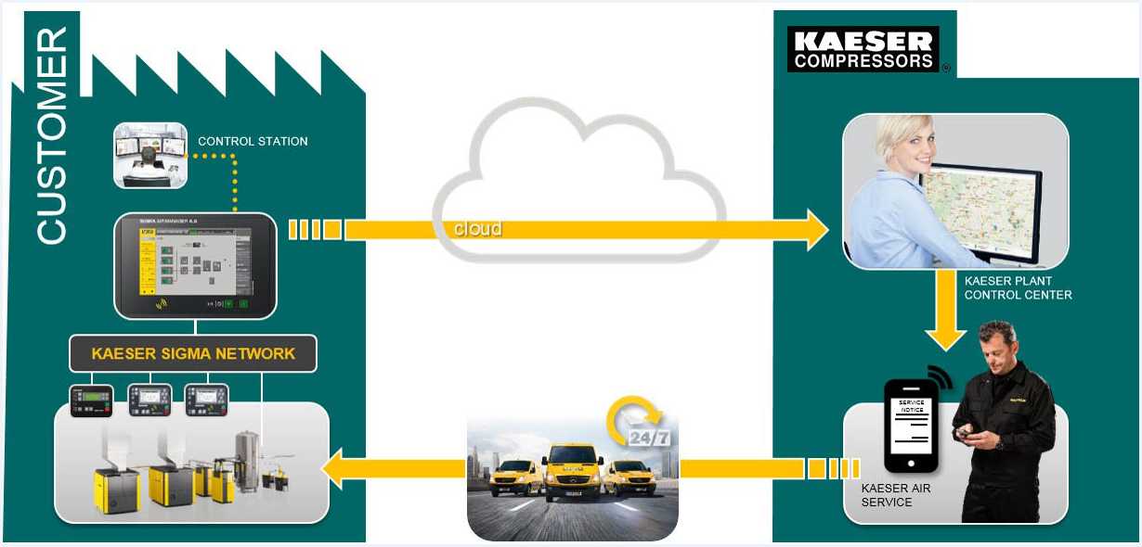
008_Image 1_KAESER-Sigma-Smart-Air.jpg
Caption: Precision service for value like never before: the new Sigma Smart Air service from Kaeser makes the dream a reality.

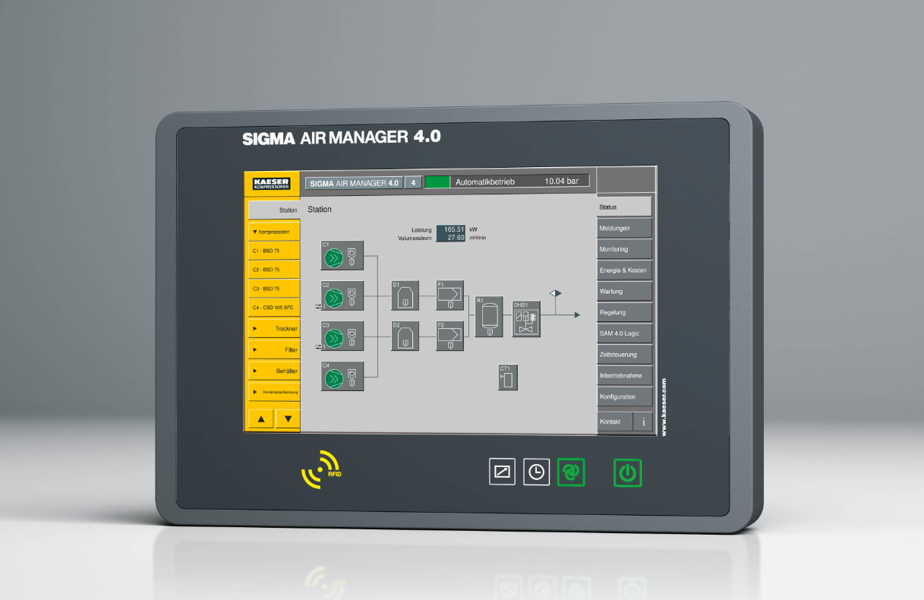
008_Image 2_KAESER SAM 4.jpg
Caption: The Sigma Air Manager 4.0 provides the foundation for the new Sigma Smart Air service capability.
((Kaeser photo – free for publication))

