January 2019

Smokin’ good: Kaeser delivers a reliable supply of clean compressed air at Texas BBQ Foods

KAESER reference project: Texas BBQ Foods invests in a Kaeser Aircenter premium compressed air station for new state-of-the-art facility in New Zealand.

Texas BBQ Foods - a New Zealand producer of Texas-inspired smoked meats, cheeses, butter, sauces and rubs - recently opted for a compact and user-friendly Kaeser Aircenter 6, to meet its requirement for a reliable supply of clean compressed air at its new state-of-the-art facility.
Texas BBQ Foods is a family owned and operated company based in Inglewood in the Taranaki Region of New Zealand’s North Island. Here in a state-of-the-art facility the team produce a range of Texas-inspired smoked beef brisket, pork belly, cheeses and butter along with rubs and sauces.
The family follows the traditional Texas BBQ style of preparing meat which has its beginnings in the European meat-smoking traditions originally brought to Texas by German and Czech settlers in the mid-19th century. Taking only the best NZ-grown beef and pork, a rub is first applied to the meat before it is smoked in one of the plants 4 big meat smokers using mesquite-chips for an authentic Texas BBQ flavour. Once the meat is cooked it goes straight into a blast chiller, before it is sliced, vacuum packed and chilled, ready to be despatched and enjoyed. The vacuum packing process is an important stage in ensuring the products retain their integrity, allowing consumers to enjoy the meats, cheeses and butters days or even weeks later.
In developing the manufacturing plant, it was clear that a reliable supply of compressed air would be critical to the operation, as Director of Texas BBQ Foods Ash Peters explains: ‘A critical factor in selecting a compressed air solution for us was to find one that would deliver a reliable supply of clean air. We also wanted it to be easy and low maintenance, quiet in operation and a nice tidy unit that would be simple to install.’
Compressed air would be required across the facility for various purposes including powering the thermoformer packing machine. This automated machine places the finished meats into trays before a vacuum seals the packets.
From the get go Texas BBQ Foods has wanted to use local suppliers wherever possible. With a good reputation and also local to the company, Texas BBQ Foods therefore contacted local authorised Kaeser partner - Pace Power & Air for a solution.
After reviewing the requirements Pace Power & Air recommended and subsequently installed a Kaeser Aircenter 6 that would operate with a food grade lubricant, along with two Kaeser F6 filters; one KE and one KA.
The Aircenter from Kaeser Compressors presents the ideal solution where - like Texas BBQ Foods - a complete and compact turnkey system is required. Within one space-saving compact package the Aircenter includes; a Kaeser rotary screw compressor, an energy efficient refrigeration dryer and an air receiver.
The Aircenter has been designed to be user- and maintenance- friendly. It has excellent accessibility to all service points and in addition it includes a Sigma Control 2 controller for ease of system control and monitoring. With this internal controller, compressor performance can be precisely adjusted to match respective compressed air consumption for optimum efficiency.
At the heart of the Aircenter’s rotary screw compressor lies a premium quality screw compressor block featuring the Kaeser Sigma profile rotors. Superior efficiency is assured with these flow-optimised rotors that are able to achieve power savings of up to 15 percent compared with conventional screw compressor block rotor profiles.
With sound levels as low as 62 dB(a) the Aircenter is also ideal for point of use applications.
To meet the air purity level required for food manufacture, two Kaeser filters were also installed. The Kaeser filter range uses modern deep-pleated filter media to remove particles and aerosols, while a highly effective carbon fibre mat traps oil vapours. Together with innovative flow dynamics, they deliver exceptional filtration efficiency with minimal pressure loss.
The compressed air system has now been in operation at Texas BBQ Foods for a couple of months and Peters concluded; ‘It’s doing exactly what it’s supposed to! We are finding it to be reliable, nice and quiet in operation, user-friendly, requiring only minimal checks.’
The SX series Aircenter models from Kaeser are available with drive powers of 2.2 to 5.5 kW, and produce flow rates from 0.26 to 0.80 m³/min, designed for pressures 7.5 to 13 bar. For more information on phone 0800 447 820 or visit www.kaeser.co.nz
-END-
Editors Notes
From 2.2 to 500 kW, Kaeser Compressors manufactures a wide range of compressors and associated auxiliary equipment that meet the varying requirements of a diverse range of industries and applications.

One of the world’s largest manufacturers of rotary screw compressors, Kaeser Compressors is represented globally in over 100 countries through a dedicated network of branches, subsidiary companies and authorised partners.

Kaeser Compressors NZ Limited provides comprehensive air compressor and blower sales and service throughout New Zealand from its offices in Auckland, alongside a dedicated and nationwide network of authorised partners.

For editorial and advertising enquiries contact:
Press office: +61 3 9791 5999 Fax: +61 3 9791 5733
E-mail: info.newzealand@kaeser.com

KAESER COMPRESSORS NZ Limited – 18B Tarndale Grove, Albany, Auckland 0632, New Zealand
Phone: +64 9 941 0499 – www.kaeser.co.nz – E-mail: info.newzealand@kaeser.com

File: Q-Texas-BBQ-Foods-nz
Approved for publication, copy acknowledgement appreciated
Images: (contact the press office for high res copies of the following images)

Overview

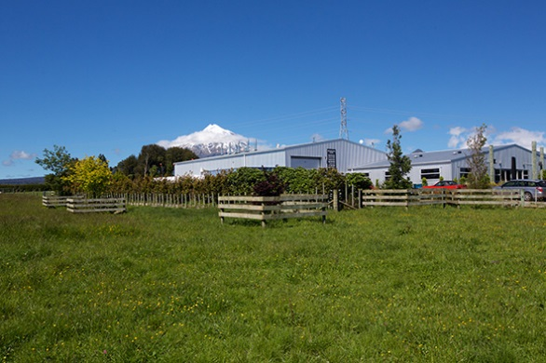
016_Image 1_Texas BBQ Foods.jpg
Caption: Texas BBQ Foods is a family owned and operated company based in Inglewood with clear views of Mt Taranaki.

Compressor
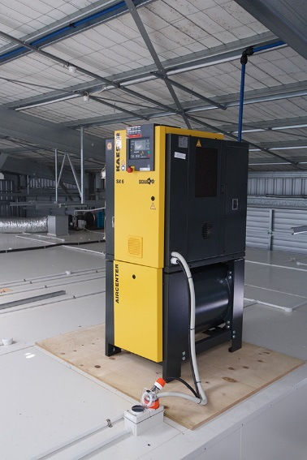
016_Image 2_KAESER compressor at Texas BBQ Foods.jpg
Caption: The Kaeser Aircenter SX 6 is meeting Texas BBQ Foods requirement for a reliable supply of clean compressed air at its new state-of-the-art facility.

Meat rub
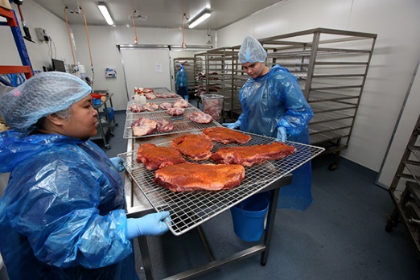
016_Image 3_meat rub at Texas BBQ Foods.jpg
Caption: Taking only the best NZ-grown beef and pork, a rub is first applied to the meat.

Smoking the meats

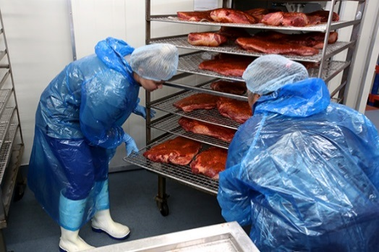
016_Image 4_meat ready for smoking at Texas BBQ Foods.jpg

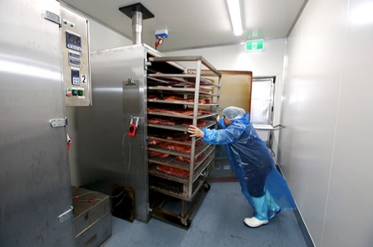
016_Image 5_meat smoking at Texas BBQ Foods.jpg
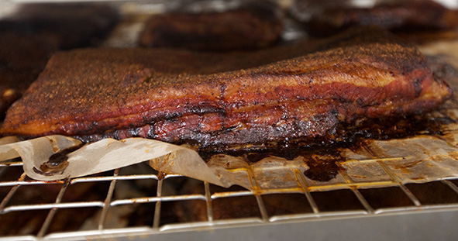
016_Image 6_smoked meat at Texas BBQ Foods.jpg

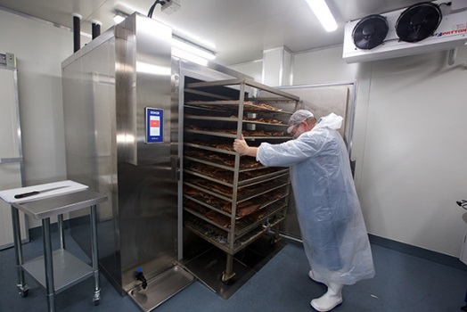
016_Image 7_smoked meat at Texas BBQ Foods.jpg

Caption: The meat is smoked in one of the plants 4 big meat smokers using mesquite-chips for an authentic Texas BBQ flavour.

Preparing and packaging the meats

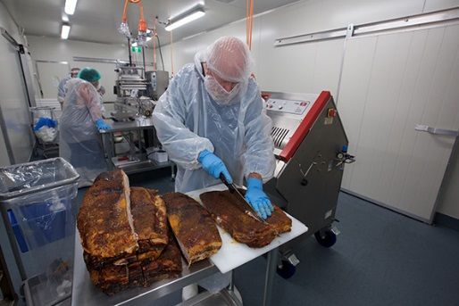
016_Image 8_processing the meat at Texas BBQ Foods.jpg

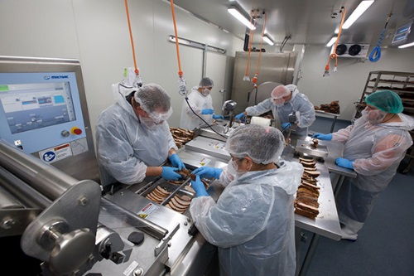
016_Image 9_ processing the meat at Texas BBQ Foods.jpg

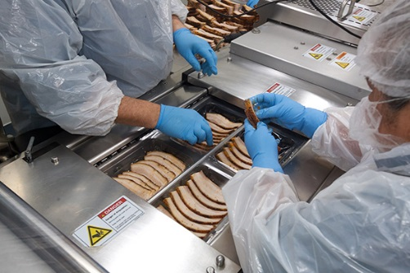
016_Image 10_ processing the meat at Texas BBQ Foods.jpg

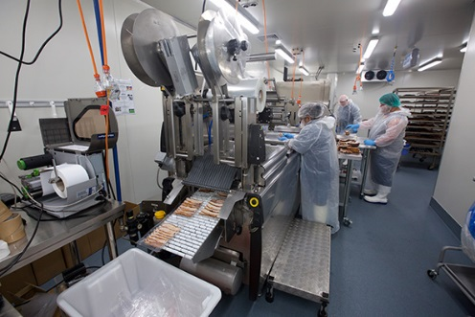
016_Image 11_ processing the meat at Texas BBQ Foods.jpg

016_Image 12_ processing the meat at Texas BBQ Foods.jpg

Caption: Once the meat is cooked it goes straight into a blast chiller, before it is sliced, vacuum packed and chilled, ready to be despatched and enjoyed.

((Kaeser photo – free for publication))

