Mobilair M 27 portable compressor with PE enclosure and generator:
A versatile compressed air powerhouse
Convenient, lightweight, powerful and efficient: These are just some of the key advantages of the Mobilair M 27 portable compressor from Kaeser Compressors. With a free air delivery of 2.6 m³/min (at 7 bar), it offers a host of optional features, such as an integrated generator and / or compressed air treatment equipment. A stationary version is also available for specialised applications and can be easily installed on the cargo bed of a truck, for example.
A true powerhouse hides beneath the Mobilair M 27's scratch and corrosion resistant rotation-sintered polyethylene (PE) sound enclosure:
The rotary screw compressor block with energy-saving Sigma Profile rotors is designed for continuous operation and is driven by a powerful, water-cooled Kubota diesel engine. Consequently, the Mobilair 27 provides a free air delivery of 2.6 m³/min at 7 bar, which makes it the ideal choice for simultaneously powering two 20 kg breakers, or other tools such as air lances, spaders, impact borers and sandblasting equipment. Moreover, the Mobilair 27 can be equipped with an integrated aftercooler and centrifugal separator to ensure a dependable supply of cool dry air. It is also available as a 6.5 kVA generator version with a free air delivery of 1.9 m³/min at 7 bar.
The M 27’s power-rating of 17.9 kW means that it is perfectly suited for use in low emission zones, since equipment in this performance class does not require a particle filter. There are no worries when it comes to those cold morning starts either: Fitted as standard, Kaeser’s patented Anti Frost Control protects air tools from potential damage caused by freezing and corrosion. In addition, the wide-opening soundproof enclosure allows quick and easy access to all maintenance points.
Another useful option is the hose reel which comes with a 20m lightweight hose, as this enables the compressed air line to be safely stowed away.

File: c-m27-nz
Approved for publication, copy acknowledgement appreciated
Image:

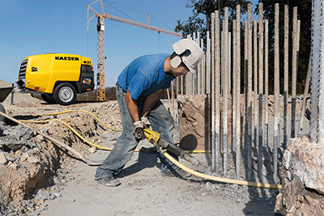
The M27 from Kaeser not only delivers impressive performance, but is also available with a wide range of equipment options to ensure maximum flexibility.

