February 2021

Kaeser becomes an associate member of the Collision Repair Association
Kaeser Compressors NZ recently became an associate member of the Collision Repair Association (CRA), and will be exhibiting at CRA’s annual conference, taking place at the Marlborough Convention Centre in Blenheim from 16 to 17 April 2021.
Kaeser Compressors NZ recently joined the Collision Repair Association as an associate member. Founded over 100 years ago - and formerly known as the NZ Motor Body Builders’ Assn - the Association represents the interests of all parts of the collision repair industry, from panel beating to motor body building to structural repairs and everything in between.
As one of the world’s largest compressed air systems providers and compressor manufacturers, Kaeser Compressors has been supplying the collision repair and wider automotive industry with compact, reliable and energy efficient compressed air system solutions for many years.

One very popular compressed air system with the collision repair industry is the Aircenter. Remaining proudly manufactured in Germany, the user-friendly Aircenter is a complete turnkey system which incorporates a Kaeser rotary screw compressor, an energy efficient refrigeration dryer and an air receiver all in one space-saving compact package. The space-saving design has long since made the Aircenter the ideal solution where space is at a premium - such as in collision repair workshops.

Peter Eckberg, Managing Director of Kaeser Compressors NZ said: ‘We are delighted to now be an associate member of the CRA. As a supplier to many businesses in the collision repair industry there was a clear synergy for us in joining the association.’

Kaeser will be exhibiting at the annual CRA conference, taking place at the Marlborough Convention Centre in Blenheim from 16 to 17 April 2021. For more information on the Kaeser Aircenter or to learn more about Kaeser’s stand at the 2021 Collision Repair Association annual conference, visit nz.kaeser.com or phone 0800 447 820.
-END- Free for publication, copy appreciated
Editors Notes
From 0.18 to 515 kW, Kaeser Compressors manufactures a wide range of compressors and associated auxiliary equipment that meet the varying requirements of a diverse range of industries and applications.

One of the world’s largest manufacturers of rotary screw compressors, Kaeser Compressors is represented globally in over 100 countries through a dedicated network of branches, subsidiary companies and authorised partners.

Kaeser Compressors NZ Limited provides comprehensive air compressor and blower sales and service throughout New Zealand from its offices in Auckland, alongside a dedicated and nationwide network of authorised partners.

For editorial and advertising enquiries contact: Beth Wood, Marketing Manager
Press office: +61 3 9791 5999 Fax: +61 3 9791 5733
E-mail: beth.wood@kaeser.com

KAESER COMPRESSORS NZ Limited
18B Tarndale Grove, Albany, Auckland 0632, New Zealand
Phone: +64 9 941 0499 Email: info.newzealand@kaeser.com
nz.kaeser.com
File: P-CRA-Membership-nz
Approved for publication, copy acknowledgement appreciated
Images: Contact our press office to request high res versions of the images found below

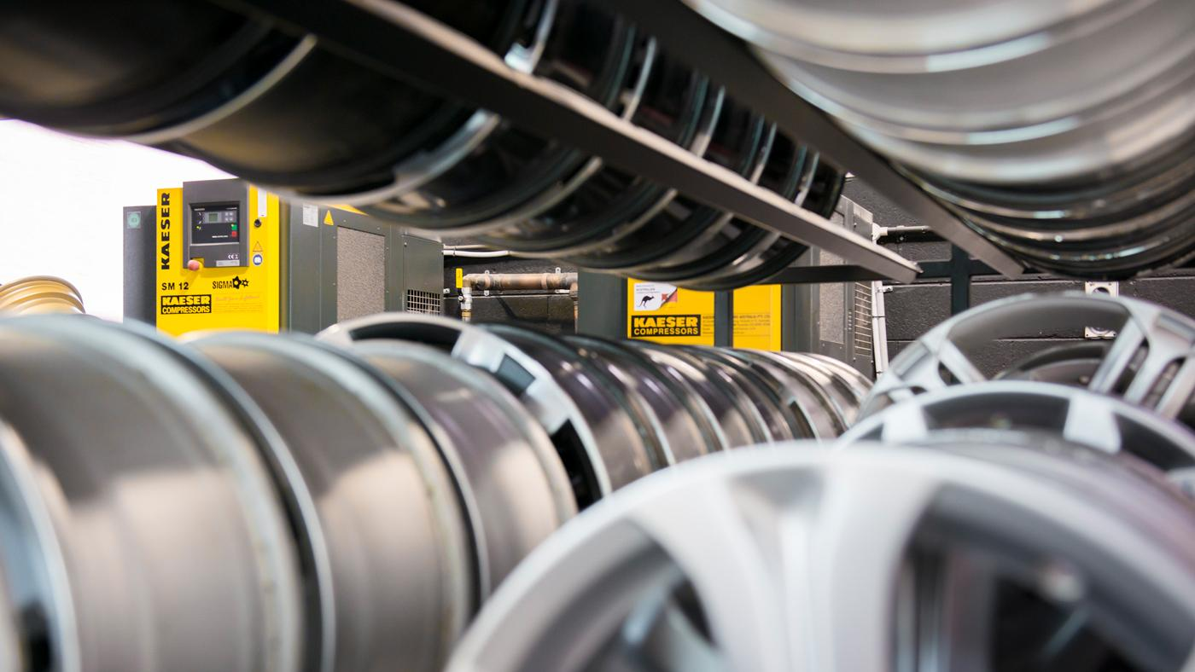
Caption: Kaeser Compressors has been meeting the compressed air needs of the collision repair industry for quite some time.

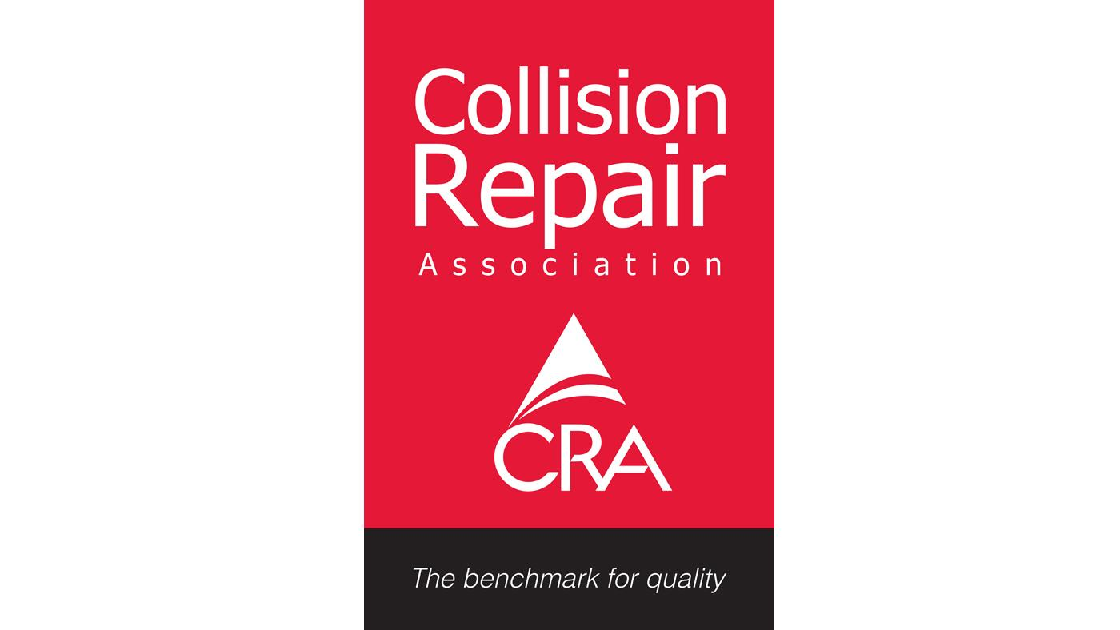
Caption: The Collision Repair Association represents the interests of all parts of the collision repair industry.

Kaeser photo(s) – free for publication, credits appreciated.

