November 2020
Sustainability woven into the fabric:
Kaeser meets Geofabrics energy efficiency requirements

Australia’s largest manufacturer of geosynthetic products recently installed a low pressure Kaeser ESD 245 rotary screw compressor at its Albury manufacturing plant in regional NSW. Replacing an ageing compressor, the new Kaeser compressor is assisting Geofabrics in continuing to meet its sustainability goals.

Geofabrics Australasia is Australia’s largest manufacturer and supplier of a range of highly engineered geosynthetics for the building and infrastructure sector. The core capabilities are across the Road, Rail, Waste, Mining, Coastal, Water, Recreation and Slopes & Wall segments. Geofabrics has a presence throughout Australia, New Zealand, PNG and the Pacific. Geofabrics is a proud Australian manufacturer and has two manufacturing plants, one in Albury (NSW) and other in Ormeau (Queensland) and contributes to Australia’s sovereign infrastructure construction capabilities.
On every project, Geofabrics has a singular focus: to provide smarter infrastructure solutions for their clients.

Manufacturing innovative geosynthetic solutions
As the Australasian leader in geotextiles and geosynthetics, Geofabrics delivers engineering support and technical leadership through a focus on innovation, research, industry education, design and independent testing services. Simply, Geofabrics’ products are a key component in building Australia’s critical infrastructure; our roads, railways, landfills and resources (mining, oil & gas).
One example of the products manufactured by Geofabrics is bidim® Green geotextile, a variant to its existing world-leading ‘Bidim’ range, which contains Australian-sourced recycled plastics (think of recycled drink bottles) and is a green innovation that came amid increasing calls for greater sustainability in the construction and infrastructure industry.
Both effective and economical, bidim Green is a superior geosynthetic solution for a range of engineering problems including weak soil, rutted and cracked roads, as well as liquid and gas leaks from landfill sites. It can be used for example, in the construction of roads, railways and embankments where the ground is soft and unstable. Using a layer of geotextile to separate the soft ground from the fill material reduces the amount of fill required, increases the lifespan of the road or rail structure, and reduces long-term maintenance costs.

Sustainable practices save energy and money
Geofabrics is committed to contributing to a positive impact on the environment and to manufacture and supply products that reduce reliance on non-renewable resources and reduce waste to landfill.
This includes making the company’s use of resources more efficient through lean manufacturing and a process of continuous improvement. As a result, Geofabrics has won many awards over the years including the 2019 Australian Exporter of the Year, the 2017-2019 Victorian Exporter of the Year (Environmental Solutions), and the 2018 AusTrade Australian Export Award for Environmental Solutions. These awards recognise outstanding international success in environmental solutions, clean energy innovation and energy efficiency.
It is no surprise then, that when Geofabrics Process Improvement Engineer Ashish Swarup began the procurement process to replace an ageing compressor at the Albury manufacturing plant - selecting an energy efficient solution was a key criterion.
Compressed air is an essential utility required to operate many functions at both of Geofabrics manufacturing plants - one in Albury (NSW) and one in southern Queensland. One crucial role is using compressed air in the filament drawing process. Reliably delivering clean compressed air is critical in fulfilling this process. Unfortunately, the ageing compressor at the Albury manufacturing plant was becoming less reliable. Aside from finding a more reliable solution, as one of the largest energy consumers in the business, accounting for around one third of all electrical consumption, finding an energy efficient compressed air solution was therefore also very important.
The procurement process included evaluating a number of possible compressor options against five key criteria, including life cycle costing, reliability of asset and environmental impact, making the process very transparent. All options were then given a total rating. Thanks to a high overall rating backed up with technical advice and support, Geofabrics opted for a low pressure Kaeser ESD 245 series rotary screw compressor to meet its requirements.

Energy efficiency as standard
The ESD 245 is a specially built dedicated low pressure oil lubricated rotary screw compressor. Unique to Kaeser it delivers flow rates up to 30.9 m³/min at pressures of 3.5 to 5 bar.

Installed complete with a comprehensive air treatment package, this proved the ideal solution for Geofabrics. Not only would this solution reliably deliver large volumes of high quality and clean compressed air, but as a highly efficient dedicated low pressure compressor - the ESD 245 would also easily create in excess of 30 percent energy savings compared to a ‘standard’ pressure 7 bar screw compressor of a similar size.

Kaeser Compressors pushes the boundaries of compressed air efficiency and availability once again with its latest generation of ESD series rotary screw compressors. Intelligent design solutions have not only led to enhanced ease of operation and serviceability, but also give this series of class-defining compressors their distinctive modern appearance.

Delivering improved specific power, the flow-optimised and further refined Sigma Profile rotors provide the foundation for exceptional energy efficiency. The use of high performance
IE4 drive motors maximise energy efficiency, whilst Kaeser’s 1:1 drive design eliminates the transmission losses associated with gear or V-belt driven systems, as the motor directly drives the airend. Kaeser is currently the only compressed air systems provider to equip its compressors with super premium efficiency IE4 class motors.
Furthermore, the radial fan fulfils the efficiency requirements for fans as per EU directive 327/2011. The advanced Sigma Control 2 compressor controller also achieves additional energy savings and minimises cost-intensive idling periods through the use of a variety of specially developed control options.

Finally, an intelligent component layout ensures even greater energy efficiency: for example, all service and maintenance points are within easy reach and are directly accessible from the front of the unit. This not only saves time and money when performing service work, but also maximises compressed air system availability.

Ashish Swarup concludes: ‘Selecting energy efficient equipment is a large part of our sustainability practices and our commitment to keeping our carbon footprint to a minimum, and the Kaeser compressor was therefore the right choice for us. Up and running now for almost a year the compressor is reliably and energy efficiently meeting our compressed air requirements.’

Kaeser has an extensive range of low pressure oil lubricated rotary screw compressors available that produce flow rates from 4.65 to 58.7 m³/min, designed for pressures 3.5 to 5 bar. For more information visit nz.kaeser.com or phone 0800 447 820.
-END- Free for publication, copy appreciated
Editors Notes
From 0.18 to 515 kW, Kaeser Compressors manufactures a wide range of compressors and associated auxiliary equipment that meet the varying requirements of a diverse range of industries and applications.

One of the world’s largest manufacturers of rotary screw compressors, Kaeser Compressors is represented globally in over 100 countries through a dedicated network of branches, subsidiary companies and authorised partners.

Kaeser Compressors NZ Limited provides comprehensive air compressor and blower sales and service throughout New Zealand from its offices in Auckland, alongside a dedicated and nationwide network of authorised partners.

For editorial and advertising enquiries contact: Beth Wood, Marketing Manager
Press office: +61 3 9791 5999 Fax: +61 3 9791 5733
E-mail: beth.wood@kaeser.com

KAESER COMPRESSORS NZ Limited
18B Tarndale Grove, Albany, Auckland 0632, New Zealand
Phone: +64 9 941 0499 Email: info.newzealand@kaeser.com
nz.kaeser.com
Kaeser photo(s) – free for publication, credits appreciated.

File: Q-Geofabrics-Case-Study-nz
Approved for publication, copy acknowledgement appreciated
Images: Contact our press office to request high res versions of the images found below
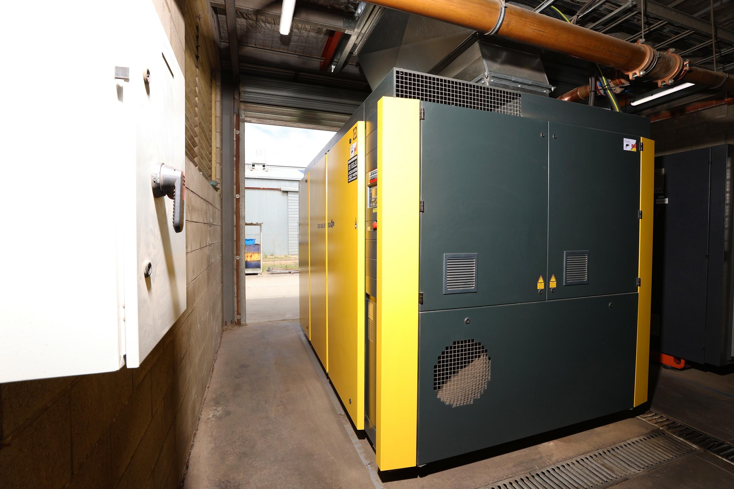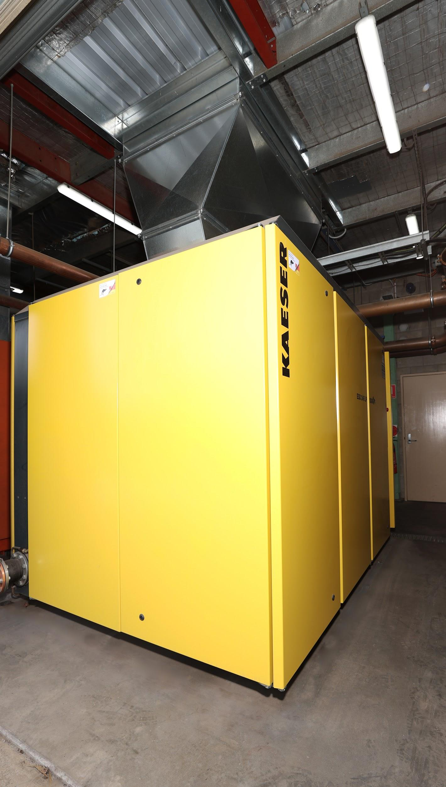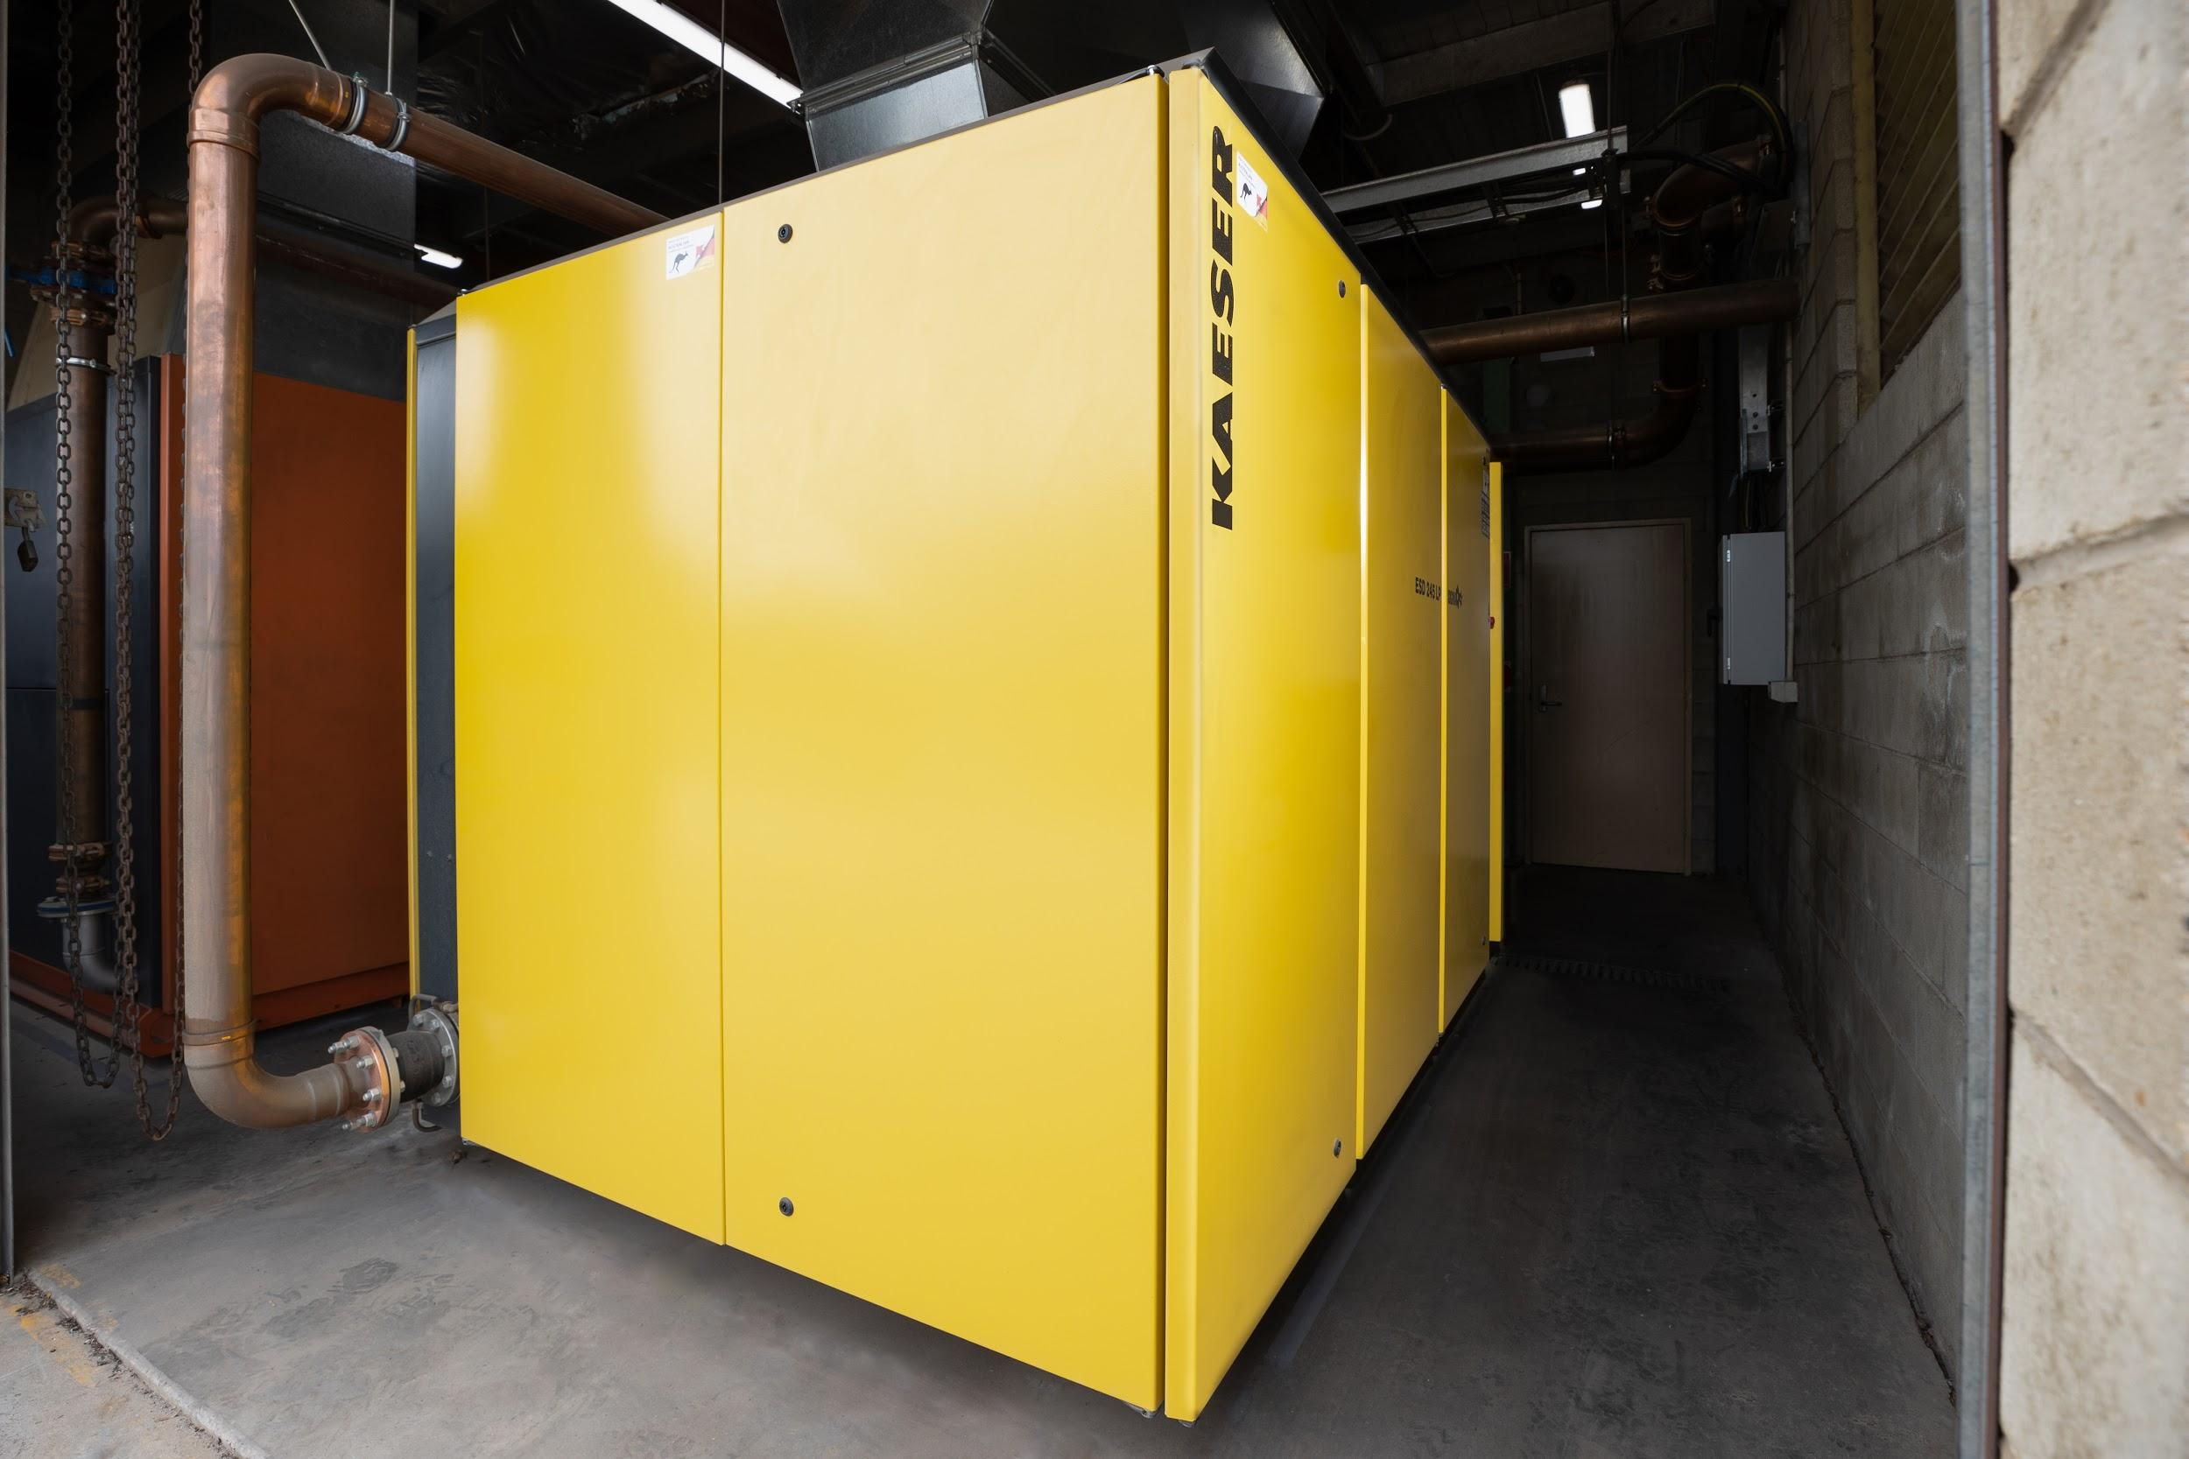
Caption: The new Kaeser compressor is assisting Geofabrics in continuing to meet its sustainability goals

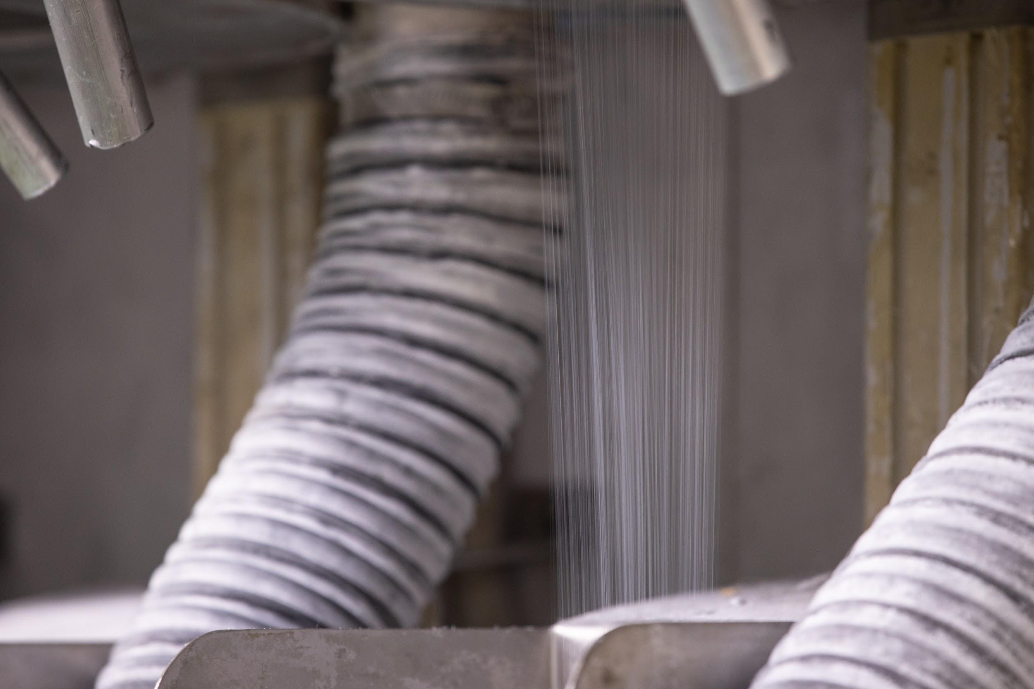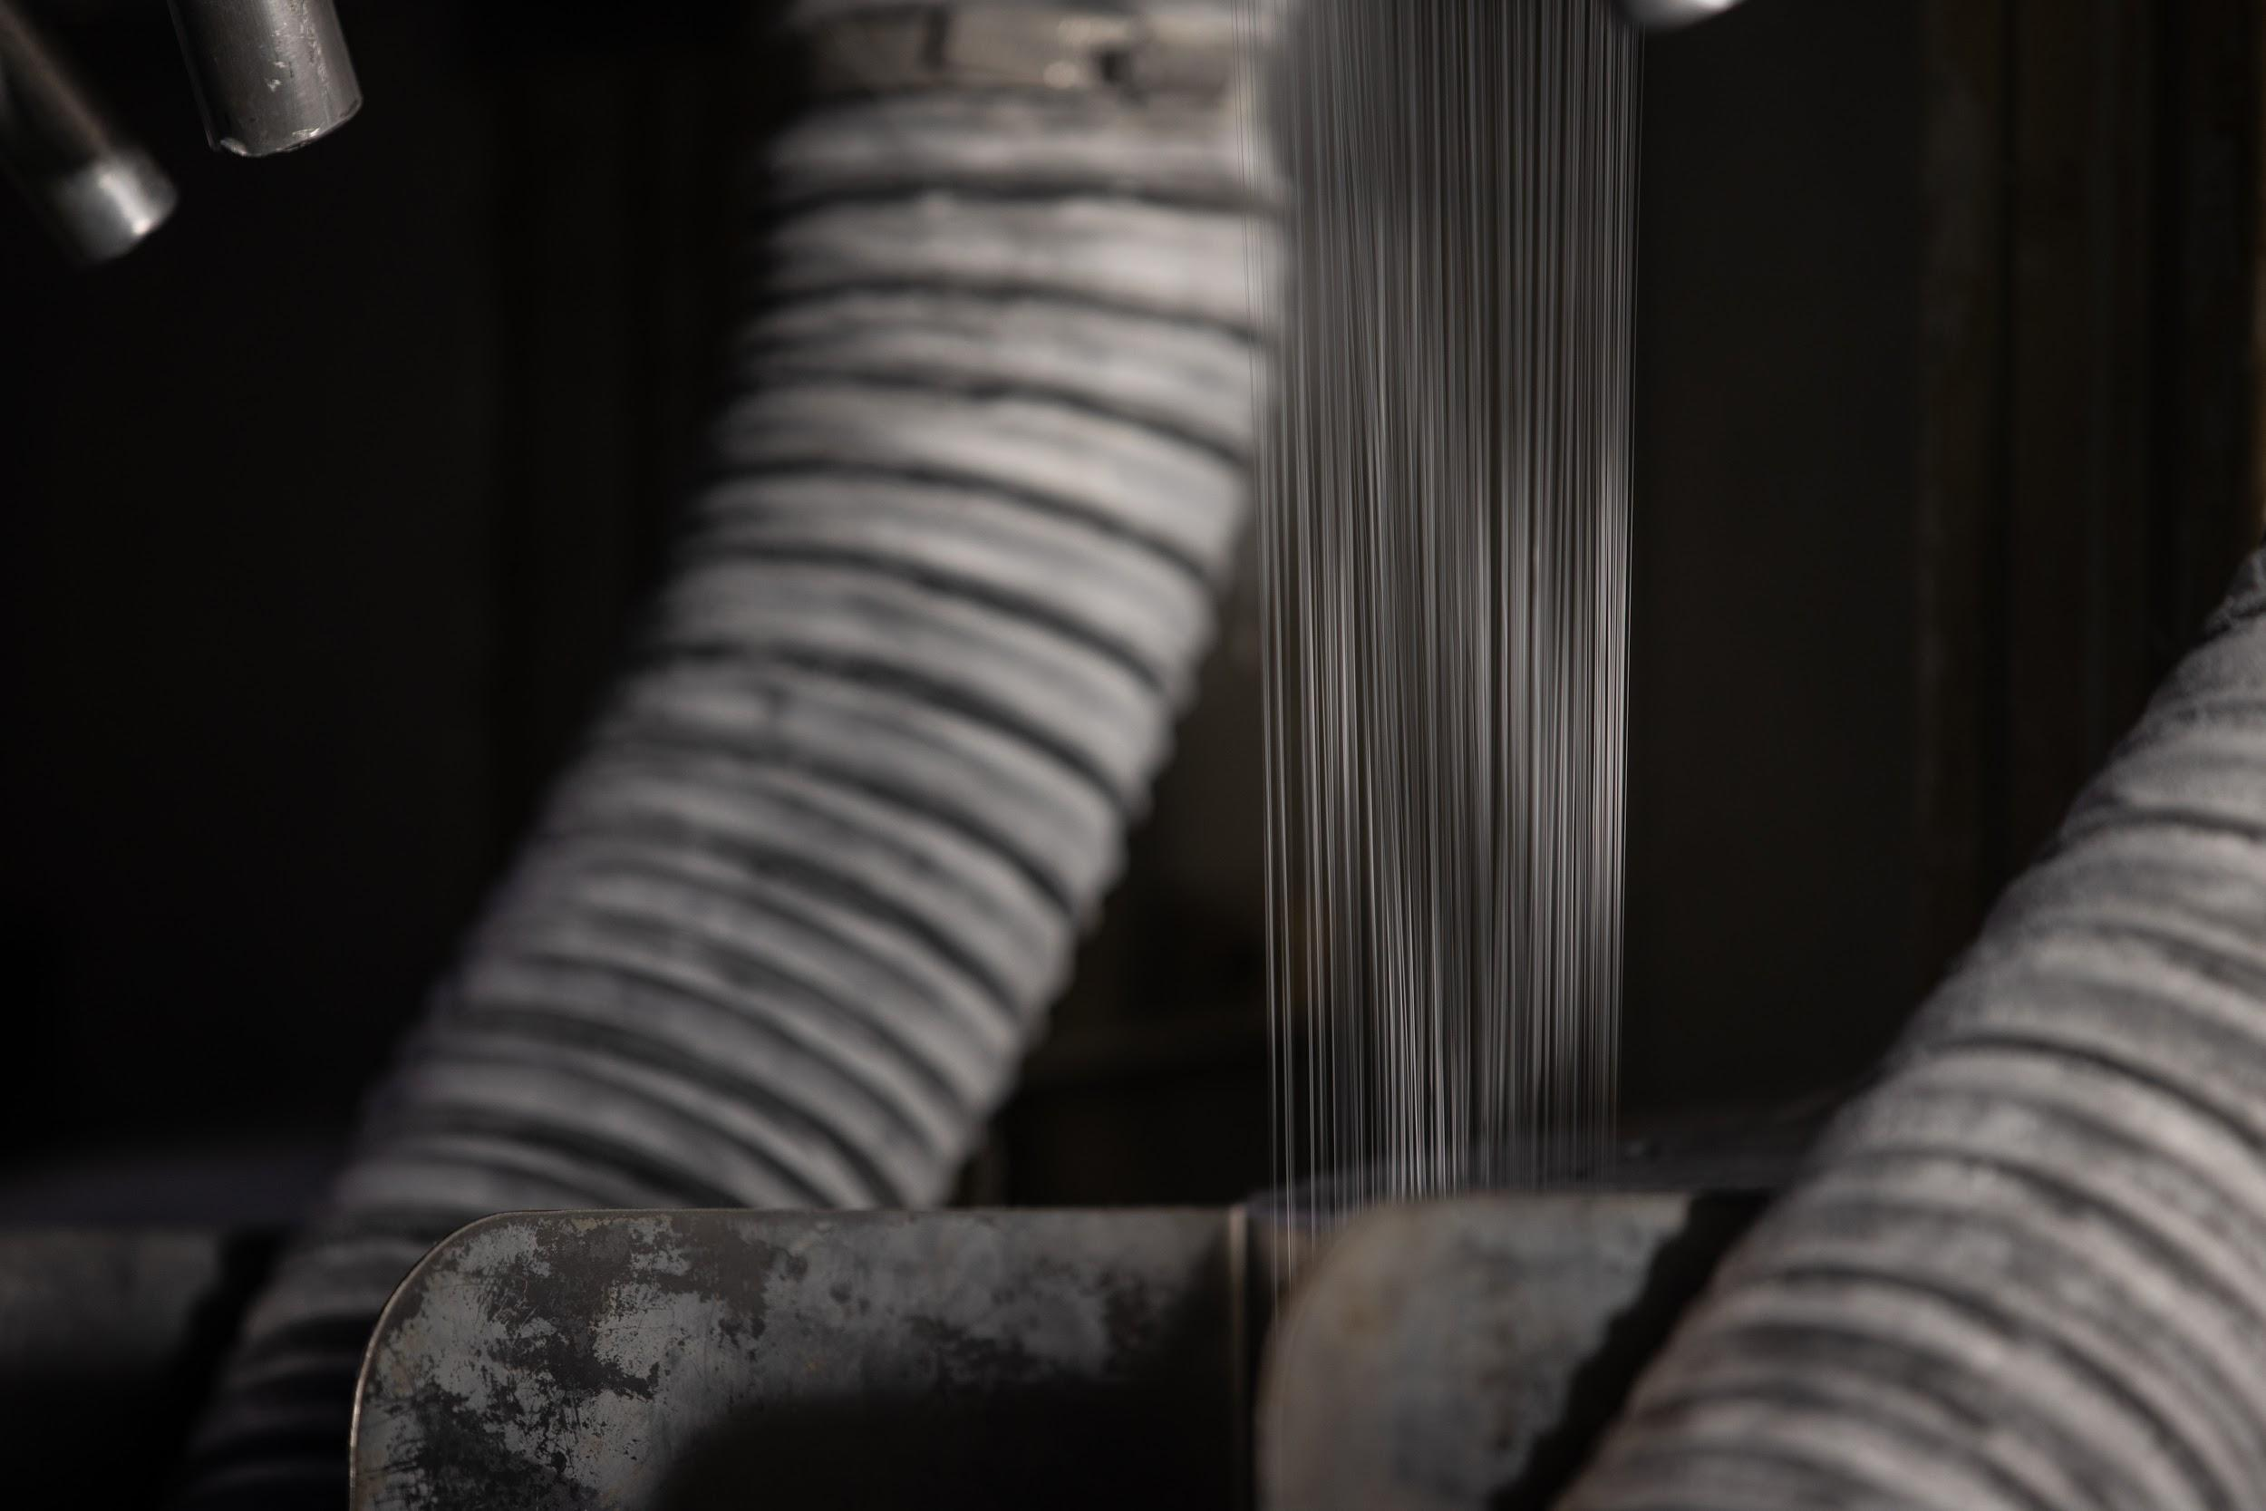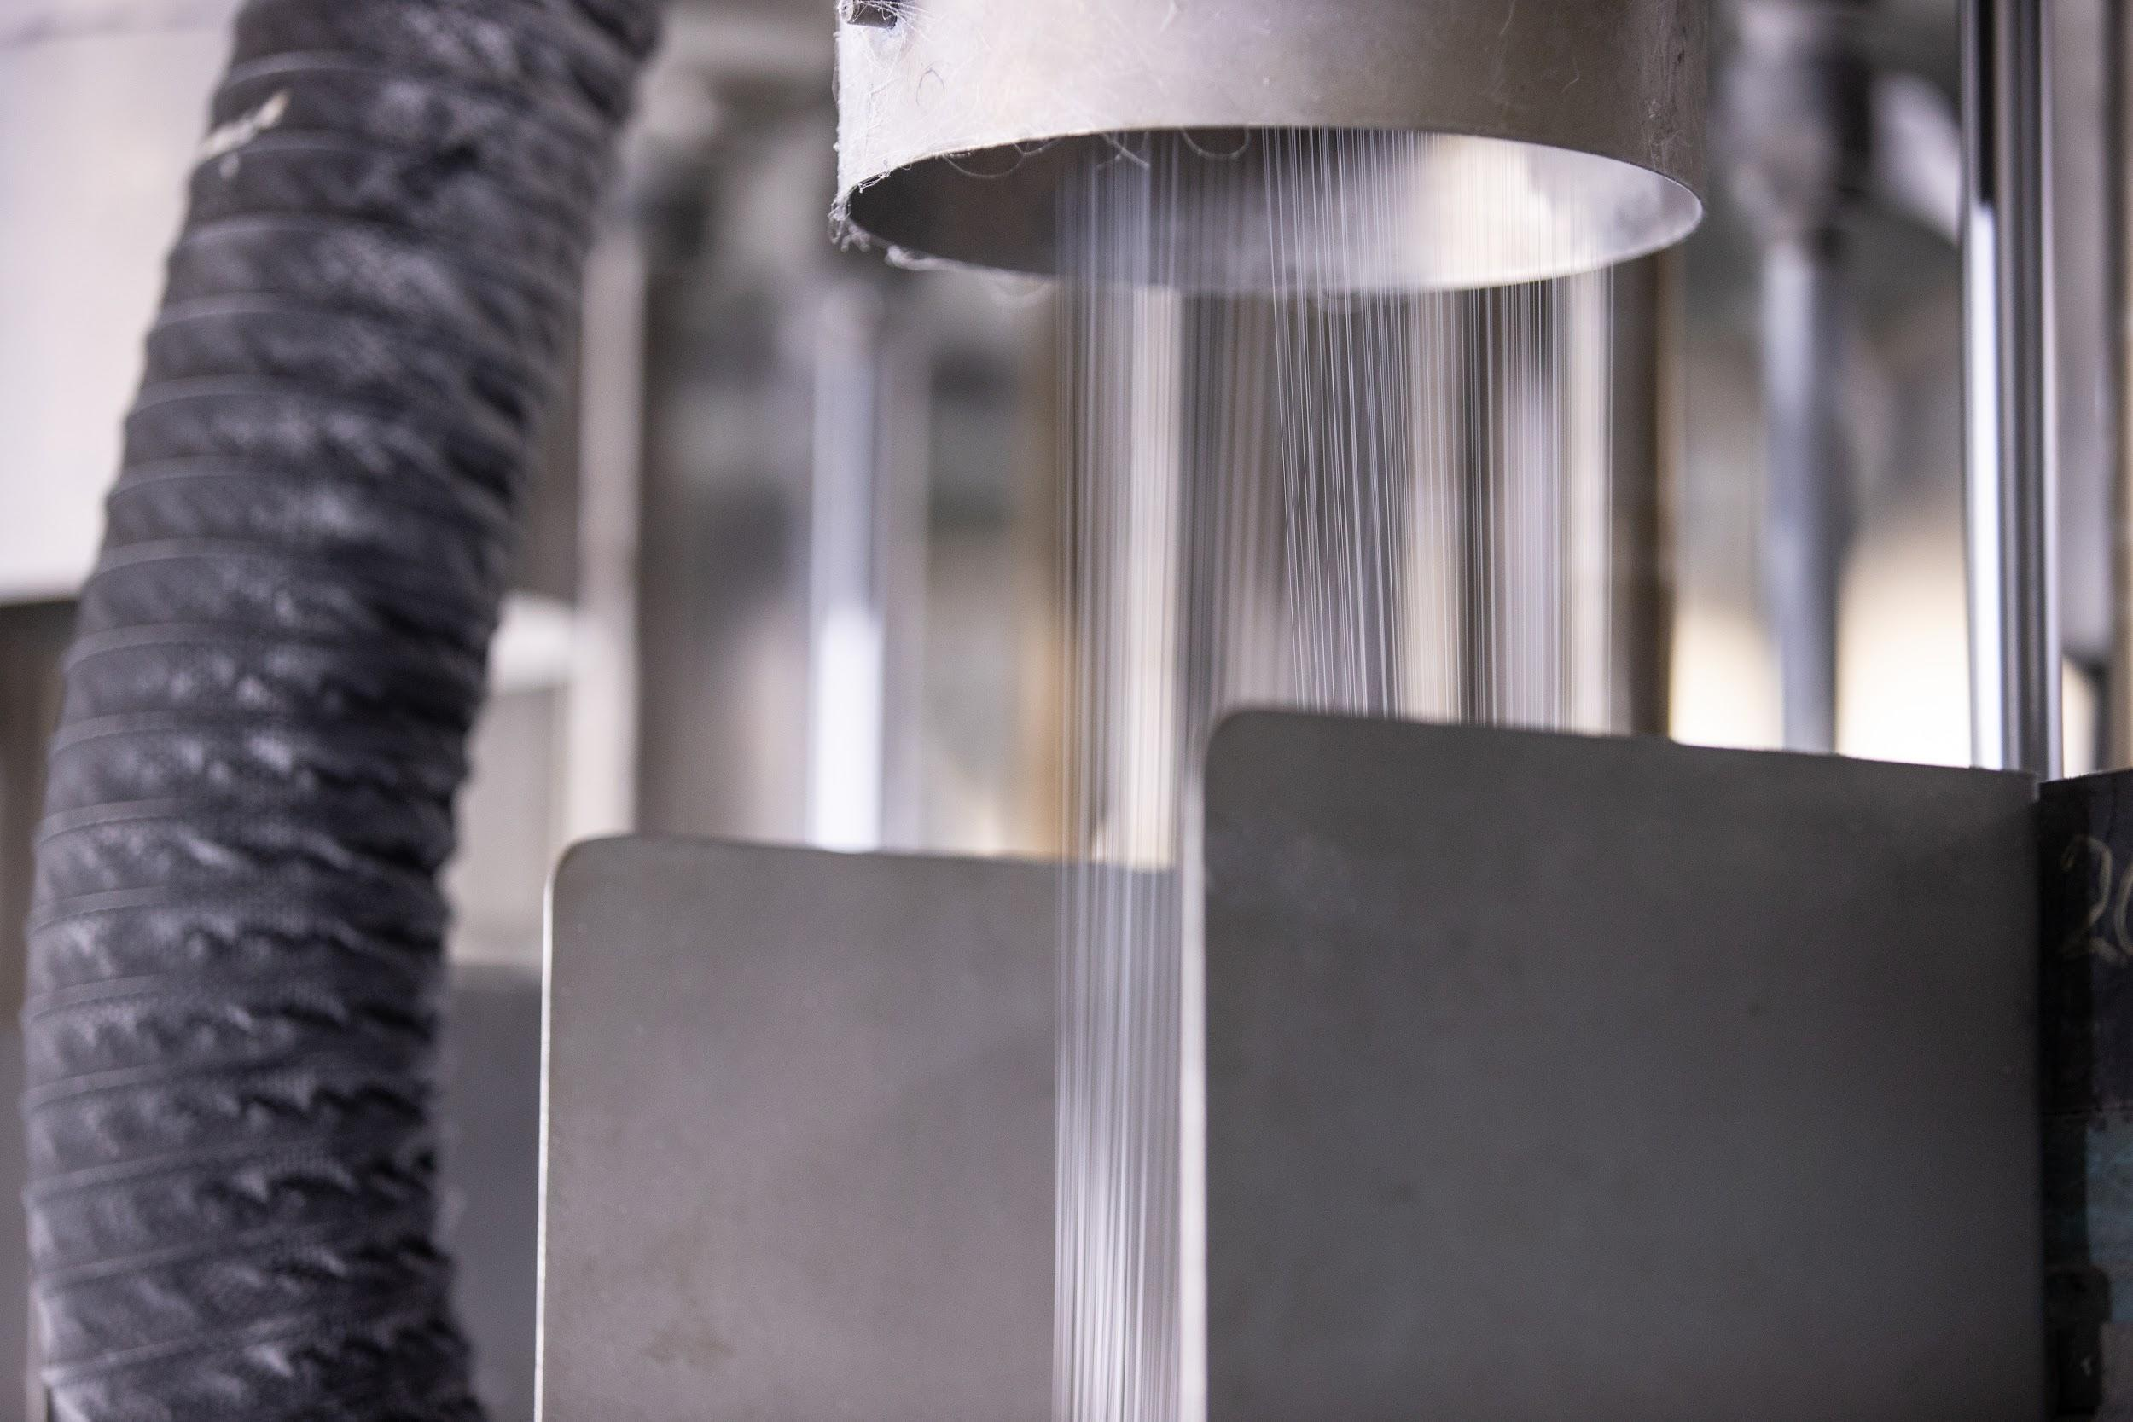
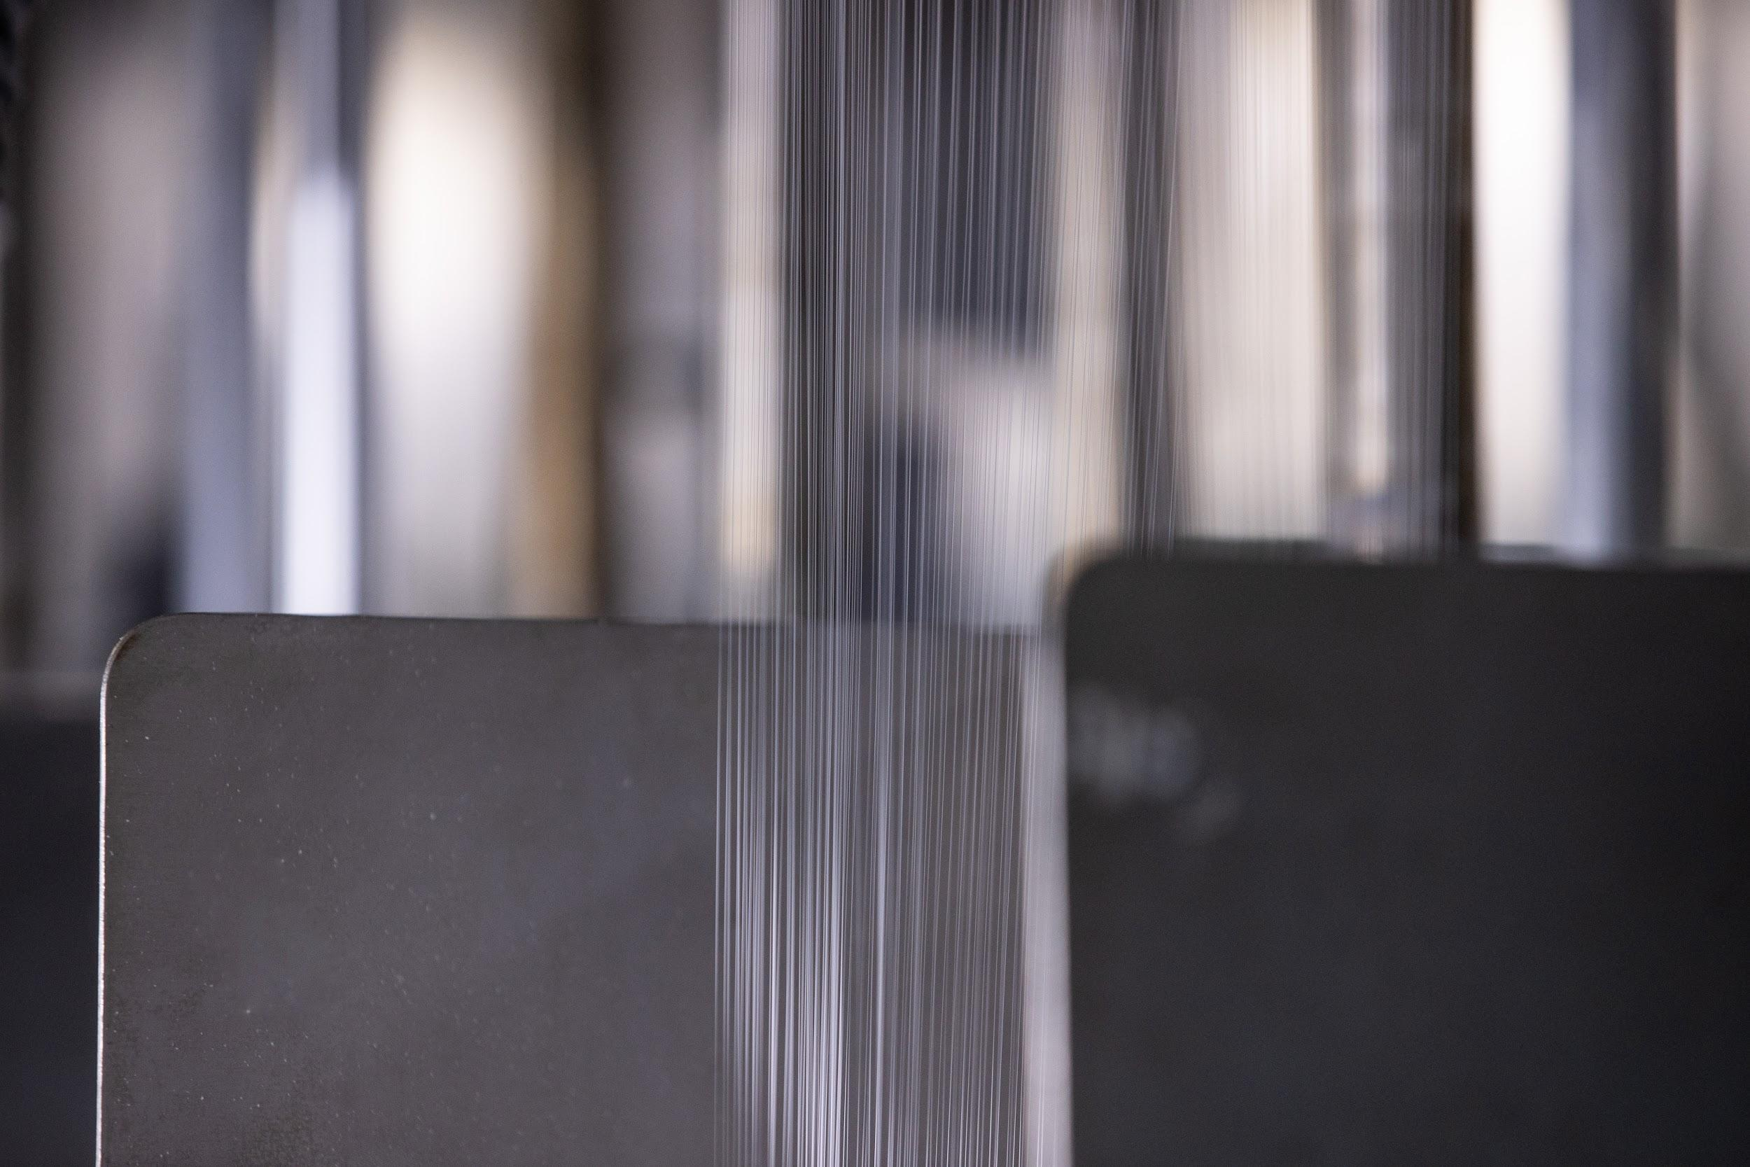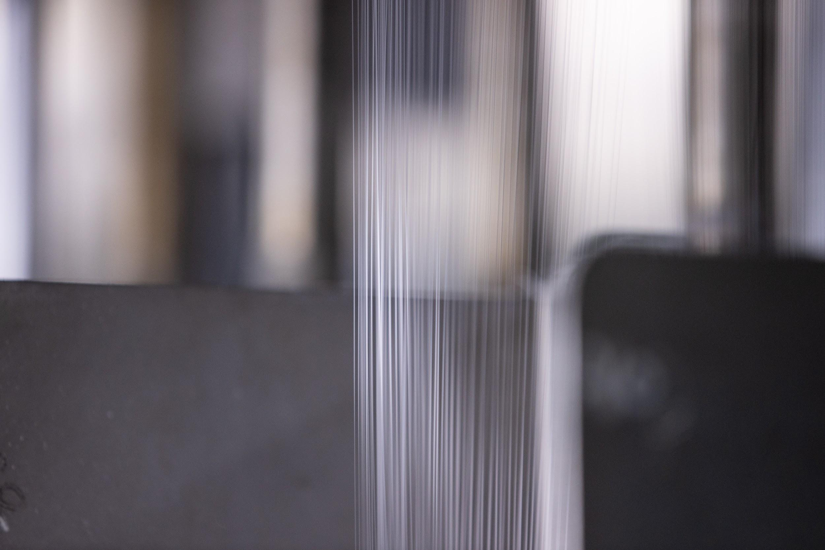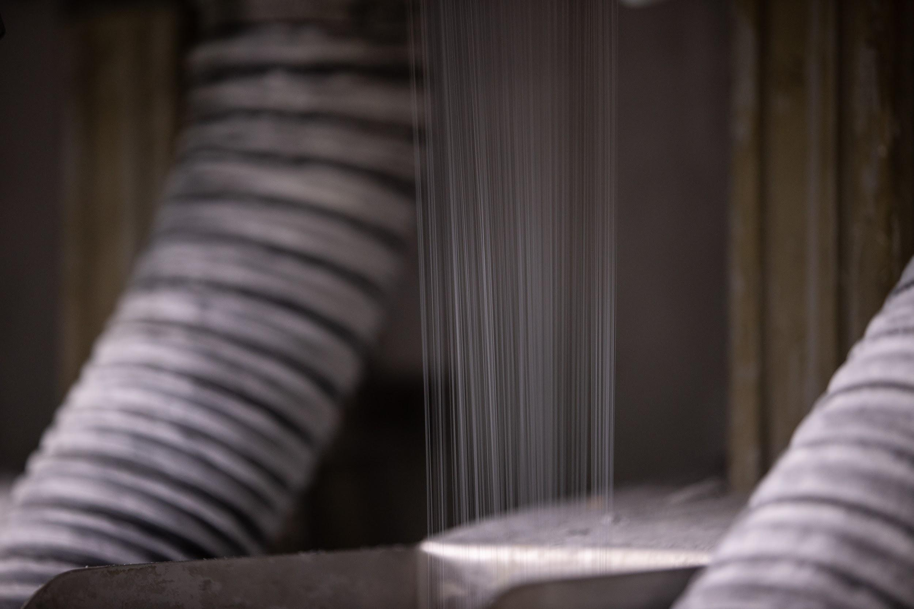
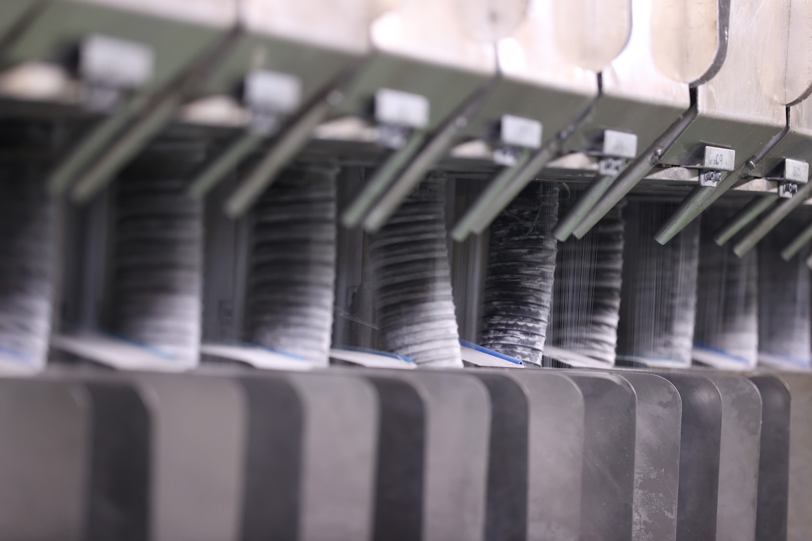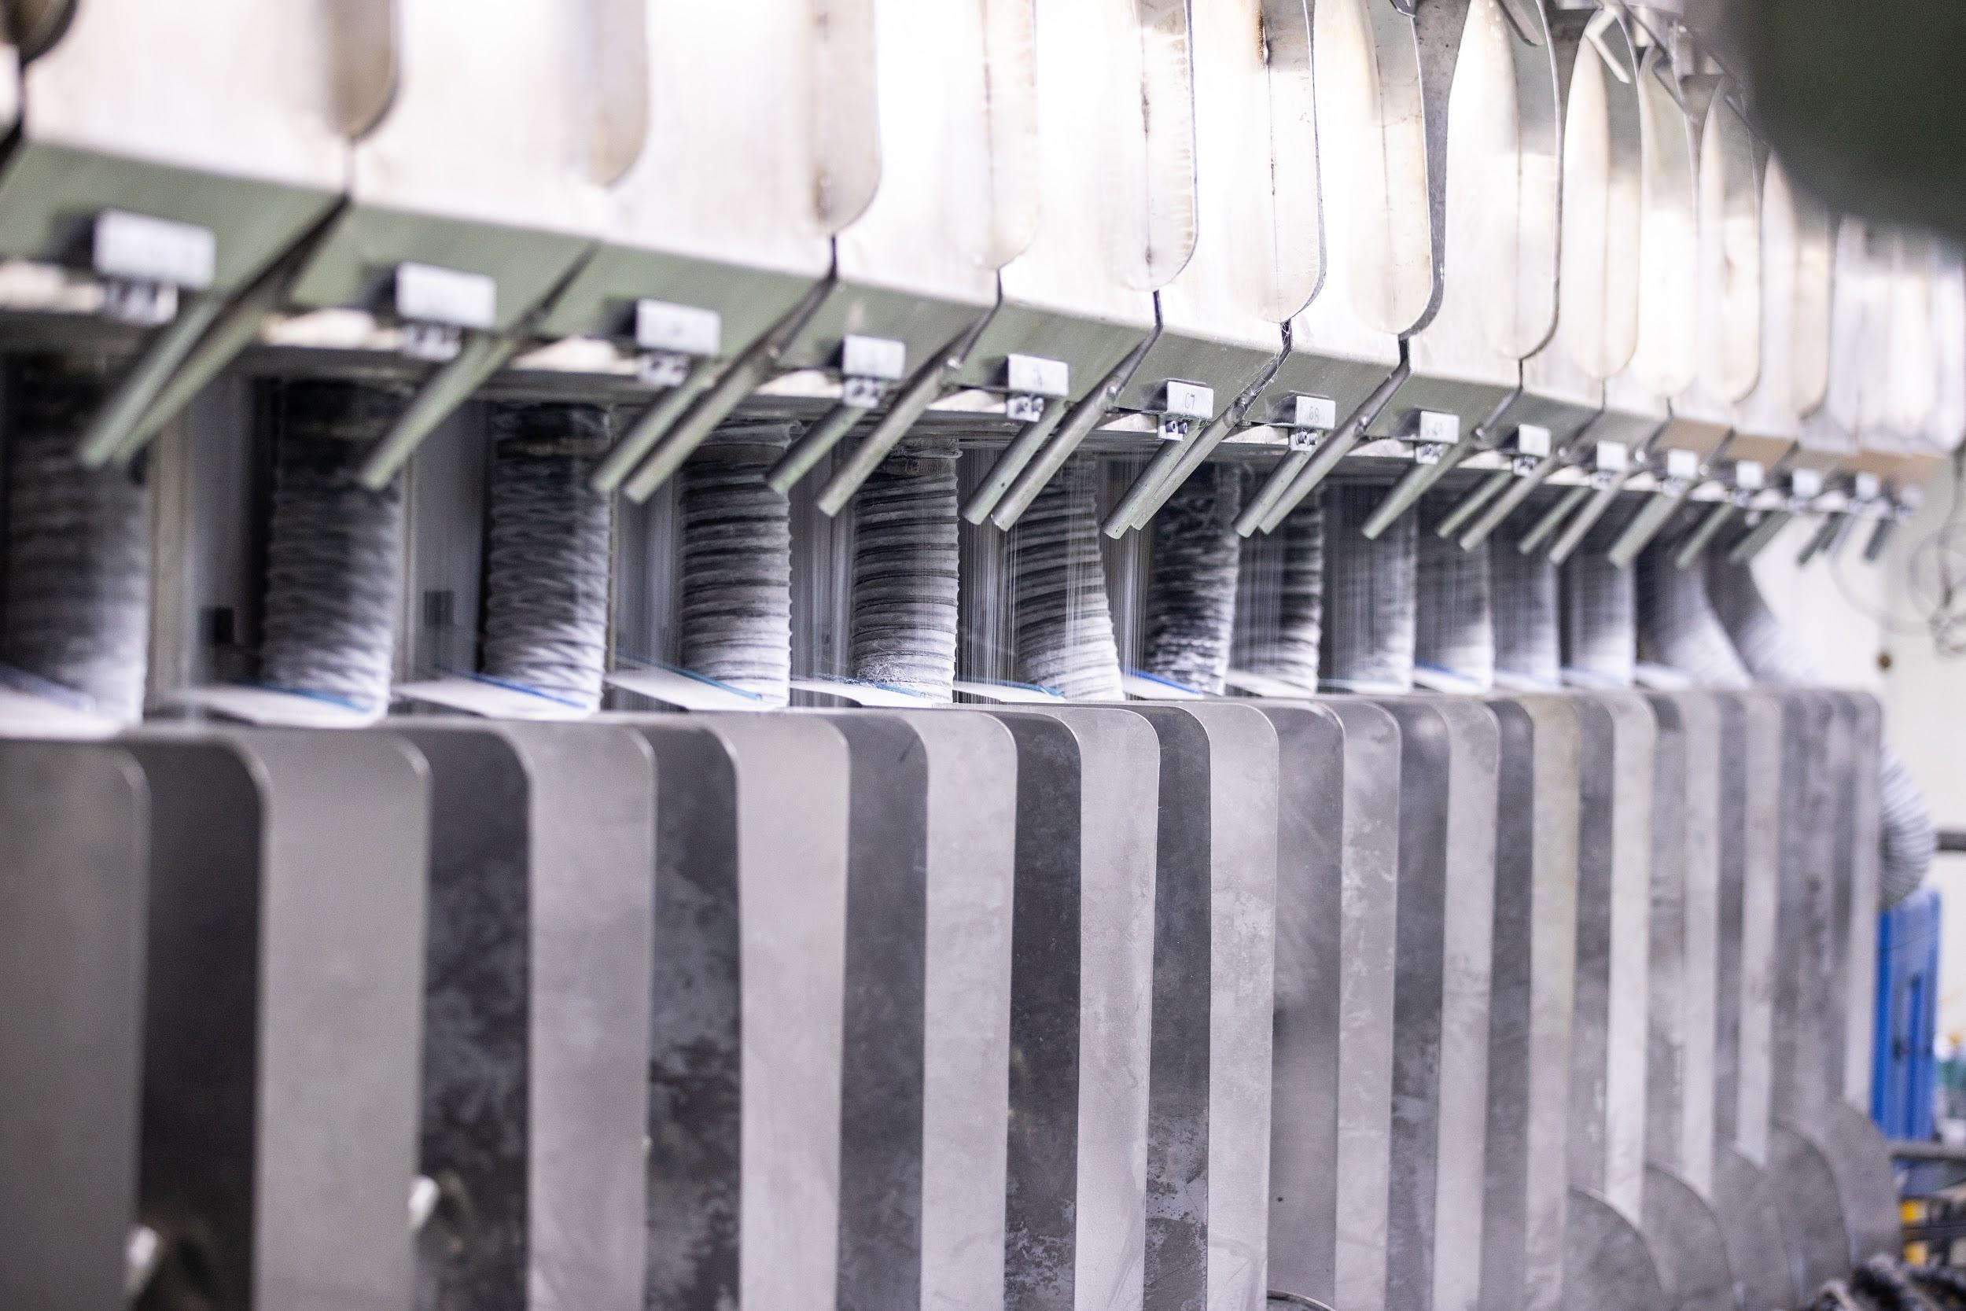
Caption: Compressed air is an essential utility required to operate many functions at Geofabrics - pictured here the filament spinning process
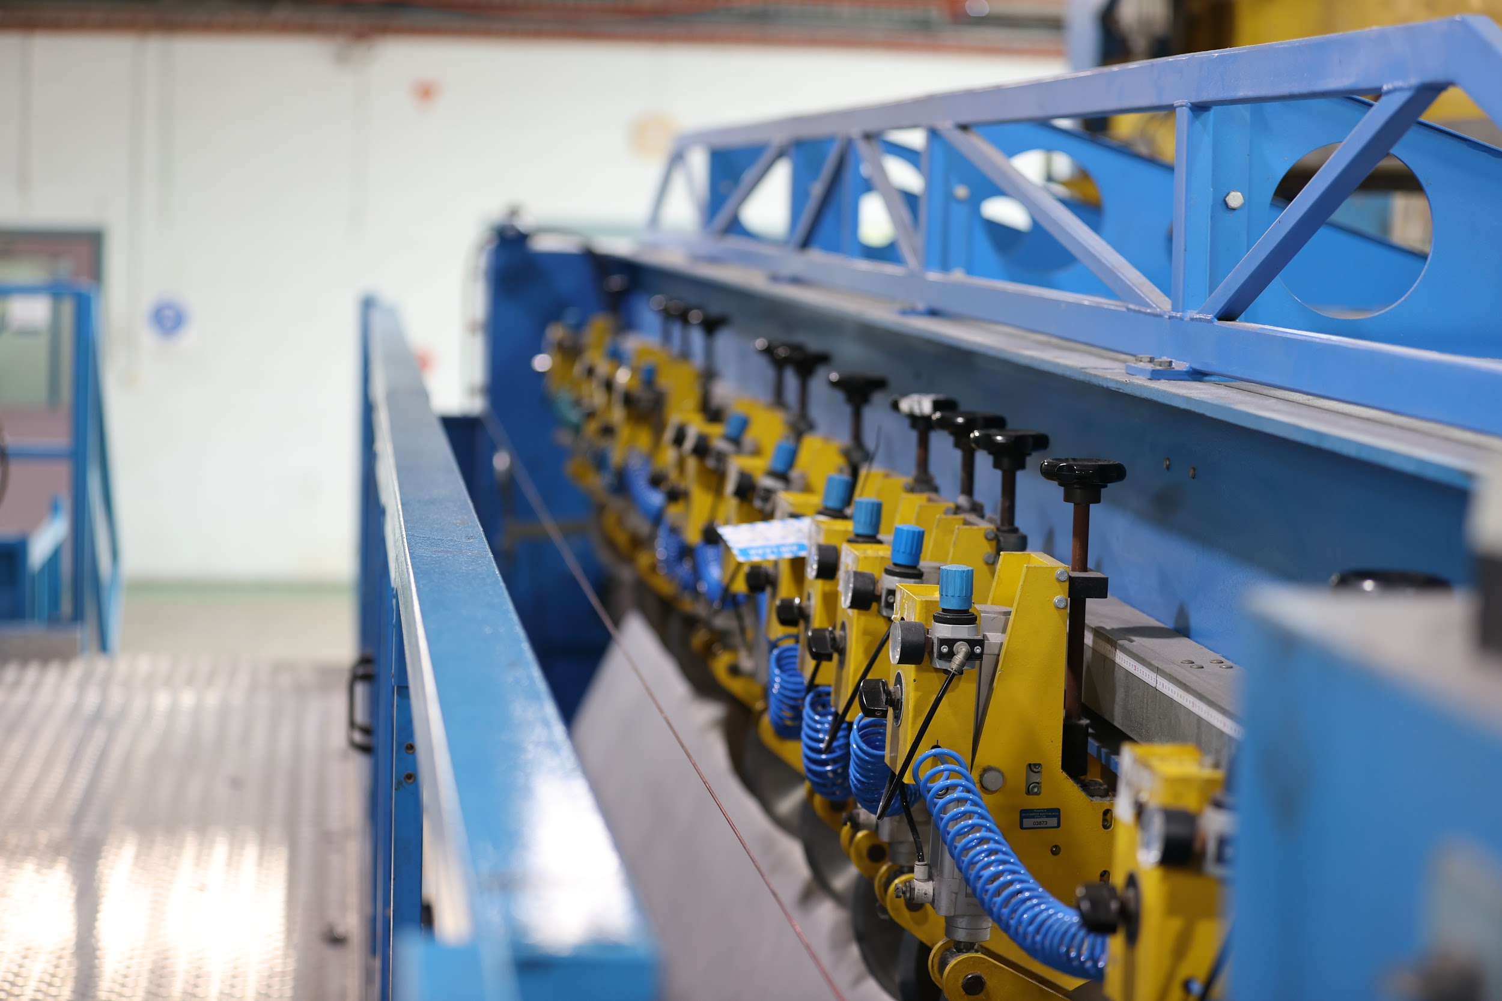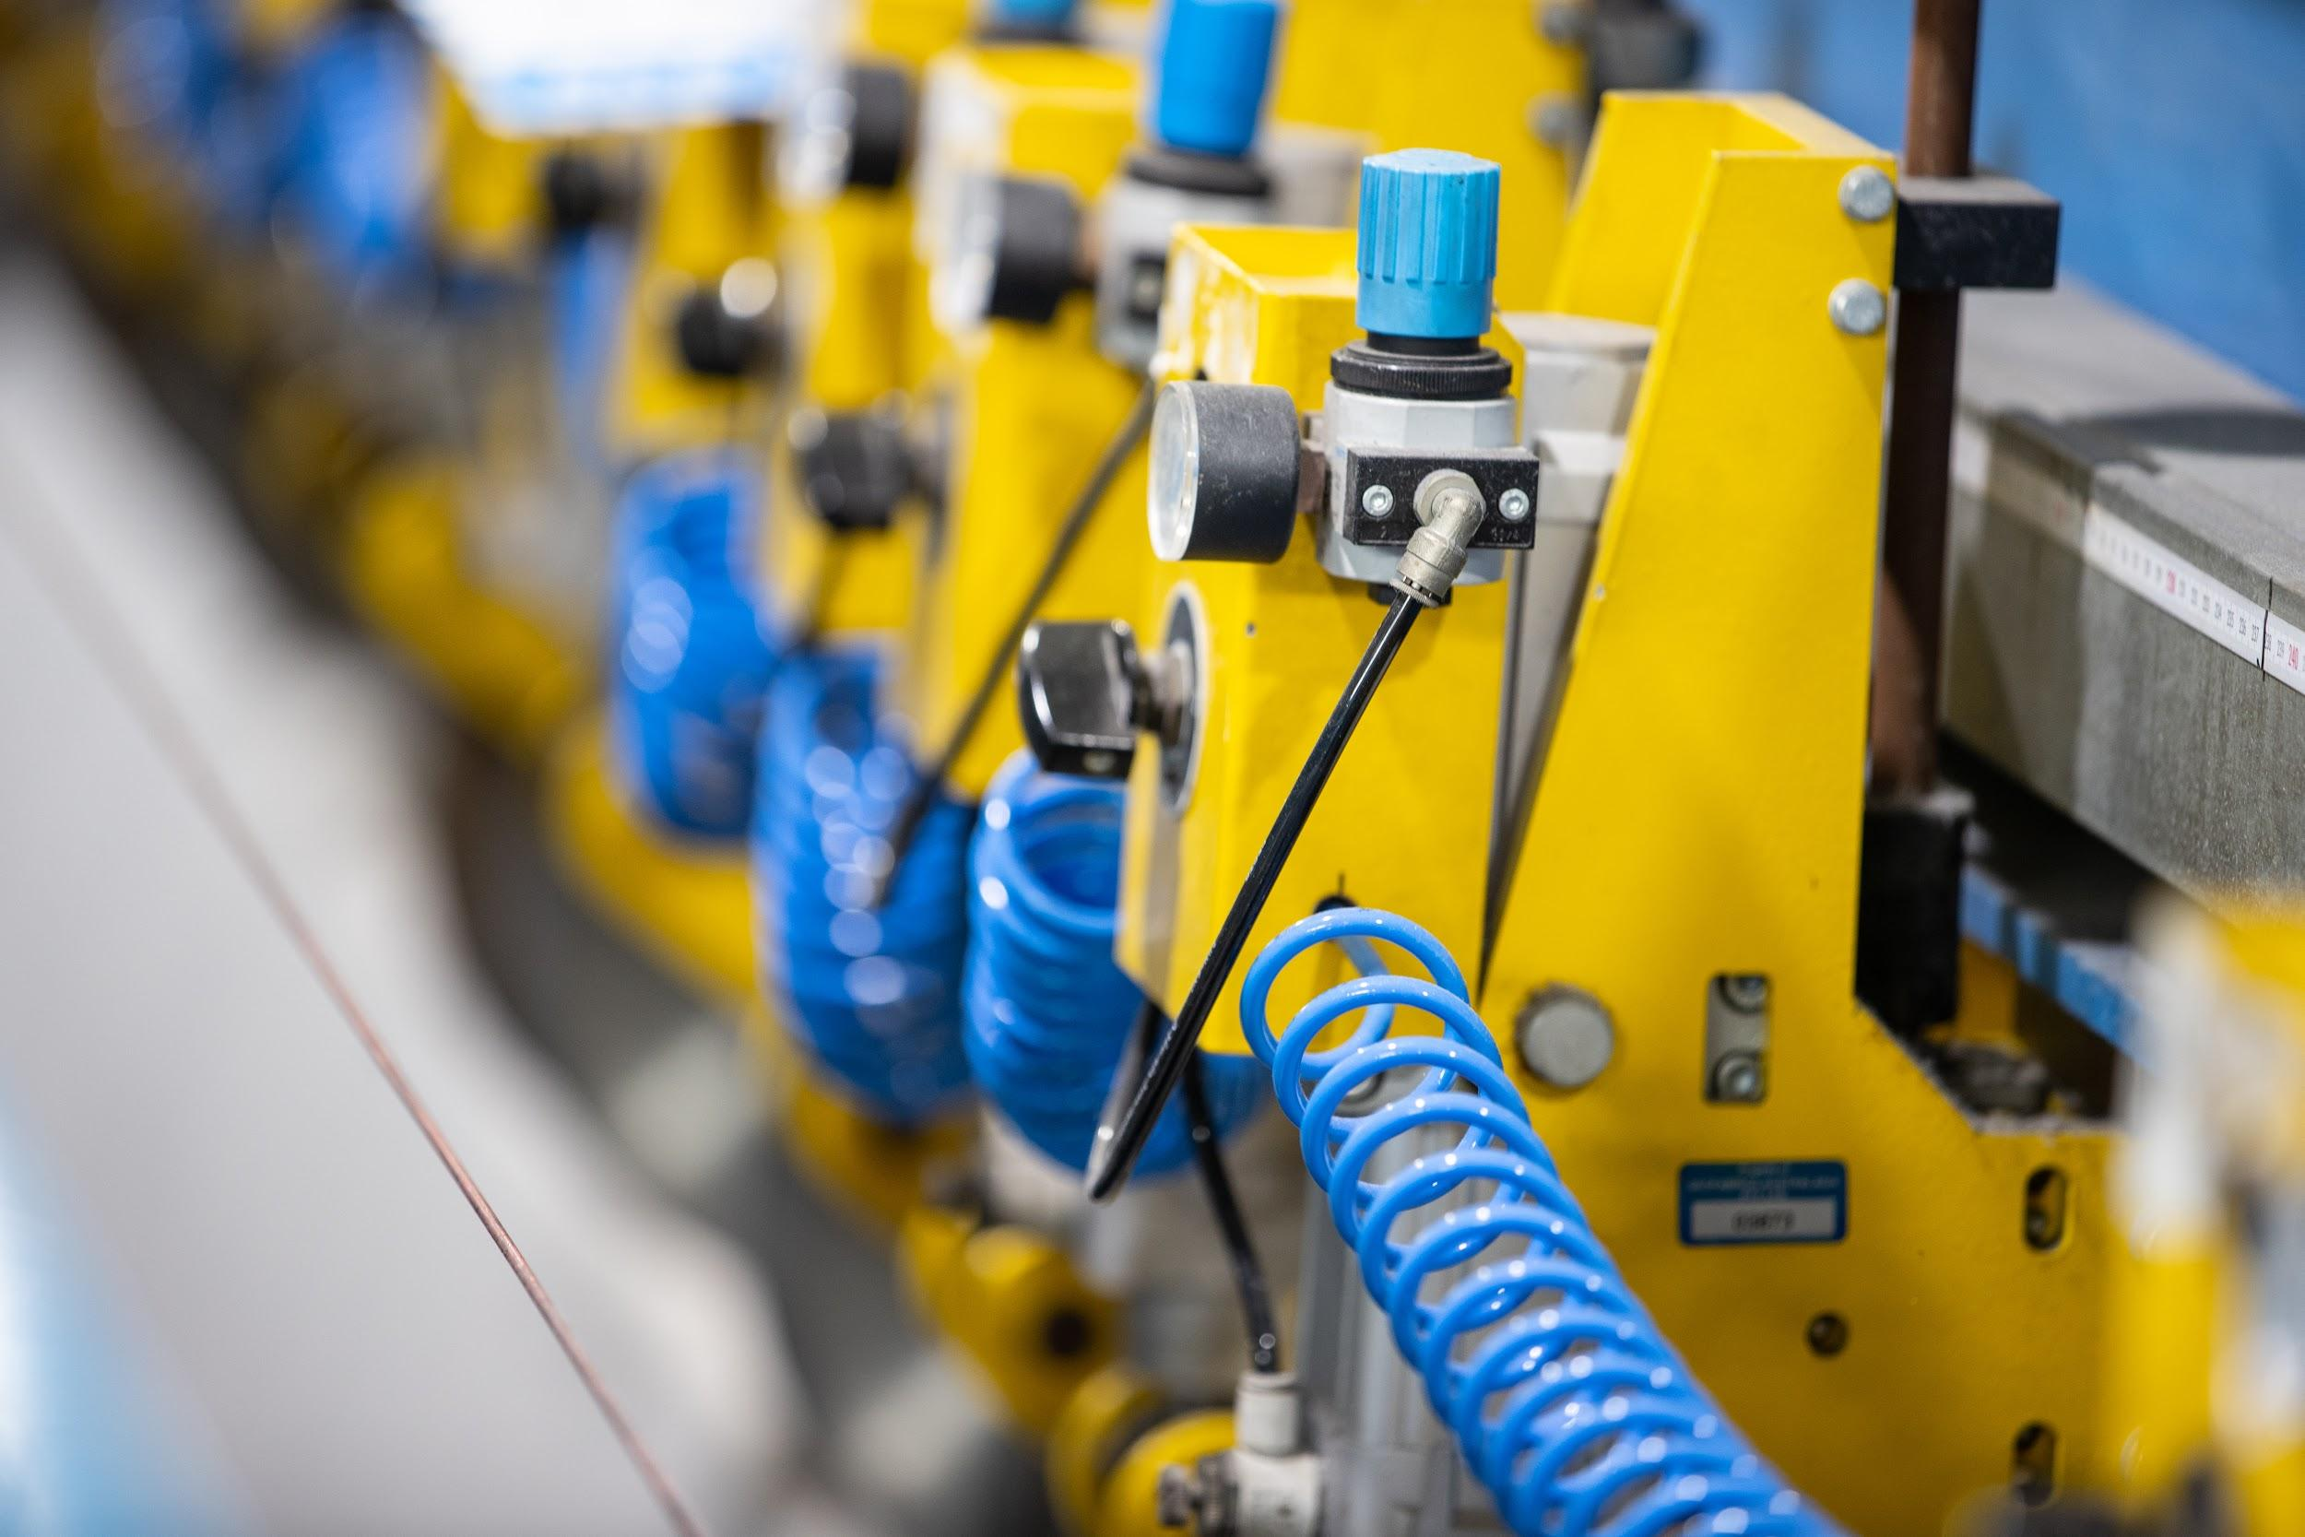
Caption: Compressed air is an essential utility required to operate many functions at Geofabrics - pictured here the in-line slitting process
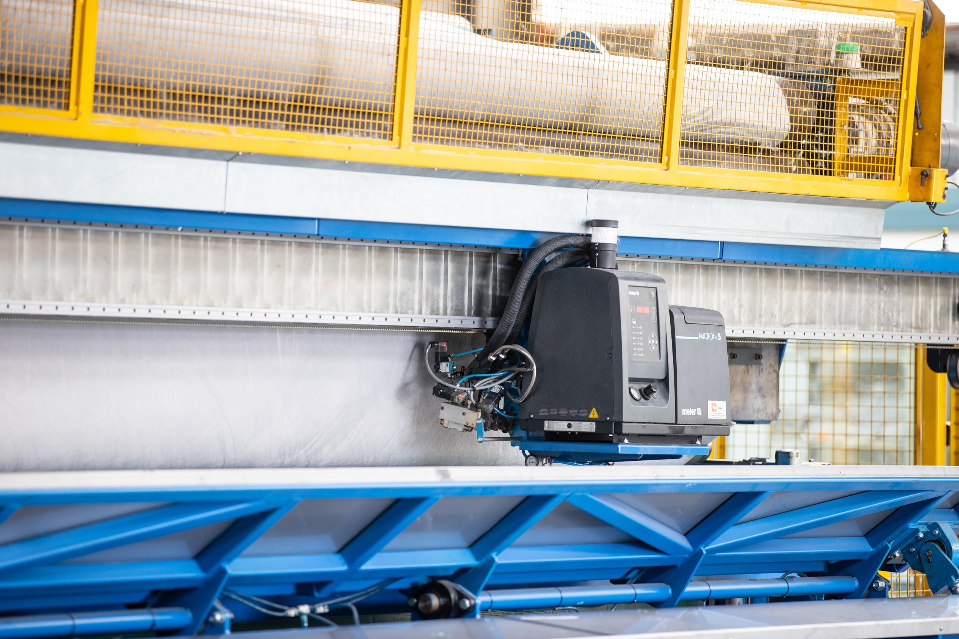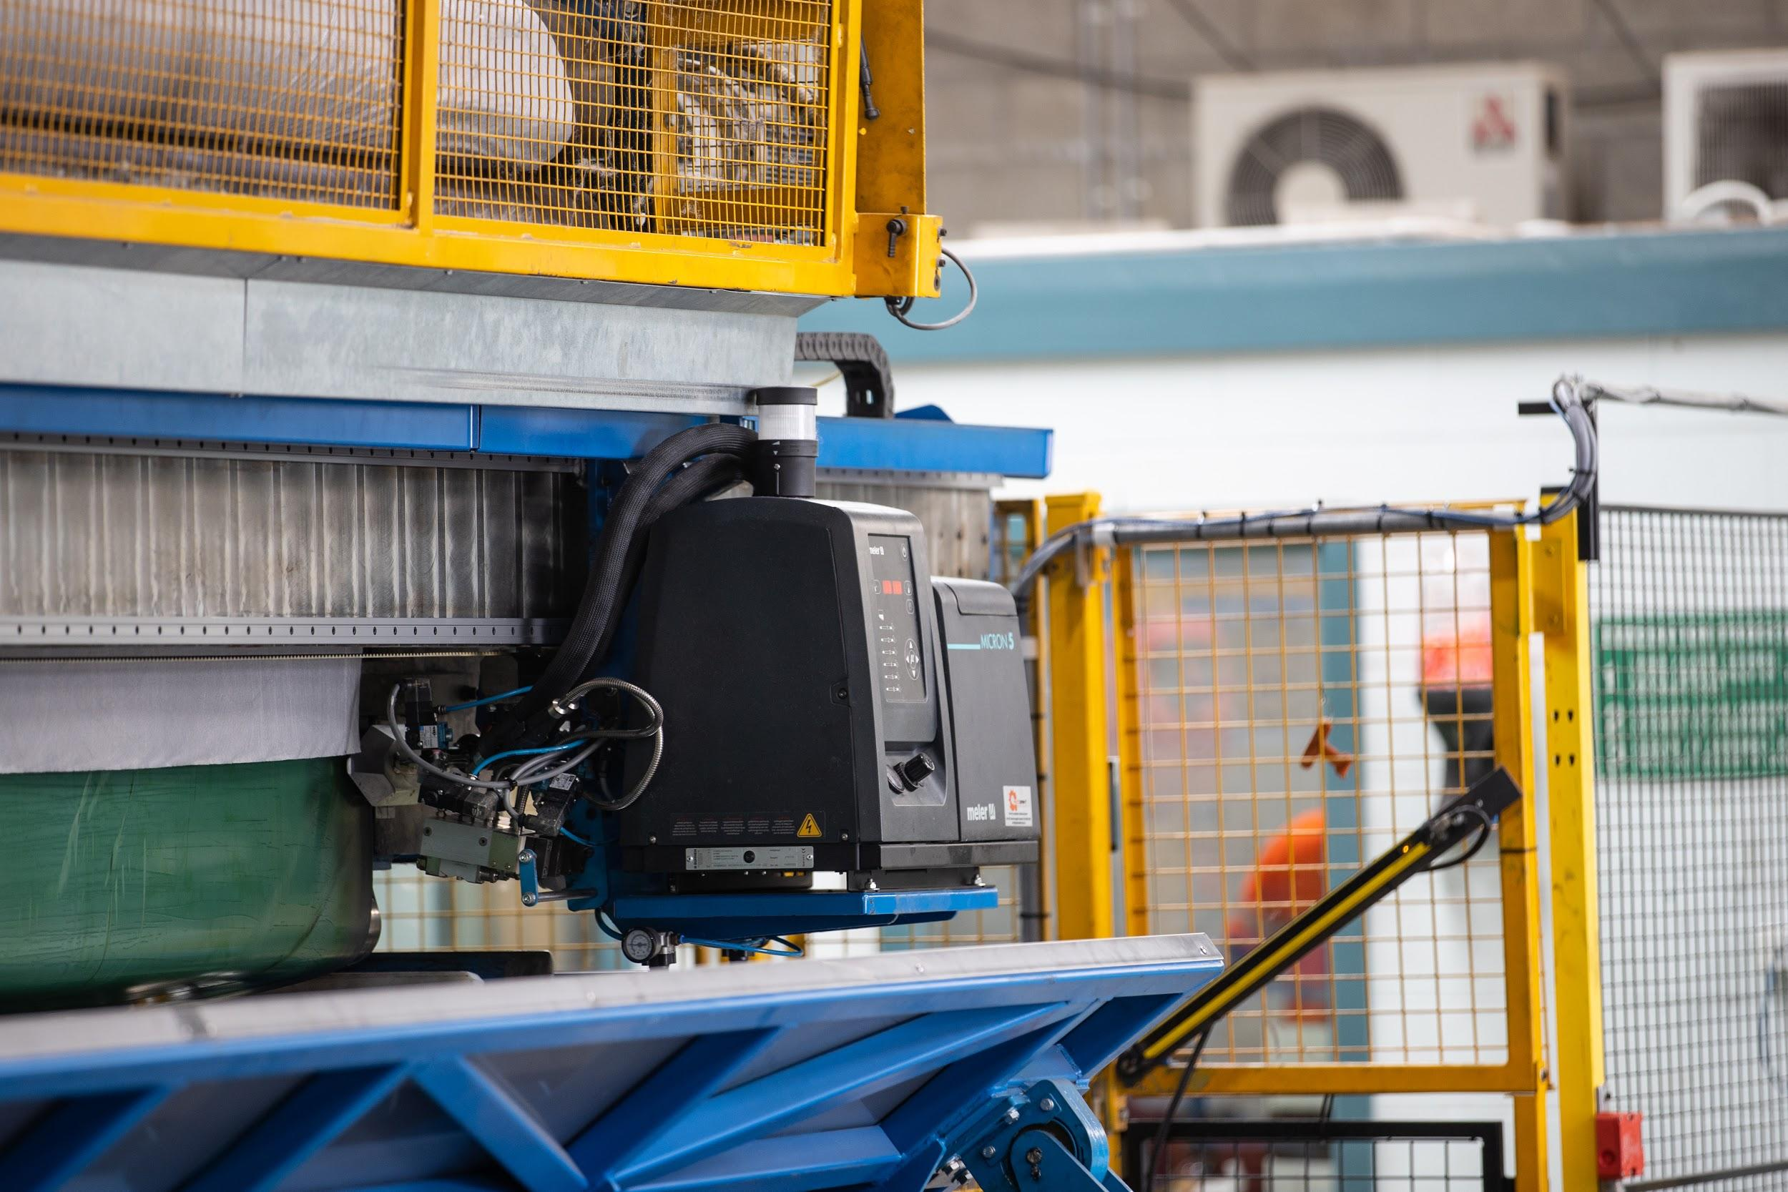
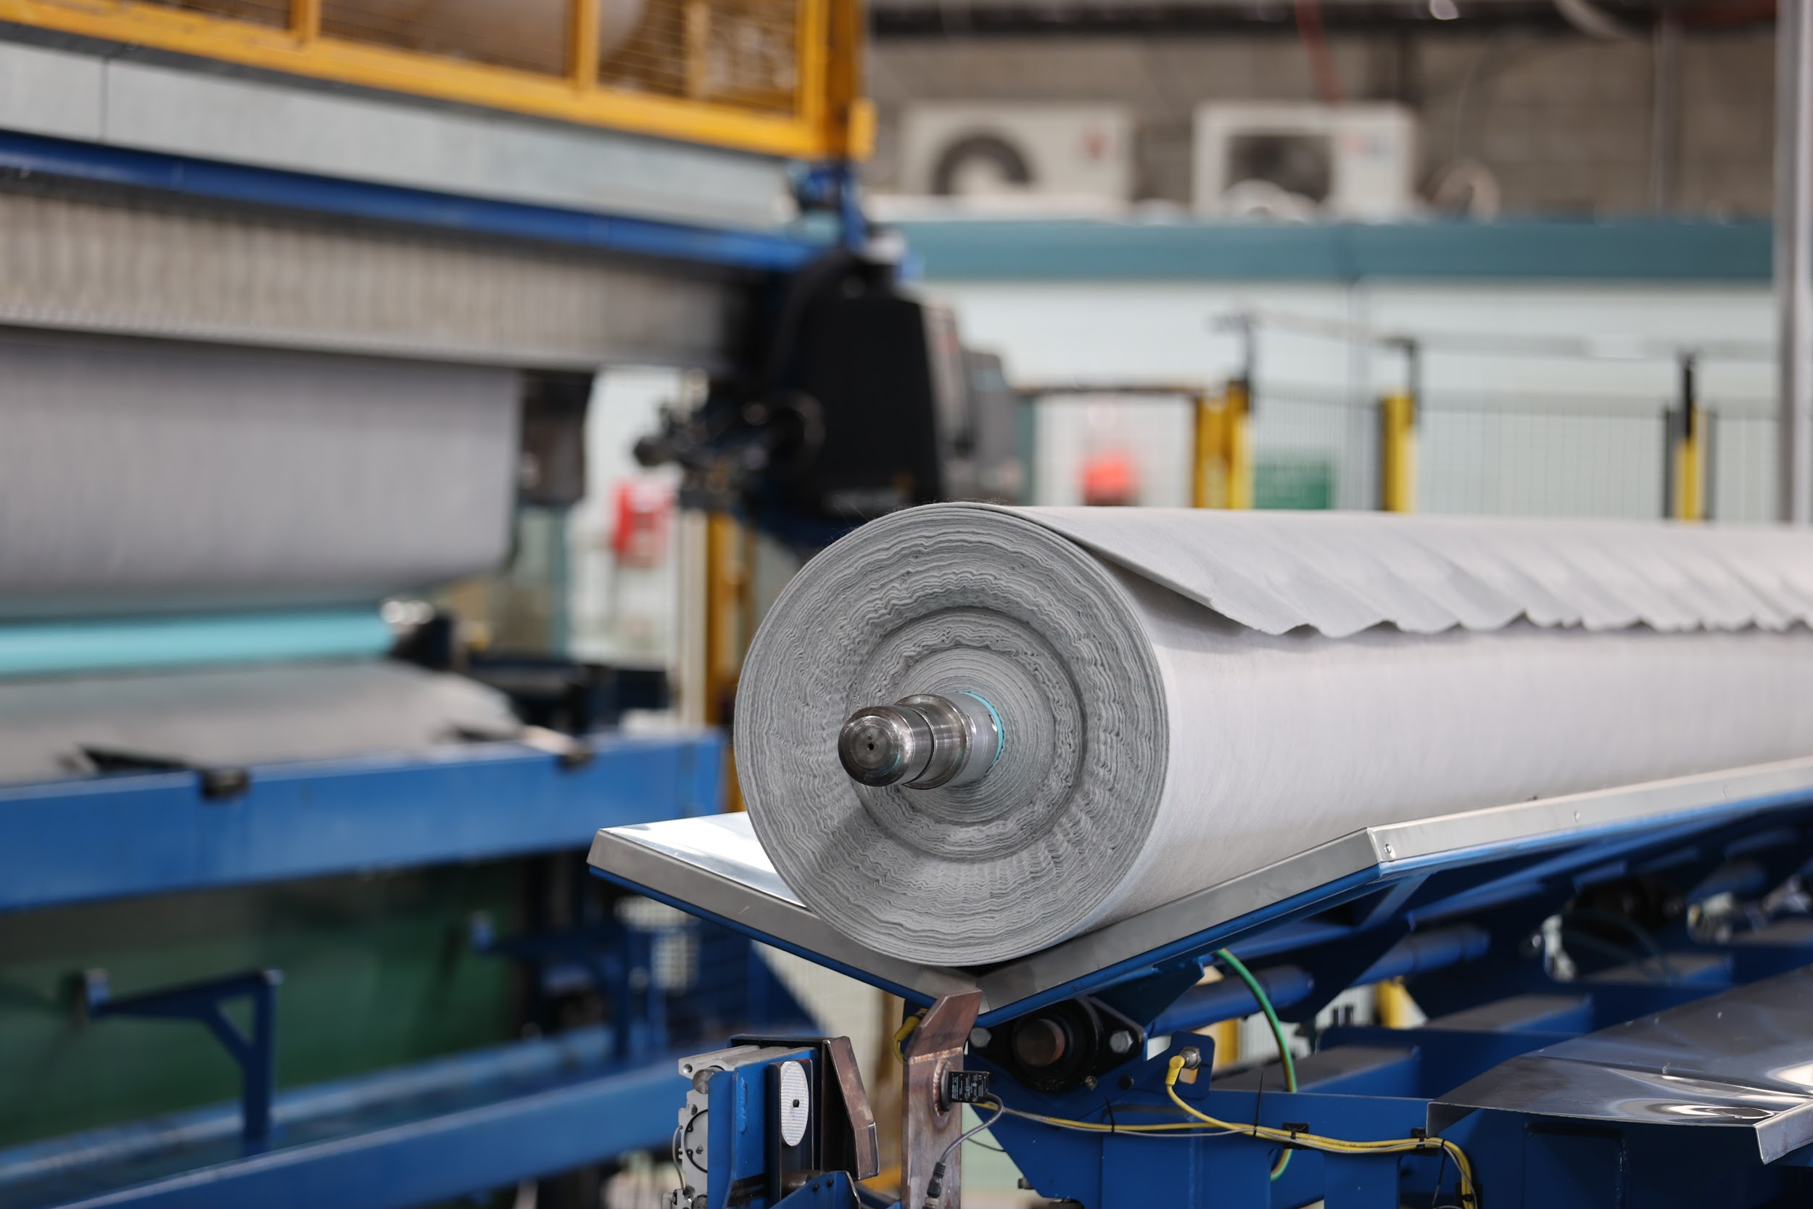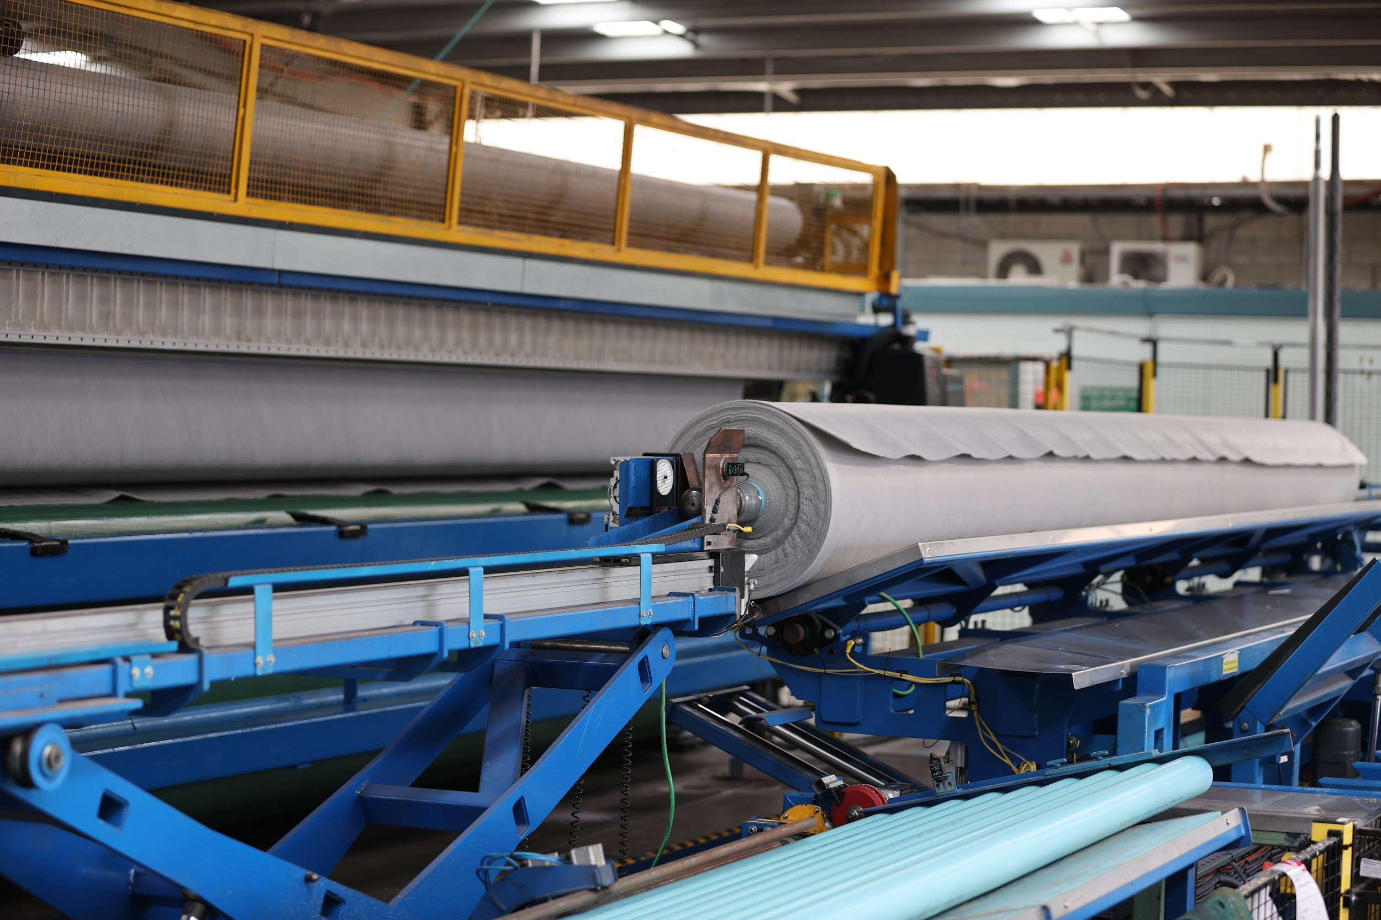
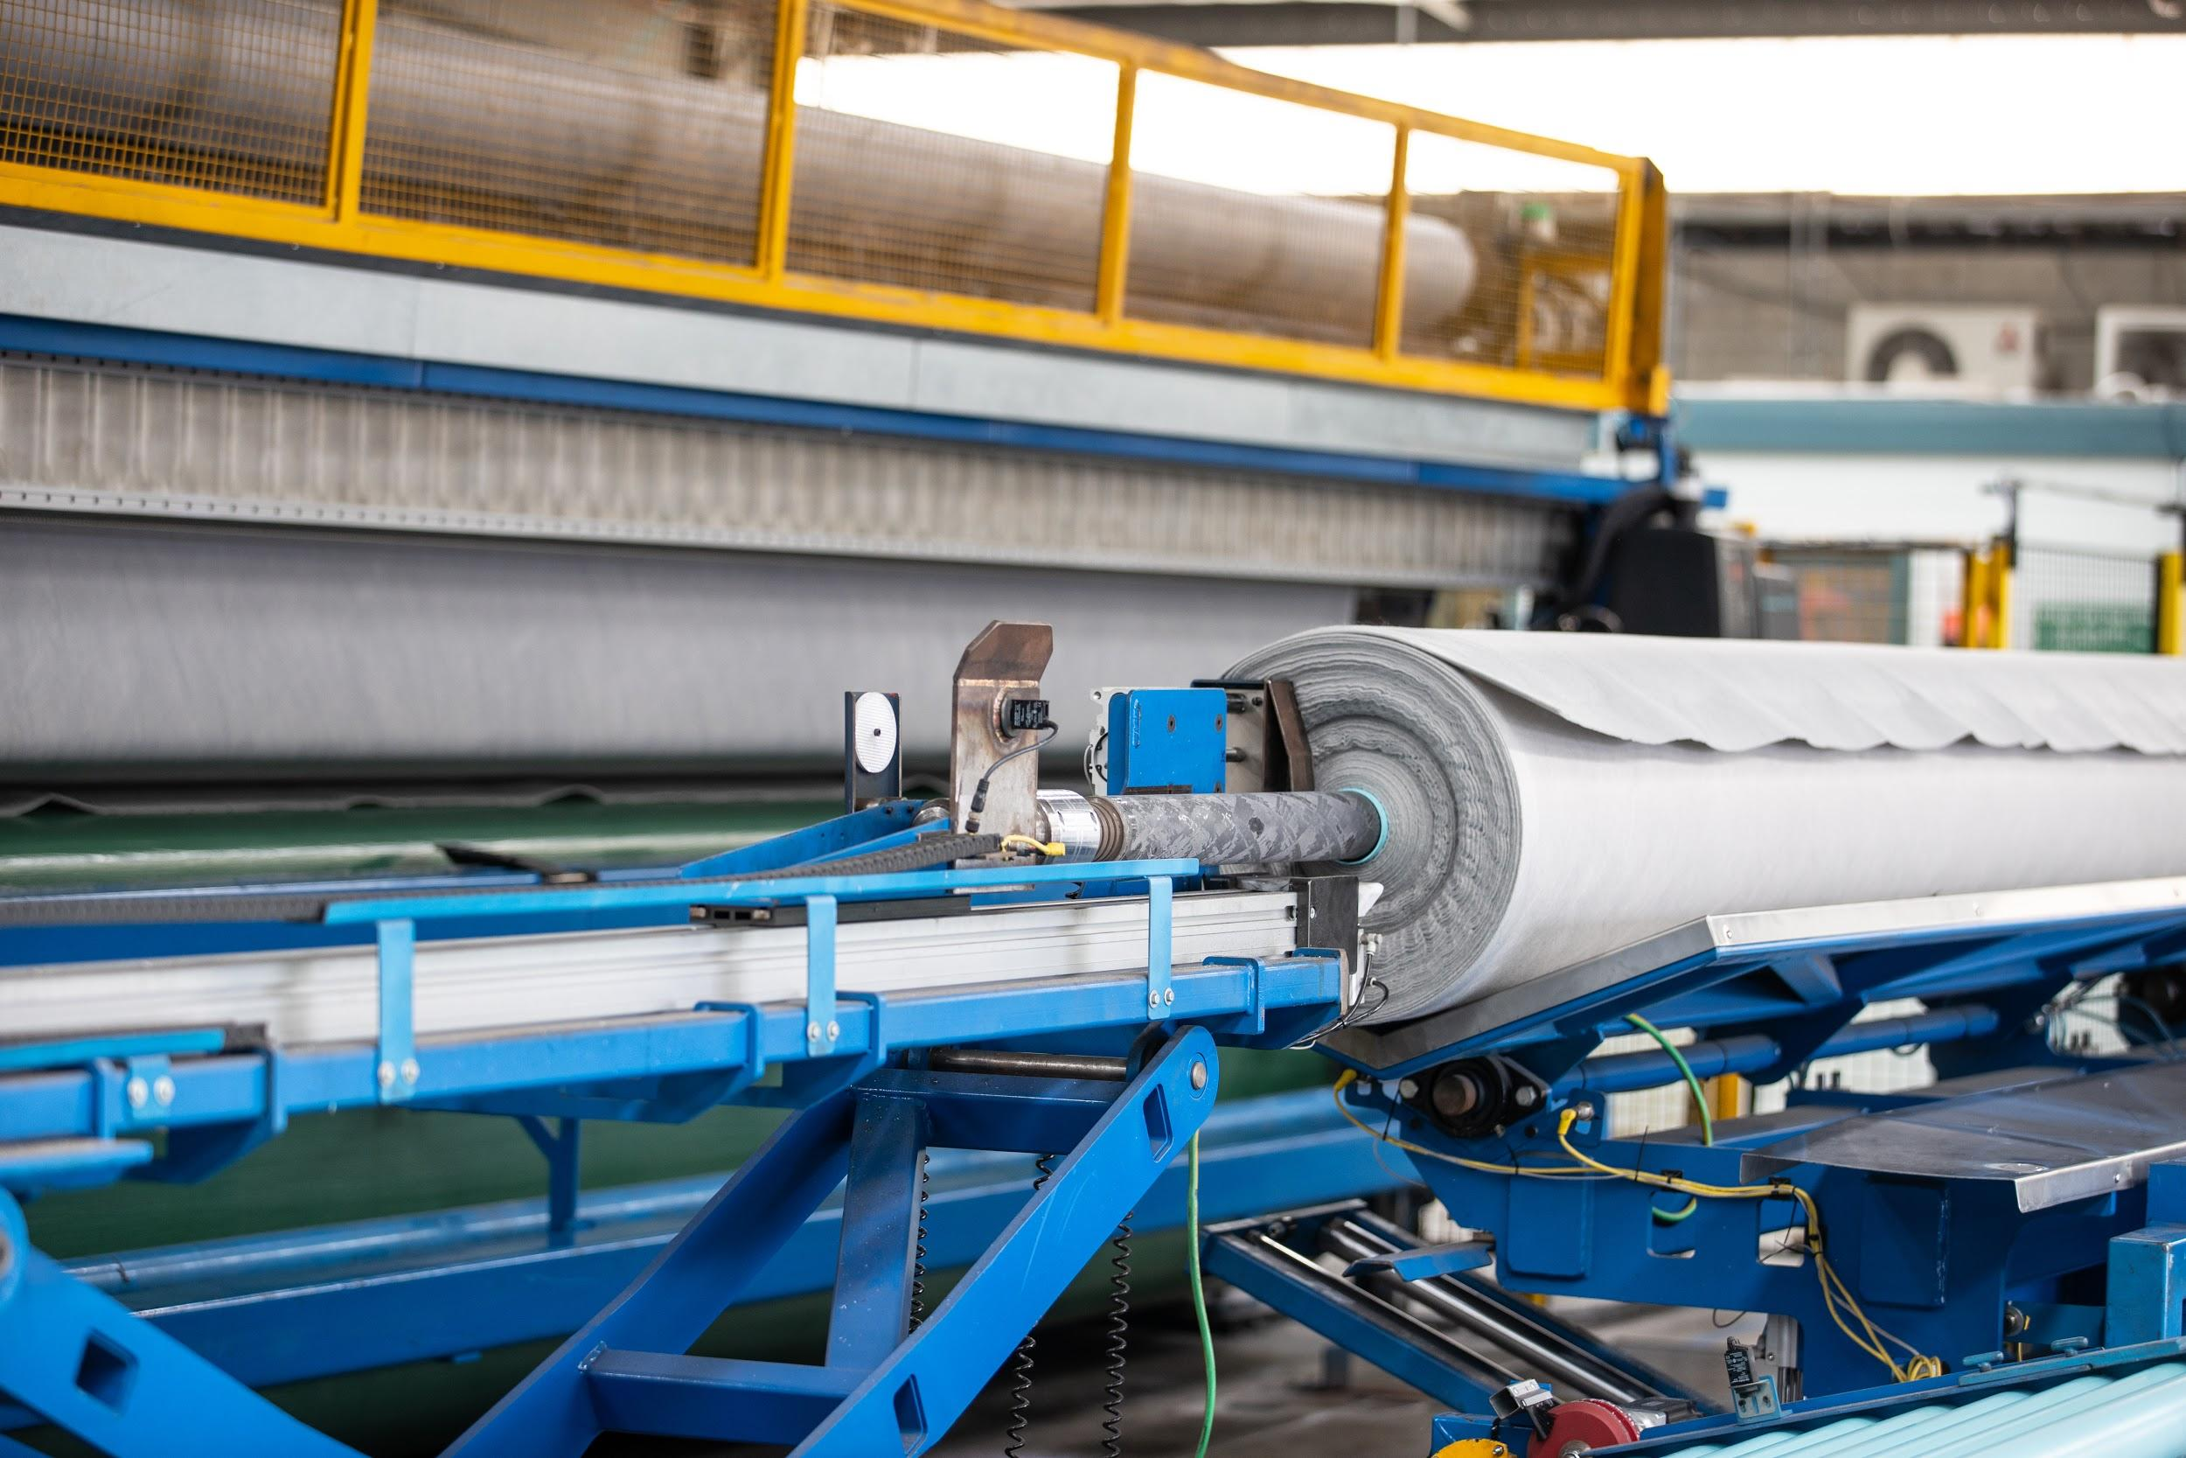
Caption: Compressed air is an essential utility required to operate many functions at Geofabrics - pictured here some end of production line machinery

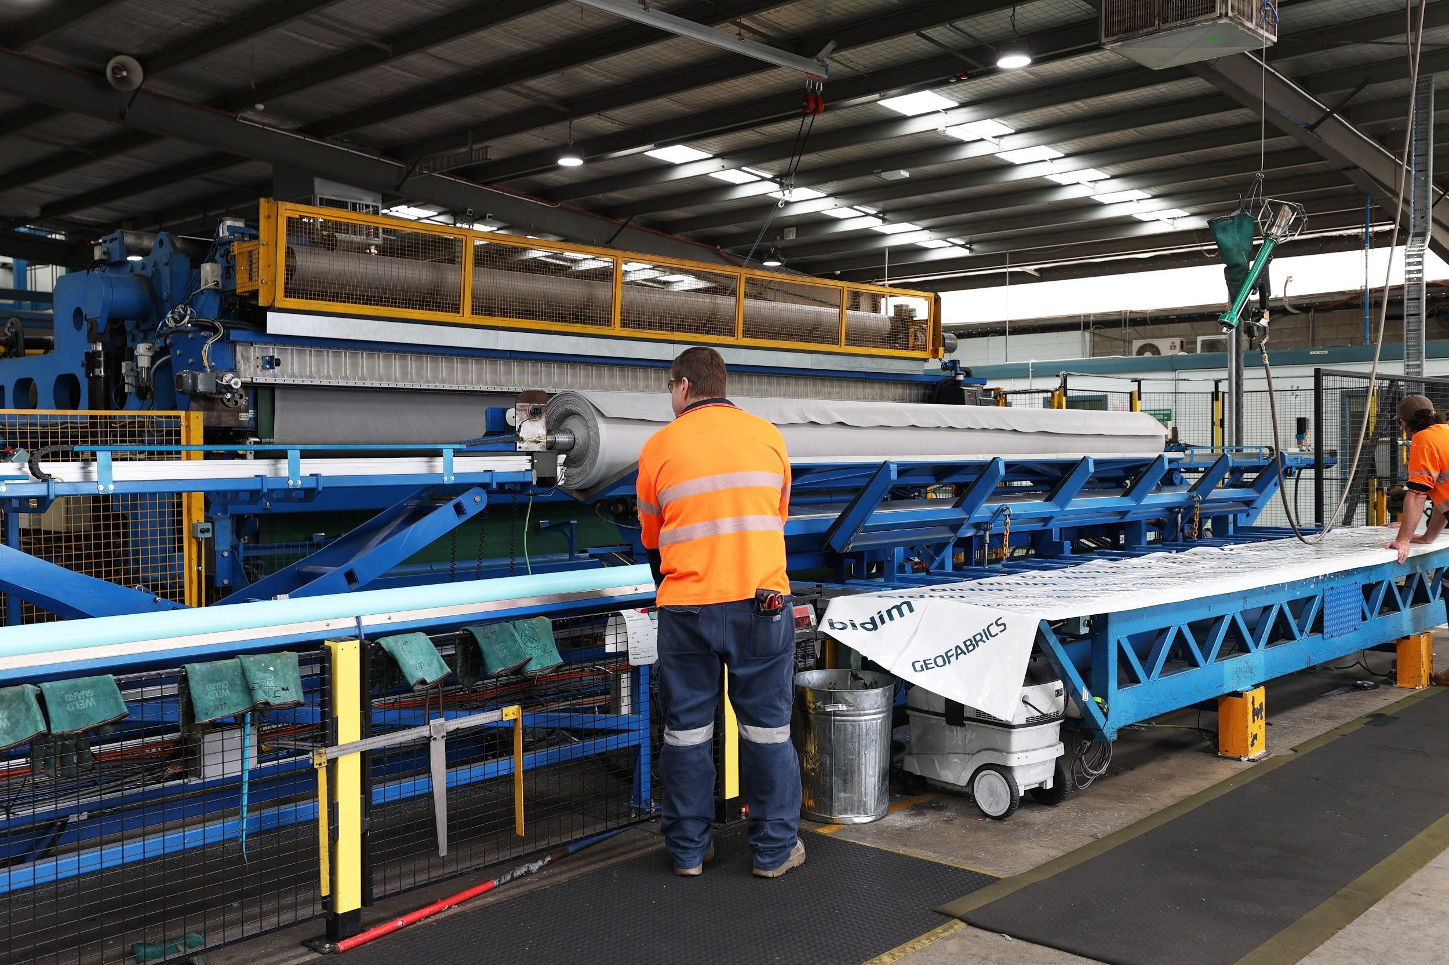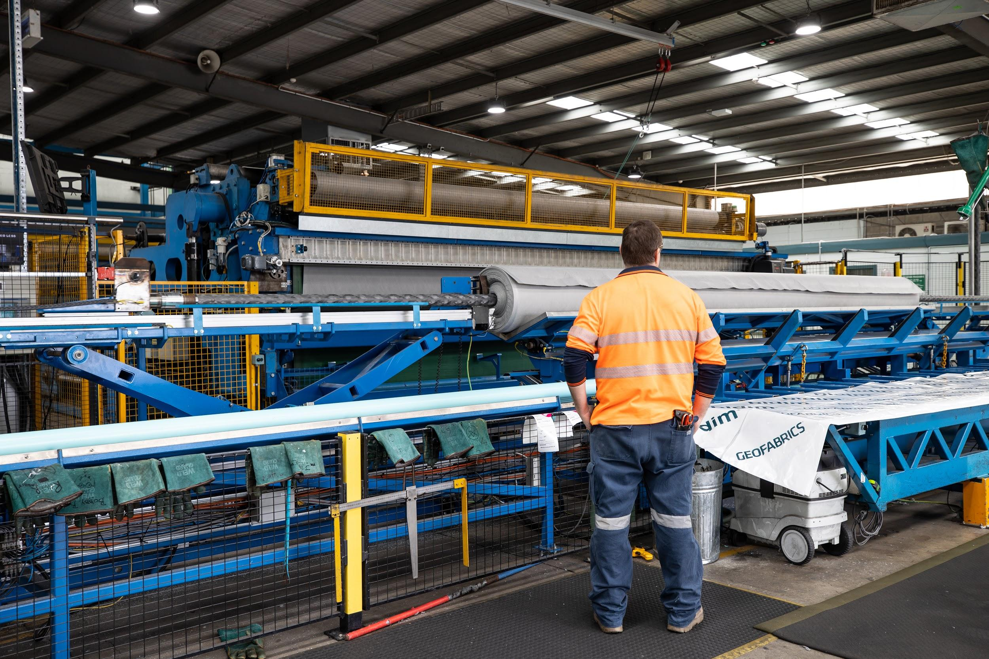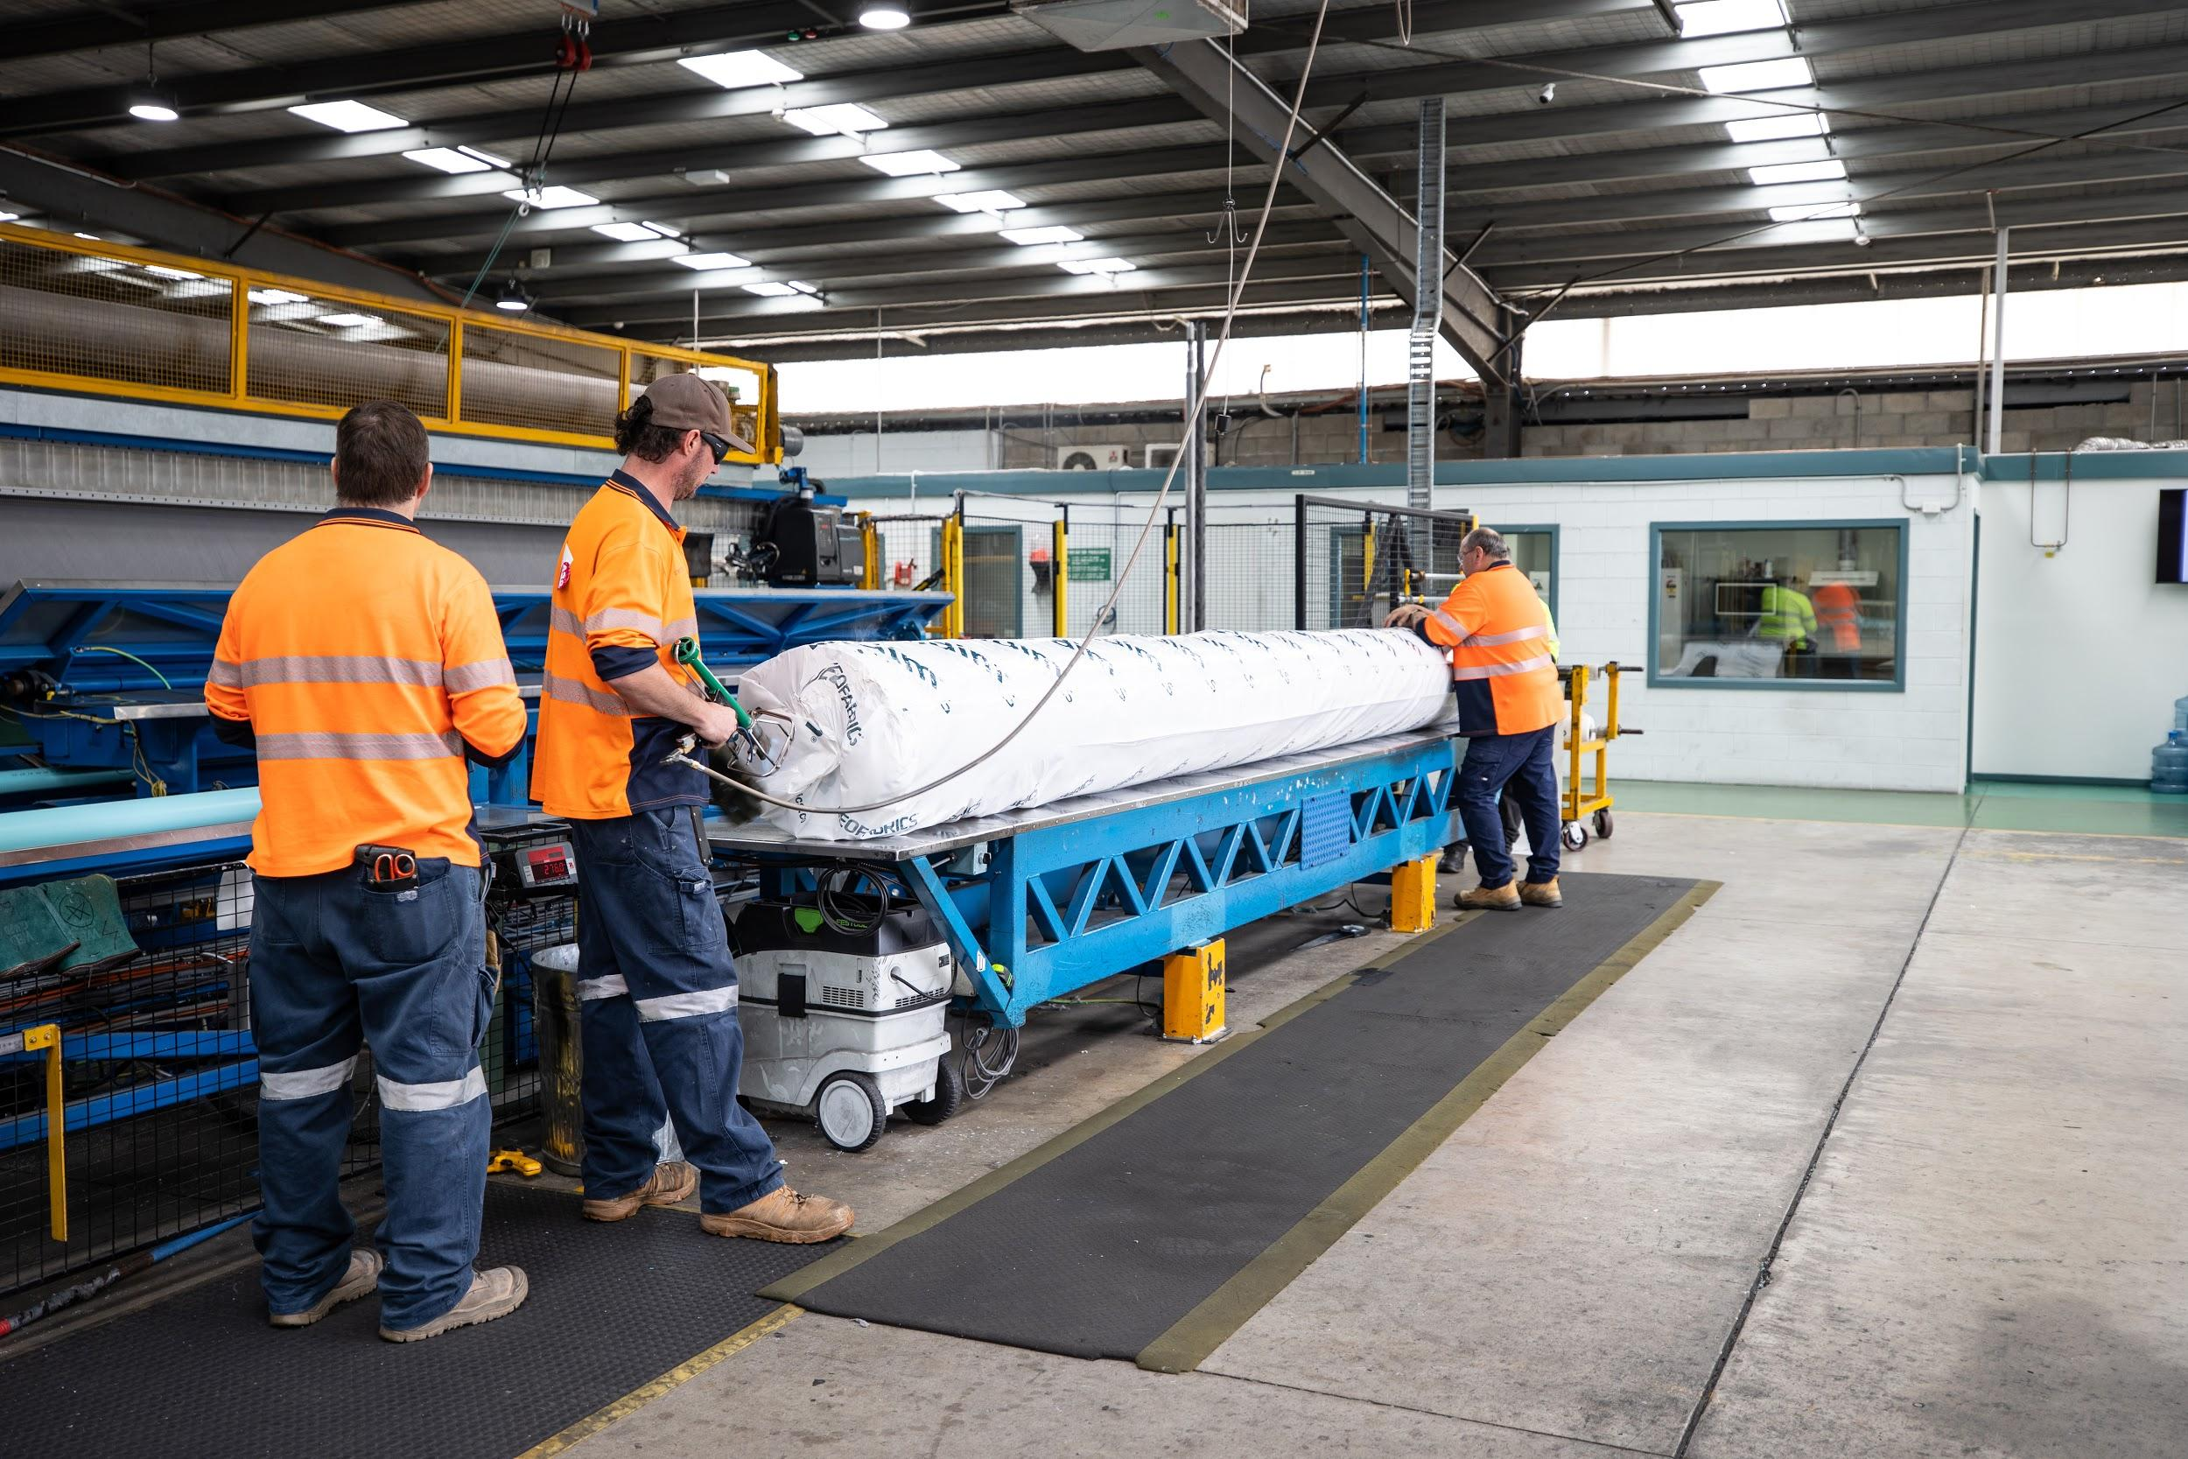
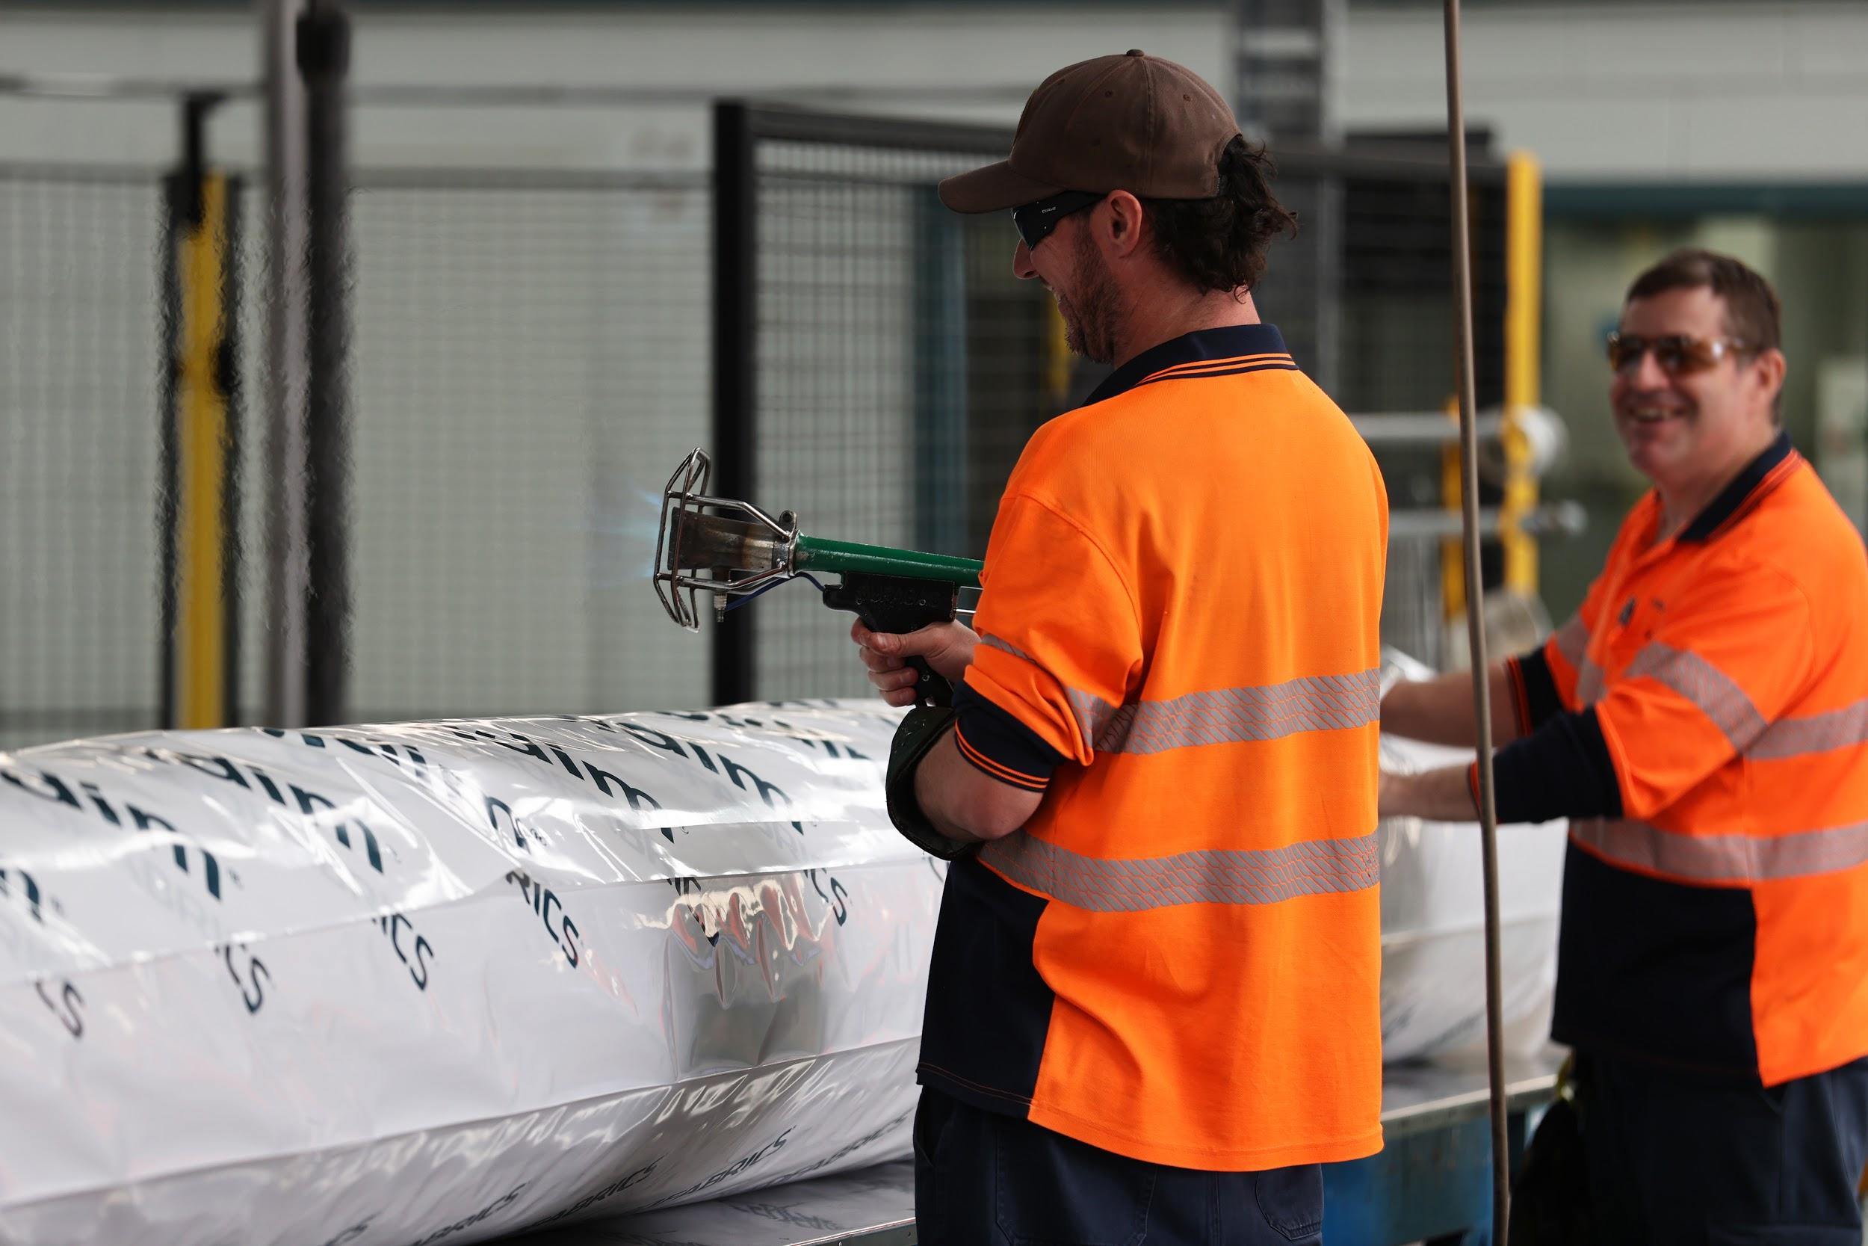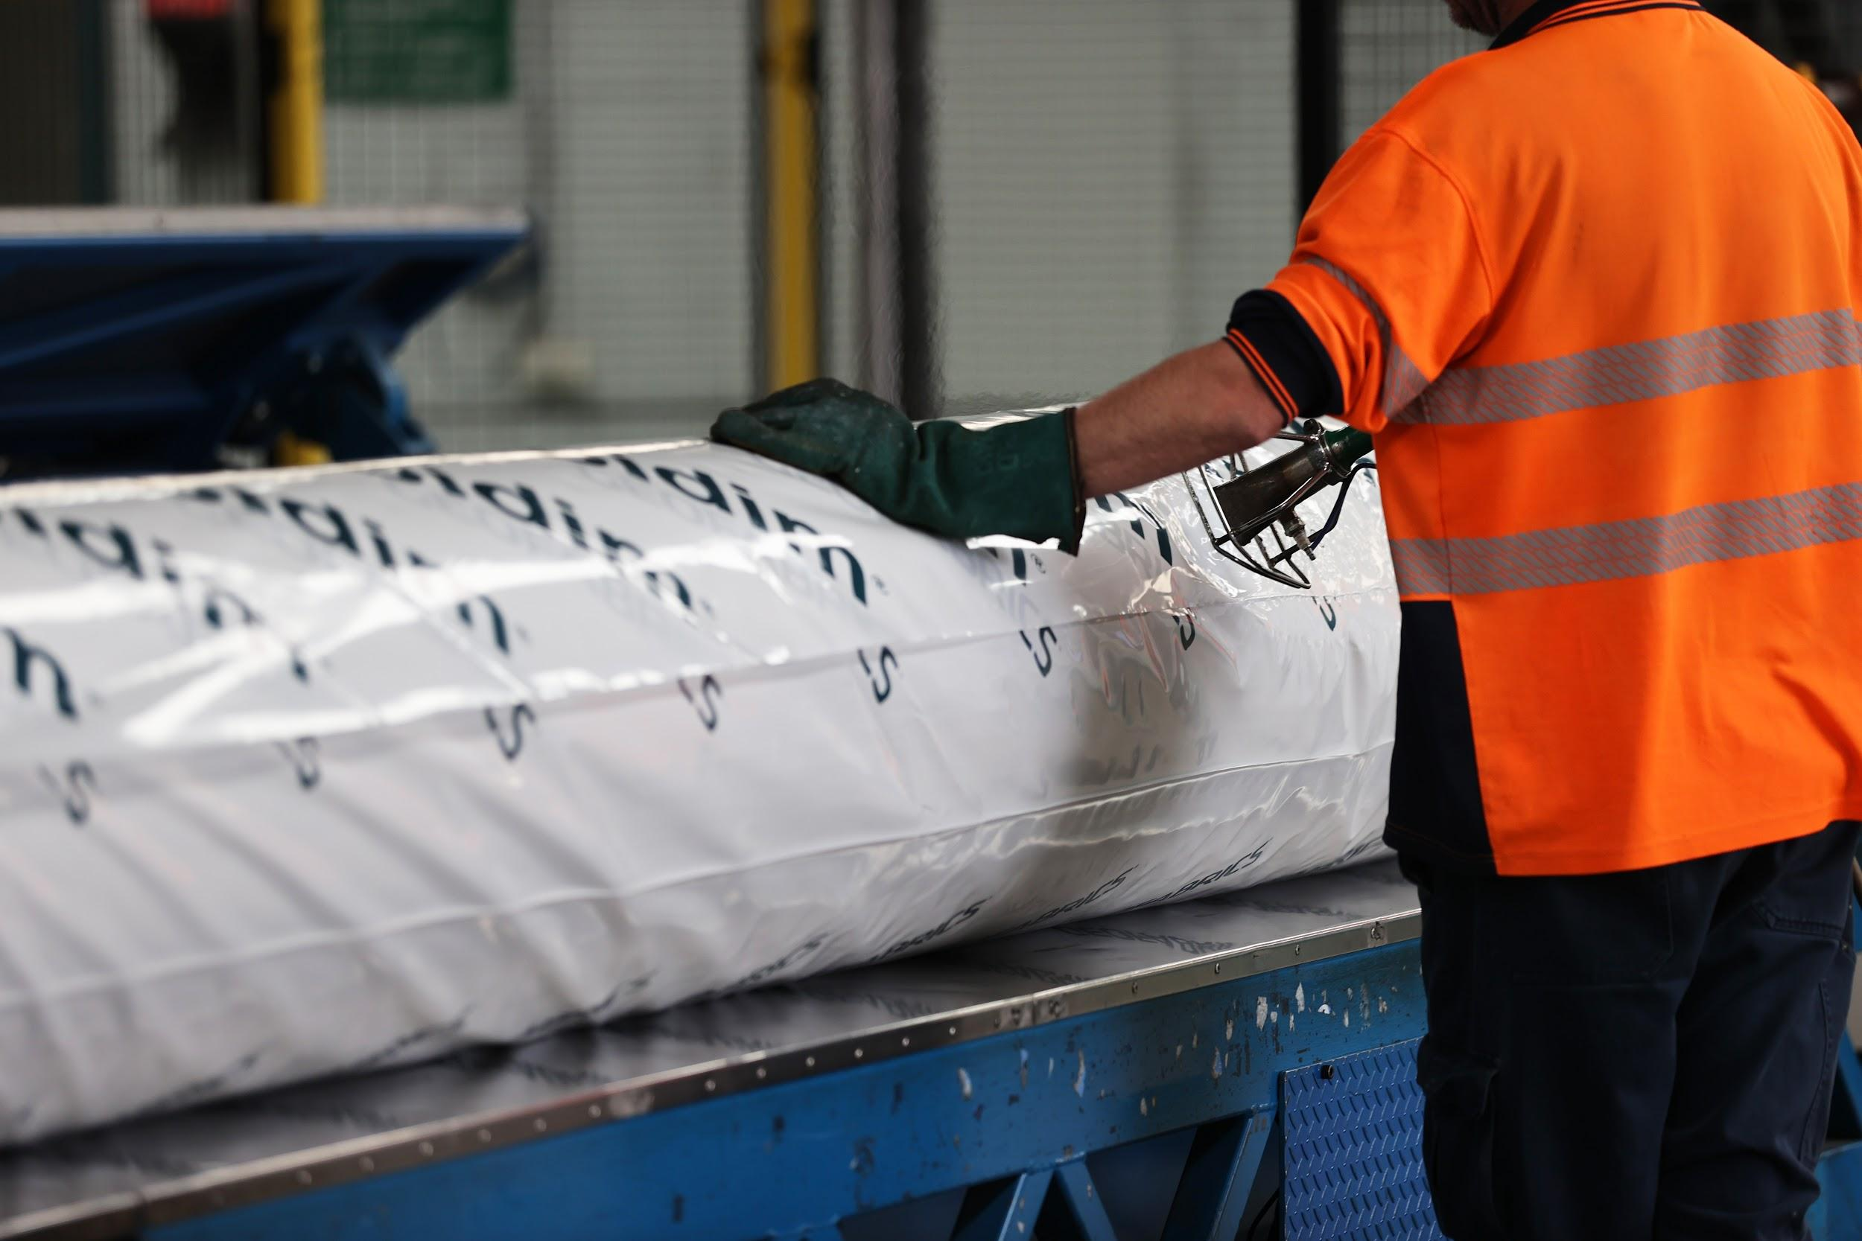
Caption: Compressed air is an essential utility required to operate many functions at Geofabrics - pictured here the end of line machinery and packaging of the final products

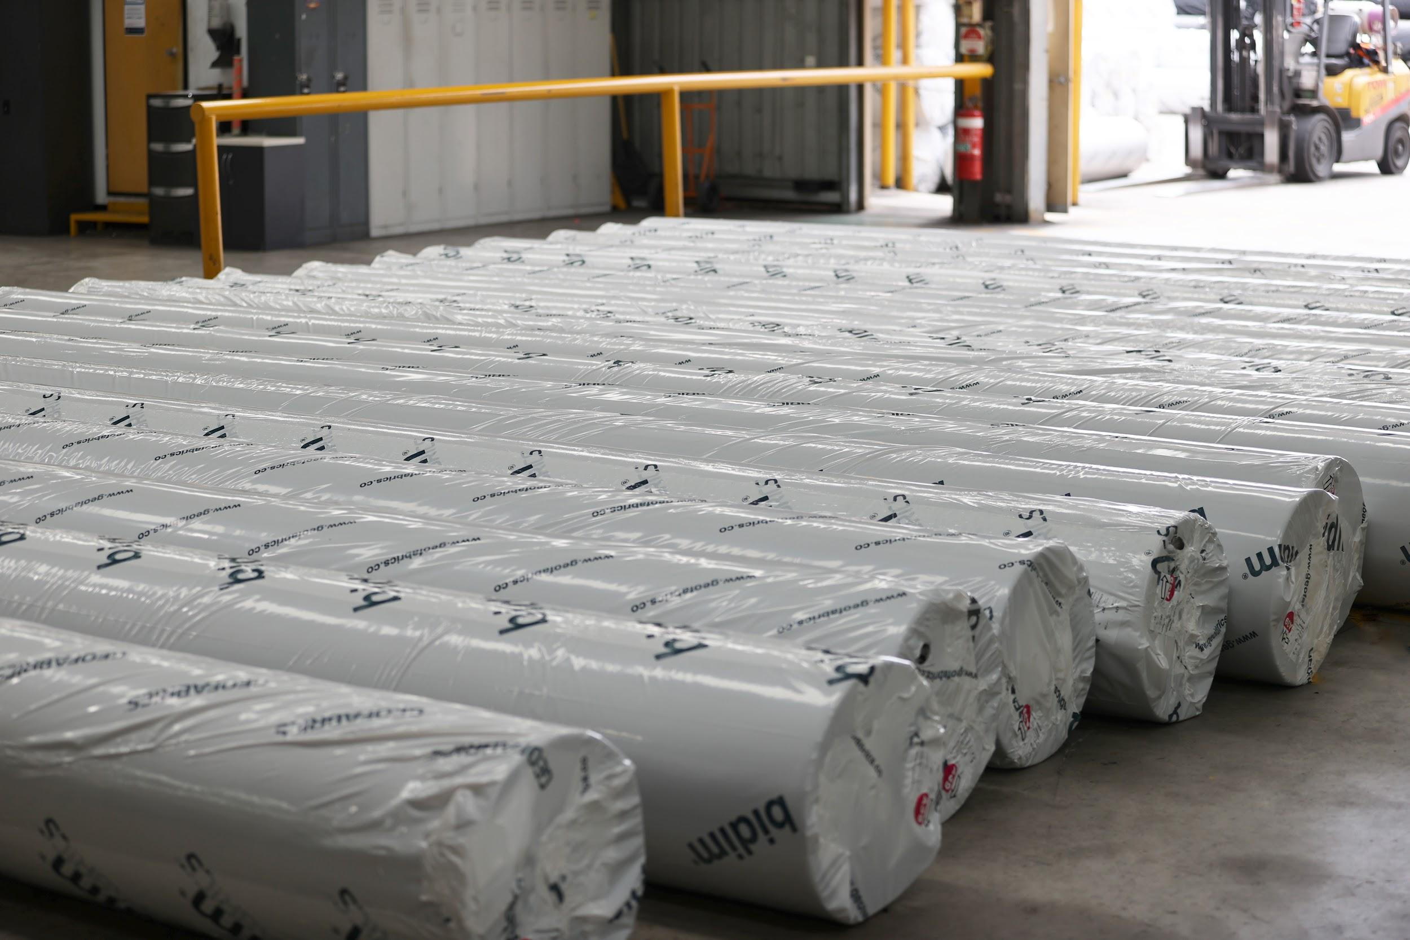
Caption: Geofabrics’ products are a key component in building Australia’s critical infrastructure. Pictured here, some end product wrapped and ready to be despatched.
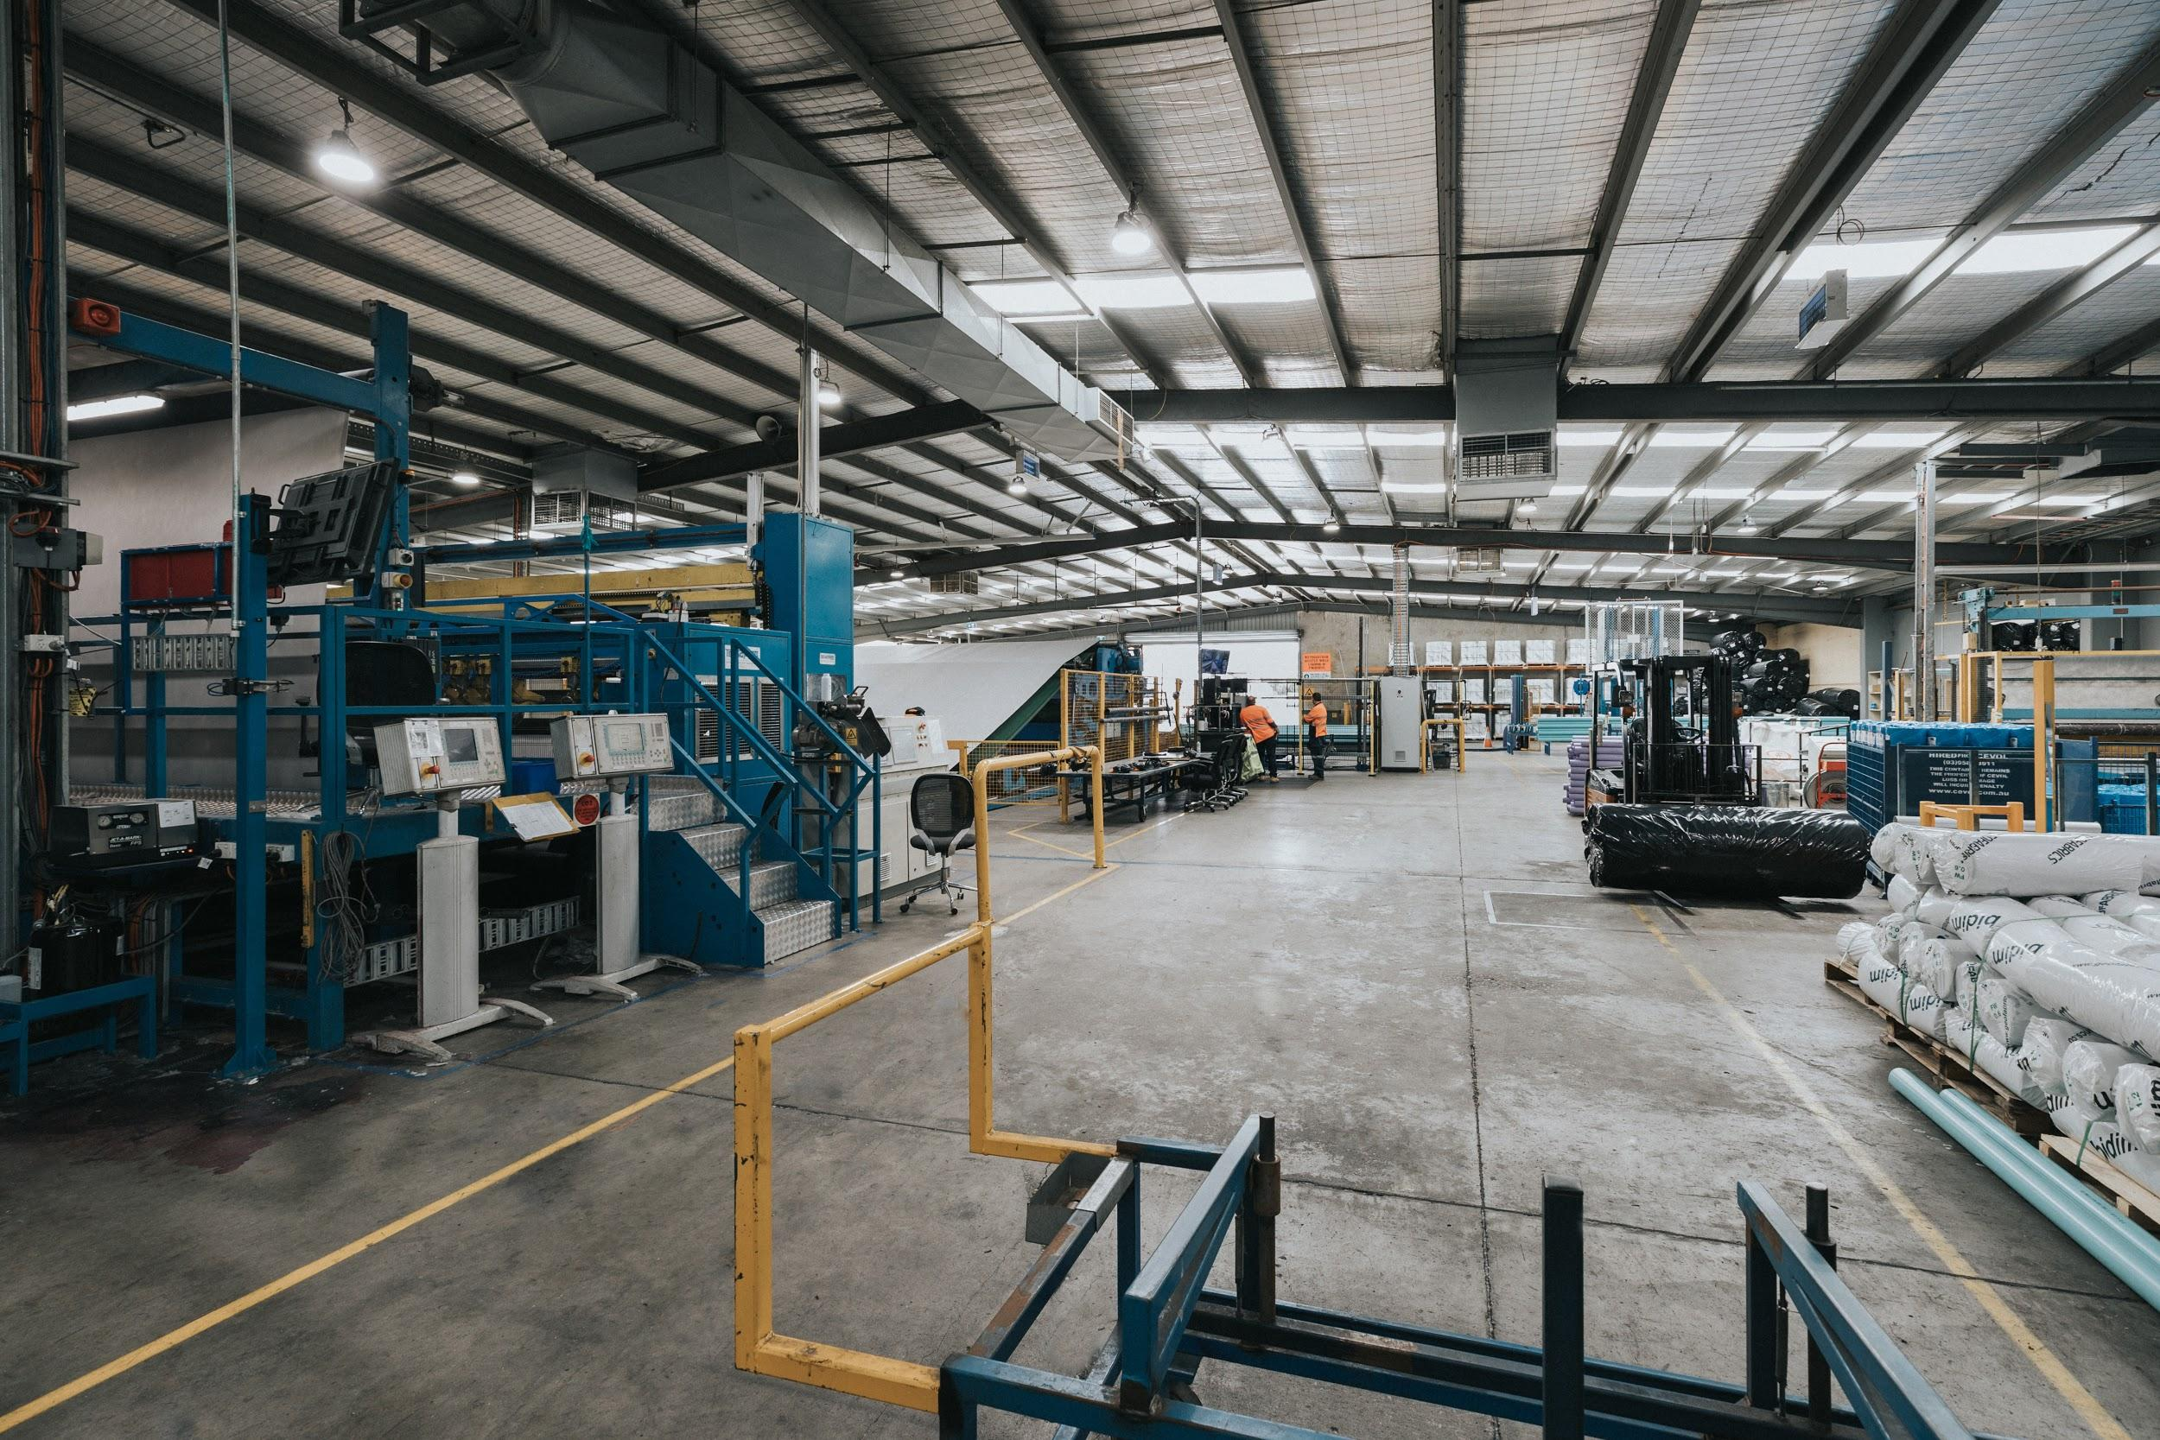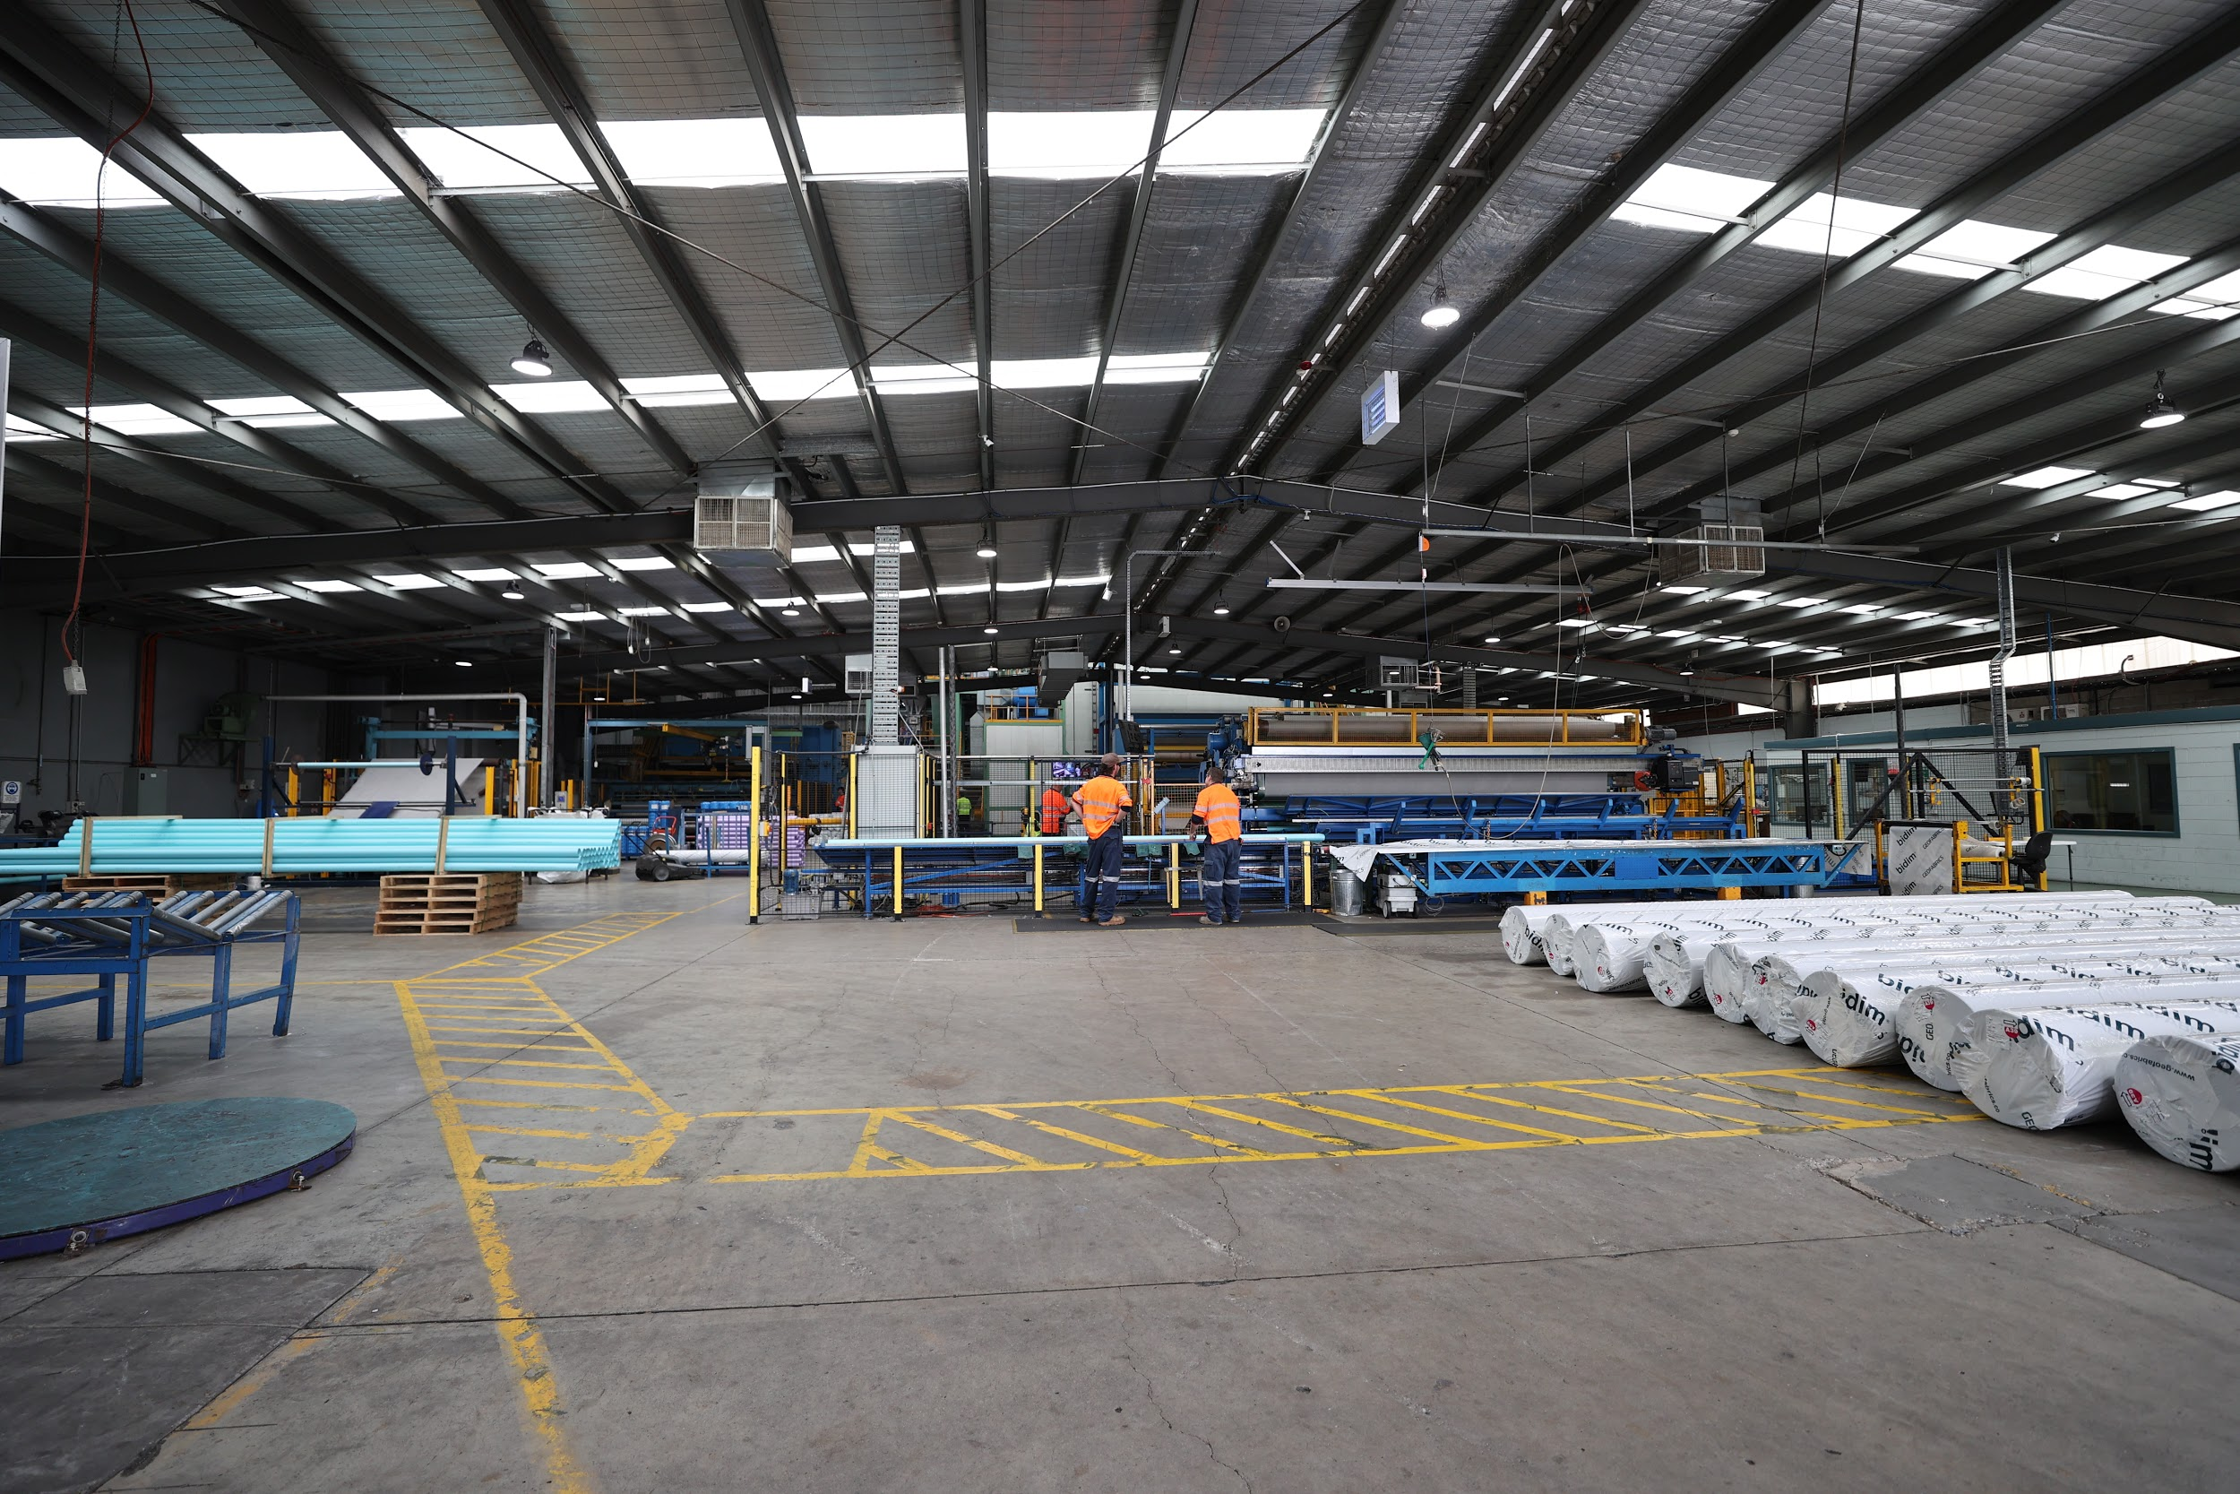
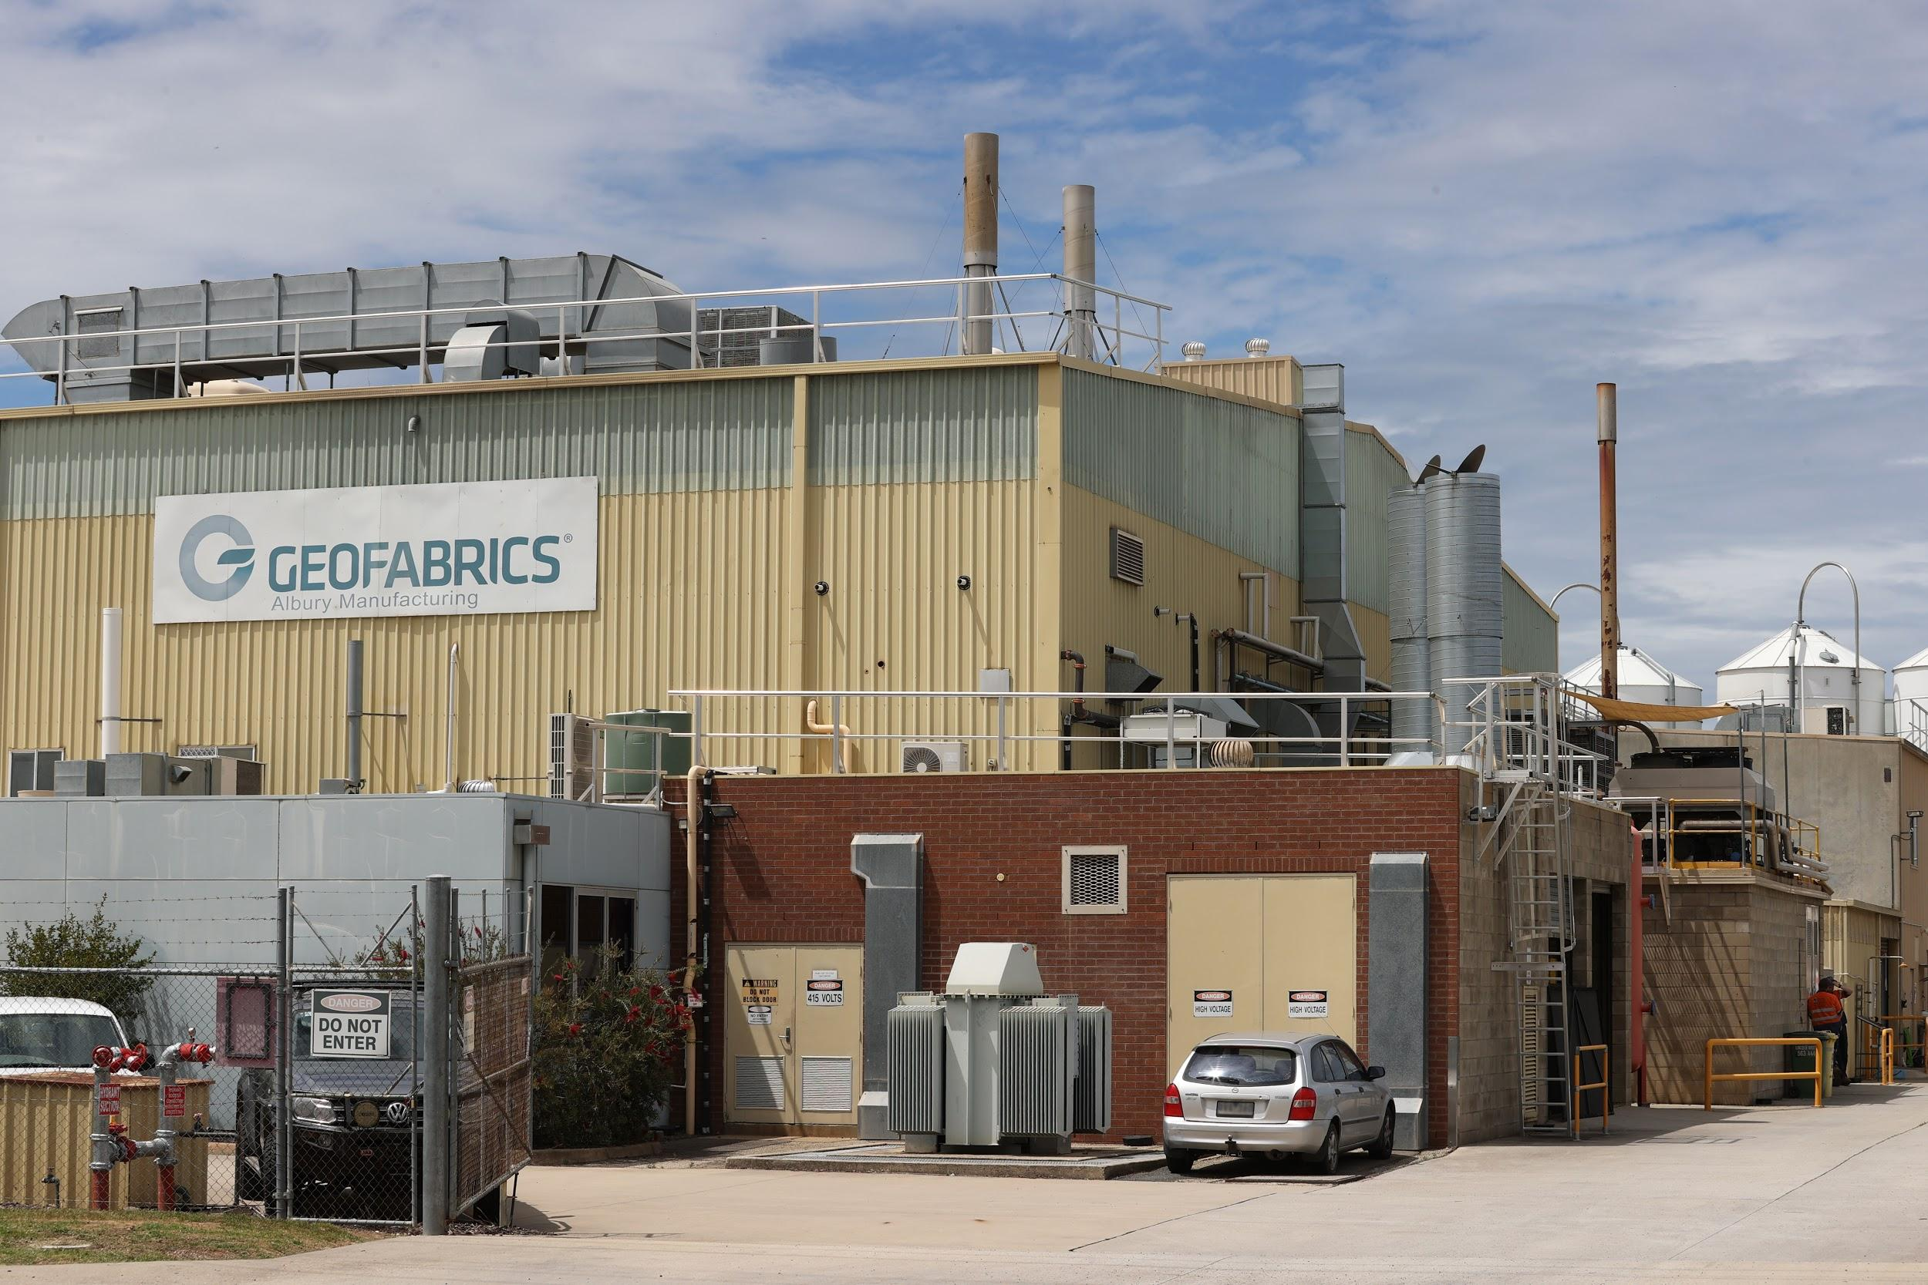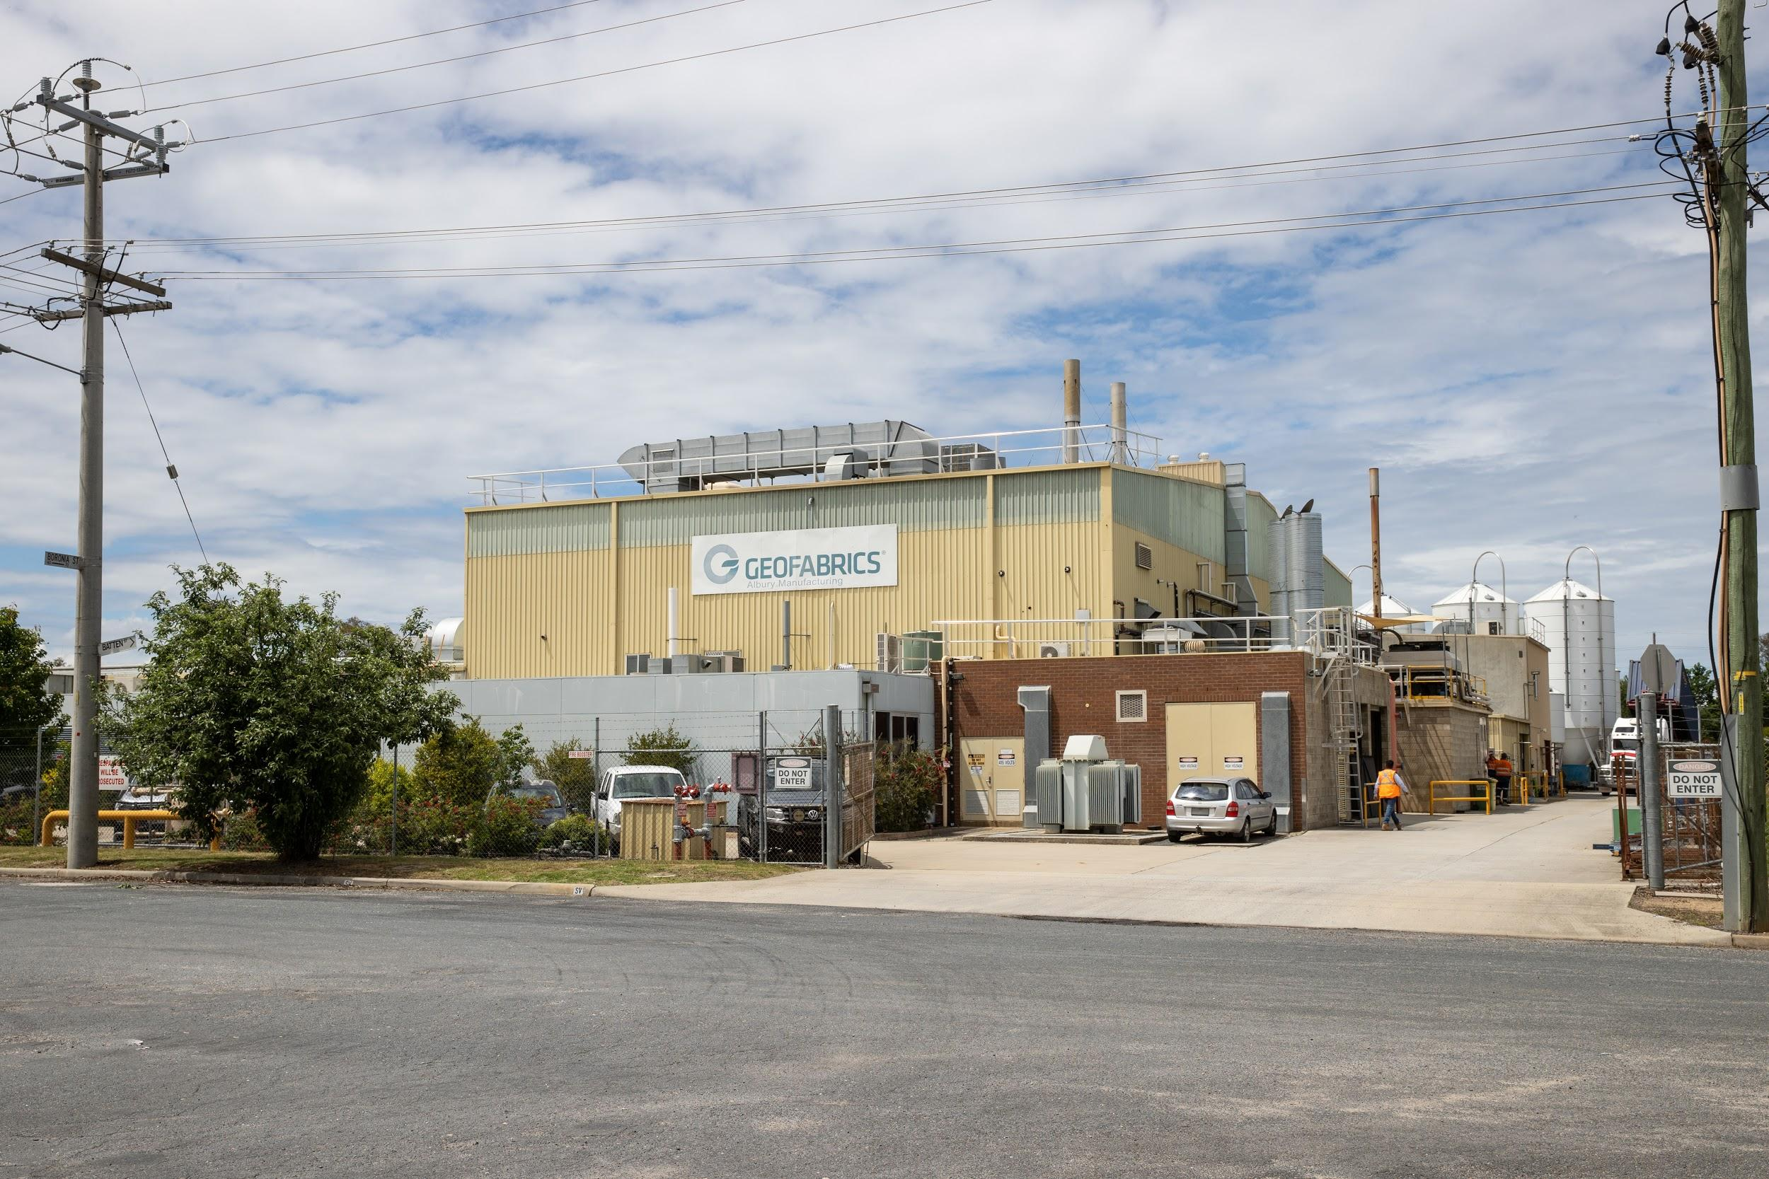
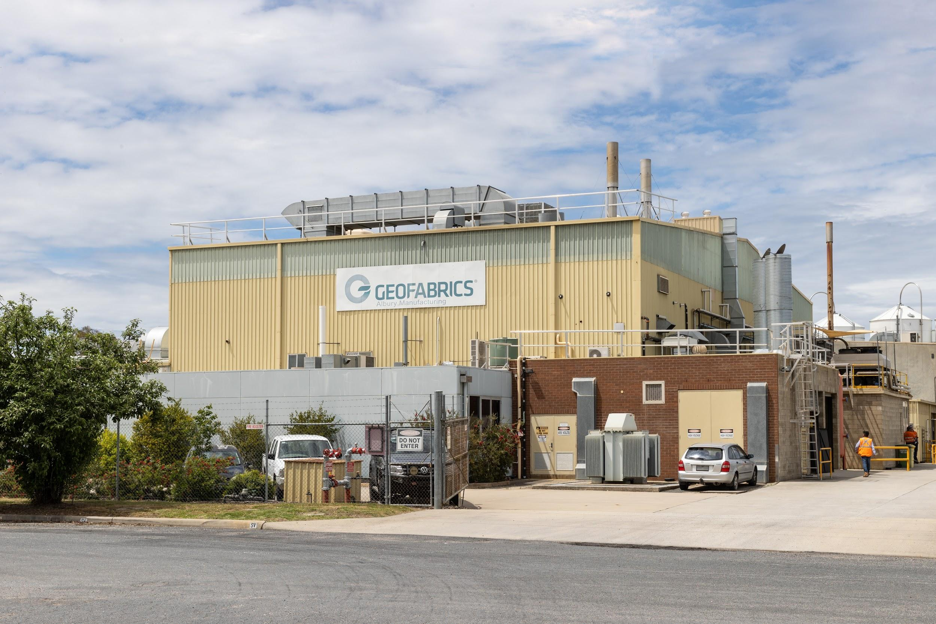
Caption: Geofabrics Australasia is Australia’s largest manufacturer and supplier of a range of highly engineered geosynthetics for the building and infrastructure sector. Pictured here the manufacturing plant in Albury, Australia.

Kaeser photo(s) – free for publication.

