August 2020

Pure efficiency:
Kaeser expands it range of rotary screw blowers

Kaeser Compressors has recently expanded its range of EBS series rotary screw blowers with the launch of the EBS 410 models. Designed especially with water industry applications in mind, these new models represent a milestone in the development of oil-free compression blower technology.

With a flow rate of 10 - 40 m³/min and pressure differentials from 0.3 to 1.1 bar, as well as a selection of motors ranging from 22 to 75 kW, the new and innovative EBS 410 series rotary screw blower models set new standards in terms of energy efficiency, space-saving design and automation;

More efficient than ever before, the standard ‘STC’ version is now equipped with an energy-saving IE4 super premium efficiency motor that reduces energy consumption and therefore costs. Kaeser is currently the only compressed air systems provider to equip its compressors with super premium efficiency IE4 class motors.
The ‘SFC - Sigma Frequency Control’ version is equipped with a frequency converter and a synchronous reluctance motor – a slip-free design that combines all the advantages of high efficiency permanent-magnet motors with those of robust, service-friendly asynchronous motors. Thanks to variable speed control, the flow rate can be adjusted as required and a control range of 1:4 is achieved, which allows exceptionally dynamic operation and optimum efficiency.
With both versions, power transmission from the motor to the airend takes place via loss-free and maintenance-free gearing, which results in an up to 8 percent improvement in specific power compared to the previous model. The complete machine achieves an isentropic efficiency of up to 80 percent, representing the pinnacle of performance for oil-free compression machines. In order to ensure that the specified performance figures are translated into reality, Kaeser guarantees performance in accordance with the strict tolerances of the ISO 1217-C/E standard.
Furthermore, efficiency remains constant across the entire control range and flow rate is virtually unaffected by pressure fluctuations. This allows the blower to be precisely regulated and adjusted at all times via the master control system. This achieves even greater energy savings and also ensures effortless integration with other control technologies.

These new models come in two different sizes – up to 37 kW and 75 kW respectively. They not only stand out on account of their attractive, contemporary design, but they can also be installed side-by-side, leading to considerable space savings and ease of maintenance. The 37 kW version in particular is impressively compact, with a footprint of only 2.2 m².

The EBS 410 series rotary screw blowers are delivered ready for immediate connection, including controller and frequency converter, or star-delta starter. All units are CE and EMC-certified, thereby minimising the planning, construction, certification, documentation and commissioning costs for planners, operators and plant manufacturers. Last but not least, highly effective sound and pulsation damping ensure exceptionally quiet operation. For more information visit nz.kaeser.com or phone 0800 447 820.
-END- Free for publication, copy appreciated
Editors Notes
From 0.18 to 515 kW, Kaeser Compressors manufactures a wide range of compressors and associated auxiliary equipment that meet the varying requirements of a diverse range of industries and applications.

One of the world’s largest manufacturers of rotary screw compressors, Kaeser Compressors is represented globally in over 100 countries through a dedicated network of branches, subsidiary companies and authorised partners.

Kaeser Compressors NZ Limited provides comprehensive air compressor and blower sales and service throughout New Zealand from its offices in Auckland, alongside a dedicated and nationwide network of authorised partners.

For editorial and advertising enquiries contact: Beth Wood, Marketing Manager
Press office: +61 3 9791 5999 Fax: +61 3 9791 5733
E-mail: beth.wood@kaeser.com

KAESER COMPRESSORS NZ Limited
18B Tarndale Grove, Albany, Auckland 0632, New Zealand
Phone: +64 9 941 0499 Email: info.newzealand@kaeser.com
nz.kaeser.com
Kaeser photo(s) – free for publication, credits appreciated.

File: H-EBS-410-nz
Approved for publication, copy acknowledgement appreciated
Images:
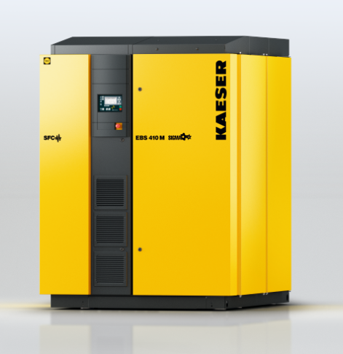
Caption: The EBS series rotary screw blowers are true standouts with their high efficiency and compact design.
Kaeser photo(s) – free for publication.

