October 2021

Hot off the press!
Reducing carbon emissions with Stuff

New Zealand’s leading media organisation Stuff, is on track to see a 40 percent reduction in compressed air associated power consumption at its Petone Print Plant.
This is being achieved by implementing recommendations provided from auditing the compressed air system including; upgrading compressed air equipment, adding an Industrie 4.0-ready compressed air management system and implementing an air leak management programme.

Stuff Limited is New Zealand’s leading media organisation. Many Kiwis will know it well for its flagship news website stuff.co.nz. However Stuff also owns and prints a large portfolio of New Zealand’s best-loved magazines and newspapers. This includes national, metropolitan and regional newspaper titles, including the Sunday Star-Times, the Press and The Dominion Post.

Stuff prints its newspapers and magazines across two print plants located in Petone and Christchurch. Both plants are continuously striving to improve processes and technology to reduce the impact they have on the environment. This is part of the company’s wider commitment to being a sustainable business. Part of this commitment includes reducing its emissions. Stuff became a signatory of the Climate Leaders Coalition in 2017, and in 2019 set an ambitious target to reduce its scope 1 (fleet fuel) and scope 2 (purchased electricity) emissions by 25% by 2025.

The print plants have already made great headway in contributing to these targets, and they were recently recognised for their efforts, winning a ‘Kodak Sonora Plate Green Leaf Award’ in 2019. This award recognised their world-class environmentally friendly initiatives and projects undertaken to reduce energy consumption.

Compressed air system audit reveals energy savings potential
A key focus for the Petone print plant in the past year has been its compressed air system. Compressed air is an essential utility used to power around 80 percent of all the machinery onsite. This includes the very large multi story print press that produces the majority of newspapers published by Stuff.
When the dryer in the existing compressed air system failed, the exorbitant price to replace it - along with the extremely high service costs to maintain the system as a whole - led them to investigate the site's compressed air requirements, in order to establish potential alternative compressed air supply solutions. Appreciating that compressed air is also one of the largest consumers of electricity on a plant, Brendon Tarrant, the Engineering Manager at Stuff was keen to see if energy savings could be made.

To understand the site's precise compressed air demand, Tarrant engaged an energy consultant, who data-logged the entire compressed air system over a period of 10 days. This included installing flow metres which monitored and measured air consumption and waste. The data was then analysed and showed;
- the existing compressor was grossly oversized for its requirements,
- compressed air leaks were accounting for 70 percent of total compressed air being used, and
- with no master controller in the existing compressed air system, Stuff had zero visibility as to whether the compressed air system was running efficiently.

With a reliable and efficient Kaeser compressed air system already in place at the Christchurch print plant, Tarrant decided to contact Kaeser Compressors for a solution for the Petone print plant.

Implementing audit recommendations
Utilising the information from the data logging, Kaeser was able to recommend a much smaller package that would most efficiently and precisely meet the site's requirements. This included an ASK 40 T rotary screw compressor with integrated refrigeration dryer, which would deliver the compressed air required at standard and peak times, along with an SM 16 T rotary screw compressor with integrated refrigeration dryer, which would provide the required compressed air when demand was low.

Kaeser designed the SM and ASK series compressors with optimum energy efficiency in mind. The energy-saving Sigma Profile rotors inside the compressor block and the use of premium efficiency IE3 motors, both contribute significantly to the energy efficient performance of these compressors. The addition of the internal Sigma Control 2 controller, reduced internal pressure losses and a unique cooling system, all combine to push the boundaries of efficiency even further.

The -T models selected for Stuff, come complete with an integrated and energy efficient refrigeration dryer. Aside from being a compact and space saving option, the integrated refrigeration dryer operates at a high level of efficiency thanks to its energy-saving control, whereby it is only activated when compressed air actually needs to be dried. As a result, the required compressed air quality is achieved with maximum energy efficiency.

To ensure complete control and transparency, a Sigma Air Manager 4.0 (SAM 4.0) was installed. This next generation and Industrie 4.0-ready compressed air management system, links all compressed air generation and treatment components together. It utilises adaptive 3-D^{advanced} Control to make air generation and treatment even more intelligent, reliable and efficient by analysing all operating data on an ongoing basis. It then simulates alternative actions and calculates the perfect compressor combination for optimum energy efficiency.

For Stuff, implementing a SAM 4.0 has meant that they can view all performance data for the entire compressed air system. And what’s more they don’t even need to be in the plant room! Thanks to secure network technology they can view all data remotely from a PC, tablet or phone at any time and any location.

Stuff provided Kaeser with remote access to the SAM 4.0, allowing them to observe the system’s behaviour after installation and to see if adding a recommended additional air receiver was required and would make the system more efficient.

Data was remotely downloaded from Stuff’s SAM 4.0, and analysed using the Kaeser Energy Savings System (KESS). This demonstrated that adding another air receiver would be beneficial in improving the system’s performance and energy efficiency. Furthermore, it highlighted that minor adjustments such as relocating the pressure sensor would help with better regulation.

After implementing these recommendations, the engineering team at Kaeser once more accessed the SAM 4.0 and updated the configuration file, taking into account the additional receiver. This would allow the SAM 4.0 to recalculate the new buffer volume of the system.

Data was then taken again from the newly configured SAM 4.0 and analysed. This demonstrated that the changes had significantly improved the system’s overall specific power, decreasing it by 5 percent. And, of course the lower the specific power, the more energy efficient a compressed air system will be.

Finally, requiring a 100 percent redundancy system, Stuff additionally opted to integrate a second ASK 40 T into the compressed air system.

Reduced power consumption means reduced carbon emissions
Installed and up and running for over a year, Tarrant said: ‘Following the recommendations from the data logging and advice from Kaeser Compressors we installed the new compressors, air receiver and SAM 4.0. In addition we are now also working through fixing the air leaks around the plant. Our aim in doing this was to reduce our power consumption and service fees. So far, we have reduced our power consumption by 31 percent and this year alone we will save around $10,000 in electricity costs and $10,000 in service fees. With work still to be done, we anticipate that we will be able to reach a total 40 percent reduction in power consumption.’

And when it comes to the bigger picture, Stuff is on track to meeting its 2025 emissions target. In FY21 Stuff has achieved a 20 percent reduction in Scope 1 and 2 emissions, from its FY19 baseline.

For more information on any of the products or services discussed in this case study, visit nz.kaeser.com or phone 0800 447 820.
-END- Free for publication, copy appreciated
Editors Notes
From 0.18 to 515 kW, Kaeser Compressors manufactures a wide range of compressors and associated auxiliary equipment that meet the varying requirements of a diverse range of industries and applications.
One of the world’s largest manufacturers of compressors, blowers and compressed air systems, Kaeser Compressors is represented throughout the world by a comprehensive network of branches, subsidiaries and authorised distribution partners in over 140 countries.

Kaeser Compressors NZ Limited provides comprehensive air compressor and blower sales and service throughout New Zealand from its offices in Auckland, alongside a dedicated and nationwide network of authorised partners.

For editorial and advertising enquiries contact: Beth Wood, Marketing Manager
Press office: +61 3 9791 5999 Fax: +61 3 9791 5733
E-mail: beth.wood@kaeser.com

KAESER COMPRESSORS NZ Limited
18B Tarndale Grove, Albany, Auckland 0632, New Zealand
Phone: +64 9 941 0499 Email: info.newzealand@kaeser.com
nz.kaeser.com
File: Q-Stuff-co-nz
Approved for publication, copy acknowledgement appreciated
Images:
Contact our press office (beth.wood@kaeser.com) to request high res versions of the images found below.

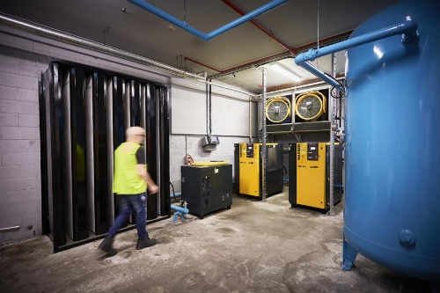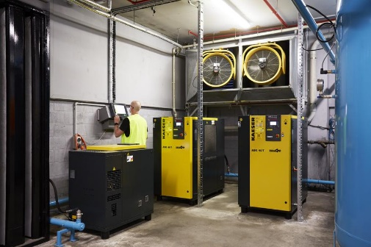
Caption: The ASK 40 T rotary screw compressor with integrated refrigeration dryer, delivers the compressed air required at standard and peak times.
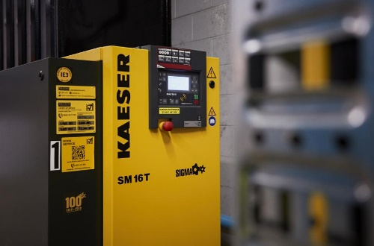
Caption: The Kaeser SM 16 T provides the required compressed air when demand is low.

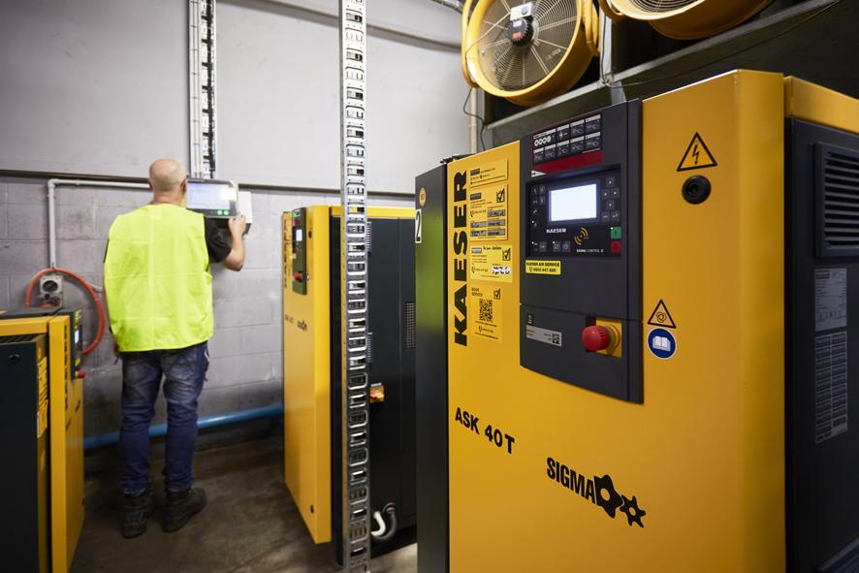
Caption: To ensure complete control and transparency, a Sigma Air Manager 4.0 (SAM 4.0) was installed.
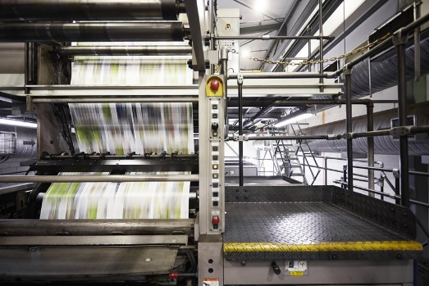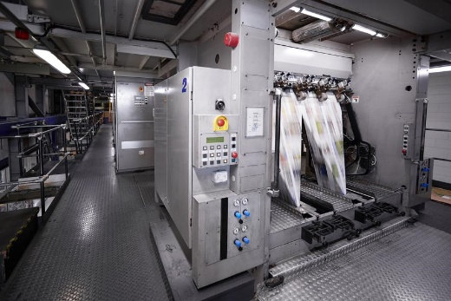
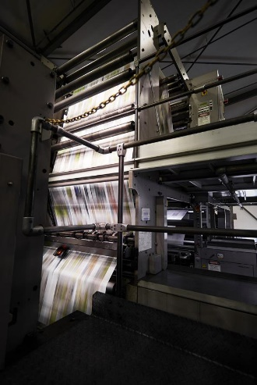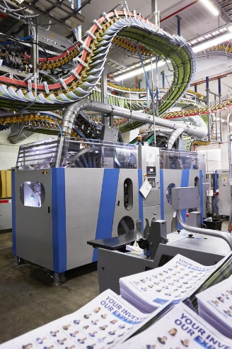
Caption: Compressed air is an essential utility used to power around 80 percent of all the machinery onsite. This includes the very large multi story print press that produces the majority of newspapers published by Stuff.
Kaeser photo(s) – free for publication, credits appreciated.

