August 2018

Premium quality compressed air for trades and workshop applications

Anyone looking for a super-quiet, efficient and cost-effective supply of quality compressed air for their workshop requires a user-oriented solution. With the space-saving i.Comp 8 and 9, Kaeser Compressors is proud to introduce a completely new compressed air supply concept that has been specifically developed with this field of use in mind.

These units are tough, powerful, compact, easy to maintain, efficient and much more. At the heart of the new i.Comp family is a new drive concept, which provides a multitude of advantages. It delivers the necessary power to cover the required compressed air demand with infinitely variable control. Needless to say, the reciprocating compressor itself is made in Germany and is manufactured to the highest industrial standards for which Kaeser is world renowned.
Moreover, i.Comp family reciprocating compressors are able to operate with 100 percent duty cycles. Intelligent solutions - such as drawing the air for compression in through the piston head - ensure exceptional filling performance and, as a result, outstanding efficiency.
With a volumetric flow rate of 412 to 580 l/min, the i.Comp Towers can be used for a wide range of workshop and trades applications and assure a constant pressure of up to 11 bar with absolute operational reliability.
Made from roto-moulded polyethylene to enable optimum corrosion- and impact-resistance, the attractive sound enclosure not only hides an advanced all-in-one compressed air station comprising a compressor and a refrigeration dryer, but also keeps sound levels to a minimum and helps retain system value.

Kaeser’s field-proven Sigma Control 2 controller allows pressure preselection and infinitely variable speed operation, as well as connection to a master controller such as the Sigma Air Manager 4.0.

Since i.Comp Tower systems deliver oil-free compressed air, no oil enters the compressed air supply itself. This in turn eliminates the potential for accumulation of oil-contaminated condensate that would otherwise have to be carefully disposed of. In addition, there is no need for oil changes or oil inspection, which of course further reduces overall service costs.

i.Comp Tower systems are the perfect choice for workshop and trades environments, such as in car repair shops, where a dependable supply of quality compressed air is required.

For more information visit www.kaeser.co.nz or phone 0800 447 820.
-END-
From 2.2 to 500 kW, Kaeser Compressors manufactures a wide range of compressors and associated auxiliary equipment that meet the varying requirements of a diverse range of industries and applications.

One of the world’s largest manufacturers of rotary screw compressors, Kaeser Compressors is represented globally in over 100 countries through a dedicated network of branches, subsidiary companies and authorised partners.

Kaeser Compressors NZ Limited provides comprehensive air compressor and blower sales and service throughout New Zealand from its offices in Auckland, alongside a dedicated and nationwide network of authorised partners.

For editorial and advertising enquiries contact: Beth Wood, Marketing Manager
Press office: +61 3 9791 5999 Fax: +61 3 9791 5733
E-mail: beth.wood@kaeser.com

KAESER COMPRESSORS NZ Limited – 18B Tarndale Grove, Albany, Auckland 0632, New Zealand
Phone: +64 9 941 0499 – www.kaeser.co.nz – E-mail: info.newzealand@kaeser.com

File: B-icomp-nz
Approved for publication, copy acknowledgement appreciated
Image:

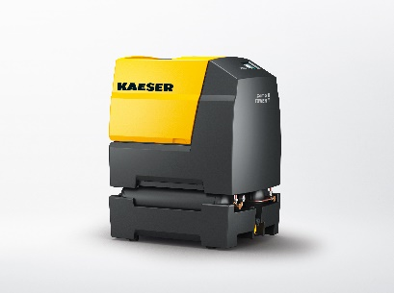

Caption: “Compressed air for the workshop”: The stationary ‘Tower’ version of the durable, variable speed and powerful i.Comp workshop compressor provides a dependable supply of quality compressed air for workshop business environments.
017_Image 1_KAESER_icomp.jpg

((Kaeser photo – free for publication))

