November 2019

Taking a load off:
Kaeser assists truck workshop in reliably meeting its compressed air demand

North Island based Trucks & Trailers – a commercial truck dealership and automotive repair shop - recently invested in an all-in-one Kaeser Aircenter 25 compressed air station to meet its requirements for an efficient and reliable supply of compressed air in its Auckland workshop.

From haulage, transportation and construction to transporting people - there are numerous commercial businesses and public services that require heavy-duty trucks, trailers, utes and vans. For over 30 years Trucks & Trailers has been meeting these requirements for its customers.

Trucks & Trailers is the authorised sales, service and parts dealership for Mercedes-Benz trucks, vans, x-class utes and Freightliner trucks in the North Island with locations in Auckland, Palmerston North and Wellington. When it comes to service and repair, Trucks & Trailers is the only Elite Support Certified Daimler dealership in New Zealand.
This certification advocates a culture of continuous improvement to ensure the dealership consistently perform at its best, as efficiently as possible, to deliver an exceptional customer experience and to ultimately maximise vehicle uptime. To meet such high standards, Trucks & Trailers relies heavily not only on their highly qualified and trained technicians, but also on the tools and equipment in their workshops.

Compressed air is an essential utility to the vehicle workshops required for many purposes such as running the air tools to pumping up tyres. An ageing compressed air system in the Auckland workshop recently led Kelly Henshaw, the Service Manager at Trucks & Trailers to source a replacement. Henshaw contacted Kaeser Compressors for a solution after receiving a recommendation from another company using a Kaeser compressed air system.

Following a review of the workshop’s requirements, Kaeser recommended replacing the ageing compressed air system with an all-in-one Aircenter SK 25 compressed air station.

The user-friendly Aircenter is a complete turnkey system which incorporates a Kaeser rotary screw compressor, an energy efficient refrigeration dryer and an air receiver all in one space-saving compact package.

At the heart of the SK series rotary screw compressor lies the premium quality Sigma Profile screw compressor block. Operating at low speed, the Kaeser screw compressor block is equipped with flow-optimised rotors for superior efficiency. Furthermore, all SK series rotary screw compressors feature energy-saving, premium efficiency IE3 drive motors, which comply with and exceed prevailing New Zealand EECA regulations for 3 phase electric motors. For Trucks & Trailers this would translate into more compressed air for less energy consumption.
Ideal at point of use, the sound adsorbing compressor enclosure additionally keep operational sound levels to a minimum ensuring a pleasant work environment.

A service-friendly design further ensures that all maintenance and service components are easily accessible. This significantly reduces the downtime associated with such tasks and helps to increase compressed air availability and minimise operating costs. Inspection glasses also allow for convenient inspection of fluid levels and drive belt tension whilst the unit is in operation.

Henshaw concluded: ‘The Aircenter was installed about a year ago and is proving to be reliable and efficient. We’ve also found the after sales support to be really good. The compressed air system recently underwent a routine service with Kaeser and the Service Technician that attended site was great, ensuring we were fully aware of what he had done as part of the service.’

The Aircenter compressed air stations from Kaeser are available with drive powers of 2.2 to 15 kW and produce flow rates from 0.26 to 2.5 m³/min, designed for pressures 7.5 to 13 bar. For more information visit nz.kaeser.com or phone 0800 447 820.
-END-
Editors Notes
From 2.2 to 500 kW, Kaeser Compressors manufactures a wide range of compressors and associated auxiliary equipment that meet the varying requirements of a diverse range of industries and applications.

One of the world’s largest manufacturers of rotary screw compressors, Kaeser Compressors is represented globally in over 100 countries through a dedicated network of branches, subsidiary companies and authorised partners.

Kaeser Compressors NZ Limited provides comprehensive air compressor and blower sales and service throughout New Zealand from its offices in Auckland, alongside a dedicated and nationwide network of authorised partners.

For editorial and advertising enquiries contact: Beth Wood, Marketing Manager
Press office: +61 3 9791 5999 Fax: +61 3 9791 5733
E-mail: beth.wood@kaeser.com

KAESER COMPRESSORS NZ Limited – 18B Tarndale Grove, Albany, Auckland 0632, New Zealand
Phone: +64 9 941 0499 – https://nz.kaeser.com – E-mail: info.newzealand@kaeser.com

File: Q-Trucks-and-Trailers-nz
Approved for publication, copy acknowledgement appreciated
Images: All high res photos are available on request. Contact the marketing department – info.newzealand@kaeser.com

((Captions)) :

Compressor system
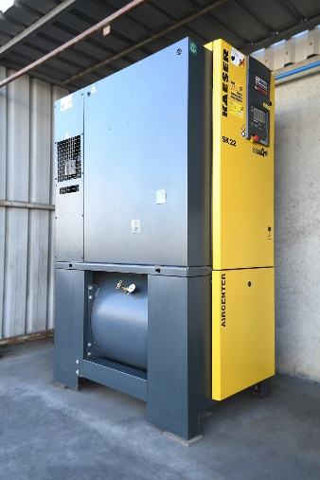
019_Image 1_compressed air at Trucks and Trailers.jpg

Caption: The all-in-one Kaeser Aircenter SK25 at Trucks & Trailers.

Compressed air applications

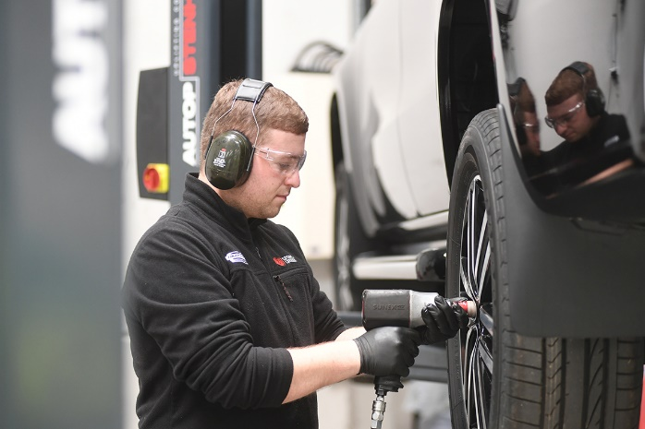
019_Image 2_compressed air being used at Trucks and Trailers.jpg

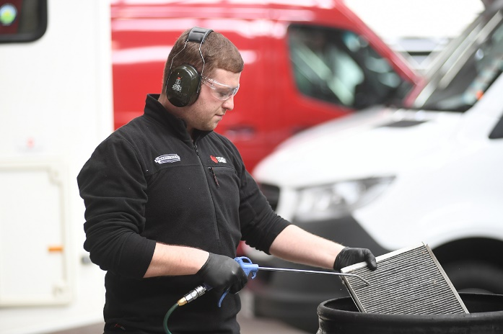
019_Image 3_compressed air being used at Trucks and Trailers.jpg

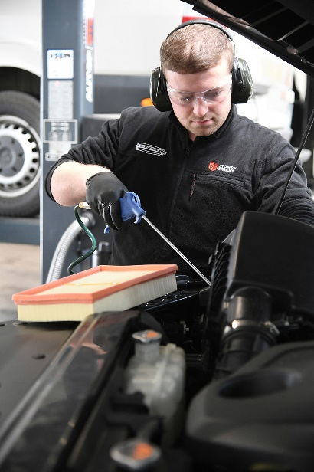
019_Image 4_compressed air being used at Trucks and Trailers.jpg

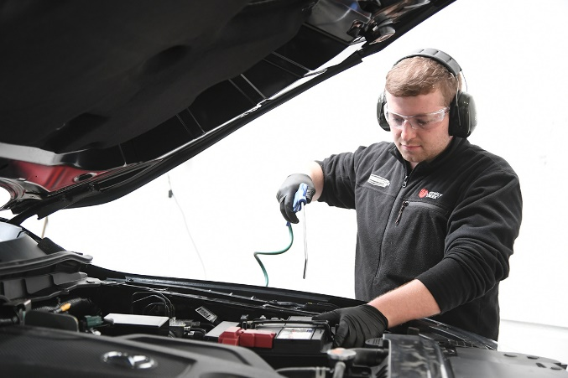
019_Image 5_compressed air being used at Trucks and Trailers.jpg

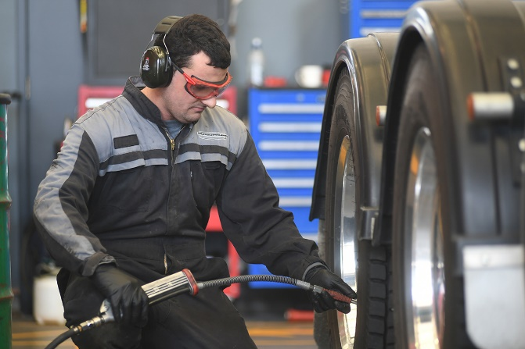
019_Image 6_compressed air being used at Trucks and Trailers.jpg

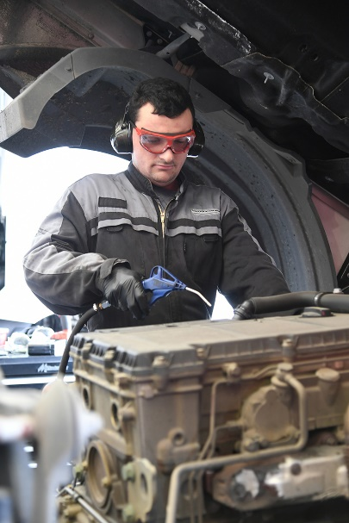
019_Image 7_compressed air being used at Trucks and Trailers.jpg

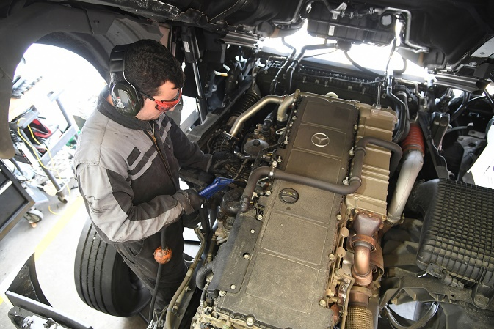
019_Image 8_compressed air being used at Trucks and Trailers.jpg

Caption: Compressed air is an essential utility to the vehicle workshops required for many purposes such as running the air tools to pumping up tyres.

Facility overview

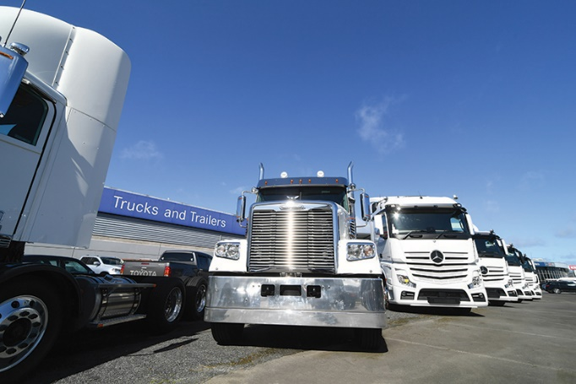
019_Image 9_Trucks and Trailers.jpg

Caption: Trucks & Trailers is the authorised sales, service and parts dealership for Mercedes-Benz trucks, vans, x-class utes and Freightliner trucks in the North Island.

((Kaeser photo – free for publication))

