February 2018

Kaeser 4.0: Discover tomorrow’s technology today at EMEX 2018

Kaeser Compressors will present a number of advanced compressed air technologies at EMEX 2018 that are all ready to take advantage of the future orientated benefits of Industrie 4.0.

At this year’s EMEX, renowned compressed air specialist provider Kaeser Compressors will showcase some of its many smart compressed air solutions that are ready to take advantage of the future orientated benefits of Industrie 4.0. This includes the advanced Sigma Air Manager 4.0 (SAM 4.0) compressed air controller.

Central Mastermind: SAM 4.0
The SAM 4.0 from Kaeser brings users ever closer to Industrie 4.0 applications, which enables optimal coordination and control of all components within a compressed air station to meet the customer's exact requirements. The real-time gathering, transmission and management of in-process operating data enables users to anticipate faults and act promptly before they occur.

SAM 4.0 is at the core of a compressed air station and is the key technology for opening up access to the services that Industrie 4.0 will offer. As the central brain of the compressor station, SAM 4.0 controls the various machines in its control for optimum efficiency, and precisely matches air delivery with the required airflow profile. Within seconds it analyses the operating data, simulates possible responses and selects the most efficient alternative. The result: an entirely new level of energy efficiency.

With the greatest of ease the SAM 4.0 can also display and analyse pressure data, air delivery, performance, maintenance messages and any fault messages, past or present. The network connection also offers the convenience of working with this data on a PC. Aside from providing peace of mind and enabling predictive maintenance, this permits energy management in compliance with ISO 50001.

Multi-device control additionally opens up new possibilities for the advance planning of compressor maintenance. In the past, maintenance was possible only when fault messages occurred or as part of scheduled servicing. With SAM 4.0, it is now possible to initiate maintenance work before faults occur, helping to avoid downtime and the further damage that faults may cause.

Clean compressed air: CSG-2 rotary screw compressors
Kaeser will also showcase one of its highly efficient dry compression rotary screw compressors at EMEX.

Producing clean compressed air is vital for many processes where the risk of oil contamination within the compressed air system is unthinkable. For such demanding applications Kaeser presents a powerful range of dry compression two-stage rotary screw compressors.

At the heart of these versatile compressors lies a quality, tried and tested dry compression, two-stage rotary screw compressor block. Even under the toughest of conditions every Kaeser screw compressor block provides optimum performance and dependability as well as maximum efficiency.

Compressed air simply has to be available where and whenever it is needed. Kaeser dry compression rotary screw compressors are therefore built to last and to ensure many years of dependable performance. Comprising tried and tested components that have been developed as a result of Kaeser’s near century of experience in mechanical engineering, Kaeser compressors deliver the durability and compressed air availability to meet even the toughest of demands.

All-in-one solution: Aircenter
Visitors to the Kaeser stand at EMEX will also be able to see the popular all-in-one Kaeser Aircenter in action. This complete and compact compressed air system incorporates a compressor, dryer and air receiver all within a single housing.

Like all other Kaeser compressors, the Aircenter incorporates a premium quality screw compressor block with Kaeser Sigma Profile rotors. Designed for maximum energy efficiency, the Kaeser Sigma Profile can achieve power savings of up to 15 percent compared with conventional screw compressor block rotor profiles.

Industrie 4.0: Compressed air technology of the future
Aside from visiting the Kaeser stand at EMEX, visitors that want to learn more about how Industrie 4.0 is paving the way for compressed air systems of the future and the benefits they hold, are invited to join Jeff Coyle, the National Design & Engineering Manager of Kaeser Compressors Australia, as he presents on this topic as part of the EMEX Seminar Program on the afternoon of Wednesday 2nd May.
-END-
Editors Notes
From 2.2 to 500 kW, Kaeser Compressors manufactures a wide range of compressors and associated auxiliary equipment that meet the varying requirements of a diverse range of industries and applications.

One of the world’s largest manufacturers of rotary screw compressors, Kaeser Compressors is represented globally in over 100 countries through a dedicated network of branches, subsidiary companies and authorised partners.

Kaeser Compressors NZ Limited provides comprehensive air compressor and blower sales and service throughout New Zealand from its offices in Auckland, alongside a dedicated and nationwide network of authorised partners.

For editorial and advertising enquiries contact: Beth Wood, Marketing Manager
Press office: +61 3 9791 5999 Fax: +61 3 9791 5733
E-mail: beth.wood@kaeser.com

KAESER COMPRESSORS NZ Limited – 18B Tarndale Grove, Albany, Auckland 0632, New Zealand
Phone: +64 9 941 0499 – www.kaeser.co.nz – E-mail: info.newzealand@kaeser.com

File: O-EMEX-2018-nz
Approved for publication, copy acknowledgement appreciated
Images:

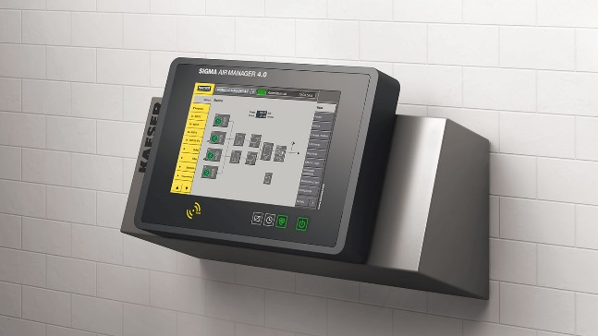
Caption: The SAM 4.0 from Kaeser brings users ever closer to Industrie 4.0 applications
005_Image 1_KAESER SAM 4-0.jpg

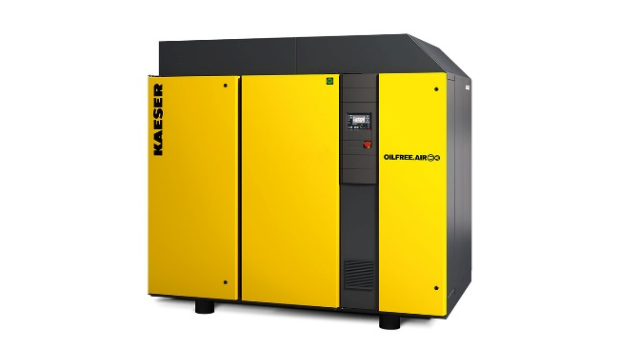
Caption: Kaeser CSG-2 series dry compression rotary screw compressors are ideal for sensitive applications
005_Image 2_KAESER CSG.jpg

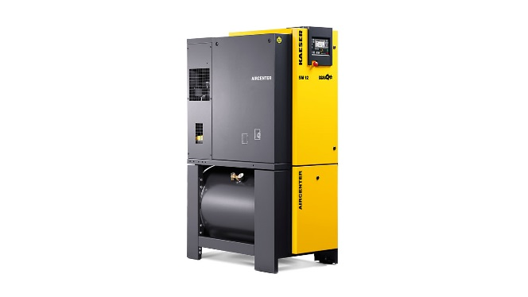
Caption:See the all-in-one Kaeser Aircenter compressed air system in action at EMEX
005_Image 3_KAESER AIRCENTER.jpg

Caption:Jeff Coyle, National Design & Engineering Manager of Kaeser Compressors Australia will be speaking within the Seminar Program at EMEX 2018
005_Image 4_KAESER Jeff Coyle.jpg

((Kaeser photo – free for publication))

