The “Omega PV” rotary blower with pre-inlet cooling
Efficient Low Vacuum Generation
Modern rotary blowers are not only suitable for pressure applications, but are also perfect for applications requiring low vacuum: Kaeser’s “Omega PV” series rotary blowers provide volume flow rates from 15 to 150 m³/min and ensure exceptional efficiency with reliability.
Kaeser’s “Omega PV” series blowers use a highly effective pre-inlet cooling system, which draws in additional cooling air through channels integrated in the left and right side of the blower block casing. This results in even coolant distribution within the block casing and increases cooling efficiency. The cooling channels are especially compact due to the rectangular design of the cooling air connections. Furthermore, non-return valves are installed within the cooling air channels to enable the blower to be switched over from vacuum to pressure operation as required.
The three-lobe “Omega Profile” blower rotors keep pulsation to a minimum and ensure outstanding energy efficiency. Used in combination with a specially designed block casing, they also provide high performance with low energy consumption. “PV” models allow 85 % continuous vacuum and can even achieve 90 % vacuum (end vacuum) over short periods.
Kaeser’s “Omega PV” series rotary blowers are not only perfect for numerous pneumatic conveying applications that require low vacuum, but are also suited to vacuum generation in tanker trucks and suction vehicles, as well as in mobile grinding and mixing systems.

File: h-Omega-PV-nz
Approved for publication, copy acknowledgement appreciated
Image:

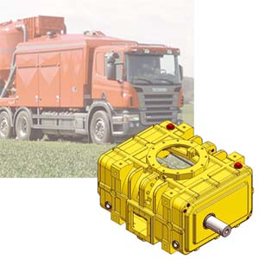
The “Omega PV” rotary blower block is equipped for vacuum operation and features pre-inlet cooling. “PV” blowers can achieve 90 % vacuum and are perfect for a wide variety of applications ranging from pneumatic conveying to vacuum generation in tanker trucks and suction vehicles, as well as in mobile grinding and mixing systems.

