February 2021
Compressed air training & education still at the forefront:
Kaeser launches 2021 webinar programme

Kaeser Compressors New Zealand has launched a new webinar programme for 2021. This programme includes a remastered online version of its popular one-day Compressed Air Seminar.
Kaeser Compressors is committed to supporting the compressed air industry with training and education. This became challenging last year with face-to-face events largely impossible. With COVID-19 restrictions likely to remain fluid throughout 2021, Kaeser has therefore taken the opportunity to move its seminars online.

The Compressed Air Webinar
Developed by Kaeser, the Compressed Air Webinar is a remastered online version of the company’s popular one-day Compressed Air Seminar. It has been specifically developed to provide a solid compressed air knowledge base for all those involved in the planning, installation, operation and maintenance of compressed air supply systems.
Like water, gas and electricity - compressed air is an essential utility that many areas of industry rely upon every day. Providing compressed air reliably and efficiently in the required quality is a complex process and requires careful consideration of a compressed air supply system as a whole. The widest possible knowledge base is therefore required in order to properly assess the various interactions within the system and its integration into the operational environment.
The complete Compressed Air Webinar is broken down into three 90 minute modules, that are held online and over three consecutive weeks. From the fundamental principles of compressed air to compressed air treatment, regulations and control systems - the Compressed Air Webinar from Kaeser, provides participants with the knowledge that can ultimately assist them in optimising the reliability and energy efficiency of a compressed air system.

The Compressed Air Webinar is scheduled to run in May and October 2021. For more information and registration options, just visit nz.kaeser.com or phone 0800 447 820.
-END- Free for publication, copy appreciated
Editors Notes
From 0.18 to 515 kW, Kaeser Compressors manufactures a wide range of compressors and associated auxiliary equipment that meet the varying requirements of a diverse range of industries and applications.

One of the world’s largest manufacturers of rotary screw compressors, Kaeser Compressors is represented globally in over 100 countries through a dedicated network of branches, subsidiary companies and authorised partners.

Kaeser Compressors NZ Limited provides comprehensive air compressor and blower sales and service throughout New Zealand from its offices in Auckland, alongside a dedicated and nationwide network of authorised partners.

For editorial and advertising enquiries contact: Beth Wood, Marketing Manager
Press office: +61 3 9791 5999 Fax: +61 3 9791 5733
E-mail: beth.wood@kaeser.com

KAESER COMPRESSORS NZ Limited
18B Tarndale Grove, Albany, Auckland 0632, New Zealand
Phone: +64 9 941 0499 Email: info.newzealand@kaeser.com
nz.kaeser.com
File: P-Webinars-launched-nz
Approved for publication, copy acknowledgement appreciated
Images:
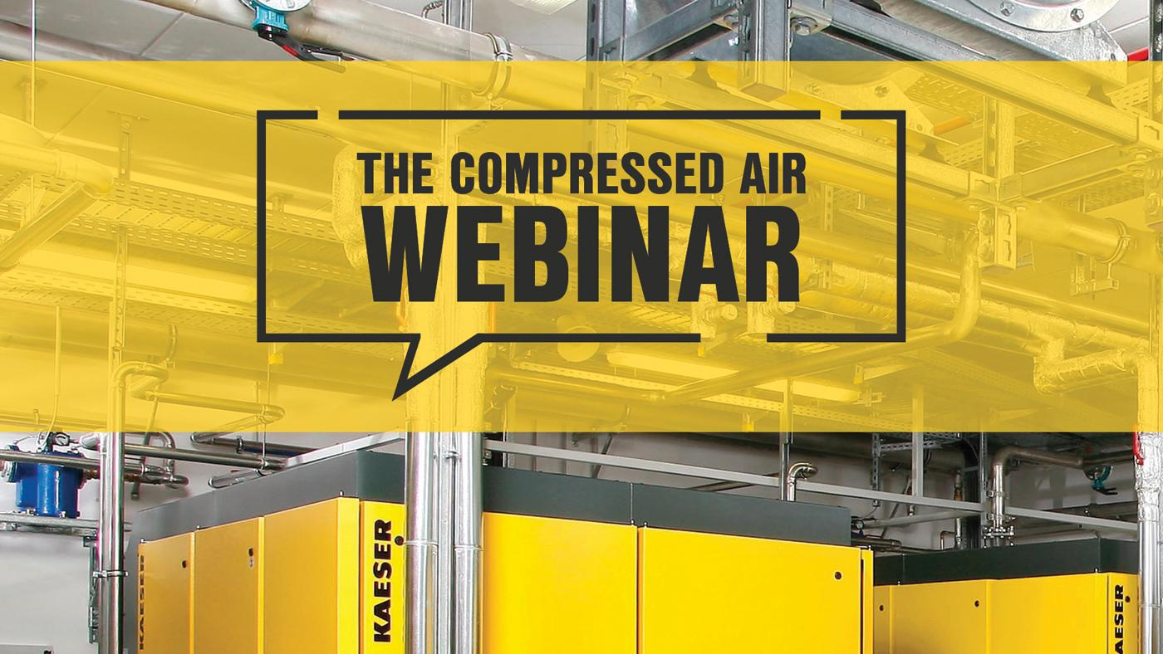

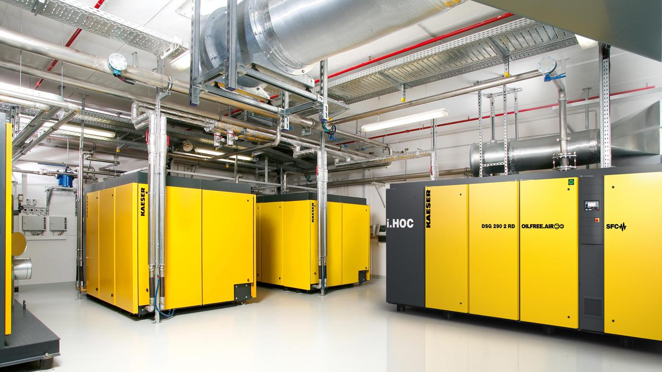
Caption: Kaeser Compressors launches The Compressed Air Webinar

Kaeser photo(s) – free for publication, credits appreciated.

