January 2020

The energy-saving and compact giant:
Kaeser launch Secotec TG series refrigeration dryers

Kaeser has extended its range of energy-saving refrigeration dryers with the introduction of the Secotec TG series. Designed for large-scale industry they deliver stable pressure dew point performance with maximum dependability and energy efficiency all within a compact footprint.

Accommodating flow rates up to 98 m³/min, the new Secotec TG series of refrigeration dryers from Kaeser ensure stable pressure dew point performance even under the toughest of operating conditions, with maximum reliability and minimal life-cycle costs, and all within a compact footprint. This is made possible thanks to a number of key design features:

All Secotec TG series refrigeration dryers are equipped with the innovative Secopack LS heat exchanger system. Its latent heat thermal mass is composed of a phase change material. Compressed air warms the material up to its melting point (thermal mass discharge), absorbing melt heat during the process. This is significantly more than the amount of heat that it can absorb based on its normal specific heat capacity (without the phase change properties). As a result, the latent heat thermal mass in the Secotec dryers has a dramatically higher thermal density than equivalent conventional systems. It is therefore capable of delivering the same performance using 98 percent less thermal mass material.

Each dryer also comes equipped with the exceptionally user-friendly Sigma Control Smart electronic controller. This provides intuitive operation and comprehensive information can be viewed at a glance from the colour display, such as; current operating data, active messages and a P&I diagram.

The high-performance thermal mass concept ensures stable pressure dew points and together with the network-capable Sigma Control Smart controller, it also guarantees long-lasting, energy-saving operation in all load phases.

The air-cooled Secotec TG refrigeration dryer models additionally feature a brand new ventilation system with unique exhaust air control that sets new standards for operational safety and cost efficiency.
Thanks to the use of a radial fan, the exhaust air ducting can be directly connected to the refrigeration dryer. The radial fans are powerful enough to blow the air out directly via the exhaust duct. Because they are frequency controlled they draw off only as much exhaust heat as is needed to maintain stable pressure dew point performance. A previously needed auxiliary fan is no longer required. With the air hood gone exhaust air flow is reduced, which means that significantly smaller exhaust ducting can be used. Furthermore the independent exhaust air control allows the refrigeration dryer to be connected directly to the collecting ducts. Less installation height is therefore required which significantly simplifies system planning and assembly.
In combination with innovative exhaust air control, the air-cooled Secotec TG series with frequency controlled radial fan, ensures stable pressure dew point performance with maximum dependability and energy efficiency.

The Secotec TG series refrigeration dryers have been specifically designed for the use of R-513A refrigerant. Utilising this climate-friendly refrigerant will assist compressed air users in future-proofing their system as New Zealand transitions to low-GWP refrigerants. It also ensures maximum efficiency and reliability – even at the highest temperatures.

With a compact footprint, the Secotec TG series have only a minimum need for space. In addition, they are easy to install with excellent accessibility for service. When it comes to service, the requirements are minimal - only the service unit in the standard Eco-drain condensate drain needs replacing. Unlike typical axial fans, the radial fan in the Secotec TG series models are designed to last for the unit’s entire service life.

Equipped as standard with a Modbus TCP module, the Secotec TG series of refrigeration dryers are Industrie 4.0 ready. They can be connected to the Sigma Air Manager (SAM 4.0) master controller, which enables comprehensive monitoring and management of the entire compressed air station. The result – maximum air availability for minimal cost.

The new Secotec TG series of energy-saving refrigeration dryers from Kaeser accommodate flow rates from 45 up to 98 m³/min and are available with a choice of air- or water-cooling. For more information visit nz.kaeser.com or phone 0800 447 820.
-END-
Editors Notes
From 2.2 to 500 kW, Kaeser Compressors manufactures a wide range of compressors and associated auxiliary equipment that meet the varying requirements of a diverse range of industries and applications.

One of the world’s largest manufacturers of rotary screw compressors, Kaeser Compressors is represented globally in over 100 countries through a dedicated network of branches, subsidiary companies and authorised partners.

Kaeser Compressors NZ Limited provides comprehensive air compressor and blower sales and service throughout New Zealand from its offices in Auckland, alongside a dedicated and nationwide network of authorised partners.

For editorial and advertising enquiries contact: Beth Wood, Marketing Manager
Press office: +61 3 9791 5999 Fax: +61 3 9791 5733
E-mail: beth.wood@kaeser.com

KAESER COMPRESSORS NZ Limited – 18B Tarndale Grove, Albany, Auckland 0632, New Zealand
Phone: +64 9 941 0499 – https://nz.kaeser.com – E-mail: info.newzealand@kaeser.com

File: D-Secotec-TG-NZ
Approved for publication, copy acknowledgement appreciated
Images:

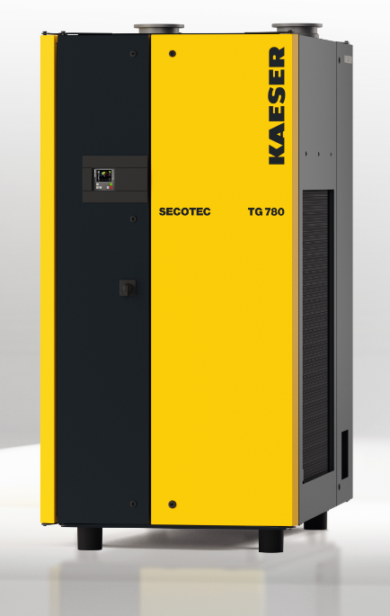
Caption: The new energy-saving and compact Secotec TG series refrigeration dryers from Kaeser Compressors

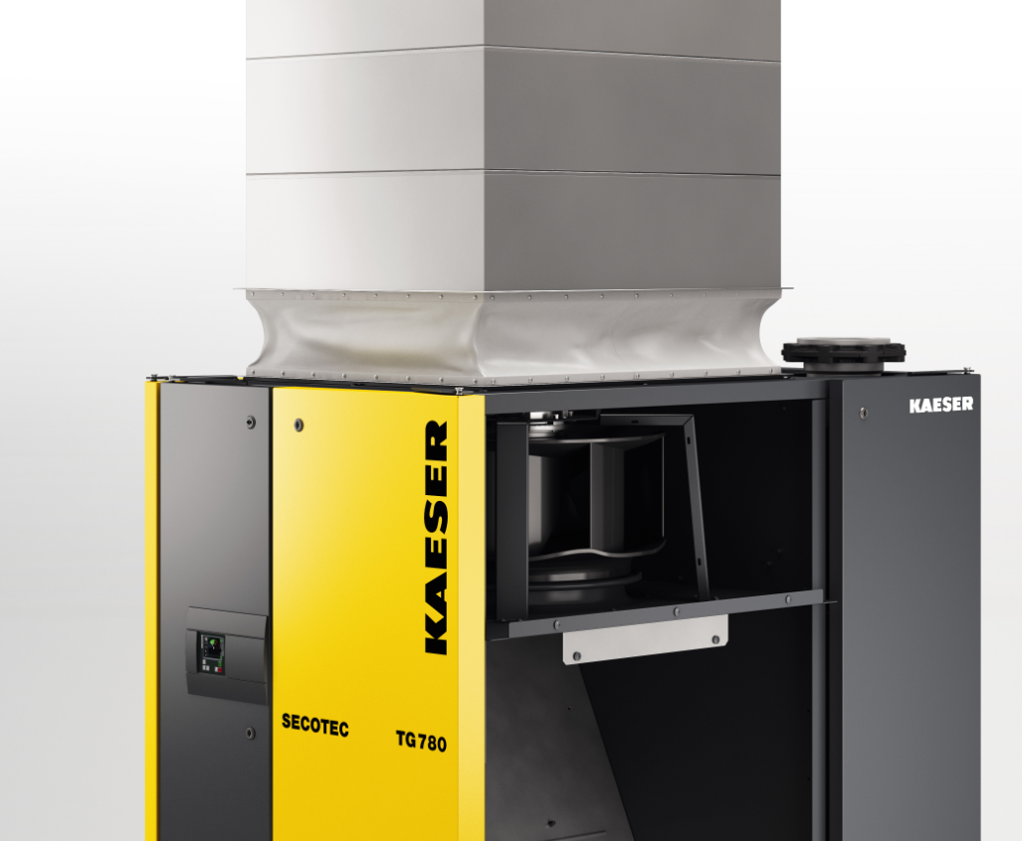

Caption: The air-cooled Secotec TG refrigeration dryer models feature a brand new ventilation system that sets new standards for operational safety and cost efficiency.

((Kaeser photo – free for publication))

