Kaeser delivers high quality compressed air to Malabar WWTP
As part of the Malabar Waste Water Treatment Plant Process and Reliability / Renewal Improvement Project being delivered by 4Malabar, an ageing compressed air system at the plant was recently upgraded with three Kaeser CSDX series rotary screw compressors, along with a Sigma Air Manager 4.0 compressed air management system.
Australia’s largest water and wastewater service provider, Sydney Water is a State Owned Corporation wholly owned by the New South Wales Government. Sydney Water collects and treats around 1.5 billion litres of wastewater each day through a network of over 25,000 kilometres of wastewater pipes, 677 pumping stations, 14 water recycling plants and 16 wastewater treatment plants.
Malabar Waste Water Treatment Plant (WWTP) is Sydney Water’s largest wastewater treatment plant. It has an average daily discharge of almost 500 ML.
A significant project was initiated at Malabar WWTP to improve the reliability of the processes that treat wastewater, to ensure Malabar WWTP continues to comply with its environment protection license requirements, improve safety and working conditions and reduce operating costs. This will ensure that Sydney Water continues to deliver great value for their customers and better conditions for their staff.
The Project is being delivered by 4Malabar, an alliance between Sydney Water, John Holland, UGL Engineering and GHD.
Work on the Improvement Project started in 2014 and is expected to be completed by mid-2019. Since work has commenced, a number of improvements have been completed and include an upgrade of the ageing compressed air system.
Compressed air is used for a number of plant site services across Malabar WWTP including valving, pneumatic actuation and sparging. A reliable and efficient supply of quality compressed air is critical to deliver these site services and was therefore a key criteria in selecting the new system.
Following a successful tender process, three Kaeser CSDX series rotary screw compressors, along with a Sigma Air Manager 4.0 (SAM 4.0) compressed air management system were selected to meet the requirements for Malabar WWTP.
The latest generation CSDX series rotary screw compressors from Kaeser push the boundaries when it comes to compressed air efficiency, providing significant energy savings in multiple ways:
Every CSDX series rotary screw compressor is equipped with a low speed and highly efficient screw compressor block featuring the high performance and flow-optimised Sigma Profile rotors. The Sigma Profile achieves power savings of up to 15 percent compared with conventional screw compressor block rotor profiles for a highly energy efficient solution. Efficiency is further enhanced with the inclusion of a premium efficiency IE3 drive motor, which complies with and exceeds prevailing Australian GEMS regulations for 3 phase electric motors.
The Kaeser 1:1 drive design further eliminates the transmission losses associated with gear or v-belt driven systems as the motor directly drives the screw compressor block. To reliably and efficiently manage the compressed air system a Sigma Air Manager 4.0 (SAM 4.0) was installed. An in-house centralised control system, SAM 4.0 enables compressor performance to be precisely matched to actual air demand thereby allowing additional energy savings.
The SAM 4.0 utilises adaptive 3D advanced control to make air generation and treatment even more intelligent, reliable and efficient. The algorithm of the adaptive 3D advanced control orchestrates the operation of the Kaeser compressed air system. As a result, just the right amount of compressed air power is provided to suit the specific needs of the application, with maximum energy efficiency. The unique adaptive 3D advanced control continuously analyses the relationship between various parameters (e.g. switching and control efficiency), and pro-actively calculates the optimum combination from a range of many in order to achieve optimum efficiency.
Up and running for some time now, the Kaeser compressed air system is proving to be reliable and efficient in delivery the high quality compressed air that the Malabar Waste Water Treatment Plant requires.
The standard CSDX series of rotary screw compressors from Kaeser are available with drive powers up to 90 kW, a working pressure 7.5, 10 or 13 bar and with free air deliveries from 79.86 to 16.16 m³/min.

File: Q-Malabar-nz
Approved for publication, copy acknowledgement appreciated
Images: (contact the press office for high res copies of the following images)

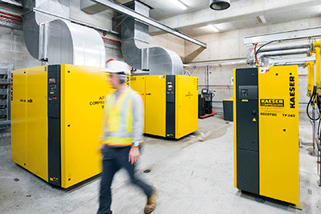
Caption: The upgraded compressed air system at Malabar Waste Water Treatment

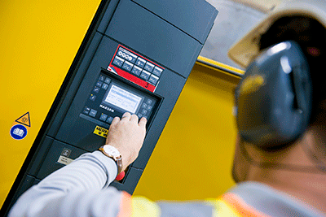
Caption: To reliably and efficiently manage the compressed air system a Sigma Air Manager 4.0 (SAM 4.0) was installed

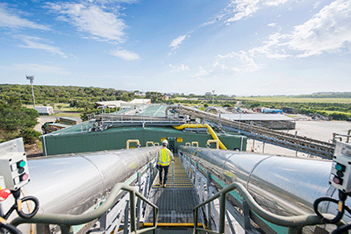
Caption: The biosolids storage and outloading facility at Malabar WWTP

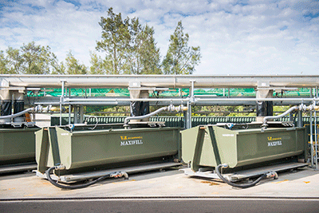
Caption: The new screenings handling area at Malabar WWTP

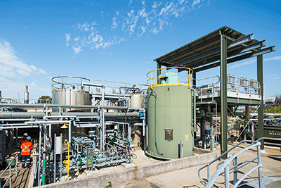
Caption: The Polymer system at Malabar WWTP, a part of the new sludge screening facility

