April 2020

High-efficiency: Compressed air for jet milling applications
When it comes to generating compressed air, operators of jet milling equipment for the production of very fine powders can achieve significant energy cost savings through the skilful use of heat recovery. It is for this very reason that Kaeser Compressors has recently expanded the options palette for its range of oil-free compression rotary screw compressors from the CSG, DSG and FSG series.
Aside from steam, jet mills are most commonly operated using nitrogen or compressed air. In the case of the latter, heat energy can be recovered from the compressed air inside the jet nozzles and subsequently reused for the milling process. Exhaust heat arises as a by-product of compressed air generation, which essentially makes it a cost-free source of energy.
With the specific needs of jet milling applications in mind, Kaeser has now extended the options palette available for its two-stage, oil-free compression rotary screw compressors to include such features as compressed air discharge temperature control. Operating via flexible, controlled adjustments to the intercooler, this option can lead to a clear reduction in specific energy consumption per tonne of the final product, depending on the type of material being processed.
Kaeser offers the option of compressed air discharge temperature control on compressors from the CSG, DSG and FSG model range, featuring a power output from 37 - 355 kW and pressure from 4 - 11 bar. Both air-cooled and water-cooled versions are available.
Furthermore, Kaeser also offers compressors specially adapted for operation with nitrogen, in which the compressor can be individually configured to the specific nitrogen circuit. For more information visit nz.kaeser.com or phone 0800 447 820.
-END-
Editors Notes
From 0.18 to 515 kW, Kaeser Compressors manufactures a wide range of compressors and associated auxiliary equipment that meet the varying requirements of a diverse range of industries and applications.

One of the world’s largest manufacturers of rotary screw compressors, Kaeser Compressors is represented globally in over 100 countries through a dedicated network of branches, subsidiary companies and authorised partners.

Kaeser Compressors NZ Limited provides comprehensive air compressor and blower sales and service throughout New Zealand from its offices in Auckland, alongside a dedicated and nationwide network of authorised partners.

For editorial and advertising enquiries contact: Beth Wood, Marketing Manager
Press office: +61 3 9791 5999 Fax: +61 3 9791 5733
E-mail: beth.wood@kaeser.com

KAESER COMPRESSORS NZ Limited
18B Tarndale Grove, Albany, Auckland 0632, New Zealand
Phone: +64 9 941 0499 Email: info.newzealand@kaeser.com
nz.kaeser.com

File: A-Compressed-air-for-jet-milling-nz
Approved for publication, copy acknowledgement appreciated
Images:
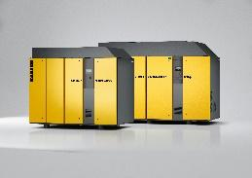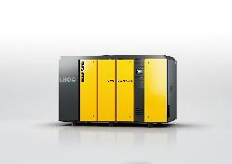

Caption: Oil-free compression rotary screw compressors from the CSG, DSG and FSG series are capable of supplying process heat as well as compressed air, making them ideal for operation in jet milling applications.

Kaeser photo(s) – free for publication, credits appreciated.

