Powerful performance in a compact package
Kaeser Compressors has just announced the launch of the CBS series of rotary screw blowers. Complimenting Kaeser’s existing range of energy efficient screw blowers, the new CBS series now brings all the advantages of screw blower technology to lower flow rate applications such as those found in the wastewater treatment sector.
From bioreactors and flotation to the production of aeration air, for municipal and industrial wastewater treatment plants there are a number of applications where low pressure compressed air with low flow rates is required. To meet these needs, Kaeser has recently extended its compact and turnkey range of highly efficient rotary screw blowers. The new CBS series of screw blowers deliver compressed air with differential pressures up to 1000 mbar, power 7.5 to 22 kW and flow rates from 15.7 to 22.3 m³/min.
Up to 35 percent more efficient compared to conventional rotary blowers, the CBS series screw blowers offer significant energy advantages in the two-digit range compared to other screw and turbo blowers on the market. In fact, one of these screw blowers is so powerful that it efficiently covers the control range of two or three rotary blowers.
This impressive efficiency is achieved in part by the inclusion of Kaeser’s screw compressor block which features the world renowned Sigma Profile rotors. This highly efficient screw compressor block includes a wide control range and ensures virtually constant specific power. Even at maximum speeds, these rotors ensure minimal transmission loss and lowest possible energy costs. In addition, the use of high-tech bearings and no need for ancillary equipment further minimises energy consumption and also enhances reliability.
The energy efficiency of the CBS series, their low maintenance requirement and the ability to set up CBS screw blower units directly adjacent to one another, makes them especially advantageous for continuous operation. Delivered ready for immediate operation, these versatile turnkey blowers are equipped with star-delta starter (or frequency converter). As a result they save considerable costs associated with planning, installation, certification, documentation and commissioning.
For efficient blower control and system monitoring all of the CBS series models come as standard with an integrated Sigma Control 2 compressor controller. Various interfaces enable rapid communication with control centres. Where multiple blowers exist, even further efficiencies and substantial cost savings can be made by integrating the Kaeser Sigma Air Manager 4.0 (SAM 4.0) master controller.
A key technology for opening up access to the services that Industrie 4.0 has to offer, SAM 4.0 forms the core of a blower station. As the central mastermind, it controls the various machines in its network for optimum efficiency, precisely matching air delivery to the required airflow. Analysing the operating data within seconds, the SAM 4.0 simulates possible responses and selects the most efficient option. The result: a new level of energy efficiency is realised.

File: h-cbs-nz
Approved for publication, copy acknowledgement appreciated
Image:

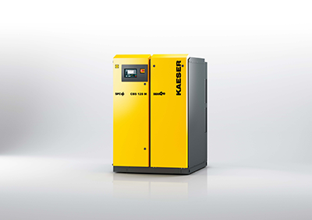
The powerful CBS series of rotary screw blowers from Kaeser are quiet in operation and save energy costs

