April 2017

Make a date with Kaeser at SouthMACH:
Industrie 4.0 compressed air systems seminar

The Maintenance Engineering Society of New Zealand has invited Kaeser Compressors NZ to run a seminar at SouthMACH 2017 on ‘Industrie 4.0’ compressed air systems.

Once again, SouthMACH – the South Island’s premier technology trade show – has invited the Maintenance Engineering Society of New Zealand (MESNZ) to run two seminars at the exhibition. One of these seminars will be on the topic of Industrie 4.0.

The way we manufacture is no doubt entering a new era led by the advances, networking and connectivity capabilities of production processes and technology. Coined Industrie 4.0, this new era presents a number of opportunities and benefits to manufacturers that choose to embrace this ‘factory of the future’.

Peter Eckberg, the Managing Director of Kaeser Compressors NZ Limited - a subsidiary of one of the world’s largest compressed air systems providers and compressor manufacturers - will be running the ‘Industrie 4.0: the future of manufacturing landscape’ seminar on behalf of the MESNZ.

Like the MESNZ, Kaeser Compressors is committed to supporting engineers on the ground. This has led to a strong association with the Society, including being the proud sponsor of the MESNZ Network Evening Series. These events bring members and interested parties alike together at local operations in a casual after hours atmosphere, to learn something about the host’s world and network with other engineers over light refreshments.

The ‘Industrie 4.0: the future manufacturing landscape’ seminar is being held at SouthMACH on Wednesday 24 May. Join the MESNZ and Kaeser Compressors at SouthMACH 2017, 24 – 25 May at the Horncastle Arena in Christchurch.
-END-
Editors Notes
From 2.2 to 500 kW, Kaeser Compressors manufactures a wide range of compressors and associated auxiliary equipment that meet the varying requirements of a diverse range of industries and applications.

One of the world’s largest manufacturers of rotary screw compressors, Kaeser Compressors is represented globally in over 100 countries through a dedicated network of branches, subsidiary companies and authorised partners.

Kaeser Compressors NZ Limited provides comprehensive air compressor and blower sales and service throughout New Zealand from its offices in Auckland, alongside a dedicated and nationwide network of authorised partners.

For editorial and advertising enquiries contact: Beth Wood, Marketing Manager
Press office: +61 3 9791 5999 Fax: +61 3 9791 5733
E-mail: beth.wood@kaeser.com

KAESER COMPRESSORS NZ Limited – 18B Tarndale Grove, Albany, Auckland 0632, New Zealand
Phone: +64 9 941 0499 – www.kaeser.co.nz – E-mail: info.newzealand@kaeser.com

File: O-Southmach-2017-nz
Approved for publication, copy acknowledgement appreciated
Image:
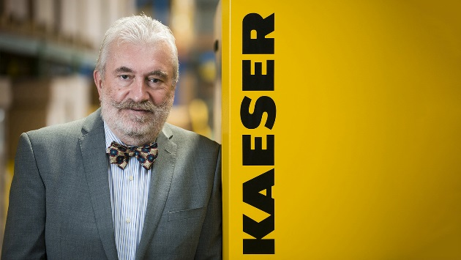
Caption: Peter Eckberg, Managing Director of Kaeser Compressors New Zealand
008_Image 1_Peter Eckberg.jpg

((Kaeser photo – free for publication))

