Unlocking the energy savings potential of your compressed air system

Any facility that relies on compressed air as source of energy will know that compressed air is a significant consumer of electricity. Not great news when you consider the heightened electricity costs we have all been faced with in recent years. However, what many compressed air users do not realise is that their compressed air system may well be hiding an energy savings potential of 30 percent or more. Uncovering and realising these savings would assist them in reducing their associated electricity bill and therefore their carbon footprint.

Unlocking your energy savings potential
The key to unlocking hidden compressed air energy savings starts with a compressed air audit. By monitoring a compressed air system for a set period of time, such sophisticated computer aided audits like the Air Demand Analysis (ADA) from Kaeser, are able to determine precisely how much power and energy is being consumed by an existing compressed air system configuration. Where appropriate, this information can then be used to simulate alternative configurations for optimum energy efficiency. As an example, proprietary tools such as the Kaeser Energy Saving System (KESS) enable efficiency comparisons and accurate predictions of the energy savings that other solutions could make.

Where can energy savings be made?
A compressed air audit may reveal simple improvements that could improve efficiency such as fixing air leaks. It is estimated that compressed air leaks can squander up to 50 percent of the compressed air produced by a typical compressed air system. However, by identifying, repairing and implementing an on-going leak detection management programme, significant improvements can be made.
Reducing artificial demand and eliminating inappropriate use of compressed air may be other simple recommendations made, that when actioned will contribute towards increased energy efficiency.

Energy efficient compressed air technologies
A compressed air audit may also identify that significant savings can be achieved by replacing ageing or inefficient equipment. If we look at just the compressor, energy savings of approximately 10 percent can be achieved through the use of efficient airends, 1:1 direct drives and efficiency optimised IE3 and IE4 electric motors;

The airend of a compressor is essential to its overall efficiency. The specific power requirement of a rotary screw compressor is a direct result of the relationship between flow rate and power consumption. It will only reach its optimum specific performance at a certain pressure and speed. Advanced compressor manufacturers are able to make low speed airends for every size range that work in their zone of optimal performance. They tend to be more efficient than compressors with higher speed airends or gearbox or belt transmission, and are able to deliver more compressed air for the same drive power, generating considerable savings.

The drive motor also plays a part in a compressors overall efficiency. Direct coupled 1:1 drives offer the best efficiency with no loss in transmission efficiency and no maintenance requirements. Belt drives do require some maintenance but offer advantages such as flexibility in pressure selection. Automatic belt tensioning devices further ensure transmission efficiency whilst protecting bearings from excess stress.

The efficiency of the drive motor should not be overlooked either. The efficiency classes according to the International Efficiency (IE) Code for low-voltage AC motors, describe the efficiency of motors in converting electrical to mechanical energy. The standard defines the minimum requirements on the energy efficiency of asynchronous motors. In addition to the classes IE1 to IE3, the most efficient class of the standard is IE4 (‘Super premium efficiency’) which is – at this point in time – not yet legally binding.

In addition to the high degree of efficiency and lower energy consumption, the other benefits of optimised compressor drives are low operating temperatures and therefore a longer life. As an example, compare the energy costs of a 15 kW base load compressor where one has an IE1 motor and the other an IE3 motor. The performance efficiency of the compressor with the IE1 motor would be around 87%, with a power loss of around 1.95 kW. Whereas the compressor with the IE3 motor would have a performance efficiency of around 92% and only a 1.5 kW power loss. The energy savings of opting for the compressor with an IE3 motor would therefore be 937 W. Based on the compressor running 8.760 h per year and a 0.15 $/kWh this would equate to NZD $1,231.00 of energy cost savings per annum.

Taking control of energy efficiency
Load optimisation and pressure reduction can also generate around 15% energy savings. This could be achieved by introducing a master controller which manages all of the compressors and the associated ancillary equipment within a compressed air system. At its basic level, a master controller switches each of the compressor units in the system on and off as required to most efficiently match the compressed air supply to the demand.

Advanced master controllers such as the Sigma Air Manager 4.0 from Kaeser, can deliver an advanced energy management solution. By managing multiple compressors and selecting the right combination of compressors to meet the current demand requirements, the controller can reduce energy consumption thereby improving the performance and efficiency of a compressed air system. It essentially achieves this by reducing compressor operating and idling times, reducing artificial demand and leaks and improving pressure performance.
It is therefore possible to improve the pressure stability and overall reliability of a compressed air system thereby keeping associated energy consumption to a minimum.

Achieving on-going efficiency
Maintenance and service should also not be overlooked when it comes to operating an energy optimised compressed air system. It is important that a compressed air user follows the OEM’s maintenance schedule in order to ensure the system operates reliably at all times. When a compressed air system operates reliably it is able to operate efficiently, keeping associated energy costs down. Opting for genuine spare parts will also impact the reliability and therefore efficiency of a compressed air system.

Energy costs account for around three quarters of the overall lifetime costs of a compressor. As such a large consumer of electrical energy within a facility, operating an energy optimised compressed air system will therefore be an essential contributor in reducing a facilities overall carbon footprint.

File: n-carbon-footprint-nz
Approved for publication, copy acknowledgement appreciated
Images:
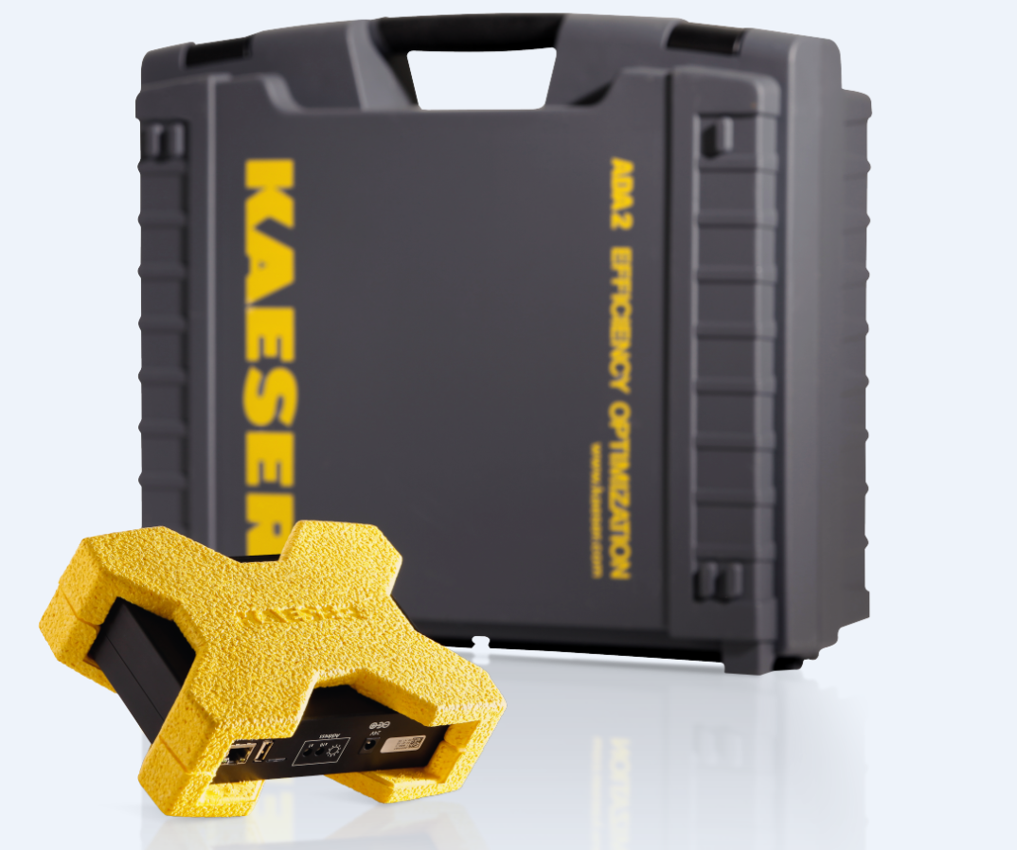
Caption: The computer aided Air Demand Analysis (ADA) from Kaeser can determine precisely how much power and energy is being consumed by an existing compressed air system configuration.
016_Image 1_KAESER_ADA.png

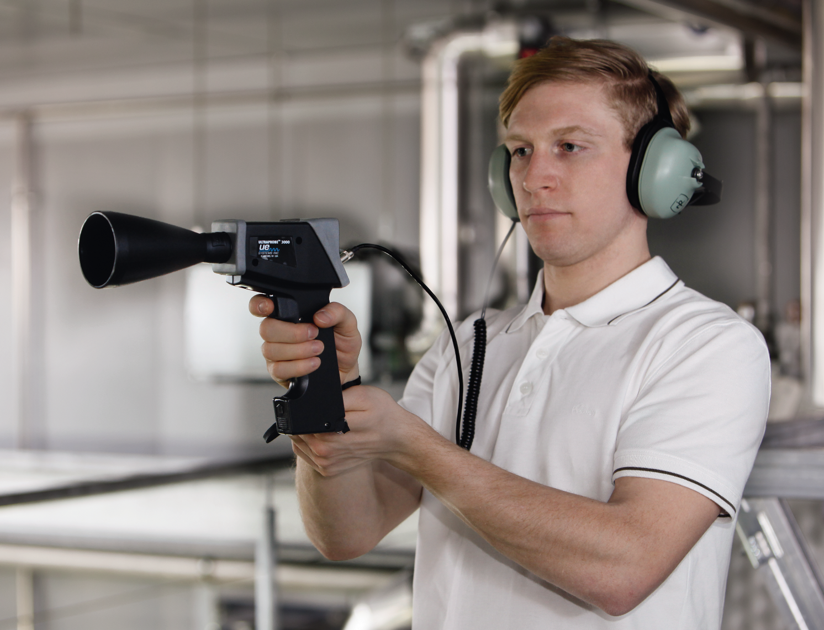
Caption: Identifying and repairing compressed air leaks can generate significant energy savings.
016_Image 2_KAESER_USLD.png

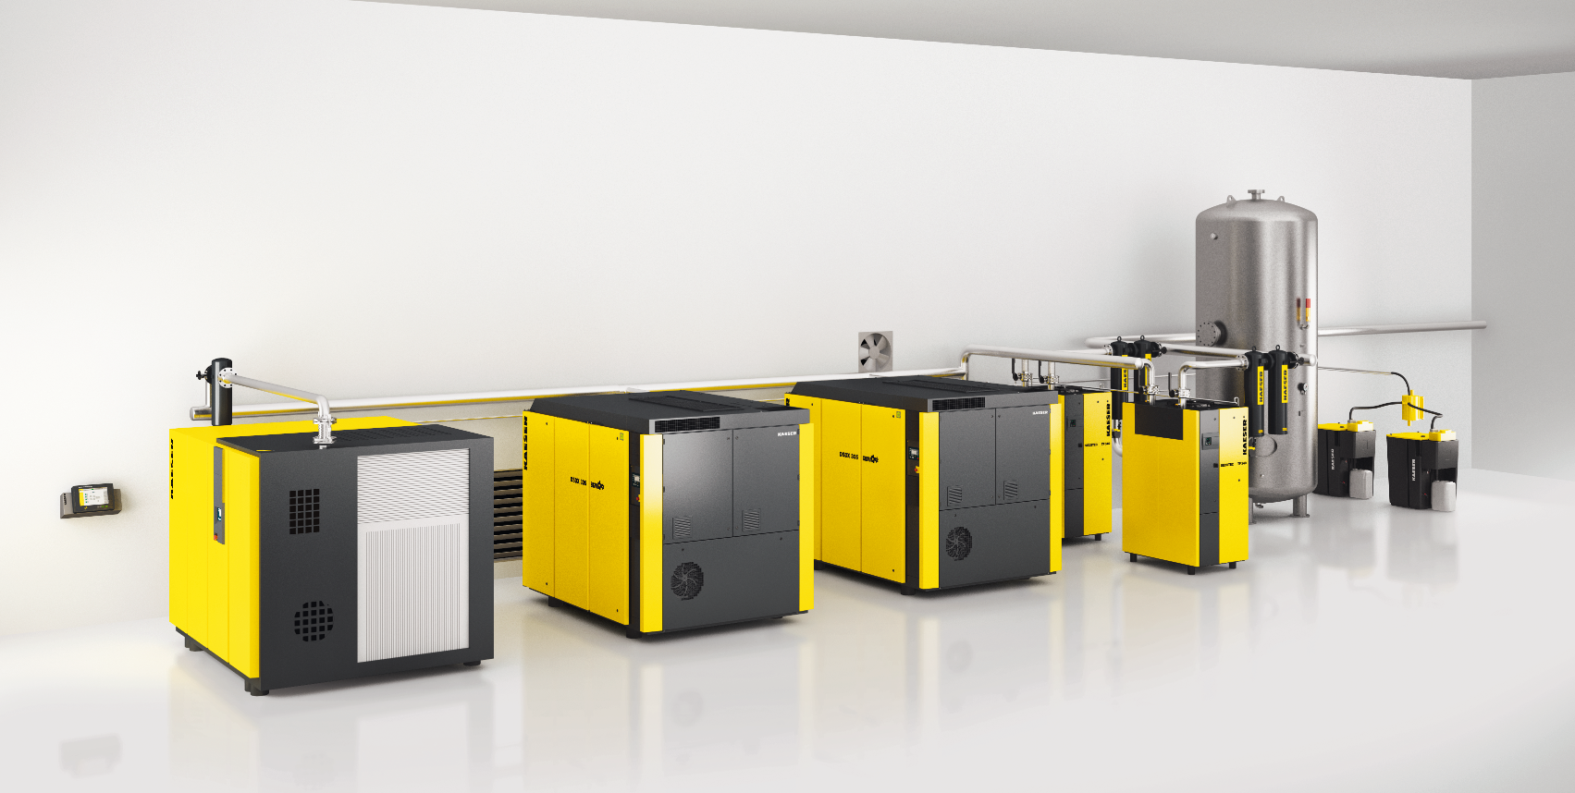
Caption: Compressors with IE3 and IE4 motors offer a high degree of efficiency and lower energy consumption.
016_Image 3_Kaeser compressed air system.png

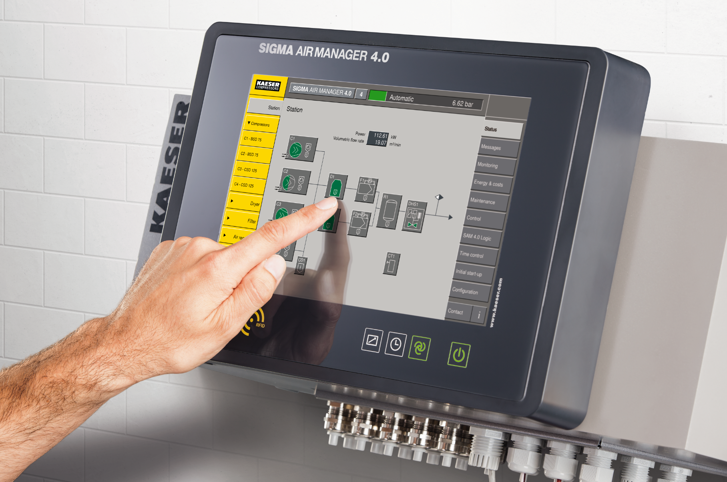
Caption: Advanced master controllers such as the Sigma Air Manager 4.0 from Kaeser, can deliver an advanced energy management solution.
016_Image 4_Sigma Air Manager 4.0.png

((Kaeser photo – free for publication))

