Kaeser CSG-2 series oil-free rotary screw compressors now available with integrated compressed air dryer

Kaeser Compressors has launched two new versions of its CSG-2 series dry compression rotary screw compressors; the CSG-2 T with integrated refrigeration dryer and the CSG-2 RD with integrated i.HOC rotation dryer. These new compressed air systems can reliably and efficiently produce clean and high quality compressed air with pressure dew points as low as -30ºC.
Whether for the food or pharmaceutical industries or high grade industrial air, the Kaeser two-stage oil-free compression rotary screw compressors have proven to deliver uncompromising efficiency even in extreme conditions.
Now available with an integrated refrigeration dryer or an integrated i.HOC rotation dryer, the CSG-2 series models offer the end user a complete compressed air system package - wherever an efficient and dependable source of high quality and clean compressed air is required.
For applications that require pressure dew points to +3ºC, the CSG-2 series dry compression rotary screw compressors from Kaeser are also now available with an integrated refrigeration dryer.
An integrated design, together with a generously dimensioned aluminium block heat exchanger, helps to ensure a minimal pressure loss of less than 0.1 bar. In addition, the energy saving scroll refrigeration compressor helps to achieve further compressed air energy savings.
All refrigeration dryer components in the new CSG-2 T series models are easily accessible via the service door on the front of the unit for ease of maintenance and service work.
Where pressure dew points below +3ºC are required, the CSG-2 RD series dry compression rotary screw compressors with integrated i.HOC rotation dryer presents the perfect solution.
The patented i.HOC rotation dryer from Kaeser can reliably and efficiently achieve pressure dew points as low as -30ºC.
The hot compressed air from the second compression stage is used to regenerate the desiccant. This heat is essentially available for free, as no additional energy is required to power the drying process.
The i.HOC rotary dryer’s intelligent control ensures dew point stability even with fluctuating flow rates and at compressor partial load. When commissioned, the target pressure dew point is reached after just one rotation of the drum. As a result the end user obtains a reliable air dryer with maximum efficiency and lower energy costs.
Both the air- and water- cooled CSG packages from Kaeser are available with the integrated i.HOC rotary dryer or integrated refrigeration dryer. Drive powers range from 37 to 90 kW, operating pressures 4 to 10 bar with flow rate up to 13.5 m³/min.

File: A-CSG-aus
Approved for publication, copy acknowledgement appreciated

Images:
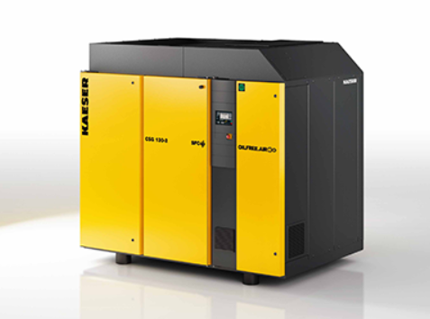
The patented i.HOC rotation dryer from Kaeser users up to 100 percent of compression heat!

