25 March 2020

Continued on-site compressed air service support for ‘essential services’:
Kaeser Air Service & COVID-19 Alert Level 4

With New Zealand moving to COVID-19 Alert Level 4 from 11.59 pm on 25 March 2020, Kaeser Compressors NZ is assuring ‘essential services’ that its team of Service Technicians will remain available for on-site compressed air service support.

Peter Eckberg, Managing Director said: ‘KAESER Compressors NZ is fully committed to supporting ‘essential services’ through these unprecedented times to the best of our ability and within the scope of Government requirements.
We are closely following updates from the Government. At time of writing the advice is that Entities and their workers carrying out services considered essential will stay open. This also includes entities in their supply chains. As such our Service Technicians will be available to support the compressed air requirements of ‘essential services’ throughout the COVID-19 Level 4 period.

We take the health and safety of our employees and customers with the utmost seriousness and we have implemented extensive preventive measures effective immediately and also moving forward.

Our warehouse is well stocked with compressors and spare parts and - for ‘essential services’ requiring a short-term increase to their existing compressed air supply - we also have compressors available for hire.’

For more information visit nz.kaeser.com or phone 0800 447 820.
-END-
Editors Notes
From 0.18 to 515 kW, Kaeser Compressors manufactures a wide range of compressors and associated auxiliary equipment that meet the varying requirements of a diverse range of industries and applications.

One of the world’s largest manufacturers of rotary screw compressors, Kaeser Compressors is represented globally in over 100 countries through a dedicated network of branches, subsidiary companies and authorised partners.

Kaeser Compressors NZ Limited provides comprehensive air compressor and blower sales and service throughout New Zealand from its offices in Auckland, alongside a dedicated and nationwide network of authorised partners.

For editorial and advertising enquiries contact: Beth Wood, Marketing Manager
Press office: +61 3 9791 5999 Fax: +61 3 9791 5733
E-mail: beth.wood@kaeser.com

KAESER COMPRESSORS NZ Limited
18B Tarndale Grove, Albany, Auckland 0632, New Zealand
Phone: +64 9 941 0499 Email: info.newzealand@kaeser.com
nz.kaeser.com

File: P-Kaeser-Air-Service-and-Covid-19-Alert-Level-4-nz
Approved for publication, copy acknowledgement appreciated
Images:
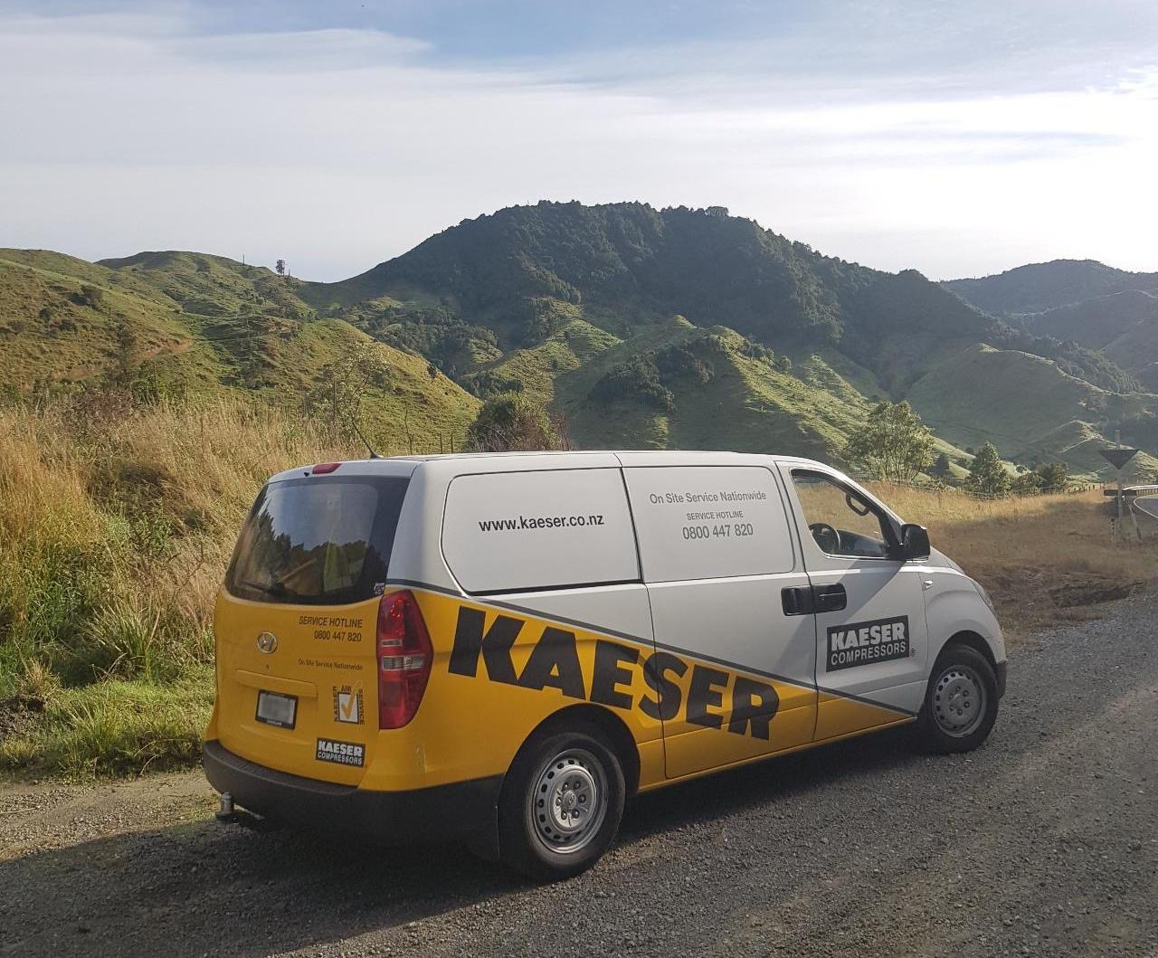

Caption: Continued on-site compressed air service support for ‘essential services’ with Kaeser Air Service

Kaeser photo(s) – free for publication, credits appreciated.

