Big savings possible with the new Kaeser DBS series screw blowers
The new DBS series screw blowers from Kaeser Compressors promise big energy savings for wastewater treatment plants. With power ratings from 15 to 37 kW and flow rates from 4 to 22.5 m³/min, they are currently the most efficient screw blowers available.
Like the EBS and FBS series screw blowers from Kaeser, the new DBS series deliver unparalleled efficiency. They are up to 35-percent more efficient than conventional rotary blowers and also provide energy savings in the double digit range compared with many commonly available screw and turbo blowers.
These benefits are made possible in no small part by the proven Sigma Profile rotor technology used in Kaeser rotary screw compressors. Another key factor is the innovative non-slip direct drive with speed transmission integrated into the screw compressor block, which delivers maximum speed with minimal transmission losses. The result: lower energy costs.
These screw blowers are especially well suited to municipal and industrial water treatment applications. Two different versions are available to meet the needs of water treatment plants requiring pressures of 400 or 650 mbar. The new blowers are exceptionally quiet, with sound levels in primary applications not exceeding 72 dB, which is equivalent to a modern vacuum cleaner.
The low energy consumption of Kaeser screw blowers makes them the perfect choice for supplying compressed air to water treatment plants. They are designed for use over long duty cycles, including continuous operation, require little maintenance, and can be installed side by side. Upon request they can be delivered with an integrated frequency converter or a star-delta starter. The screw blowers are delivered as turnkey systems (including power electronics and the Sigma Control 2 controller) that are ready for commissioning straight “out of the box”.
The integrated Sigma Control 2 system controller provides extensive monitoring functionality and makes it easy to connect each individual piece of equipment to a communications network. Going forward, this integrated controller will also make it possible to integrate the blowers into a Sigma Network, if desired. This is now possible since the Sigma Air Manager 4.0 master controller – already well established in the compressor sector – is now also available for blower systems.
Compact and efficient the DBS series blower systems from Kaeser deliver exceptional dependability for long duty cycles whilst keeping energy costs to an absolute minimum.
File: h-dbs-nz
Approved for publication, copy acknowledgement appreciated
Image:

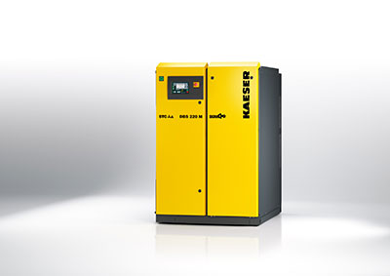
The new DBS screw blowers from Kaeser are compact and efficient systems

