April 2020
The portable powerhouse:
Delivering large volumes of oil-free compressed air - when it's needed, where it's needed

With flow rates up to 45.8 m³/min, when it comes to producing large volumes of oil-free portable compressed air, the Mobilair M500-2 dry-running diesel driven portable screw compressor from Kaeser Compressors presents an exceptionally powerful and flexible solution.

From mining, construction and refineries sites to the manufacture and production of food, beverages, chemicals and pharmaceuticals to name only a few - a diverse range of industries and applications require large volumes of oil free - and often portable - compressed air.

The Mobilair 500-2 from Kaeser Compressors is the ideal solution. Expertly engineered for maximum versatility and fuel efficiency, the innovative M500-2 combines all the advantages of a two-stage dry-running oil-free rotary screw compressor with those of a mobile unit, and is always ready when it’s needed and wherever it’s needed.

At the heart of the M500-2 is a proven two-stage dry running rotary screw compressor. Thanks to an innovative coating that withstands temperatures up to 300ºC, the machines sandblasted, phosphate-treated rotors show no measurable signs of wear, even after years of operation. This translates into maximum long-term efficiency and no increase in fuel consumption over the operating life of the machine.
A generously sized fuel tank further ensures the M500-2 can run for two entire sequential shifts without the need to refuel and can even run continuously when connected to an optional external fuel tank. The reliable on-board Caterpillar C18 diesel engine is rated at 447.5 kW.

The M500-2 includes an integrated Sigma Control mobile controller which automatically adjusts the motor speed to the exact pressure set-point between 4 and 10.3 bar. Compressed air discharge temperature can also be selected via the controller.

This portable compressor also comes as standard with a spark arrestor and motor shut off valve for installation in refineries and is mounted on a supporting chassis with parking brake so that it can be quickly and safely positioned anywhere. It also features crane and lashing eyes, as well as forklift pockets. This giant unit, which weighs in at just less than twelve tonnes, can therefore be precisely placed exactly where needed; the parking brake on the chassis also ensures that it stays put.

The M500-2 delivers a dependable supply of quality compressed air from 4 to 10.3 bar. Maximum free air delivery varies from 38 m³/min (10.3 bar) to 45.8 m³/min (6.9 bar). For more information visit nz.kaeser.com or phone 0800 447 820.
-END-
Editors Notes
From 0.18 to 515 kW, Kaeser Compressors manufactures a wide range of compressors and associated auxiliary equipment that meet the varying requirements of a diverse range of industries and applications.

One of the world’s largest manufacturers of rotary screw compressors, Kaeser Compressors is represented globally in over 100 countries through a dedicated network of branches, subsidiary companies and authorised partners.

Kaeser Compressors NZ Limited provides comprehensive air compressor and blower sales and service throughout New Zealand from its offices in Auckland, alongside a dedicated and nationwide network of authorised partners.

For editorial and advertising enquiries contact: Beth Wood, Marketing Manager
Press office: +61 3 9791 5999 Fax: +61 3 9791 5733
E-mail: beth.wood@kaeser.com

KAESER COMPRESSORS NZ Limited
18B Tarndale Grove, Albany, Auckland 0632, New Zealand
Phone: +64 9 941 0499 Email: info.newzealand@kaeser.com
nz.kaeser.com

File: C-M500-2-2020-nz
Approved for publication, copy acknowledgement appreciated
Image:
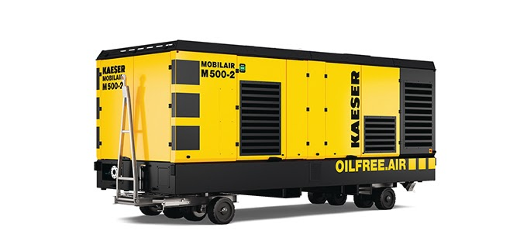
Caption: The M500-2 portable powerhouse - delivering large volumes of oil-free compressed air - when it's needed, where it's needed

Kaeser photo(s) – free for publication, credits appreciated.

