A powerful, versatile and energy efficient supply of portable compressed air
For applications where large volumes of portable compressed air are required, the Mobilair 500-2 dry running diesel driven portable screw compressor from Kaeser Compressors presents an exceptionally powerful and versatile solution.
The M500-2 sets new standards in the fifty cubic metre class, delivering compressed air from 4 to 10.3 bar. Maximum free air delivery varies from 38 m³/min (10.3 bar) to 45.8 m³/min (6.9 bar). The M500-2 is the ideal solution for leasing companies, combining the advantages of a dry-running rotary screw compressor with those of a portable machine. In addition, the Mobilair 500-2 can be easily integrated into compressor stations controlled by a master control system.
The perfect choice where large volumes of compressed air are required, the M 500-2 from Kaeser can be used in industrial applications, especially when it is needed to bridge maintenance outages or when a plant is being upgraded. Other potential applications include tunnel construction and pipeline flushing in refineries.
At the heart of the Mobilair 500-2 is a proven two-stage dry running rotary screw compressor. Thanks to an innovative special coating that withstands temperatures up to 300ºC, the machines sandblasted, phosphated rotors show no signs of wear, even after many years of operation. This translates to consistent high energy efficiency and no increase in fuel consumption over the operating life of the machine. A large capacity fuel tank enables back-to-back operation over two shifts without the need to refuel. Continuous operation is also possible via an optional external fuel tank. The reliable on-board Caterpillar C18 diesel engine is rated at 447.5 kW.
The Mobilair 500-2 comes with an integrated Sigma Control mobile controller which automatically adjusts the motor speed to the exact pressure set-point between 4 and 10.3 bar. Compressed air discharge temperature can also be selected via the controller. The M500-2 comes as standard with a spark arrestor and motor shutoff valve for installation in refineries and is mounted on a supporting chassis with parking brake so that it can be quickly and safely positioned anywhere. It also features crane and lashing eyes, as well as forklift pockets. This giant unit, which weighs in at just less than twelve tonnes, can therefore be precisely placed exactly where needed; the parking brake on the chassis also ensures that it stays put.
In the unlikely event of a fault, the integrated Mobilair fleet management system automatically notifies Kaeser Air Service. The Mobilair fleet management system also supplies the leasing company with a steady stream of data that can be used for invoicing, documents the machine's location and provides notification when maintenance is required during long-term use. Everything is accessible online.

File: c-m500-2-nz
Approved for publication, copy acknowledgement appreciated
Image:

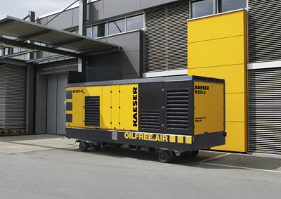
Kaeser Mobilair 500-2 provides a powerful, versatile and energy efficient supply of portable compressed air

