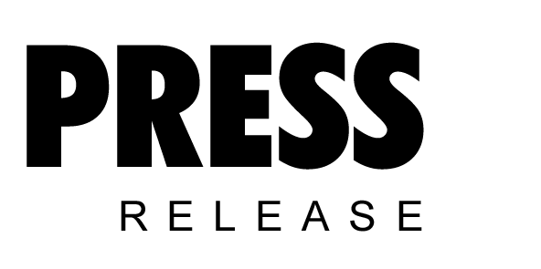

July 2017

Kaeser compressed air seminar returns to NMEC Training Village

Engineers wishing to extend their understanding of how to operate an energy efficient compressed air system are invited to join Kaeser Compressors for the one-day Compressed Air Seminar being held within the NMEC Training Village in Hamilton on 14 November.

Kaeser Compressors is delighted to be bringing the Compressed Air Seminar back to the NMEC Training Village. Following a successful inaugural half-day seminar in 2016, Kaeser will return to the NMEC Training Village, this year with an extended one-day program.

From the fundamental principles of compressed air to the operation and maintenance of air compressors, control systems and air treatment, this Compressed Air Seminar from Kaeser will provide participants with the knowledge that can ultimately assist them in optimising the energy efficiency of a compressed air system.

Often considered the fourth utility, compressed air is commonly one of the largest single energy consumers within a manufacturing facility and, depending on utilisation, electrical power can account for up to 90 percent of the total costs of compressed air production. In addition, the energy costs of a typical compressed air system can account for almost three quarters of its lifetime costs. It therefore makes sense to keep the power consumption of a compressed air system to a minimum.
Fortunately, compressed air is one source of energy where significant and sustainable energy savings can be found and many existing compressed air users could be hiding an energy savings potential of 30 percent or more!

Anyone wanting to use compressed air energy efficiently must consider the compressed air system as a whole and understand the numerous correlations and interactions within the system and its integration into the operational environment. The first step in realising such energy savings potential is therefore knowledge, and for many, compressed air training and education will be the key to unlocking this potential.

Committed to supporting the compressed air industry with training and education, this Compressed Air Seminar is designed to equip compressed air; end users, operators, supervisors and consultants, with the knowledge to assist them in optimising the productivity and energy efficiency of a compressed air system as well as controlling associated operating costs.
-END-
Editors Notes
From 2.2 to 500 kW, Kaeser Compressors manufactures a wide range of compressors and associated auxiliary equipment that meet the varying requirements of a diverse range of industries and applications.

One of the world’s largest manufacturers of rotary screw compressors, Kaeser Compressors is represented globally in over 100 countries through a dedicated network of branches, subsidiary companies and authorised partners.

Kaeser Compressors NZ Limited provides comprehensive air compressor and blower sales and service throughout New Zealand from its offices in Auckland, alongside a dedicated and nationwide network of authorised partners.

For editorial and advertising enquiries contact: Beth Wood, Marketing Manager
Press office: +61 3 9791 5999 Fax: +61 3 9791 5733
E-mail: beth.wood@kaeser.com

KAESER COMPRESSORS NZ Limited – 18B Tarndale Grove, Albany, Auckland 0632, New Zealand
Phone: +64 9 941 0499 – www.kaeser.co.nz – E-mail: info.newzealand@kaeser.com

File: O-NMEC-CAS-2017-nz
Approved for publication, copy acknowledgement appreciated
Image:

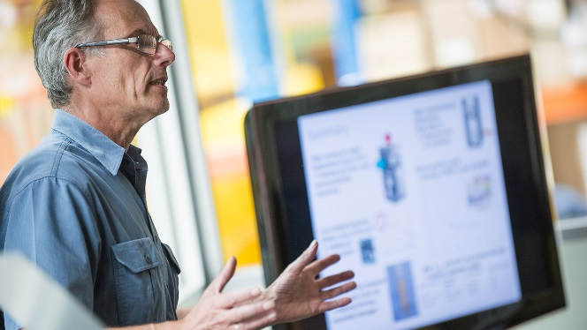
Join Kaeser in the NMEC Training Village for the Compressed Air Seminar
017_Image 1_Kaeser Compressed Air Seminar.jpg

((Kaeser photo – free for publication))

