**September 2024**

**Introducing the M10E and M13E portable compressors:  
KAESER expands its e-power range**

**Powerful, lightweight, quiet, versatile, and easy to transport - these are the standout features of the Mobilair M10E and M13E, the newest and smallest additions to KAESER’s popular e-power range of portable compressors.**

Designed to meet smaller compressed air requirements wherever an electrical supply is available, these compressors are a game-changer for users across a range of industries.

**Versatile performance and technically oil-free compressed air**

The M10E and M13E are ideal for users who need a reliable and efficient portable compressor. With an air delivery volume of 1.2 m³ per minute at 7 bar, the Mobilair M13E can easily power pneumatic hammers, saws, sewer robots, and impact moles. Additionally, the Mobilair M13E is available in 10-, 12-, 13-, and 15-bar pressure variants, making it suitable for various applications - from traditional hammer operations and blasting work to cable blowing and even as a temporary replacement in compressor rooms.

When paired with the Purpac F16 support frame, which includes a compressed air aftercooler and filter combination for the 1 m3 class, users can benefit from technically oil-free compressed air, ideal for sensitive applications.

**Plug-and-Play simplicity with flexible power options**

Equipped with a 7.5 kW motor, the M13E can be plugged into a 400V three-phase socket with a 32A circuit breaker, ready for immediate operation. For sites with limited power supply options - such as those powered by construction site distributors, generators, or external battery storage - the M10E, with its 5.5 kW motor and slightly lower flow rate, is the perfect solution. It operates seamlessly on a 16A connection, significantly broadening its range of potential applications.

**Durable, quiet, and easy to transport**

All models feature a corrosion-resistant, soundproof enclosure made from rotation-sintered polyethylene, ensuring they are exceptionally quiet and highly durable. Their compact and lightweight design allows for easy transport in a delivery vehicle, or on the loading floor of a truck or ute, leaving the towing hitch free for other needs.

For applications requiring cool, condensate-free compressed air, an external aftercooler can be installed in a support frame equipped with fixed connections for compressed air, condensate return, and electrical power (12 V supply from the compressor). The aftercooler ensures any accumulated condensate is collected in a canister within the compressor for professional disposal.

**User-friendly design for easy maintenance and handling**

The M10E and M13E are designed with the user in mind, offering exceptional ease of maintenance and handling. Their manoeuvrability on-site is enhanced by a long handle, rugged wheels with pneumatic tyres, four convenient lifting-lugs, and a countersunk crane eye. Maintenance is a breeze with all service points easily accessible via the wide-opening sound enclosure. For more information visit nz.kaeser.com or phone 0800 447 820.  
**-END-**

**Editors Notes**Kaeser Compressors is one of the world’s leading compressor manufacturers and compressed air system providers, represented internationally by a comprehensive network of subsidiaries and authorised distribution partners in over 140 countries.

Kaeser’s comprehensive product range comprises; reciprocating and rotary screw compressors ranging from 0.18 to 515 kW, portable rotary screw compressors, high-pressure and dry-running compressors, compressor control systems, vacuum pumps, rotary blowers, rotary screw blowers, turbo blowers, air filters, refrigeration & desiccant dryers, as well as compressed air system accessories and services.  
  
Established in 2015, Kaeser Compressors NZ Limited, provides comprehensive sales and service throughout New Zealand, from its facility in Auckland, alongside an extensive network of authorised partners.  
  
**For editorial and advertising enquiries contact:**

Press office: +64 9 941 0499 E-mail: marketing.nz@kaeser.com  
  
**KAESER COMPRESSORS NZ Limited**

18B Tarndale Grove, Albany, Auckland 0632, New Zealand  
Phone: +64 9 941 0499 Email: info.newzealand@kaeser.com Web: nz.kaeser.com

**Images:**

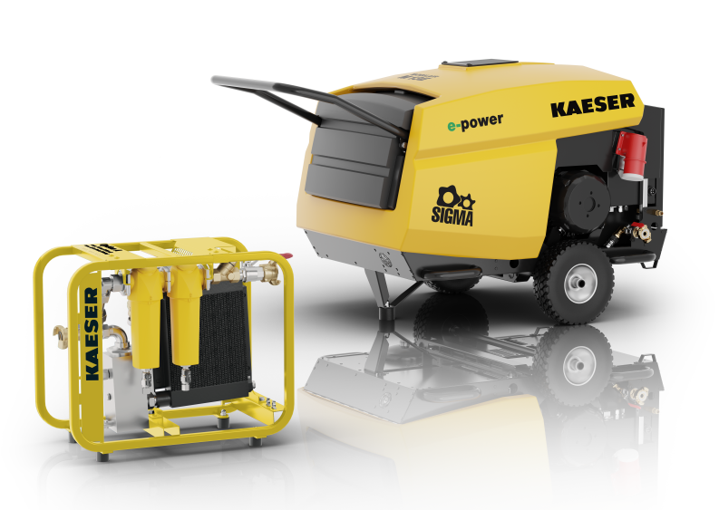

C-M_13_E_001.jpg

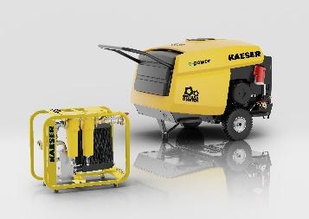

C-M_13_E_002.jpg

Caption: Introducing the new M10E and M13E with optional support frame - delivering reliable, technically oil-free compressed air with a compact and powerful design.

((Kaeser photo – free for publication))