July 2025
Kaeser Compressors NZ celebrates a decade of excellence in compressed air solutions
2025 marks a significant milestone for Kaeser in New Zealand – ten years since the establishment of Kaeser Compressors NZ Limited. Kaeser has been present in the New Zealand market for over 30 years, supporting customers nationwide through a dedicated network of authorised sales and service partners. Continued growth and demand led to the formation of the limited company in 2015, strengthening Kaeser’s local presence. With its head office in Auckland and ongoing support from its nationwide network, Kaeser delivers premium compressed air solutions and exceptional service to industries across the country.
Supporting New Zealand industry with premium compressed air solutions
Kaeser’s direct presence in New Zealand ensures that compressed air users from Whangarei to Invercargill benefit from fast and reliable access to the latest in German-engineered compressed air technology. With locally held stock and a nationwide network of Authorised Sales and Service Partners, some of whom have been representing Kaeser for over 30 years, Kaeser is well positioned to respond quickly to customer needs. From manufacturing and food processing to aquaculture and marine industries, Kaeser’s energy-efficient and reliable compressed air systems have become a trusted part of production operations large and small.
Service you can count on
Kaeser’s dedicated network of highly skilled service technicians provides comprehensive service and backup nationwide. Each service vehicle is fully equipped with locally held genuine Kaeser service and maintenance parts, ensuring fast, efficient support and minimal downtime. This enables customers across New Zealand to rely on a consistent, dependable supply of compressed air – on demand.
A local team with global backing
Kaeser Compressors NZ is proud to be part of a global organisation with over a century of experience in compressed air innovation. Founded in 1919 in Coburg, Germany, Kaeser Kompressoren has grown into one of the world’s leading compressed air system providers, with a presence in more than 140 countries and over 8,000 employees worldwide.
Despite its global scale, Kaeser remains a family-owned company, and this is reflected in its values. The New Zealand team shares Kaeser's long-standing commitment to building lasting relationships, delivering technical excellence, and maintaining unwavering service quality—principles that have guided the company for over 100 years.
Looking ahead
As Kaeser Compressors NZ marks its 10-year anniversary, the company looks to the future with the same pioneering spirit that has driven its success since day one. With continued investment in local expertise, sustainable technologies, and customer-focused solutions, Kaeser remains dedicated to supporting New Zealand’s industrial future – one reliable compressed air system at a time.

-END-
Editors Notes
Kaeser Compressors is one of the world’s leading compressor manufacturers and compressed air system providers, represented internationally by a comprehensive network of subsidiaries and authorised distribution partners in over 140 countries.

Kaeser’s comprehensive product range comprises; reciprocating and rotary screw compressors ranging from 0.18 to 515 kW, portable rotary screw compressors, high-pressure and dry-running compressors, compressor control systems, vacuum pumps, rotary blowers, rotary screw blowers, turbo blowers, air filters, refrigeration & desiccant dryers, as well as compressed air system accessories and services.
Established in 2015, Kaeser Compressors NZ Limited, provides comprehensive sales and service throughout New Zealand, from its facility in Auckland, alongside an extensive network of authorised partners.
For editorial and advertising enquiries contact:
Press office: +64 9 941 0499 E-mail: marketing.nz@kaeser.com
KAESER COMPRESSORS NZ Limited
18B Tarndale Grove, Albany, Auckland 0632, New Zealand
Phone: +64 9 941 0499 Email: info.newzealand@kaeser.com Web: nz.kaeser.com

Images:

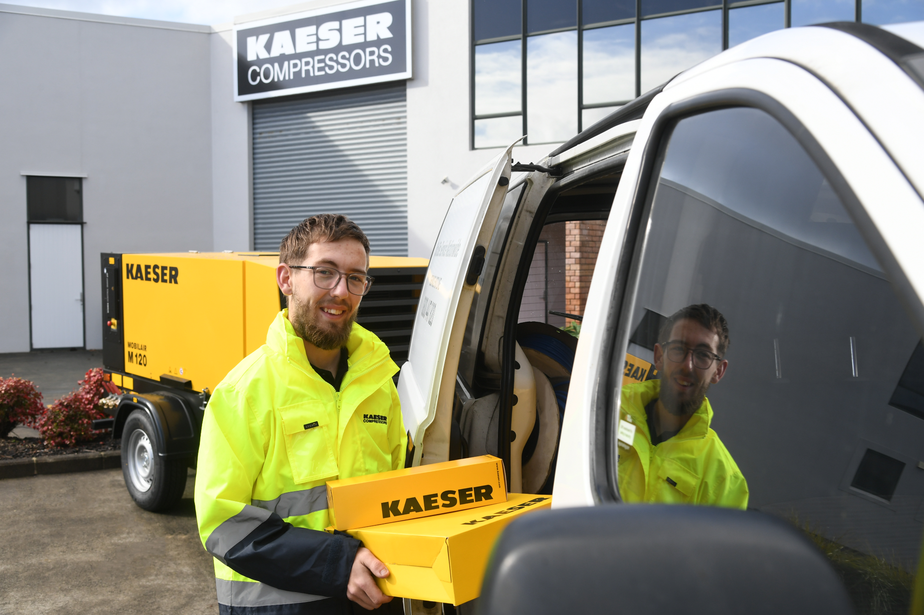

Caption: Kaeser’s skilled service technicians deliver nationwide support, ensuring compressed air systems remain reliable and efficient – whenever and wherever they’re needed.

((Kaeser photo – free for publication))

Caption: Celebrating 10 years of local excellence – the Kaeser Compressors NZ team marks a decade of delivering premium compressed air solutions and service across New Zealand.

((Kaeser photo – free for publication))
