Kaeser expands its range of energy saving low pressure screw blowers
Following the successful 2014 market launch of the highly efficient EBS series screw blowers featuring Sigma Profile rotors, Kaeser is proud to announce the launch of the FBS series screw blowers which provide free air deliveries up to 67 m³/min.
Launched at Hannover Fair 2015, the new FBS series screw blowers provide a low pressure compressor solution that is remarkably quiet, yet highly efficient. In fact, the FBS series screw blowers are up to 35 percent more efficient than conventional rotary blowers, outclassing other comparable screw and turbo blowers on the market. Such significant energy savings are realised thanks to the inclusion of the same proven and trusted technology inherent in the standard Kaeser compressor range.
The rotors found in the EBS and FBS series screw blowers from Kaeser are uncoated. This ensures that the user can enjoy outstanding efficiency, year after year. The data provided for the effective total energy consumption and usable flow capacity correspond precisely to the machines' actual performance (as per the conservative tolerances outlined by Standard ISO 1217; measurements validated by TÜV-Süd). This ensures that the estimated savings calculated as a result of investing in this piece of equipment are actually realised.
All EBS and FBS series screw blowers from Kaeser feature an integrated Sigma Control 2 controller. This provides continuous and comprehensive monitoring whilst allowing straightforward connection of each machine to communications networks.
For users requiring further productivity and energy savings capabilities, the Sigma Air Manager (SAM) master controller can be introduced. SAM features further refined software specialised for blower operations. Sectors such as the food and beverage, pharmaceutical, chemical, pulp and paper, textile and construction materials industries, and applications such as wastewater treatment, pneumatic conveying systems and power generation, can all benefit from this innovative screw blower technology.
Made in Germany, the EBS and FBS series screw blowers possess numerous other outstanding qualities that Kaeser products are renowned for. This includes an internal cooling system that makes the energy-intensive use of oil pumps and oil coolers redundant.
Furthermore, they feature a highly effective sealing concept that ensures long-term seal integrity without the need for vacuum pumps. The durability and reliability of these machines is also enhanced by eliminating the need for auxiliary equipment and circulating oil lubrication. Cooling and process air are drawn in separately from outside the machine enclosure, which not only provides greater usable air mass flow for the same power consumption, but also ensures optimum cooling and efficiency.
Thanks to a clever component layout, these units can easily be installed directly next to a wall, or side-by-side, additionally making maintenance easy.
The durable EBS/FBS series screw blowers from Kaeser have been designed for dependable and continuous operation, and are available with free air deliveries from 10 to 67 m³/min, maximum differential pressure 1.1 bar.

File: h-fbs-nz
Approved for publication, copy acknowledgement appreciated
Image:

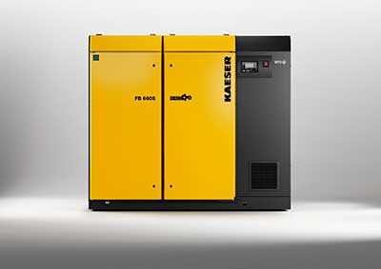
The new FBS series screw blowers provide a low pressure compressor solution that is remarkably quiet, yet highly efficient

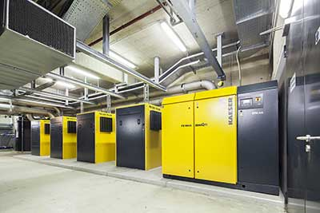
A clever component layout ensures that these units can easily be installed directly next to a wall, or side-by-side, additionally making maintenance easy.

