## **August 2025**

## **Kaeser's custom Mobilair** **M 50PE: Powering Akaroa Salmon's operations**

**Akaroa Salmon grows premium king salmon in Akaroa Harbour. A reliable supply of high-quality compressed air is critical to their operation, effectiveness and efficiency. When ageing compressed air equipment began to impact their operations, Akaroa Salmon sought a reliable, sustainable solution that would support their unique operational needs. Kaeser Compressors delivered with a custom, aquaculture-specific compressed air system that enabled the continuation of their practices and aligned with their commitment to environmental stewardship.**

**Akaroa Salmon's commitment to natural growth and environmental care**

Akaroa Salmon is dedicated to a natural growth process for its king salmon. Salmon are initially raised in Waiau, North Canterbury, for six months before being transferred to Akaroa Harbour for an additional 16 months. Akaroa Salmon prioritises a natural growth pace, maintaining low stocking densities with pens being 99% water and 1% fish. This commitment extends to its marine environment through the avoidance of antifouling chemicals and artificial lighting, preserving natural ecosystems. Harvesting occurs five days a week, with salmon dispatched the same day to local supermarkets and premium international markets, including China and Singapore.

**Replacing ageing equipment to continue operations**

A reliable supply of compressed air is essential to Akaroa Salmon's operational system. "Compressed air is critical to our operation," explained Ben Divett, Aquaculture Manager at Akaroa King Salmon. With aging equipment showing signs of failure, there was an urgent need for replacement. The company required an air compressor capable of delivering approximately 5 m³/min of compressed air, durable enough for permanent outdoor operation in a salty marine environment. Finding a solution that aligned with their standards of environmental stewardship was non-negotiable.

**Kaeser delivers custom aquaculture-specific solution**

Kaeser Compressors supplied Akaroa Salmon with a custom M 50PE portable compressor. This unit was specifically designed for the demanding conditions in Akaroa Harbour, offering exceptional corrosion protection and reliable performance in harsh, saltwater environments. Engineered to operate continuously outdoors, the M 50PE delivers the long-lasting performance and reliability that Akaroa King Salmon's operations require.

## 

## 

## **Exceeding expectations in reliability and ease of use**

The M 50PE has now been in operation for over six months at Akaroa Salmon and is exceeding expectations. The equipment has proven to be extremely reliable, ensuring Akaroa Salmon’s critical systems operate without interruption. Divett immediately noticed the user-friendly features of the new unit. "It’s a lot more accessible than our old equipment — the plastic canopy lifts up easily, making refilling and servicing straightforward."

Divett concludes, "The Kaeser equipment is fantastic. It’s exceeding our expectations. It’s very reliable, more accessible, and incredibly user-friendly compared to our old system."

For more information on Kaeser products, visit nz.kaeser.com or call 0800 447 820.

**-END-**

**Editors Notes**Kaeser Compressors is one of the world’s leading compressor manufacturers and compressed air system providers, represented internationally by a comprehensive network of subsidiaries and authorised distribution partners in over 140 countries.

Kaeser’s comprehensive product range comprises; reciprocating and rotary screw compressors ranging from 0.18 to 515 kW, portable rotary screw compressors, high-pressure and dry-running compressors, compressor control systems, vacuum pumps, rotary blowers, rotary screw blowers, turbo blowers, air filters, refrigeration & desiccant dryers, as well as compressed air system accessories and services.  
  
Established in 2015, Kaeser Compressors NZ Limited, provides comprehensive sales and service throughout New Zealand, from its facility in Auckland, alongside an extensive network of authorised partners.

**For editorial and advertising enquiries contact:**

Press office: +64 9 941 0499 E-mail: marketing.nz@kaeser.com  
  
**KAESER COMPRESSORS NZ Limited**

18B Tarndale Grove, Albany, Auckland 0632, New Zealand  
Phone: +64 9 941 0499 Email: info.newzealand@kaeser.com Web: nz.kaeser.com



**Images:**

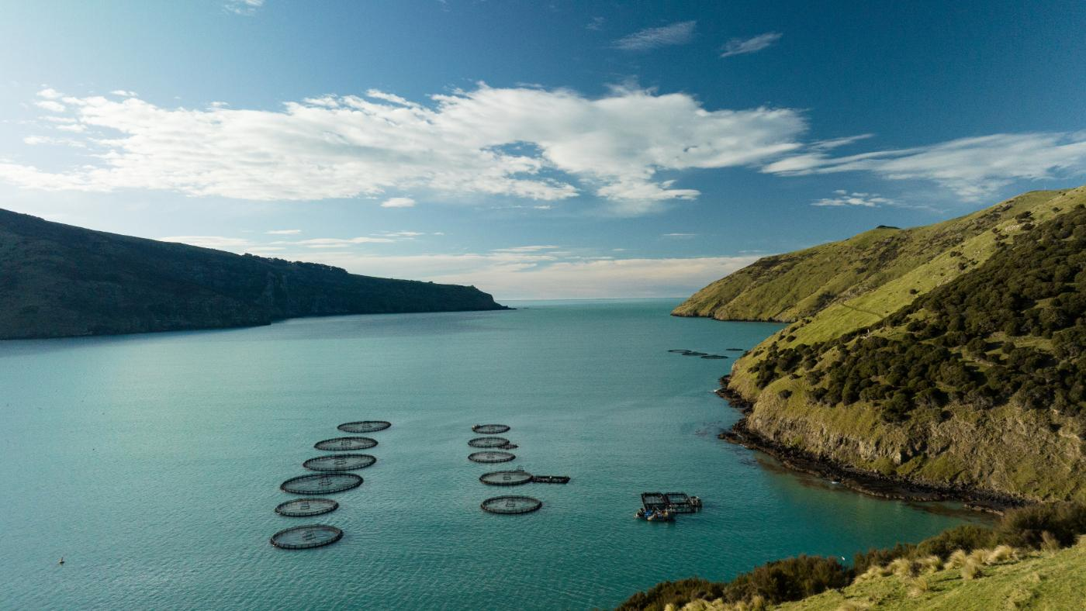

Caption: Overview of Akaroa Harbour, where Akaroa King Salmon's operations are situated.

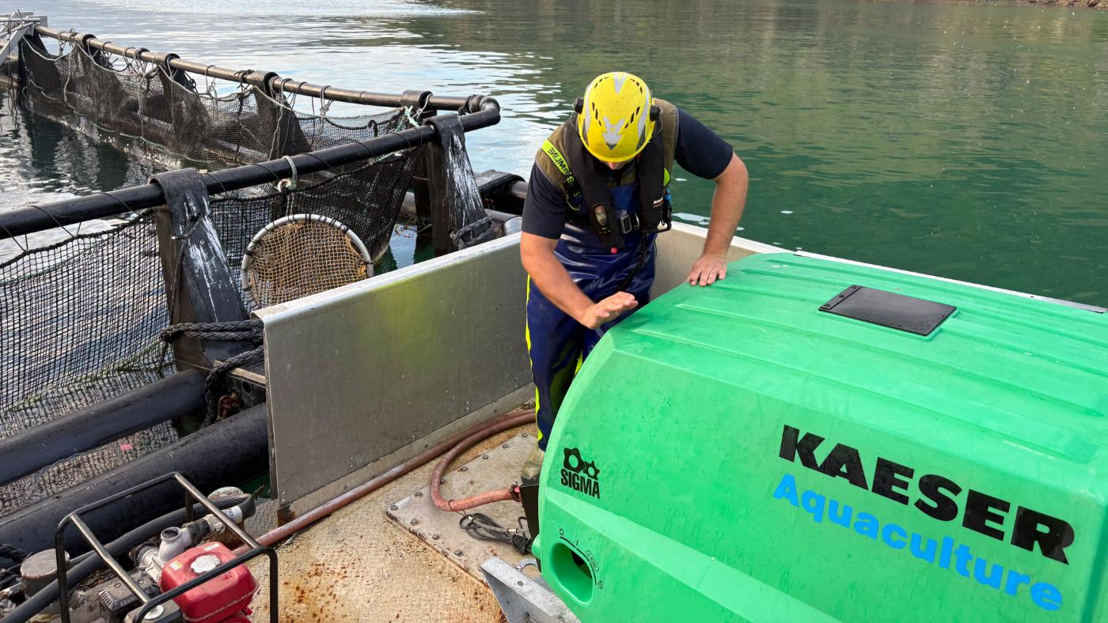

Caption: Built for the harbour: Kaeser's custom Mobilair M 50PE portable compressor delivers uninterrupted compressed air to Akaroa King Salmon.

((Kaeser photos – free for publication))