**April 2025  
Mobilair M 50E: The versatile powerhouse**

**The proven 5 m³ M 50E from the e-power series now comes in a new version with cutting-edge control technology. In addition to the existing model with a robust star-delta starter, the M 50E SFC (Sigma Frequency Control) is now available with a frequency converter. This innovation significantly enhances the flexibility of this portable construction compressor, delivering decisive benefits across a range of applications**.

With the frequency converter, maximum pressure can be adjusted seamlessly between 6 and 11 bar, making it easy to tailor performance to specific tasks - whether blowing out formwork at 7 bar or dry ice cleaning at 10 bar. The frequency converter also reduces starting current, making it the perfect choice for sensitive power networks, when operating with generators, or in future-ready applications with external battery storage. As a result, power network overloads are effectively prevented.

Moreover, motor speed is automatically adjusted according to air demand, optimising power consumption and further improving energy efficiency. This not only reduces costs but also makes operation of the M 50E SFC even more sustainable.

**Compact, durable and environmentally friendly**

Despite its enhanced features, the M 50E SFC remains a compact and highly portable unit, weighing in at under 750 kg. It is available with a roto-moulded, impact-resistant PE enclosure for mobile use or a zinc-phosphated, powder-coated metal enclosure for stationary applications. Both options provide excellent protection and long-term durability.

Another environmentally friendly feature is the optional compressed air aftercooler. Like all e-power Mobilair compressors, the separated condensate is collected in a dedicated container for safe and responsible disposal.

**Ideal for construction sites and industrial service applications**

The new M 50E SFC is ideal for construction sites with a power supply, but it also excels as a temporary backup unit during service work on industrial compressor stations. Combining efficiency, flexibility, and sustainability, it sets a new benchmark for portable screw compressors.

For more information on our products, visit nz.kaeser.com or call 0800 447 820.

**-END-**

**Editors Notes**Kaeser Compressors is one of the world’s leading compressor manufacturers and compressed air system providers, represented internationally by a comprehensive network of subsidiaries and authorised distribution partners in over 140 countries.

Kaeser’s comprehensive product range comprises; reciprocating and rotary screw compressors ranging from 0.18 to 515 kW, portable rotary screw compressors, high-pressure and dry-running compressors, compressor control systems, vacuum pumps, rotary blowers, rotary screw blowers, turbo blowers, air filters, refrigeration & desiccant dryers, as well as compressed air system accessories and services.  
  
Established in 2015, Kaeser Compressors NZ Limited, provides comprehensive sales and service throughout New Zealand, from its facility in Auckland, alongside an extensive network of authorised partners.  
  
**For editorial and advertising enquiries contact:**

Press office: +64 9 941 0499 E-mail: marketing.nz@kaeser.com  
  
**KAESER COMPRESSORS NZ Limited**

18B Tarndale Grove, Albany, Auckland 0632, New Zealand  
Phone: +64 9 941 0499 Email: info.newzealand@kaeser.com Web: nz.kaeser.com

**Images:**

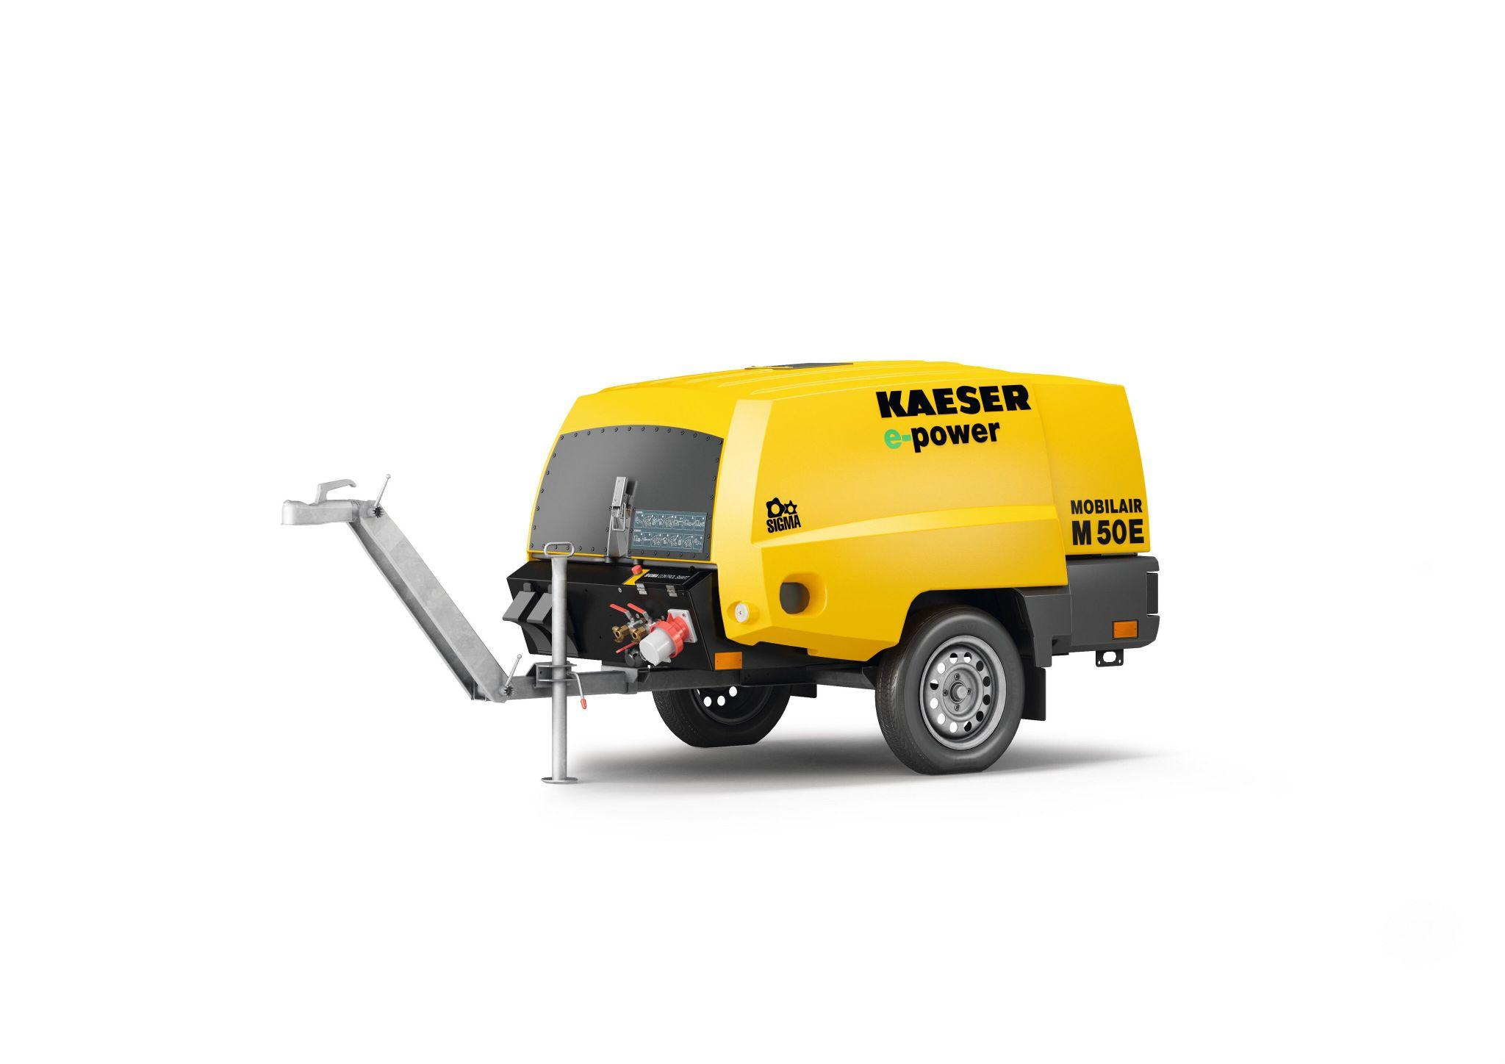

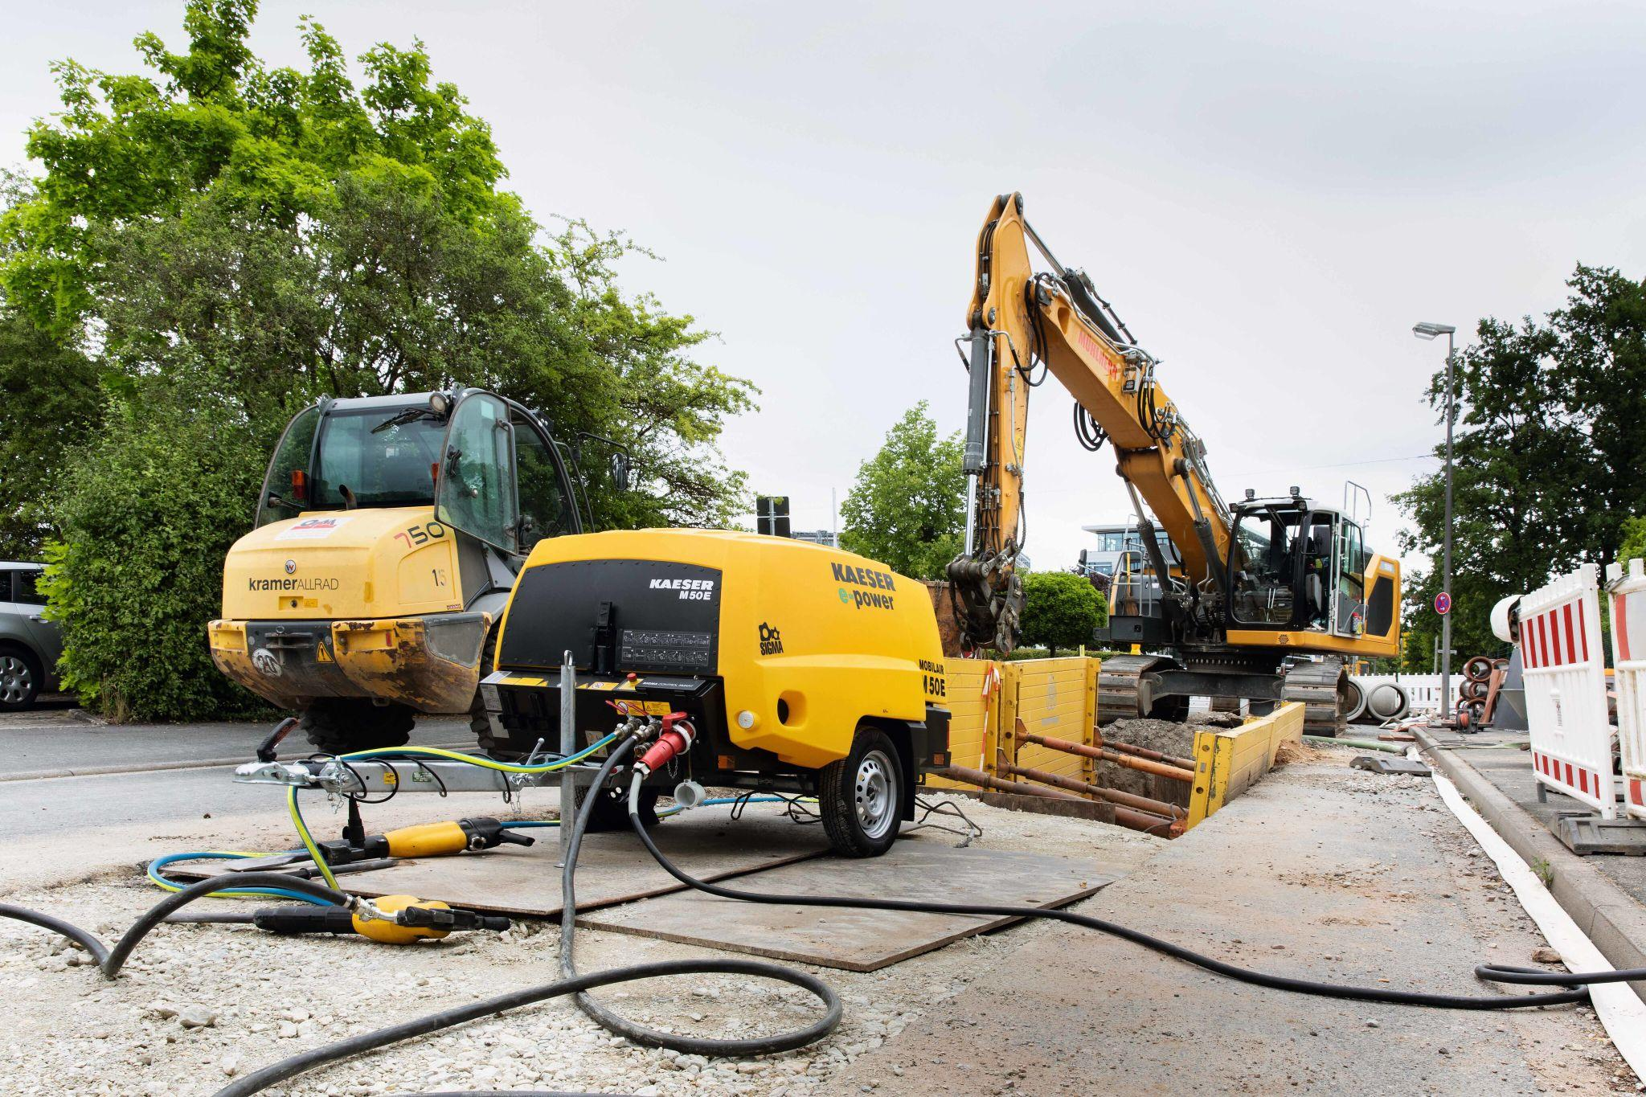

Caption: The M 50E is a true all-rounder for construction site applications.

((Kaeser photo – free for publication))