**August 2024**

**Introducing the innovative Kaeser Aquamat i.CF:**

**The first intelligent oil-water separator**

**Kaeser Compressors has revolutionised condensate treatment with the introduction of its next-generation Aquamat oil-water separator. Available for delivery volumes up to 90 m³/min, the innovative Aquamat i.CF features an advanced internal controller - the Aquamat Control - which undertakes active management of the treatment process whilst simplifying maintenance planning and making service work cleaner.**

Liquid condensate is an inevitable by-product of compressed air generation which must be disposed of in an environmentally responsible manner. Before this can happen, the oily condensate must first be separated out. Conventional oil-water separators rely on gravity to facilitate the separation process, allowing the condensate to trickle through a filter that absorbs the oil. The new Aquamat i.CF, however, has revolutionised condensate treatment by actively and intelligently optimising process efficiency and functional reliability.

**Dependable, resource-friendly operation**

The internal Aquamat Control controller is entirely new. It monitors the condensate level in the oil-water separator and, when the maximum level is reached, uses short bursts of

compressed air to push the condensate through the filter cartridges. This method maximises the absorption capacity of the cartridges, resulting in reliable and resource-efficient operation of the Aquamat i.CF, even under high operational demands. In the unlikely event of a problem, the controller detects it and issues a notification.

For the first time, this active mode of operation allows the remaining service life of the filter cartridges to be accurately determined based on load. The network-capable Aquamat Control controller not only simplifies maintenance planning for the oil-water separator but also guides the operator through the necessary work steps. Another intelligent design feature is the pressurisation of the cartridges, which ensures they are already empty when replacement is needed, making them much lighter and easier to handle.

The overall design of the Aquamat i.CF sets new standards when it comes to hygiene. No contact with the condensate is necessary when changing the cartridges and the whole procedure is contaminant-free, thereby protecting both the environment and service personnel.

**Dependable oil-water separation for delivery volumes up to 90 m³/min**

The Aquamat i.CF is available in five new model variants for compressors with delivery volumes from 8 to 90 m³/min. For added practicality, all models use cartridges of the same size. This considerably simplifies spare parts stocking and supply, thereby saving time and money.

The different capacities of the five model variants are achieved by connecting multiple cartridges in parallel; this modular design concept enables simple, retrospective adjustment of the respective capacity.

The Aquamat i.CF is certified and approved by the Berlin Institute for Construction Technology for state-of-the-art treatment of compressor condensates containing mineral and synthetic oils, providing operators with the highest possible level of technical and legal security. For more information visit nz.kaeser.com or phone 0800 447 820.

**-END-**

**Editors Notes**

Kaeser Compressors is one of the world’s leading compressor manufacturers and compressed air system providers, represented internationally by a comprehensive network of subsidiaries and authorised distribution partners in over 140 countries.

Kaeser’s comprehensive product range comprises; reciprocating and rotary screw compressors ranging from 0.18 to 515 kW, portable rotary screw compressors, high-pressure and dry-running compressors, compressor control systems, vacuum pumps, rotary blowers, rotary screw blowers, turbo blowers, air filters, refrigeration & desiccant dryers, as well as compressed air system accessories and services.

Established in 2015, Kaeser Compressors NZ Limited, provides comprehensive sales and service throughout New Zealand, from its facility in Auckland, alongside an extensive network of authorised partners.

**For editorial and advertising enquiries contact:**

Press office: +64 9 941 0499 E-mail: [marketing.nz@kaeser.com](mailto:marketing.nz@kaeser.com)

**KAESER COMPRESSORS NZ Limited**

18B Tarndale Grove, Albany, Auckland 0632, New Zealand

Phone: +64 9 941 0499 Email: [info.newzealand@kaeser.com](mailto:info.newzealand@kaeser.com) Web: nz.kaeser.com

**Images:**

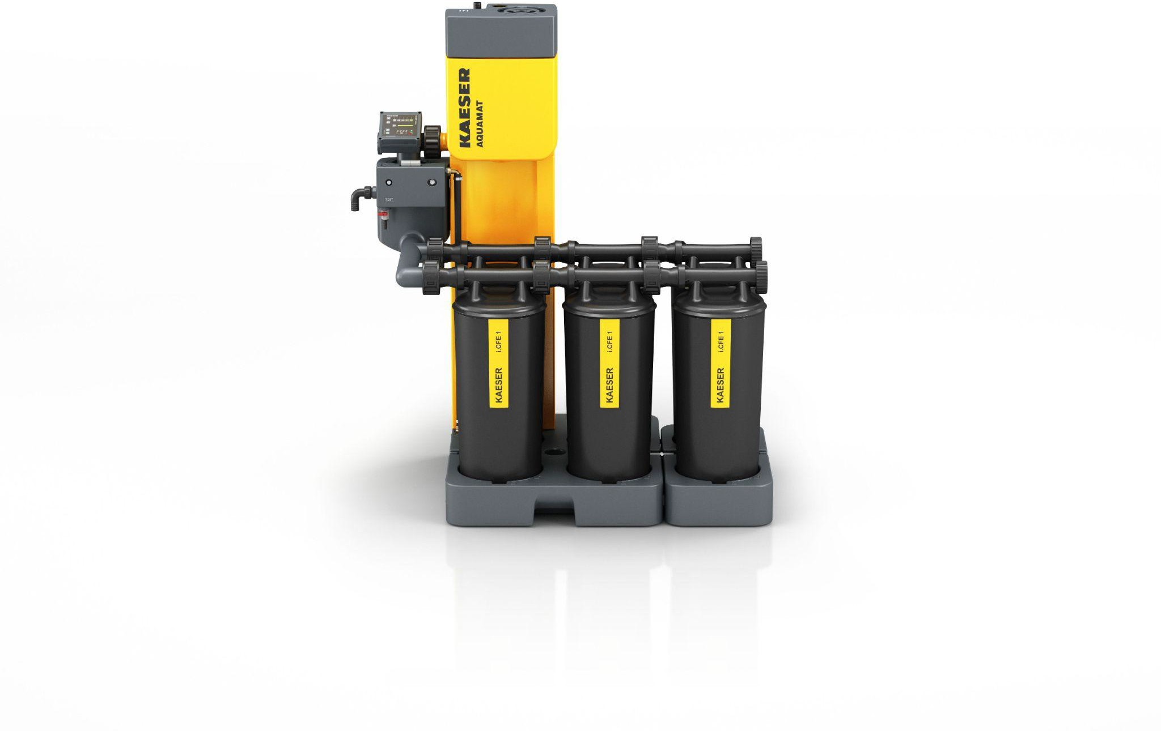

D-KAESER-Aquamat-i-CF-1.jpg

Caption: The active, intelligent Aquamat i.CF – clean, safe and modular.

((Kaeser photo – free for publication))