**May 2025**

**Kaeser Compressors NZ and PSL Total Air to exhibit at SouthMach 2025**

**Kaeser Compressors NZ will be co-exhibiting with PSL Total Air on stand 98 at SouthMach 2025. Visitors will have the opportunity to explore Kaeser's range of reliable and energy-efficient compressed air equipment, including the i.Comp 3, SM 13, M 27, and more. These solutions are designed to deliver a dependable supply of energy-efficient compressed air.**

The i.Comp 3 provides a consistent supply of oil-free compressed air at all times. This flexible, space-saving, and lightweight compressor can be easily transported anywhere, making it an ideal all-rounder for various applications.

The latest generation SM 13 rotary screw compressor features the new SIGMA 06 airend, delivering even greater intake volume and efficiency. With refined SIGMA PROFILE rotors, the SM 13 reduces energy requirements by up to 13%. This versatile compressor is perfect for medium-sized enterprises seeking reliable and energy-efficient solutions.

The Mobilair M 27 portable compressor is convenient, lightweight, powerful, and efficient. It offers a free air delivery of 2.6 m³/min (at 7 bar) and comes with optional features, such as an integrated generator and/or compressed air treatment equipment. A stationary version is also available for specialized applications and can be easily installed on the cargo bed of a truck.

PSL Total Air, an exclusive KAESER dealer, offers high-quality KAESER compressed air systems, pneumatics, pipework, and more. Visit us at SouthMach to discover how Kaeser and PSL Total Air can optimise your compressed air systems.

For more information on our products, visit nz.kaeser.com or call 0800 447 820.

**-END-**

**Editors Notes**Kaeser Compressors is one of the world’s leading compressor manufacturers and compressed air system providers, represented internationally by a comprehensive network of subsidiaries and authorised distribution partners in over 140 countries.

Kaeser’s comprehensive product range comprises; reciprocating and rotary screw compressors ranging from 0.18 to 515 kW, portable rotary screw compressors, high-pressure and dry-running compressors, compressor control systems, vacuum pumps, rotary blowers, rotary screw blowers, turbo blowers, air filters, refrigeration & desiccant dryers, as well as compressed air system accessories and services.  
  
Established in 2015, Kaeser Compressors NZ Limited, provides comprehensive sales and service throughout New Zealand, from its facility in Auckland, alongside an extensive network of authorised partners.  
  
**For editorial and advertising enquiries contact:**

Press office: +64 9 941 0499 E-mail: marketing.nz@kaeser.com  
  
**KAESER COMPRESSORS NZ Limited**

18B Tarndale Grove, Albany, Auckland 0632, New Zealand  
Phone: +64 9 941 0499 Email: info.newzealand@kaeser.com Web: nz.kaeser.com

**Images:**

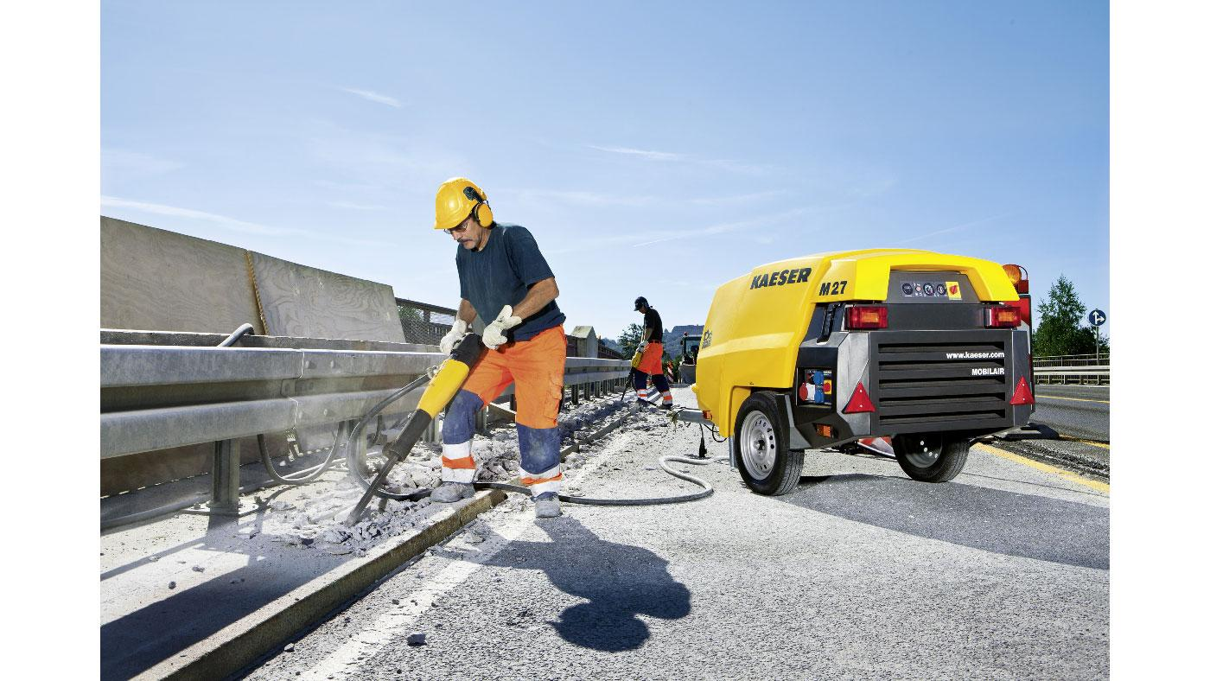

Caption: The Mobilair M 27 portable compressor is convenient, lightweight, powerful, and efficient.

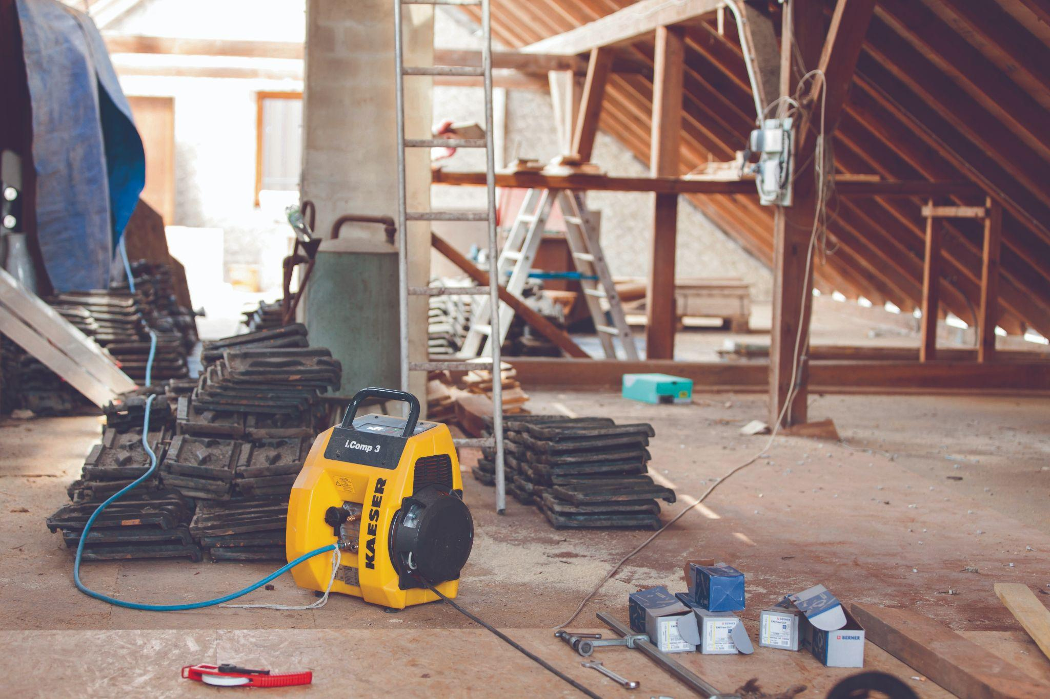

Caption: This flexible, space-saving, and lightweight i.Comp 3 can be easily transported anywhere.

((Kaeser photo – free for publication))