**May 2025**

**Measuring technology - Enhanced safety and efficiency through “artificial eyes”**

**All industries face ever-growing technical demands, driving the need for continuous optimisation and energy-efficient advancements in production processes, including compressed air supply systems. Measurement technology is crucial in maintaining both the efficiency and safety of these systems. Cutting-edge intelligent devices deliver exceptional transparency, enhance supply reliability, and significantly reduce costs.**

Compressed air generation transforms electrical or mechanical energy into pneumatic energy, a process that comes with its own set of challenges, such as minimising energy consumption, maintaining stable pressure levels, ensuring production safety, and preventing contamination or leaks. Measurement technology tackles these challenges by delivering key data that can be used to monitor, control, and optimise system performance.

Compressed air quality requirements in the industrial production are sometimes highly demanding. Manufacturing guidelines are becoming increasingly rigorous, often requiring certification and detailed documentation. Continuous monitoring across the entire process chain - from compressed air generation to distribution - is therefore essential to guarantee quality and safety in sensitive compressed air applications.

In recent years, innovative compressed air solution providers have developed advanced measurement technology systems capable of fully monitoring entire compressed air networks. These systems aggregate data, conduct analyses, and generate evaluations, paving the way for continuous monitoring and optimisation.

Every compressed air system generates an enormous volume of data every second. The challenge lies in capturing this data and converting it into meaningful information that can then be used to draw conclusions and derive actionable recommendations, providing tangible benefits for the compressed air station operator.

While sensors in compressors and compressed air stations have been in use for years, not all sensors and monitoring systems are created equal. Digitalisation has revolutionised measurement technology. Modern compressed air systems utilise multi-sensors capable of transmitting real-time data to central control units or cloud platforms via IoT solutions. This allows for advanced trend analysis and predictive maintenance, reducing both costs and unplanned downtime.

**The right device in the right place**

A meaningful picture only emerges when intelligent sensors are strategically positioned to capture and interpret optimisation-relevant data. Purpose-specific individual sensors, strategically installed at key points within the compressed air system, act as "artificial eyes", capturing targeted data points.  
 This information is then transmitted to a central management system, where it is recorded, analysed, and visualised. The subsequent results can be accessed in the operator's control system and forwarded to the compressed air provider's cloud for intelligent remote monitoring. The station operator has the option to independently monitor their compressed air system and implement optimisation measures or leverage the provider's expertise for real-time monitoring, allowing them to oversee and continuously optimise the compressed air supply as a tailored service. Data collection requires the use of suitable sensors. With advancements in sensor technology, modern measuring devices have become ever more compact and powerful. The latest generation of innovative, intelligent sensors allow flexible installation, even in challenging or hard-to-reach places. These sensors are energy-efficient and deliver reliable data over extended periods.

**The complete system in view**

For comprehensive air system monitoring, it is recommended to install a range of measuring devices to accurately assess flow rate, process air, pressure dew point, intake and ambient air, and energy consumption. These devices should support process and environmental monitoring, ensure quality and energy oversight, and integrate all components into a highly efficient system. Quick and intuitive data analysis is equally essential to maximise efficiency and effectively meet documentation requirements.

So, where are sensors needed, and why? When evaluating a compressed air system, it is crucial to begin at the intake point of the compressors. Room monitoring, often overlooked, plays a significant role, since intake and ambient conditions directly influence the compressed air station components and the quality of the compressed air that is produced. For instance, ambient temperature impacts the compressor's operating temperature, which in turn affects its efficiency by altering the amount of electrical energy required to generate the desired volume of compressed air. In air-cooled compressors, the ambient air also determines the compressed air discharge temperature. Based on the measured conditions, adjustments may be needed for downstream compressed air treatment components, such as refrigeration or desiccant dryers. If key parameters exceed the limits accounted for during the system's initial design, this can lead to a degradation in compressed air quality - a particularly unfavourable outcome for sensitive applications such as tablet manufacturing, where overly moist compressed air can cause tablets to swell. Furthermore, and most importantly, contamination in the compressed air poses a health risk to the end consumer.

A measuring device that monitors room and intake conditions is ideal for evaluating environmental parameters, determining the operating conditions of compressed air station components, and assessing the moisture entering the system under the prevailing conditions. The operating and intake conditions relayed to the monitoring system offer valuable insights into the performance of the components. For instance, this data can help determine the necessary cooling and ventilation requirements within the compressed air station, such as managing recirculated air during the winter months. For certain processes, compressed air mass flow is required instead of volume flow. By measuring intake conditions, the mass flow can be accurately determined, dynamically adjusted, and supplied as required.

Moreover, intake and ambient conditions are invaluable for error analysis and play a key role in applications such as flow rate control for blowers, vacuum regulation, and dynamic compensation for standardised volume flow. The measured parameters ensure that system malfunctions resulting from irregularities can be effectively prevented.

One of the most important process parameters is the pressure at the transfer point, which is essential for optimising compressor control and determining whether production can continue safely. Further analysis options involve measuring media temperatures or pressures downstream from the compressed air generators, as well as upstream and downstream from the compressed air treatment process. The data obtained provides valuable insights into additional opportunities for compressed air supply optimisation.

The next type of measuring device to include in a compressed air station is one designed to monitor flow rates. It is important to distinguish the operating principle of the measuring device and where it is used within the compressed air system. Installed directly downstream from the compressor, a flow rate measuring device based on the differential pressure principle is ideal for determining the generated flow rate, even at high temperatures and for air with an increased moisture concentration. In this case, the flow rate and total consumption are measured and calculated, while pressure, temperature, and flow velocity are also recorded. These devices typically operate within a measurement range of 1:10.

A flow meter based on the thermal mass flow sensor principle has the advantage of covering a larger measurement range. However, it is more sensitive to contamination and should therefore only be used in the compressed air system downstream from compressed air treatment components, such as a refrigeration dryer. This device can also measure low flow rates, making it possible, for example, to detect leaks when work is not being carried out over the weekend.

**Safety for production**

Adherence to specific limit values is of immense importance when using compressed air in production. With proper monitoring, failures and production downtime become a thing of the past. For this purpose, and to assess system pressure at various points, combined measuring devices that monitor pressure and temperature are the ideal choice. These can be installed at key locations, such as the inlet and/or outlet of components or upstream of sensitive applications. This setup enables, among other aspects, pressure differential monitoring throughout the entire compressed air treatment process and compressed air network, as well as ensuring compliance with required temperature levels. It also helps identify potential savings opportunities, such as lowering system pressure, scheduling timely filter replacements and more. In addition, the inlet and outlet temperatures of components can be monitored. Early detection of elevated inlet temperatures in treatment components effectively prevents overloading. An advanced version of this device also measures the pressure dew point, which reflects the moisture content of the compressed air, ensuring the air meets the required degree of dryness to maintain optimal quality.

**Energy monitoring**

The system is complemented by one or more measuring devices for energy analysis, such as a multifunctional network analyser designed to monitor the electrical energy supply. The analyser tracks the quality and reliability of the power supply while recording all critical values and metrics, making it an ideal system solution for modern energy data management, including compliance with ISO 50001 standards. For operators who wish to use the device for energy data management, it can be optionally upgraded with MID (Measuring Instruments Directive) certification for legal metrology. This device also supports compressed air station operators in documenting energy savings and meets the requirements for verifying voltage quality, such as those outlined in EN 61000-2-4.

**Networking for an efficient system**

As previously mentioned, all of the intelligent sensors collect data in various ways and transmit relevant measurements from their respective locations via a data line to a compressed air management system, seamlessly integrating them into a unified network. This process enables real-time monitoring, data analysis, the creation of key performance indicators, and predictive maintenance. Any irregularities can be identified early on, and in the event of a fault, long-term data storage facilitates detailed problem diagnosis.

In an optimally-designed compressor station, the integration of decentralised intelligence (component control) with centralised intelligence (a compressed air management system) establishes the perfect framework for seamless data exchange and analysis. This capability provides the operator with complete oversight. Using internal interfaces and the compressed air management system, they gain a clear, consolidated view of all critical performance metrics of the compressed air station. This is done in real time and on any device. Compressed air management systems can provide the following information: compressor operating data, faults, consumption behaviour, efficiency of the entire compressed air system and connected peripheral devices such as compressed air dryers, condensate drains, and treatment units, as well as ambient conditions and process data. This enables analysis of past anomalies, the prediction of future issues, and the proactive resolution of potential issues before they arise. The collected data can be retrieved from the compressed air management system for up to one year.

This enables the operator to remotely monitor the status of the compressed air supply. Moreover, detailed reporting and effortless data downloads further streamline documentation processes.

With the integration of advanced measuring devices and intelligent technology, previously hidden operations and processes can now be revealed and visualised. The goal is to achieve complete transparency, providing the critical insights needed to create accurate predictive models. Cutting-edge advancements are making this a reality, steadily setting high supply reliability as the new standard.

For more information on our products, visit nz.kaeser.com or call 0800 447 820.

**-END-**

**Editors Notes**Kaeser Compressors is one of the world’s leading compressor manufacturers and compressed air system providers, represented internationally by a comprehensive network of subsidiaries and authorised distribution partners in over 140 countries.

Kaeser’s comprehensive product range comprises; reciprocating and rotary screw compressors ranging from 0.18 to 515 kW, portable rotary screw compressors, high-pressure and dry-running compressors, compressor control systems, vacuum pumps, rotary blowers, rotary screw blowers, turbo blowers, air filters, refrigeration & desiccant dryers, as well as compressed air system accessories and services.  
  
Established in 2015, Kaeser Compressors NZ Limited, provides comprehensive sales and service throughout New Zealand, from its facility in Auckland, alongside an extensive network of authorised partners.  
  
**For editorial and advertising enquiries contact:**

Press office: +64 9 941 0499 E-mail: marketing.nz@kaeser.com  
  
**KAESER COMPRESSORS NZ Limited**

18B Tarndale Grove, Albany, Auckland 0632, New Zealand  
Phone: +64 9 941 0499 Email: info.newzealand@kaeser.com Web: nz.kaeser.com

**Images:**

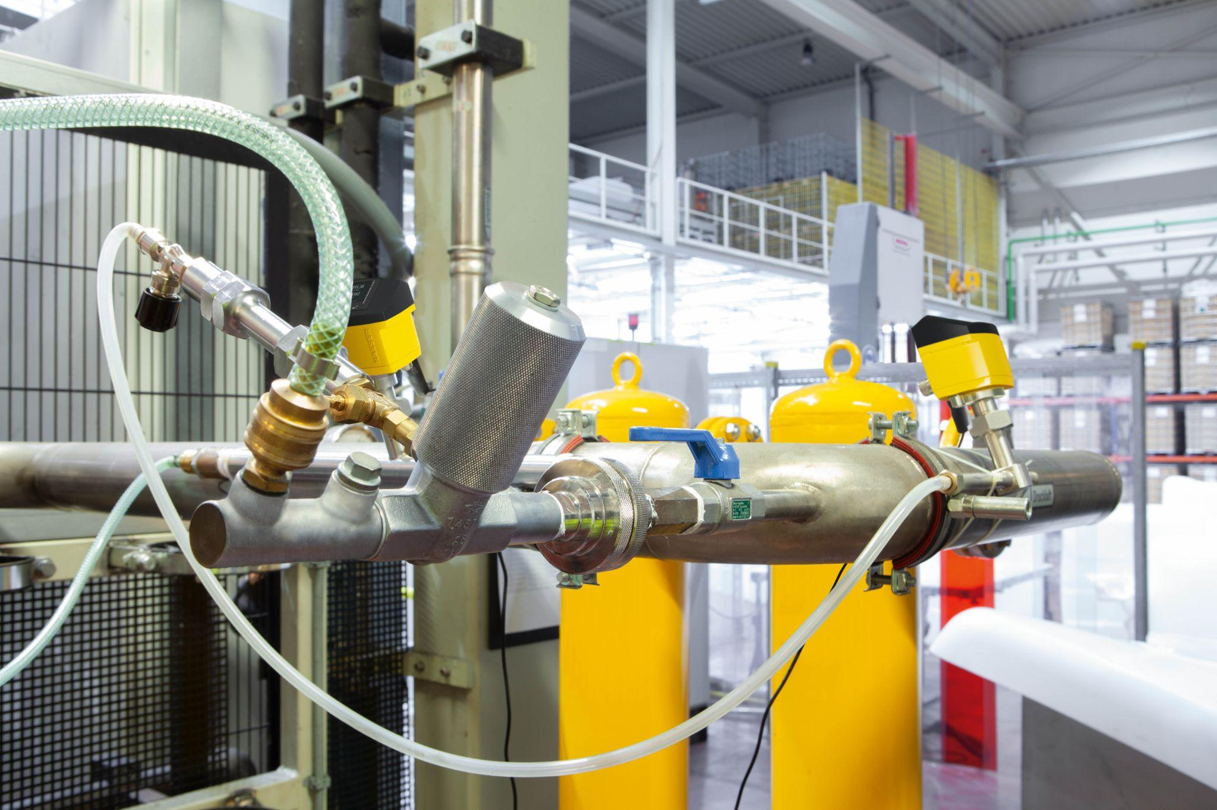

Caption: Strategically placed sensors in a compressed air system enhance safety, efficiency, and sustainability.

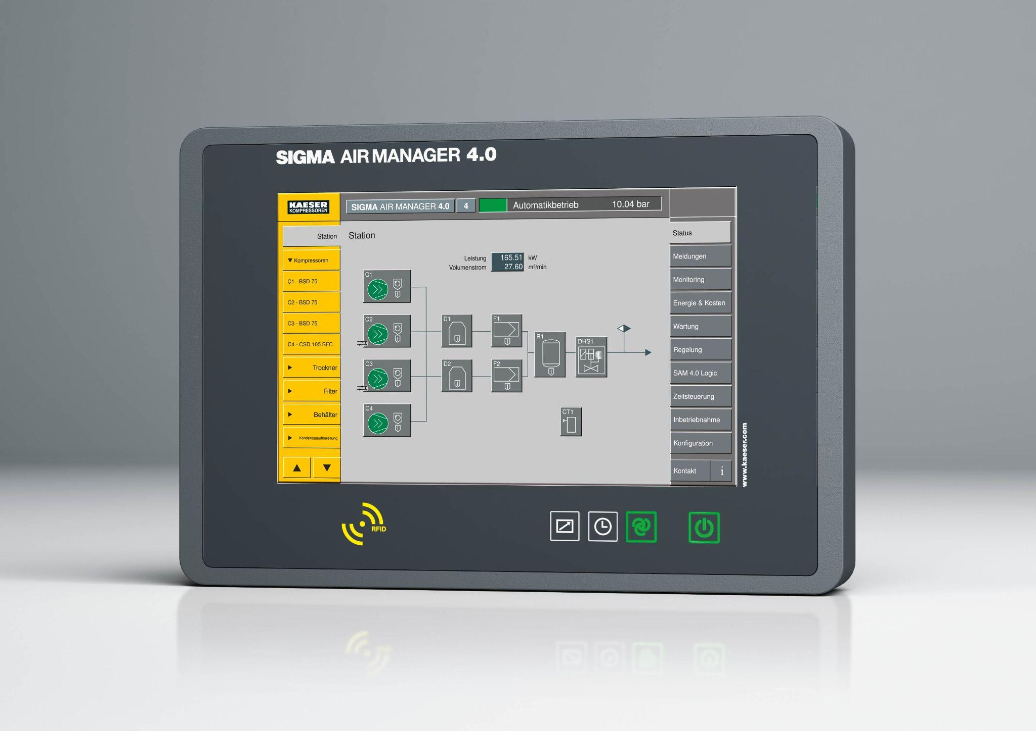

Caption: A compressed air management system acts as the central hub, consolidating data, analysing it, and offering optimisation solutions.

((Kaeser photo – free for publication))