IE4 motor debut
The new BSD series for more air and more savings…
Kaeser's new BSD series rotary screw compressors are compact, powerful, dependable and efficient. They are available as stand-alone units, with an integrated refrigeration dryer, with variable speed drive or as a complete package.

Kaeser Compressor's new BSD series demonstrates that the technology used for large compressors can also be applied to medium-sized rotary screw compressors. For systems with a pressure range up to 15 bar and free air deliveries from 5 to 8 m³/min, any one of the BSD series versions demonstrates the enormous energy savings that can be achieved when using the very latest compressor technology.

Six percent better specific power
The rotary screw compressor airends feature enhanced flow-optimised "Sigma Profile" rotors. Thanks to these further refined rotors and other improvements, such as minimisation of internal pressure losses, Kaeser was able to improve the specific power compared to previous models by up to six percent.

Motors boast world's highest efficiency class
The new Super Premium Efficiency IE 4 motors contribute significantly to this improvement. Kaeser worked in close partnership with a renowned motor manufacturer and already uses these motors exclusively in this next generation of high performance compressor packages. The IE4 motors' ground-breaking efficiency further reduces the peripheral equipment losses associated with compressed air production.

These new compressor packages feature an impressively effective cooling system that makes it possible to maintain extremely low compressed air discharge temperatures. This system includes an efficient condensate separator with a monitored energy saving drain: As a result, over 95 % of the condensate is separated from the air flow. The large external cooler surfaces located on the back of the compressor package also help save energy. Thanks to their cooling efficiency, the compressors can easily be installed in environments where ambient temperatures reach 45 °C. Their external placement also allows easy access and cleaning.

Energy-saving, environmentally friendly fluid filter
Kaeser's developers also gave considerable thought to resource conservation when designing the inside of the compressor package. Whereas in the past, filters had to be completely replaced, on the new BSD compressors, the fluid filter housing is reusable – only the filter element itself needs to be replaced. Not only is this cheaper, it is easier on the environment.

Sigma Control 2 for optimum coordination
All BSD systems are equipped as standard with the Sigma Control 2 controller, which features an RFID reader and Ethernet connection. Furthermore, variable interfaces and - for the first time - plug-in communications modules, enhance flexibility when interfacing with master compressed air management systems, computer networks and/or remote diagnostics and remote monitoring systems such as Kaeser's Teleservice. A large display with thirty language options makes onsite operation simple, whilst an SD card slot allows for easy data readout and software updates. The integrated RFID reader helps standardise field servicing, enhances service quality and provides excellent security. The Sigma Control 2 also monitors the compressor, the refrigeration dryer and the optional variable speed drive.

Wide range of models
Versions equipped with an integrated refrigeration dryer module are also available in addition to the standard models and provide all-in-one compressed air production and drying within a single, compact package. The dryer is sized to handle high ambient temperatures and operates with minimal pressure loss. It is significantly more energy efficient than predecessor models and uses almost fifty percent less cooling fluid. The dryer is mounted in a separate housing and is therefore thermally shielded from the compressor.
The 37-kW BSD package (BSD 75 SFC) is also available with variable speed control. The maximum free air delivery and control range is up to fourteen percent higher than previous versions. These systems provide optimum efficiency throughout their entire control range and ensure the same impressive reliability as standard packages.

File: A-bsd-aus
Approved for publication, copy acknowledgement appreciated

Images:
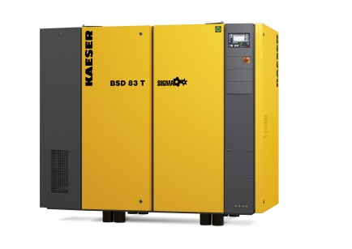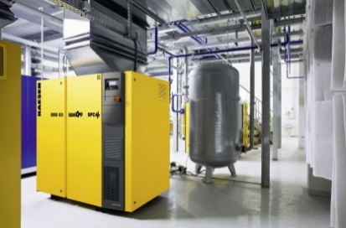

Kaeser's new BSD series rotary screw compressors use even less power thanks to their brand new Super Premium Efficiency IE 4 motors and further enhanced flow-optimised Sigma Profile rotors. They are also available with variable speed drive and integrated dryer as required.

