September 2019

Kaeser opens the door of compressed air energy efficiency for Hume

Hume Doors & Timber - one of Australia’s leading door manufacturers - recently invested in an energy efficient Kaeser CSD 125 rotary screw compressor to meet the increased demand for compressed air created by the expansion of its Sydney manufacturing facility.

Hume Doors and Timber (Hume) is one of Australia’s largest door manufacturers with operations in every capital city and strategically placed regional branches within Australia and New Zealand. Established over 60 years ago and now with over 1,000 employees, Hume proudly remains a 100% Australian owned company.

Hume provides innovation in doorway technology and manufactures an extensive range of products - over 2,000 to be exact - for the building industry including the; commercial and industrial, multi-unit, aged care, residential and renovation sectors. From their manufacturing facilities Hume is able to deliver specialist low volume to mass high volume production. In fact, they were the first company to introduce cold pressing technology to allow for the mass production of doors using sustainable practices - a procedure that also greatly reduces power consumption.

Hume is committed to operating its entire business process in an environmentally sustainable manner. As such its manufacturing and distribution processes have been designed to minimise their environmental footprint. Innovation, sustainability and recycling therefore all have a key role in their manufacturing facilities. One way they try and minimise their environmental footprint is by utilising energy to its maximum efficiency.

It’s no surprise then, that when it comes to the compressed air systems at all of their manufacturing operations, Hume has long since opted for compressed air equipment that is not only reliable but also highly energy efficient. Compressed air is an important utility to Hume and can be found in use across the manufacturing process, responsible for powering the woodworking machinery such as the sanders and staple guns.

Hume recently expanded its manufacturing operation in Sydney. With the expansion came an increased demand for compressed air which the current system could not meet. Eddie Luke, the General Manager at Hume therefore contacted long standing compressed air supplier Kaeser Compressors for a solution.

Kaeser recommended and subsequently installed a CSD 125 rotary screw compressor to meet Hume’s increased demand for compressed air in the most energy efficient manner.

The CSD series rotary screw compressor from Kaeser push the boundaries when it comes to compressed air efficiency. These versatile compressors provide significant energy savings in four key ways:

At the heart of every CSD system lies a premium quality rotary screw compressor block featuring Kaeser’s energy saving Sigma Profile rotors. Operating at low speed, Kaeser’s rotary screw compressor blocks are equipped with flow optimised rotors for superior efficiency. The newly-refined rotors found in the latest generation models, together with additional optimisation measures such as reduced pressure losses, are now delivering between three and six percent better specific power performance compared to previous models.

Kaeser’s 1:1 drive design additionally delivers superior efficiency by eliminating the transmission losses associated with gear or v-belt driven systems. 1:1 direct drive rotary screw compressors provide outstanding performance and enable significant savings.

Featuring an IE4 super premium efficiency drive motor further maximises energy efficiency. IE4 motors are the technology of tomorrow, as current regulations introduced in January 2015 simply require the use of IE3 class motors. IE4 motors comply with and exceed prevailing New Zealand EECA regulations for 3 phase electric motors.

Finally, the Sigma Control 2 industrial PC-based internal controller ensures efficient control and system monitoring. This dynamically adjusts flow rate to match actual compressed air demand thereby assuring further energy savings.

Eddie Luke said: ‘We have opted for Kaeser compressors for many years in our manufacturing facilities. In fact we have one Kaeser that has been reliably in operation now for over 15 years! We have also realised energy savings over the years by opting for Kaeser compressors.’

The fixed speed CSD series of rotary screw compressors from Kaeser are available with working pressures 7.5 to 13 bar, motor power 45 to 75 kW and free air deliveries 5.50 to 12.02 m³/min. For more information visit nz.kaeser.com or phone 0800 447 820.
-END-
Editors Notes
From 2.2 to 500 kW, Kaeser Compressors manufactures a wide range of compressors and associated auxiliary equipment that meet the varying requirements of a diverse range of industries and applications.

One of the world’s largest manufacturers of rotary screw compressors, Kaeser Compressors is represented globally in over 100 countries through a dedicated network of branches, subsidiary companies and authorised partners.

Kaeser Compressors NZ Limited provides comprehensive air compressor and blower sales and service throughout New Zealand from its offices in Auckland, alongside a dedicated and nationwide network of authorised partners.

For editorial and advertising enquiries contact: Beth Wood, Marketing Manager
Press office: +61 3 9791 5999 Fax: +61 3 9791 5733
E-mail: beth.wood@kaeser.com

KAESER COMPRESSORS NZ Limited – 18B Tarndale Grove, Albany, Auckland 0632, New Zealand
Phone: +64 9 941 0499 – https://nz.kaeser.com – E-mail: info.newzealand@kaeser.com

File: Q-Hume-nz
Approved for publication, copy acknowledgement appreciated
Images: All high res photos are available on request. Contact the marketing department – info.newzealand@kaeser.com

((Captions)) :

Compressor system

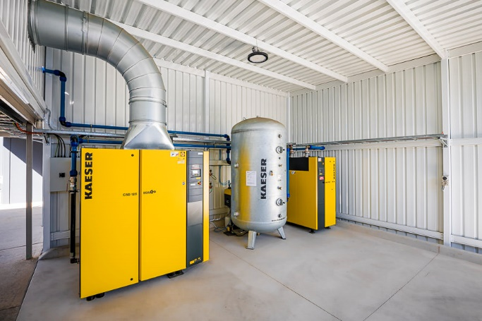
023_Image 1_compressed air at Hume Doors.jpg

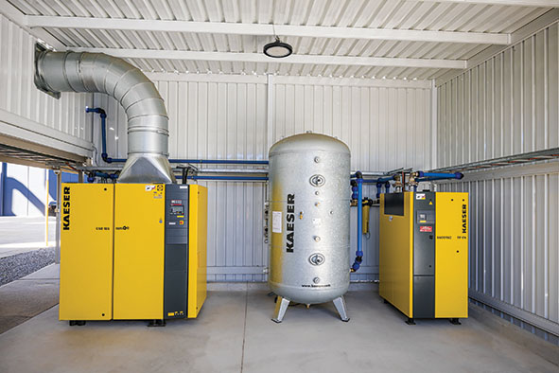
023_Image 2_compressed air at Hume Doors.jpg

Caption: The complete new Kaeser compressed air station at Hume Doors including the CSD 125 rotary screw compressor.

CNC routing machine
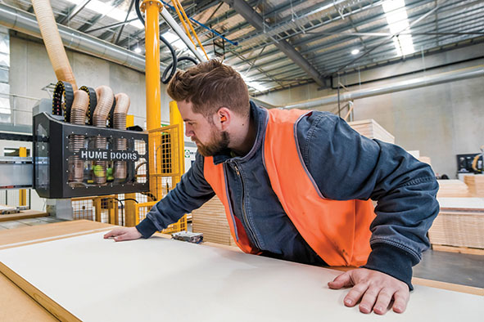
023_Image 3_CNC routing machine at Hume Doors.jpg

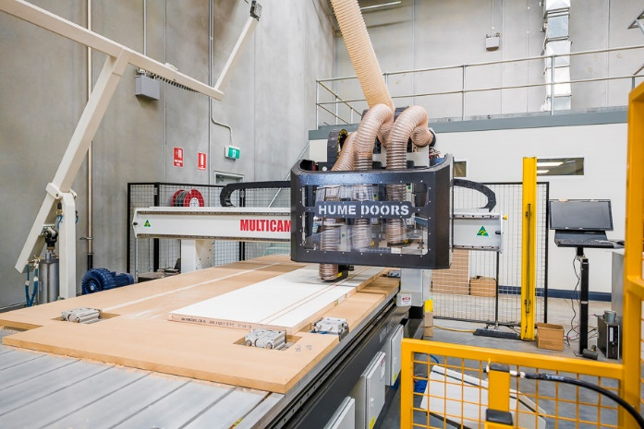
023_Image 4_ CNC routing machine at Hume Doors.jpg

Caption: Compressed air is an important utility to Hume and can be found in use across the manufacturing process, here being used to power a CNC routing machine.

Staple guns
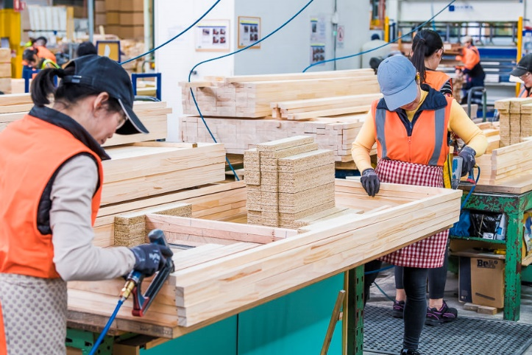
023_Image 5_staple guns being used at Hume Doors.jpg
023_Image 6_staple gun being used at Hume Doors.jpg

Caption: Compressed air is used here to power staple guns.

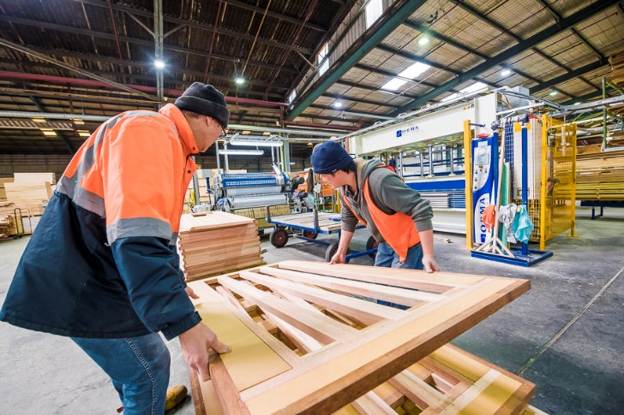
023_Image 7_production process at Hume Doors.jpg

Caption: Above, part of the production process at Hume Doors.

Axis robot & vacuum grip
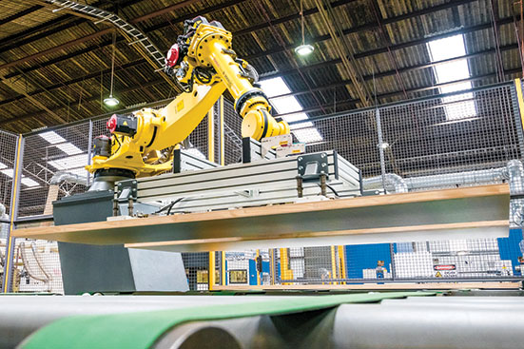
023_Image 8_axis robot lifting and moving the finished doors at Hume Doors.jpg

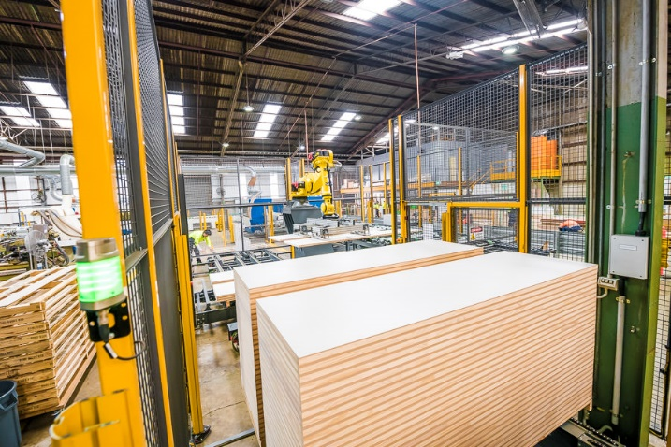
023_Image 9_axis robot stacking finished doors at Hume Doors ready for despatch.jpg

Caption: Compressed air powers a number of axis robots that vaccum grip the doors, taking them through the final stages of the production process before they are stacked ready for despatch.

The finished products

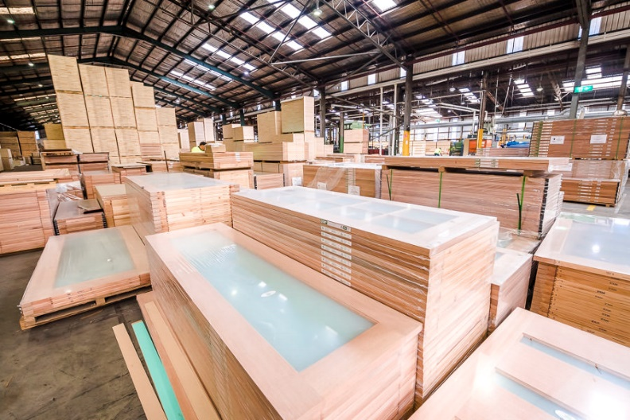
023_Image 10_finished doors at Hume Doors.jpg

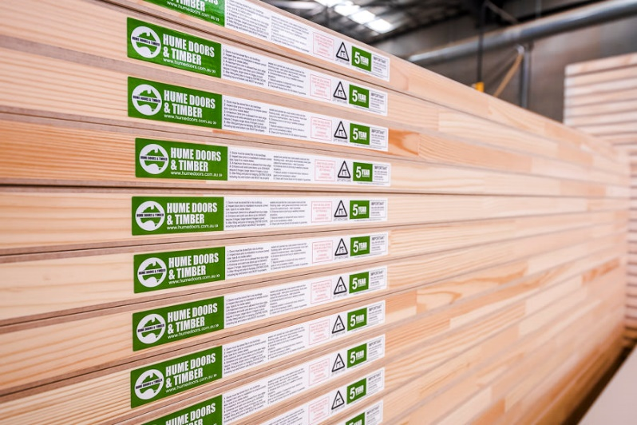
023_Image 11_finished doors at Hume Doors.jpg

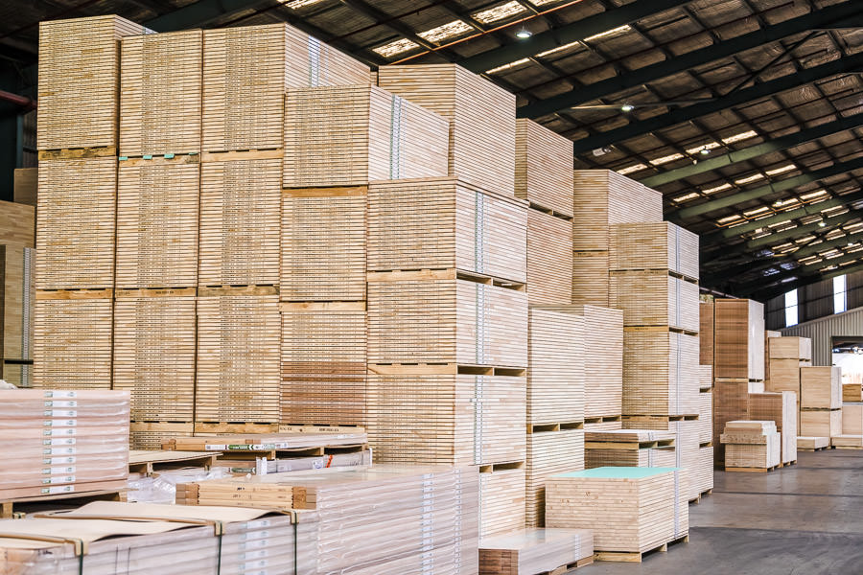
023_Image 12_finished doors at Hume Doors.jpg

Caption: The finished products! Hume provides innovation in doorway technology and manufactures an extensive range of products - over 2,000 to be exact.

((Kaeser photo – free for publication))

