Hannover Messe 2015 Preview - Kaeser Compressors is ready for Industrie 4.0!
Kaeser Compressors is proud to showcase a host of innovations at this year's Hannover Messe (HMI). This includes the next generation Sigma Air Manager 4.0 master controller along with the new Sigma Network, FBS series rotary screw blower models and a new generation of motors.
Kaeser products are not only designed to deliver the most reliable, efficient and cost-effective compressed air supply possible, but they are also fully ready to take advantage of the future-oriented benefits that Industry 4.0 has to offer.
SAM 4.0
The Sigma Air Manager (SAM 4.0) is the even more powerful second generation version of the highly successful master controller from Kaeser. Amongst its numerous features, SAM 4.0 maximises the efficiency of all components within the compressed air station. It also evaluates gathered data to provide predictive maintenance. For the user this translates into reduced energy costs, improved efficiency and sophisticated energy management as per ISO 50001.
Introducing the Sigma Network
Created by Kaeser, Sigma Network is a highly secure, closed Ethernet network specifically designed for Kaeser products which further aids optimal monitoring and control of compressed air stations.
Developed in collaboration with renowned software and hardware manufacturers, Sigma Network is yet another example of an independent service from Kaeser that provides exceptional quality and performance. Users are consequently able to enjoy significant cost savings and maximum service convenience as a result of rapid data availability and evaluation.
Predictive maintenance
Imagine no longer having to deal with unscheduled downtime! What if you could immediately know whether a compressor truly requires maintenance today, or in the near future, and to what extent servicing is actually required? It is already possible! With the Sigma Network you can simply switch from scheduled maintenance to predictive maintenance - a feature that promises significantly lower lifecycle costs for compressed air production.
Energy saving low pressure screw blower product range extended
Following the successful 2014 market launch of the highly efficient EBS series screw blowers featuring Sigma Profile rotors, Kaeser is proud to announce the launch of the FBS series screw blowers which provide free air deliveries up to 67 m³/min. Kaeser screw blowers are now available with free air deliveries from 10 to 67 m³/min, and a maximum differential pressure of 1.1 bar.
Utilising the same proven and trusted technology inherent in the standard Kaeser compressor range, the new FBS series screw blowers provide a low pressure compressor solution that delivers significant energy savings. In fact, the FBS series are up to 35 percent more efficient than conventional rotary blowers, outclassing other comparable screw and turbo blowers through its significant energy advantages.
In addition, the integrated Sigma Control 2 controller provides continuous and comprehensive monitoring, whilst allowing straightforward connection of each machine to communications networks.
Latest generation DSDX rotary screw compressors
An industry leader in rotary screw compressor technology, Kaeser is proud to introduce further refinements with its latest generation DSDX rotary screw compressor models. The DSDX series now feature an optimised version of the highly efficient Sigma airend which delivers greater output with enhanced efficiency; specific power has been improved by five percent and free air delivery is two to three percent higher.
New motors for optimum efficiency
Kaeser will also present a new and innovative generation of high efficiency motors at HMI 2015. Developed in collaboration with a renowned motor manufacturer as part of a research trial, these next generation motors provide further improved performance, especially in partial load ranges.
Kaeser and Industrie 4.0
Capable of seamless integration into an overall system and of communicating with one another, all Kaeser products are ready to take advantage of the future-oriented benefits that Industrie 4.0 has to offer.
All elements of a Kaeser compressed air system can be networked together from; production planning to implementation and predictive maintenance, enabling intelligent control, which allows for the automatic delivery of the compressed air volume and quality required by each specific user. This strategy helps to maintain availability and efficiency, and keeps lifecycle costs to a minimum.
The comprehensive data collected by the system is additionally used to make future products ever more innovative and efficient based on real-world operating conditions.
Visit Kaeser Compressors at Hannover Messe in Hall 26 / Booth D42, 13-17 April 2015.

File: o-Hannover-preview-nz
Approved for publication, copy acknowledgement appreciated
Image:

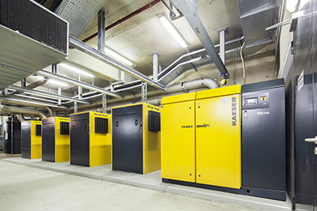
The innovative and energy-efficient FBS series screw blowers from Kaeser provide an effective and dependable supply of low pressure quality compressed air.

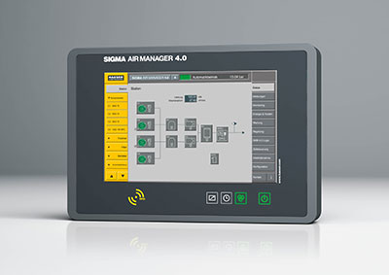
The Sigma Air Manager 4.0 (SAM 4.0) not only ensures highly efficient monitoring and control of all compressed air station components, but also enables the user to take advantage of the future-oriented benefits that Industrie 4.0 has to offer.

